HRITIK AJAY BANSAL
180905105
CSE A 15

Lab 1:

Q1)
#include<mpi.h>
#include<stdio.h>
#include<math.h>
#include<stdlib.h>
int main(int argc, char const *argv[])
{
int rank, size;
int x=10;
int ierr=MPI_Init(NULL,NULL);
MPI_Comm_size(MPI_COMM_WORLD,&size);
MPI_Comm_rank(MPI_COMM_WORLD,&rank);
double result = pow(x, rank);
printf("PROCESSOR %d of %d: pow value=%f \n",rank,size,result );
MPI_Finalize();
return 0;
}
OUTPUT:
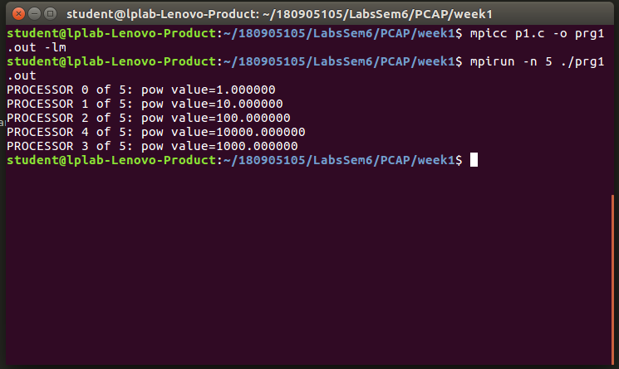

Q2)
#include<mpi.h>
#include<stdio.h>
int main(int argc, char const *argv[])
{
int rank, size;
int ierr=MPI_Init(&argc,&argv);
MPI_Comm_size(MPI_COMM_WORLD,&size);
MPI_Comm_rank(MPI_COMM_WORLD,&rank);
if(rank%2==0)
printf("PROCESSOR %d of %d: HELLO \n",rank,size );
else
printf("PROCESSOR %d of %d: WORLD \n",rank,size );
MPI_Finalize();
return 0;
}

OUTPUT:
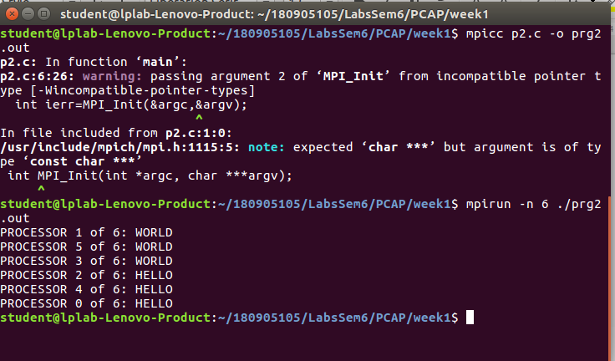

Q3)
#include<mpi.h>
#include<stdio.h>
int main(int argc, char const *argv[])
{
int rank, size;
int a=7,b=10;

int ierr=MPI_Init(&argc,&argv);
MPI_Comm_size(MPI_COMM_WORLD,&size);
MPI_Comm_rank(MPI_COMM_WORLD,&rank);
switch(rank){
case 0:
printf("PROCESSOR %d of %d: A: %d B:%d \n",rank,size,a,b );
break;
case 1:
printf("PROCESSOR %d of %d:ADDITION: %d \n",rank,size,a+b );
break;
case 2:
printf("PROCESSOR %d of %d:SUBTRACTION: %d \n",rank,size,a-b );
break;
case 3:
printf("PROCESSOR %d of %d:MULTIPLICATION: %d \n",rank,size,a*b );
break;
case 4:
printf("PROCESSOR %d of %d:DIVISION: %f \n",rank,size,a/b );
break;

}

MPI_Finalize();
return 0;
}

output:
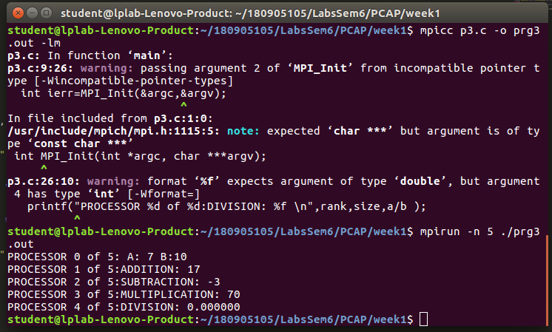

Q4)
#include<mpi.h>
#include<stdio.h>
#include<string.h>
int main(int argc, char const *argv[])
{
char c[10];
strcpy(c,"HeLLO");
int rank, size;
int ierr=MPI_Init(&argc,&argv);
MPI_Comm_size(MPI_COMM_WORLD,&size);
MPI_Comm_rank(MPI_COMM_WORLD,&rank);

if(rank==0)
printf("ORIGINAL STRING %s\n",c);
if (c[rank]>='A'&&c[rank]<='Z')
{
c[rank]+=32;
/* code */
}
else
c[rank]-=32;
printf("processor %d: STRING %s\n",rank,c );

MPI_Finalize();
return 0;
}
OUTPUT:
