LAB 2:
HRITIK AJAY BANSAL
CSE A 15
180905105

Q1)#include<mpi.h>
#include<stdio.h>
#include<string.h>
#define comm MPI_COMM_WORLD
int main(int argc, char const *argv[])
{
char str[10];
MPI_Status status;
int len;
int rank,size;
MPI_Init(NULL,NULL);
MPI_Comm_rank(comm, &rank);
MPI_Comm_size(comm,&size);
if (size!=2)
{
printf("requires 2 processes \n");
MPI_Abort(comm,911);
}
if (rank==0)
{
printf("enter a string \n");
scanf("%s",str);
len=strlen(str);

MPI_Ssend(&len,1,MPI_INT,1,0,comm);
MPI_Ssend(&str,len+1,MPI_CHAR,1,1,comm);

MPI_Recv(&str,len+1,MPI_CHAR,1,3,comm,&status);
printf("updated string sent by process 1 is: %s \n",str);

}

if (rank==1)
{
MPI_Recv(&len,1,MPI_INT,0,0,comm,&status);

MPI_Recv(&str,len+1,MPI_CHAR,0,1,comm,&status);

for (int i = 0; i < len; ++i)
{
if (str[i]>='A'&&str[i]<='Z')
{
str[i]+=32;

}
else
str[i]-=32;
}
MPI_Ssend(&str,len+1,MPI_CHAR,0,3,comm);
}
MPI_Finalize();
return 0;
}

OUTPUT:
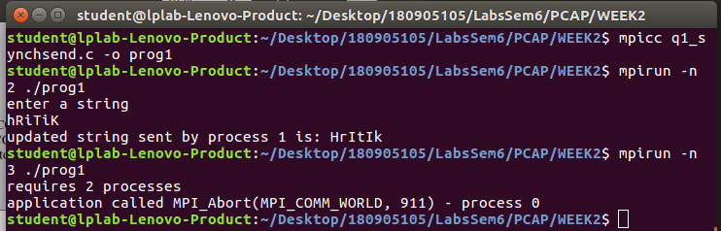

Q2) #include<mpi.h>
#include<stdio.h>
#include<string.h>
#define comm MPI_COMM_WORLD
int main(int argc, char const *argv[])
{
int root=0;
int a;
int rank,size;
MPI_Init(NULL, NULL);
MPI_Status status;
MPI_Comm_rank(comm,&rank);
MPI_Comm_size(comm,&size);

if (rank==root)
{
printf("enter a number\n");
scanf("%d",&a);
for (int i = 1; i < size; ++i)
{
MPI_Send(&a,1,MPI_INT,i,i,comm);
}
printf("process %d: %d sent to all other processes\n",rank,a);
}
else{
MPI_Recv(&a,1,MPI_INT,0,rank,comm,&status);
printf("process %d: %d\n",rank,a);
}

MPI_Finalize();
return 0;
}
output:
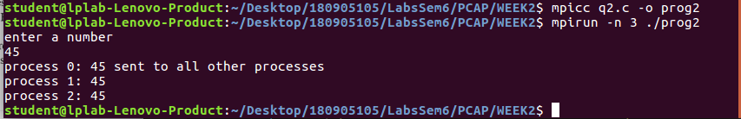

Q3)#include<mpi.h>
#include<stdio.h>
#include<string.h>
#define comm MPI_COMM_WORLD
int main(int argc, char const *argv[])
{
int root=0;
int a;
int rank,size;
MPI_Init(NULL, NULL);
MPI_Status status;
MPI_Comm_rank(comm,&rank);
MPI_Comm_size(comm,&size);
int b[size];
char buff[100];
int sl=100;
MPI_Buffer_attach(buff,sl);
if (rank==root)
{
printf("enter an arry of length %d \n",size);
for (int i = 0; i < size; ++i)
{
scanf("%d",&b[i]);
}

for (int i = 1; i < size; ++i)
{
a=b[i];

MPI_Bsend(&a,1,MPI_INT,i,i,comm);

}
printf("process %d: Array elements sent to respective processes\n",rank);
}
else
if (rank%2==0)
{
MPI_Recv(&a,1,MPI_INT,0,rank,comm,&status);
printf("process %d: %d recieved\n",rank,a);
int x=a*a;
printf("process %d: square: %d \n",rank,x);
}
else
{ MPI_Recv(&a,1,MPI_INT,0,rank,comm,&status);
printf("process %d: %d recieved\n",rank,a);
int x=a*a*a;
printf("process %d: cube: %d \n",rank,x);
}
MPI_Buffer_detach(&buff,&sl);
MPI_Finalize();
return 0;
}
OUTPUT:
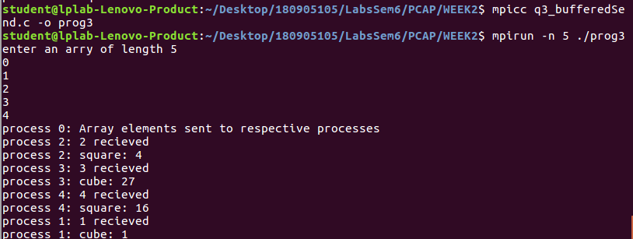

Q4)
// program works the same for MPI_Send() and MPI_Ssend()

#include<mpi.h>
#include<stdio.h>
#include<string.h>
#define comm MPI_COMM_WORLD
int main(int argc, char const *argv[])
{
int root=0;
int a;
int rank,size;
MPI_Init(NULL, NULL);
MPI_Status status;
MPI_Comm_rank(comm,&rank);
MPI_Comm_size(comm,&size);

if (rank==root)
{
printf("enter a number\n");
scanf("%d",&a);

MPI_Ssend(&a,1,MPI_INT,rank+1,rank,comm);
printf("process %d: %d sent to process %d\n",rank,a,rank+1);
MPI_Recv(&a,1,MPI_INT,size-1,size-1,comm,&status);
printf("process %d: %d recieved from process %d\n",rank,a,size-1);
}
else{
MPI_Recv(&a,1,MPI_INT,rank-1,rank-1,comm,&status);
a=a+1;
MPI_Ssend(&a,1,MPI_INT,(rank+1)%size,rank,comm);
printf("process %d: %d sent to process %d\n",rank,a,(rank+1)%size);

}

MPI_Finalize();
return 0;
}
output:
