LAB 3
HRITIK AJAY BANSAL
CSE A 15
180905105

Q1)#include<mpi.h>
#include<stdio.h>
#include<string.h>

int facto(int c){
int t=1;int flag=1;
for (int i = 1; i <=c; ++i)
{
t*=i;
}
return t;
}
int main(int argc, char const *argv[])
{
int fact;
int x;
int rank;int size;
int root=0;int flag=1;

MPI_Init(NULL,NULL);
MPI_Comm_rank(MPI_COMM_WORLD,&rank);
MPI_Comm_size(MPI_COMM_WORLD,&size);
int a[size],b[size];
if(rank==root){
printf("enter %d no of elemnts\n",size );
for (int i = 0; i < size; ++i)
{
scanf("%d",&a[i]);
}

}
MPI_Scatter(a,1,MPI_INT,&x,1,MPI_INT,0,MPI_COMM_WORLD);

fact=facto(x);
printf("process %d: factorial of %d: %d\n",rank,x,fact );

MPI_Gather(&fact,1,MPI_INT,b,1,MPI_INT,0,MPI_COMM_WORLD);

if (rank==0)
{ int recv=0;
for (int i = 0; i < size; ++i)
{
recv+=b[i];
}
printf("process 0: sum of factorials:%d\n",recv );
}

MPI_Finalize();
return 0;
}

OUTPUT:
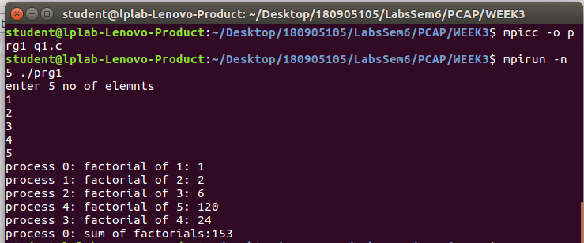

Q2)#include<mpi.h>
#include<stdio.h>
#include<string.h>

double avrg(int* b,int m){
double sum=0,avv;
for (int i = 0; i < m; ++i)
{
sum+=b[i];
}
avv=sum/m;
return avv;
}
int main(int argc, char const *argv[])
{
int rank;int size;
int root=0;int flag=1;

MPI_Init(NULL,NULL);
MPI_Comm_rank(MPI_COMM_WORLD,&rank);
MPI_Comm_size(MPI_COMM_WORLD,&size);\
int n=size;
int m;
int *a;
double avr[n];
if (rank==root)
{
printf("enter the value of m\n");
scanf("%d",&m);
a=malloc(m*n*(sizeof(int)));
printf("enter %d elements\n",n*m);
for (int i = 0; i < n*m; ++i)
{
scanf("%d",&a[i]);
}

}

MPI_Bcast(&m,1,MPI_INT,0,MPI_COMM_WORLD);
int *b;
b=malloc(m*sizeof(int));

MPI_Scatter(a,m,MPI_INT,b,m,MPI_INT,0,MPI_COMM_WORLD);
double avg=avrg(b,m);
printf("process %d: average of my m nos is: %f\n",rank,avg);

MPI_Gather(&avg,1,MPI_DOUBLE,avr,1,MPI_DOUBLE,0,MPI_COMM_WORLD);
if (rank==0)
{double sum=0;
for (int i = 0; i < n; ++i)
{
sum+=avr[i];

}
double avg1=((sum)/n);
printf("process 0: average of all nos is: %f\n",avg1);
}

MPI_Finalize();
return 0;
}
output:
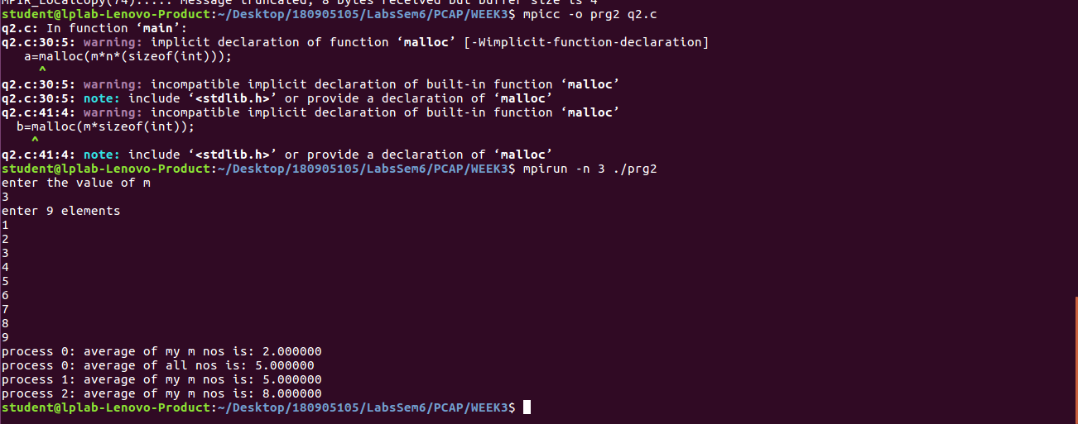
Q3)#include<mpi.h>
#include<stdio.h>
#include<string.h>

int non_count(char* b){
int non=0;
for (int i = 0; i < strlen(b); ++i)
{
if(isalpha(b[i]))
if (b[i]!='a'&&b[i]!='e'&&b[i]!='i'&&b[i]!='o'&&b[i]!='u'&&b[i])
{
non++;
}
}
return non;
}
int main(int argc, char const *argv[])
{
int fact;
int x;
int rank;int size;
int root=0;int flag=1;

MPI_Init(NULL,NULL);
MPI_Comm_rank(MPI_COMM_WORLD,&rank);
MPI_Comm_size(MPI_COMM_WORLD,&size);
char a[100],b[100];
int c[size];
int m;
if(rank==root){
printf("enter a string having multiple of %d characters\n",size );
gets(a);
m=(strlen(a)/size);

}
MPI_Bcast(&m,1,MPI_INT,0,MPI_COMM_WORLD);

MPI_Scatter(a,m,MPI_CHAR,&b,m,MPI_CHAR,0,MPI_COMM_WORLD);

int nonc=non_count(b);
printf("process %d: non-vowel alphabet count is: %d\n",rank,nonc );

MPI_Gather(&nonc,1,MPI_INT,c,1,MPI_INT,0,MPI_COMM_WORLD);

if (rank==0)
{ int recv=0;
for (int i = 0; i < size; ++i)
{
recv+=c[i];
}
printf("process %d: final non-vowel alphabet count is: %d\n",rank,recv );
}
MPI_Finalize();
return 0;
}
output:
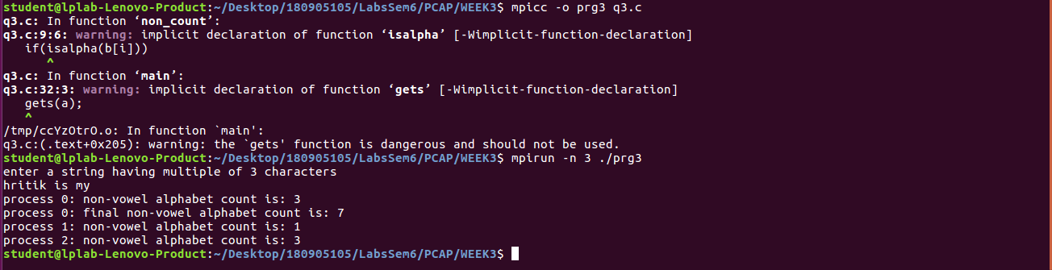
Q4)#include<mpi.h>
#include<stdio.h>
#include<string.h>
#include<stdlib.h>
char* mixed(char* d, char*f){
char* xx=(char *)calloc(100,sizeof(char));
int j=0,k=0;
for (int i = 0; i < strlen(d)*2,j<strlen(d),k<strlen(d); ++i)
{
if (i%2==0)
{
xx[i]=d[j++];
}
else
xx[i]=f[k++];
}
xx[2*strlen(d)]='\0';

return xx;
}
int main(int argc, char const *argv[])
{
int fact;
int x;
int rank;int size;
int root=0;int flag=1;

MPI_Init(NULL,NULL);
MPI_Comm_rank(MPI_COMM_WORLD,&rank);
MPI_Comm_size(MPI_COMM_WORLD,&size);
char a[100],b[100];
char a1[100],b1[100];

char c[100];
int m;int n=0;
if(rank==root){
printf("enter 2 strings having multiple of %d characters\n",size );
gets(a);
gets(a1);
m=(strlen(a)/size);
n=2*strlen(a);

}
MPI_Bcast(&m,1,MPI_INT,0,MPI_COMM_WORLD);

MPI_Scatter(a,m,MPI_CHAR,b,m,MPI_CHAR,0,MPI_COMM_WORLD);
MPI_Scatter(a1,m,MPI_CHAR,b1,m,MPI_CHAR,0,MPI_COMM_WORLD);

char* tt=(char *)calloc(100,sizeof(char));
strcpy(tt,mixed(b,b1));
printf("process %d: mixed string is: %s\n",rank,tt);

MPI_Gather(tt,2*m,MPI_CHAR,c,2*m,MPI_CHAR,0,MPI_COMM_WORLD);

if (rank==0)
{
c[n]='\0';
printf("process %d: final mixed string is: %s\n",rank,c);

}

MPI_Finalize();
return 0;
}
output:
