Scenario: SEC College Football Stats Tracker

**Task list:**

1. Construct a data model **(10-15 entities)** – Sally (Due 10/7)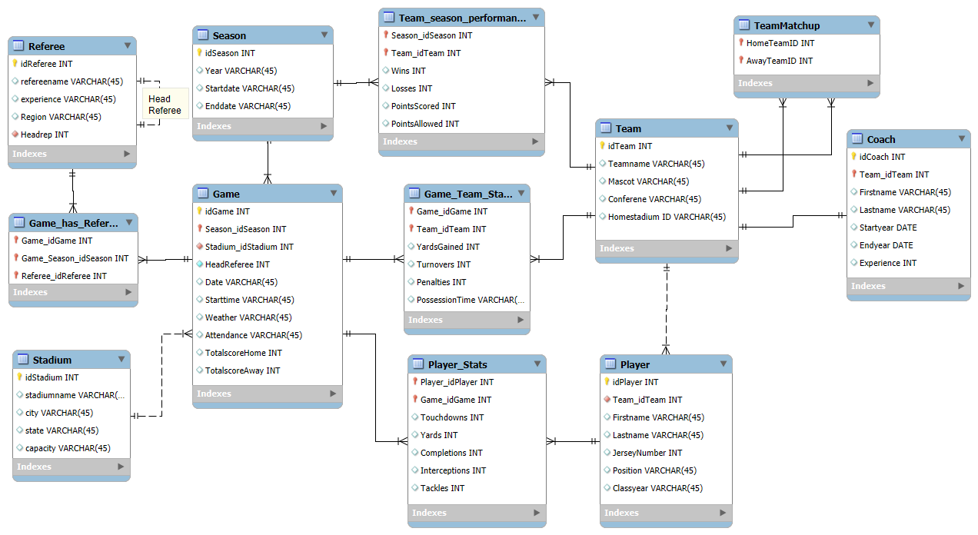
2. Build a database corresponding to that data model – Mattie (Due 10/19)
3. Populate the database with data (forward engineer) – Tucker (Due 10/23)
4. Formulate **10 SQL queries** (6 complex and 4 simple) – Dylan (10/25)
   1. These queries must be relevant from a managerial perspective (i.e., why would a manager care about these queries) and not too similar to one another.
5. At least one team member needs to construct/maintain a GitHub repository with details of the team project described below

**10 SQL Queries (6 Complex and 4 Simple)**:

**Simple:**

1. Show all referees with more than 10 years of experience.

SELECT refereename, experience, role

FROM Referee

WHERE experience > 10;

**Managerial Reasoning:** A manager may want to see which referees are veterans to find which referees to allocate for a bowl or championship game.

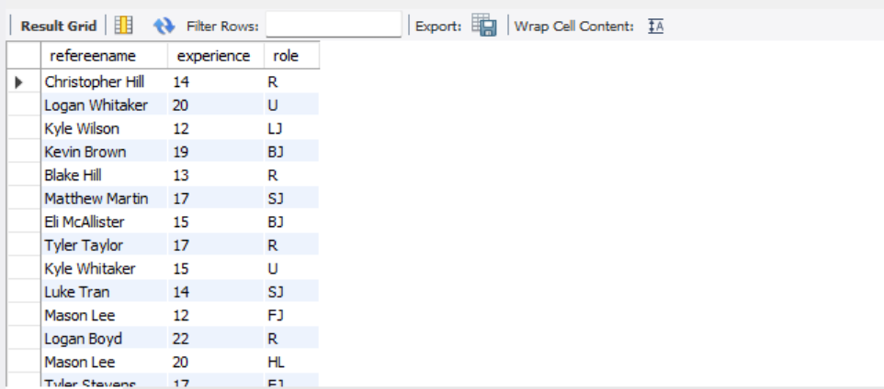

**:**

1. Count the total number of referees by their role.

SELECT role, COUNT(*) AS NumReferees

FROM referee

GROUP BY role;

**Managerial Reasoning:** A manager may want to see how many referees are assigned to each role to get a better understanding of staffing balance, and would be helpful to assess hiring or promotion needs.  
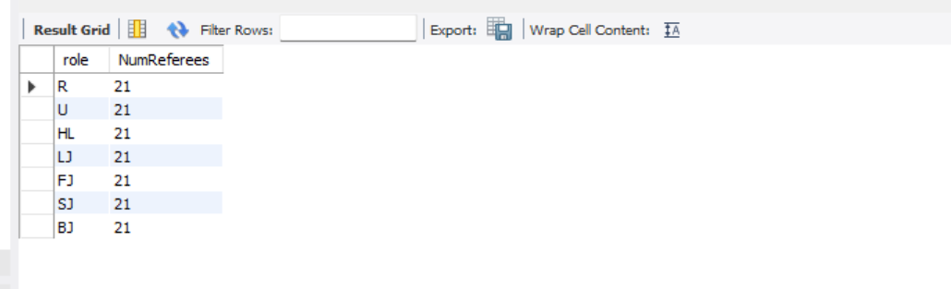

**:**

1. Show the points allowed by each team starting with the team with the most points allowed.

SELECT teamid, pointsallowed

FROM team_season_performance

ORDER BY pointsallowed DESC;

**Managerial Reasoning:** Would help a manager to identify weak defensive teams which may be in need of coaching focus or a new coach, or more player recruitment.

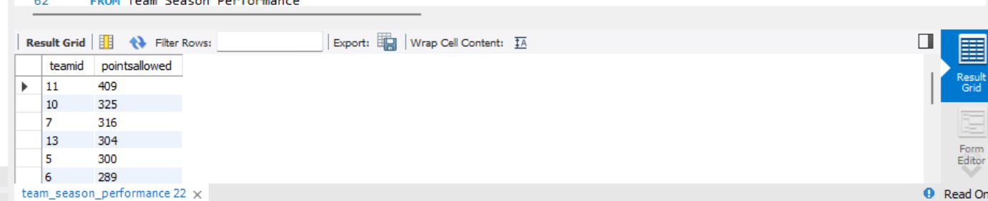

**Simple:**

1. Show the teams and their win-loss ratio and put it in descending order.

SELECT teamid, wins, losses, (wins * 1.0) / losses AS WinLossRatio

FROM team_season_performance

ORDER BY WinLossRatio DESC;

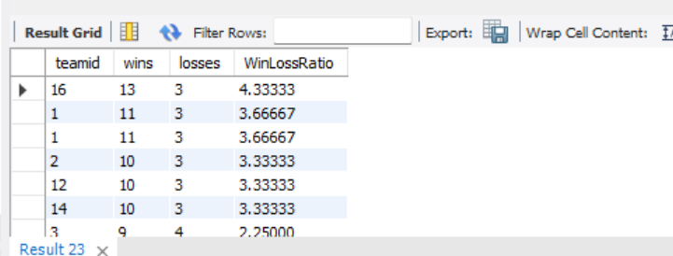

**Complex:**

1. Group referees into their respective experience levels (Beginner, Intermediate, Advanced, Veteran).

SELECT CASE

WHEN experience BETWEEN 0 AND 3 THEN 'Beginner (0–3 yrs)'

WHEN experience BETWEEN 4 AND 7 THEN 'Intermediate (4–7 yrs)'

WHEN experience BETWEEN 8 AND 12 THEN 'Advanced (8–12 yrs)'

ELSE 'Veteran (13+ yrs)'

END AS ExperienceLevel,

COUNT(*) AS NumReferees

FROM Referee

GROUP BY ExperienceLevel

ORDER BY NumReferees DESC;

**Managerial Reasoning:** Provides a snapshot of the experience levels for each of their referees in a clear and clean format. This would help for management to assess whether their hiring and development are balanced.

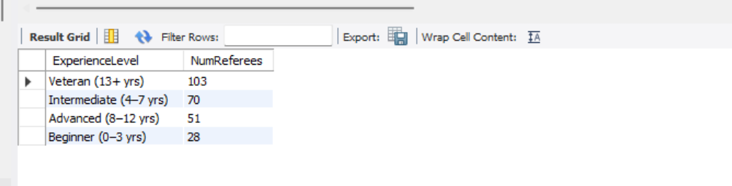

1. Group each team by their win percentage ranges.

SELECT CASE

WHEN (wins*1.0)/(wins+losses) BETWEEN 0 AND 0.25 THEN 'Low (0–25%)'

WHEN (wins*1.0)/(wins+losses) BETWEEN 0.26 AND 0.5 THEN 'Moderate (26–50%)'

WHEN (wins*1.0)/(wins+losses) BETWEEN 0.51 AND 0.75 THEN 'High (51–75%)'

ELSE 'Excellent (76–100%)'

END AS WinCategory,

COUNT(*) AS NumTeams

FROM teams_season_performance

GROUP BY WinCategory

ORDER BY NumTeams DESC;

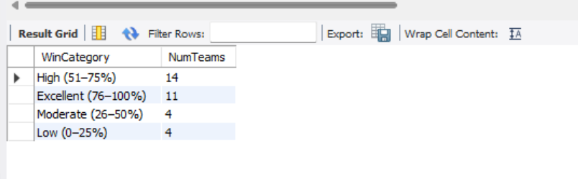

**Managerial Reasoning:** Might be useful to a manager to identify underperforming teams and be able to lend coaching support or changes, as well as identifying the best performing teams to plan out marketing strategies for the most profitable teams.

1. Show which teams gain the most yards per game.

SELECT T.teamname,

AVG(GT.yardsgained) AS AverageYards

FROM game_has_team AS GT

JOIN team AS T ON T.idteam = GT.teamid

GROUP BY T.teamname

ORDER BY AverageYards DESC;

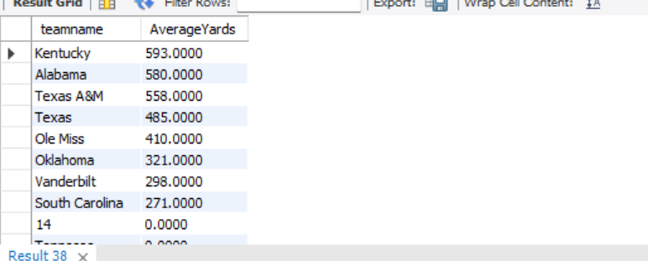

**Managerial Reasoning:** This will show which teams are the strongest offensively and which may need coaching or recruitment improvement.

1. Which stadiums draw above the leagues average in attendance?

SELECT

S.stadiumname,

S.city,

S.state,

AVG(G.attendance) AS average_attendance

FROM games AS G

JOIN stadium AS S

ON S.stadiumid = G.stadiumid

GROUP BY

S.stadiumname,

S.city,

S.state

HAVING

AVG(G.attendance) > (SELECT AVG(attendance) FROM games)

ORDER BY

average_attendance DESC;

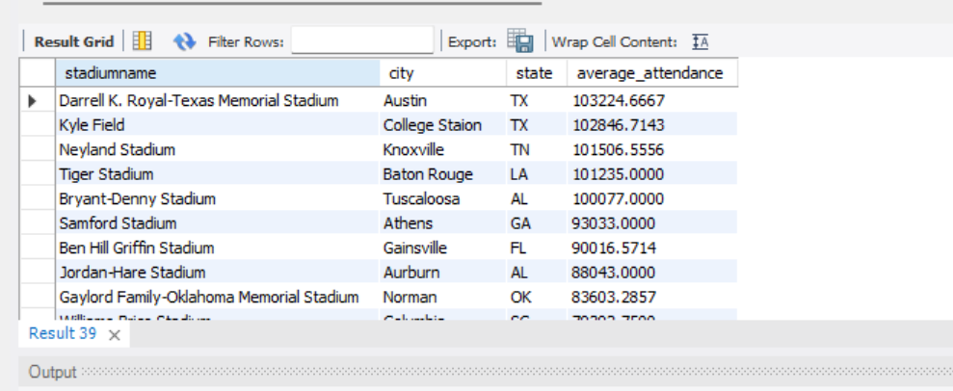

**Managerial Reasoning:** Shows which stadium venues draw in the most amount of fans to assess premium pricing for future events and scheduling, or possible bowl and championship games.

1. Which teams get more yards per game than the average yards per game by a given team?

SELECT

T.teamname,

AVG(GT.yardsgained) AS yards_per_game

FROM

game_has_teams AS GT

JOIN

team AS T

ON T.idTeam = GT.Team_idTeam

GROUP BY

T.teamname

HAVING

AVG(GT.yardsgained) > (

SELECT AVG(yardsgained) FROM game_has_teams

)

ORDER BY

yards_per_game DESC;

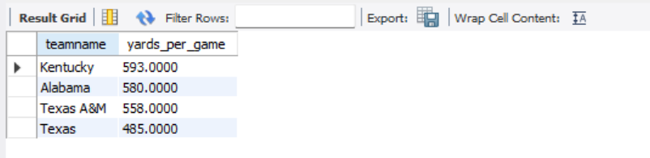

**Managerial Reasoning:** Finds which teams have a better than average performance on the offensive side, which can be used to find which teams are the best and have the highest chance of doing well in the playoffs/making it to a championship game.

1. Which team(s) is/are undefeated at their home stadium?

SELECT

T.teamname,

AVG(GT.yardsgained) AS yards_per_game

FROM

game_has_teams AS GT

JOIN

team AS T

ON T.idTeam = GT.Team_idTeam

GROUP BY

T.teamname

HAVING

AVG(GT.yardsgained) > (

SELECT AVG(yardsgained) FROM game_has_teams

)

ORDER BY

yards_per_game DESC;

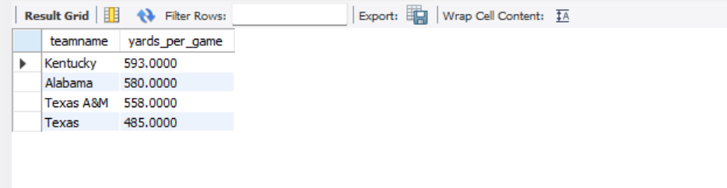

**Managerial Reasoning:** This could be helpful for managers because the stronger the team's home game performance means more fan engagement and can be used for pricing leverage on home games of an undefeated team at home. Could also be used for TV streaming slots/ads placement (putting more ads on a big game with an undefeated team at home because there will be more fan engagement)