Staff Detection System
Technical Summary · YOLOv11 + Swin Transformer

Purpose | Automatically detect and count staff members in video footage
Input | Video file (.mp4) or webcam / RTSP stream
Output | Annotated video with staff bounding boxes and per-frame counts
Models | YOLOv11m (person detection) + Swin Transformer Base (staff/non-staff)
Run command | python detect.py --detection_model yolo11m.pt --staff_model staff_class.pt  --video sample.mp4 --thres 0.3 --det_thres 0.4
1 Detection Pipeline
Every video frame passes through a two-stage pipeline: a fast person detector locates all individuals, then a binary classifier determines whether each person is staff (based on uniform / nametag appearance).
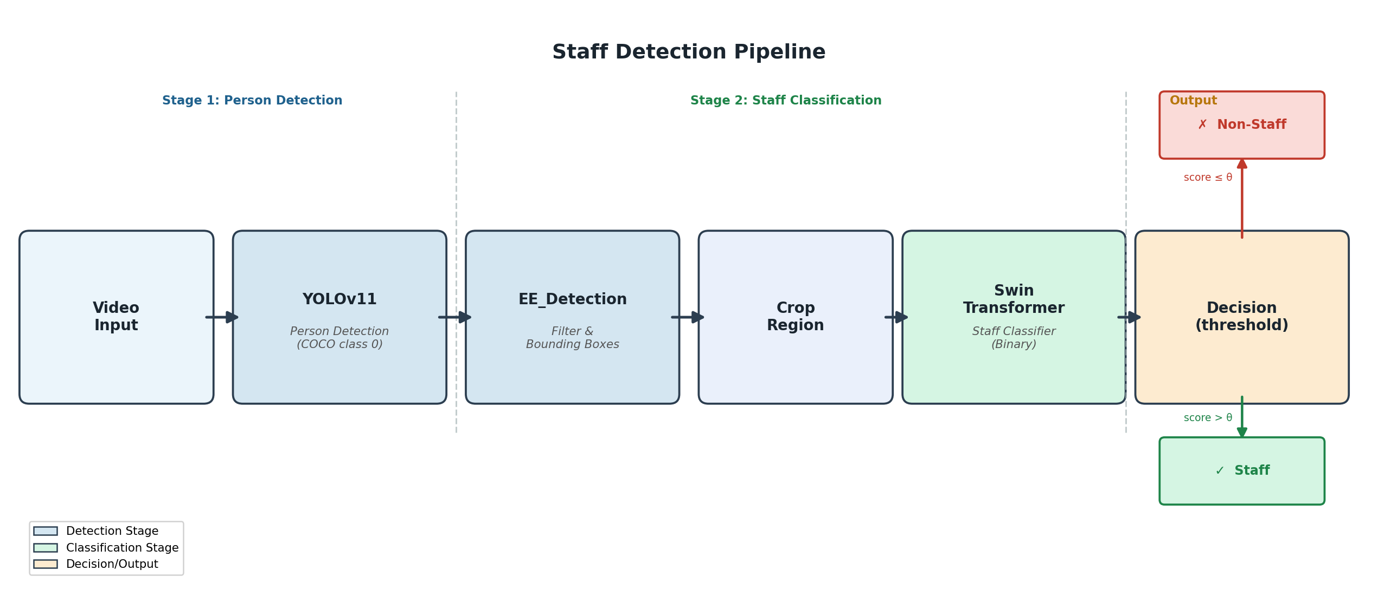
Figure 1 — Two-stage detection pipeline (θ = confidence threshold, default 0.3)
2 Key Components
Scripts  - detect.py — main inference script  - employee_detection.py — filters YOLO output  - id_classification.py — runs Swin classifier  - train.py — person tracking & counting | Models & Artifacts  - yolo11m.pt — YOLOv11 medium (person detector)  - staff_class.pt — Swin Transformer (staff classifier)  - Centroid Tracker — tracks persons across frames  - Crop saved to runs/detect/runN/crops/

3 Model Details
Person Detector — YOLOv11m  Architecture: YOLOv11 medium (ultralytics)  Input: 640 × 640 pixels  Class: COCO class 0 (person only)  Default conf: 0.4 (--det_thres)  Purpose: Locate bounding boxes of all people in frame | Staff Classifier — Swin Transformer  Architecture: Swin Transformer Base (timm)  Input: 224 × 224 RGB crop • No ImageNet normalisation  Output: Scalar score ∈ [0, 1] (1 = staff)  Default thres: 0.3 (--thres)  Purpose: Binary staff / non-staff classification per crop
4 Training the Staff Classifier
The Swin Transformer classifier was fine-tuned on labelled crops extracted from real video footage using train.py. YOLOv11 first detects all persons; each person crop is manually or automatically labelled as staff (1) or non-staff (0). The model is trained to output a scalar confidence score.
Data preparation | Run train.py on labelled footage → save crops → label 0 / 1
Pre-processing | Resize to 224 × 224 · ToTensor (raw [0, 1]) · NO ImageNet normalisation
Fine-tuning | Swin-B backbone from timm · binary cross-entropy · AdamW optimiser
Output | staff_class.pt — PyTorch checkpoint loaded by ID_Classificaiton class
5 Installation & Quick Start
Install dependencies (CPU):
pip install -r requirements.txt
GPU install (CUDA 11.8):
pip install -r requirements_gpu.txt
pip install -r requirements.txt
Run staff detection:
python detect.py \
--detection_model yolo11m.pt \
--staff_model staff_class.pt \
--video sample.mp4 \
--thres 0.3 \
--det_thres 0.4 \
--view
6 Key Parameters
--detection_model | YOLOv11 weights file (default: yolo11m.pt)
--staff_model | Staff classifier checkpoint (required)
--video | Path to input video (default: sample.mp4)
--thres | Staff score threshold — raise to reduce false positives (default: 0.3)
--det_thres | Person detection confidence threshold (default: 0.8)
--no_crop | Disable saving cropped staff detections to crops/
--view | Show live preview window during processing
Staff Detection System · Technical Summary · YOLOv11 + Swin Transformer

