**CNN_based_Seismic_Fault_Prediction**

(Using synthetic seismic data)

**Overview**

This is an ongoing project on building deep learning models to accurately detect faults from seismic images.

**Introduction**

Seismic images provide a structural snapshot of the Earth's subsurface at a specific point in time. The Earth's layers are folded and faulted as a result of numerous geological and tectonic processes. A seismic fault is essentially a crack in the rock layers caused by the movement of a block of rocks/sediments. They are visible in seismic data if the displacement is large enough. These faults are important in hydrocarbon exploration because they can trap oil or act as a conduit for oil to escape. They also pose a significant risk during the drilling process, so proper fault identification and mapping is critical.

**Data**

The synthetic data were taken from the FORCE competition provided by xeek.ai website.

An example of seismic images with fault overlay:

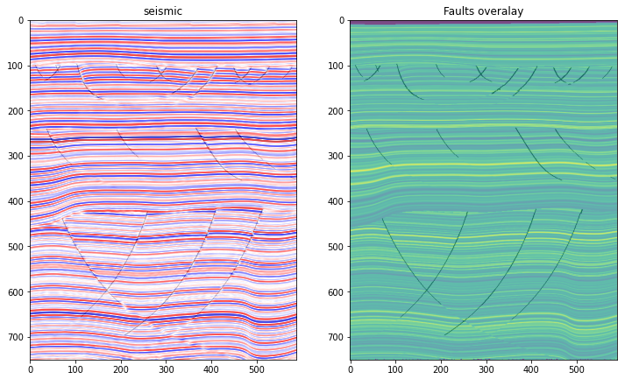

**Model**

The introductory data exploration will be provided in a separate notebook while the machine learning models will be provided under each type of the machine learning framework name. The current model uses a simple U-Net framework using PyTorch implementation:

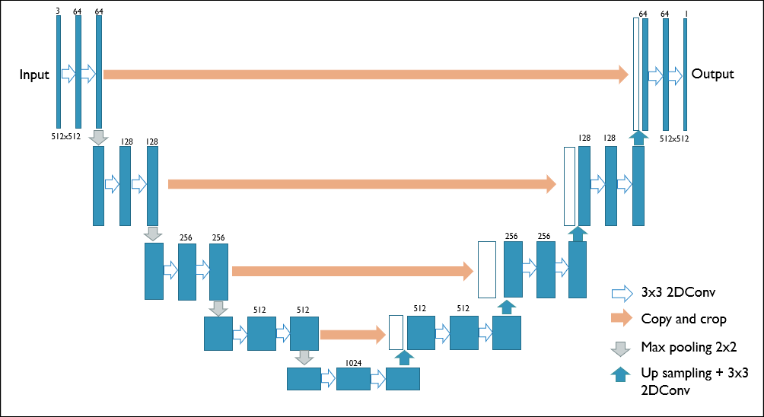

**Results**

The example below is taken randomly from 3 different epochs. Within 20 epochs, the model starts to pick faults effectively.

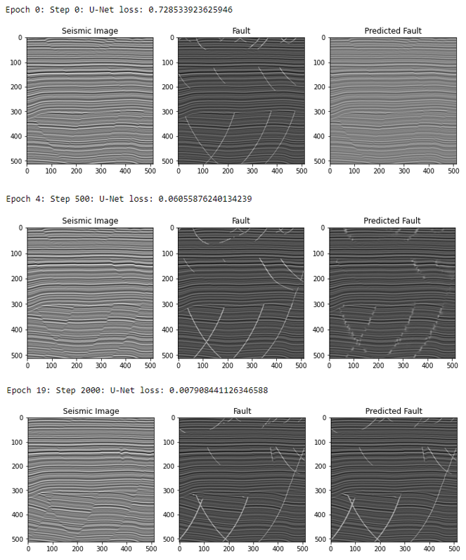

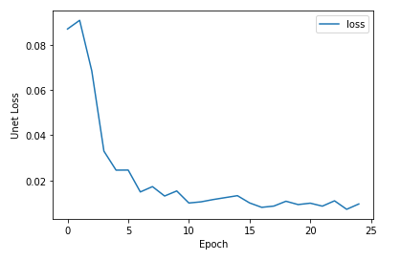

├── Overview

├── images

├── Data_exploration

├── Pytorch_based_UNet_Model_versions.ipynb

└── README.md