Memo for “Physical Appearance and Elections: An Inequality Perspective”
We thank the Editor for giving us the possibility to revise our work and the two reviewers for their comments, suggestions and excellent constructive criticism. We have done our best to take all comments and suggestions very seriously, and to implement every single one of them. We hope that the paper not only reads better now but also has improved substantively and methodologically.
We have structured the memo in two parts. In the first part we respond to Reviewer #1 (R1, henceforth), and in the second part we respond to Reviewer #2 (R2, henceforth). To make this memo more efficient, we have re-stated the original question (in boldface for easier readability), and then we proceed with our answer. Immediately after we show the relevant paragraph that will go into the paper (for readability we put those in blue). We also make sure we reference the edited version if the reader wants to cross-check our revisions.

Reviewer #1
We wanted to thank you for your comments and suggestions. We believe your constructive criticism really improved our paper. Below you will find that we’ve done all we could to implement all your suggestions.
What makes somebody look like having a working class, middle class or upper class occupation? In other words, is there any criterion that makes somebody either working, class, middle class or upper class?
Thank you very much for this question. We think it’s a great opportunity for us to clarify things even further.
We’ve taken three measures to answer your question. First, we’ve incorporated an edited paragraph where we explain our measurement strategy. As we explain there (see below relevant paragraph), we did not ask respondents to evaluate the degree in which candidates’ physical appearance was congruent with their social class. Since in the Finnish context this constitutes an inappropriate question (see detailed explanation below), the answers we would have received could have been contaminated with social desirability biases. Second, we clarify that we rather asked respondents whether the candidates’ physical appearances were congruent with their occupations. As noted in the paper, candidates state their occupations in the poster campaigns. Importantly, and third, we took a data-driven approach: raters did not receive instructions or definitions of what a “janitor” or a “lawyer” should look like. Thus, for us this is rather an empirical question. As we note in the edited paragraph we added after reading your comment, we now clarify that our data-driven approach consisted of evaluating “the extent to which a member of a category (in this case, a person representing a certain occupation) fits a more generally shared idea or image of the meaning of the category name (cf. Rosch & Mervis, 1975)” (p. 8 of the edited paper). This approach then (empirically) exploits these shared ideas without defining, nor a priori nor directly, what “upper,” “middle” or “working” class mean.
Thus, we have added the next paragraph (p. 8 of the edited paper) where we address this issue:
“
Ideally, we would have directly asked the 7,920 raters to evaluate whether candidates looked as if they came from the working, middle, or upper class. However, that would have introduced social-desirability biases into our responses. This widely studied effect appears in other contexts where subjects avoid answering truthfully, due to social pressure, especially when the questions ask about drug use (Druckman et al., 2015), sexual preferences (LaBrie & Earleywine, 2000), attitudes toward race (Kuklinski et al., 1997; Redlawsk et al., 2010) or vote buying (Blair & Imai, 2012; González-Ocantos et al., 2012; Bahamonde, 2022). We believe that directly asking raters to make inferences about the candidates' social classes based on physical appearances constituted an inappropriate question in the Finnish context. Furthermore, the term “social class” is not very often used among the general population because of the “equal Finland” narrative. Thus, to elicit truthful answers, our empirical strategy considered instead asking this question indirectly, that is, asking raters to evaluate the extent to which a member of a category (in this case, a person representing a certain occupation) fits a more generally shared idea or image of the meaning of the category name (cf. Rosch & Mervis, 1975), only then matching those occupations within the three social classes.
- ”
In addition, and very importantly, we have added a theoretical and an empirical discussion about the relationship between social class and physical appearance. These paragraphs were added to the edited version of the paper (in p. 4):
“An alternative approach that links physical appearance and inequality is the Bourdieusian approach. According to this framework, different types of capital are the basis of social classes: economic capital (e.g., wealth and income), cultural capital (e.g., educational qualifications, attitudes toward art, culture, clothing, and physical appearance), and social capital (e.g., social relations), the composition and volume of which varies from one social class to another (Bourdieu, 1984, 1986). Thus, for example, the upper class might comprise individuals with relatively higher levels of cultural capital but not excessive incomes (e.g., professors), as well as people with higher incomes but not necessarily much formal education (e.g., successful entrepreneurs; Flemmen et al. 2017). Even more importantly, Bourdieu emphasized the embodied nature of social class: clothing and physical appearance can provide social markers that sort different social classes, according to how individuals dress and look (Bourdieu, 1984).
All in all, the Bourdieusian approach consistently makes the case that social class is embodied. Thus, people not only express their own social class through their appearance but also make inferences about other people's class status based on their own. Thus, styles of grooming (i.e., make-up, hair, and beard styles), clothing (Skeggs, 2001; Nelissen & Meijers, 2011; Kraus et al. 2013), and body size and shape (Keas & Beer, 1992; cf. Vandebroeck, 2016), become cues of social class. Importantly, such cues make a difference, for instance, in “filtering in” certain job candidates in some labor markets (De Keere, 2021; Friedman & Laurison, 2020; Mears, 2011). Furthermore, recent research has shown that young children are already able to classify other people into occupational status categories using attributes of physical appearance as cues (Vandebroeck, 2021). We believe a similar process of occupational status recognition and “filtering in” likely takes place in low-information elections.
”
We hope these added paragraphs clarify the issue. We wanted to thank you once again for this comment. If there is anything else we should explain and/or incorporate in our paper, we would gladly do so.
I wonder how we can detect the class status of candidates. On official candidate photos, they should all look alike. Men are probably in a suit and women in a dress. How can we detect the occupational status from these features?
Thank you so much for this comment, we think it’s very relevant. You’re absolutely right: One would think that all candidates “should look alike.” However, that's not the case.
To address your point in full, we’ve taken several measures. First, we’ve added some discussion where we explain (based on past research; see below relevant paragraph) that due to the electoral institutions that rule Finnish Municipal Elections, parties are usually forced to recruit as many candidates as possible, effectively getting on board “normal”/”ordinary” people, and not just “career-oriented” politicians. This fact actually shows in the poster campaigns, as candidates (both men and women) dress in a very casual way: it is very easy to see suits, hoodies, knitwear, etc. Second, now we point out (again, based on past research; see below relevant paragraph) to a feature of Finnish society that’s heavily based on functionality and frugality, something that for the same reasons, does show in the candidates’ pictures.
Thus, in sum, not all candidates look alike. More on the contrary, Finnish citizens actually are able to distinguish working, middle and upper-class “looks” because they do look different from each other. As Figure 1 shows in p. 10 (a figure that was in our original submission), particularly, panel B (see panel detail below), Finns effectively and consistently are able to tell the difference between working, middle and upper-class looking candidates. (The three densities show high levels of convergence towards the mean, with little departure from normality).
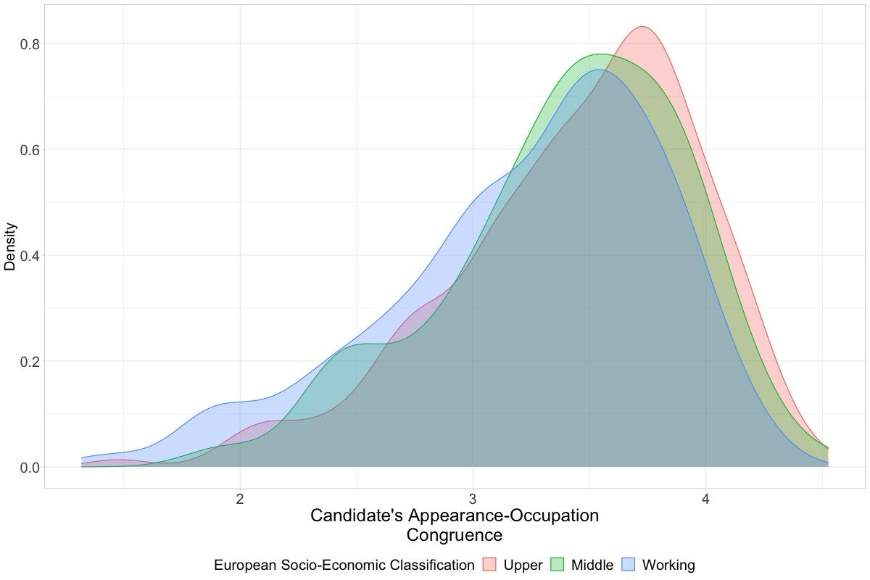
In particular, Panel B of Figure 1 (a figure already included in the original submission of our paper) shows that the variances are quite consistent among working, middle, and upper-class-looking candidates. Also, the figure shows that the mean of these congruence scores is approximately 3.5 (out of a max of 5, see Table 1 in p. 9 for more details about our 1-5 scale of congruence). All in all, (1) there are differences among candidates, and also (2) Finnish citizens are able to identify these differences.
Added paragraph in p. 7 where we explain why there are “normal” and diverse “looks” among candidates:
“
Finnish municipal elections use the D’Hondt electoral system, in which citizens vote for candidates running on party lists. The votes candidates receive determine their rank. Seats are then filled in proportion to the total votes received by each party list. Consequently, parties have strong incentives to present large lists of candidates, even if that means bringing in “list fillers.” Importantly, recruiting such a large number of candidates to fill in the lists is a difficult task for parties, which must actively convince local residents to stand as candidates (Kestilä-Kekkonen et al., 2018). Thus, recruited individuals are not necessarily career-oriented politicians. As a result, ordinary people do run for municipal elections. This electoral feature is critical for our identification strategy as it ensures that “normal” individuals do campaign, as opposed to, e.g., only the wealthy or the good-looking. In fact, this feature shows in campaign posters, where casual knitwear and even hoodies are as common as suits and other more formal clothes, a fact that goes hand-in-hand with the Finnish emphasis on functionality and frugality (Sarpila et al., 2021).
.”
An important additional measure to address your question was to develop a new figure (Figure 2 in the edited version of the paper, in p. 11):
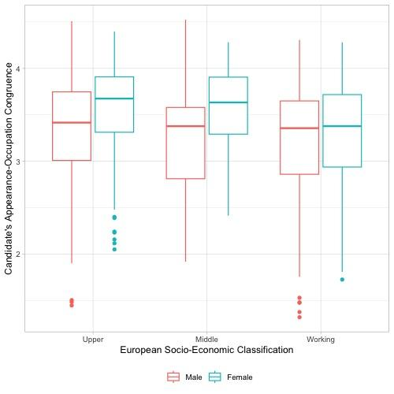
The figure shows that (1) candidates look like the occupation (social class) they do have, and that (2) Finnish citizens are able to correctly distinguish these differences.
Plus, we’ve added the next paragraph which expands on these two points.
Added paragraph that addresses the issue of “[how to] detect the class status of candidates [because all candidates] should all look alike.”
“
For internal consistency, we would also like to see Finnish voters perceiving working-class candidates as working-class individuals, middle-class candidates as middle-class individuals, and so on. Similarly, we would like to see that Finnish candidates who look as though they have working-class occupations actually are working-class individuals, candidates who look as though they have middle-class occupations actually are middle-class individuals, and so on. Other results would mean that either Finnish voters have a hard time assessing the occupation (class) of the candidate based on the candidate’s appearance, or candidates systematically look different from what they are. Either way, one or both assumptions failing to hold would seriously compromise our empirical claims.
.
To verify these assumptions, we show in Figure 2 that Finnish candidates scored an average of 3.3 (see Table 1; a score of 5 is the maximum congruence between physical appearance and occupation). This implies that Finnish voters find that 66% of the time, candidates do look like they belong to the class to which they actually belong. The figure also shows that candidates who look like they have working-class occupations are actually working-class individuals, and so on. Importantly, these levels are consistent for both male and female candidates.
- ”
We wanted to thank you once again for this comment. We in fact made sure to thank you as well in a footnote (footnote #9) for encouraging this discussion. If there is anything else we should explain and/or incorporate in our paper, we would gladly do so.
- What is the inter-coder inter-reliability in this study? In other words, how many coders converge in their occupation judgment? For this analysis to be trustworthy there needs to be strong convergence in voters’ evaluation.
This is also a great question, and we’re sorry if the original manuscript was not clear about our procedures.
We, in fact, did not use “coders” in the typical sense. Coders are usually convenient samples (research assistants, graduate students, etc.) who are paid to code. As we call them in our paper, we effectively recruited 7,920 “raters.” They are in fact a random sample of the Finnish-speaking Finnish population aged 18-64 years old. And to answer R1 more directly, and as Table 1 states in p. 9 (a table that was already in the original submission, which for convenience we paste here below), raters were divided in 5 samples. This was to avoid fatigue effects. Since it was not advisable to ask each of our raters to evaluate all 1,500 candidate images, raters were divided in 5 sub-samples. Each sample evaluated one of the five attributes (see details below in Table 1).
Statistically speaking, having raters randomly drawn from a population, should take care of all observable and unobservable characteristics of the raters (gender, political attitudes, preconceptions of what, say, “working-class looking” means, and others). In other words, our representative sample of Finns (i.e., the raters), and their random assignment to their corresponding task (i.e., evaluating one of the five candidate attributes–as described in Table 1, see below), should make the assignment mechanism completely orthogonal (i.e., uncorrelated) to the characteristics of the rater himself/herself and the characteristics of the candidates that the rater was asked to evaluate. In the edited version of the paper we explain these procedures in detail (see below relevant paragraphs).
Table 1: Attributes Assigned to Raters by Sampling Criteria and Answer Set
Sample | Attribute | Question | Answer Set
1 | Occupation-Congruent Appearance | To what extent does this person correspond to your image of someone working in [occupation]? | 5 = perfectly corresponds to my image; 4 = corresponds well to my image; 3 = somewhat corresponds to my image; 2 = does not correspond well to my image; 1 = does not correspond to my image at all.
2 | Attractiveness | In your opinion, how attractive does this person look compared to others of the same age and gender? | 5 = very attractive; 4 = more attractive than average; 3 = average; 2 = below average; 1 = well below average (e.g., Bono et al., 2017; Griffin & Langlois, 2006; Tu et al., 2022).
3 | Masculinity | To what extent do you think that this person looks masculine compared to others of the same age and gender? | From 1 = not masculine at all to 5 = very masculine (e.g., Hoss et al., 2005).
4 | Femininity | To what extent do you think that this person looks feminine compared to others of the same age and gender? | From 1 = not feminine at all to 5 = very feminine.

Furthermore, and to make sure we take R1’s comments as seriously as we can, we now provide intra-class correlation scores for both male and female candidates. We find that our data show high levels of intra-class correlation, similar to what others have found (see below relevant paragraph which includes some references).
All in all, and continuing with R1’s question, this is the reason why we have a “strong convergence in voters’ evaluation [about] their occupation judgment” (as R1 suggests). As Figure 1 shows in p. 10 of the edited paper, we find that our strategy proves adequate since the candidates scores show very consistent and centered scores regarding all attributes, including the candidates’ occupation attribute (see below in this memo the detail of the figure). In particular, we find high consistency levels regardless of the gender of the candidate (Panel A), the social class of the candidate (Panel B) and the party of the candidate (Panel C).
Detail of Figure 1 showing Panels A, B and C (complete Figure 1 is in p. 10 of the edited version of the paper) :
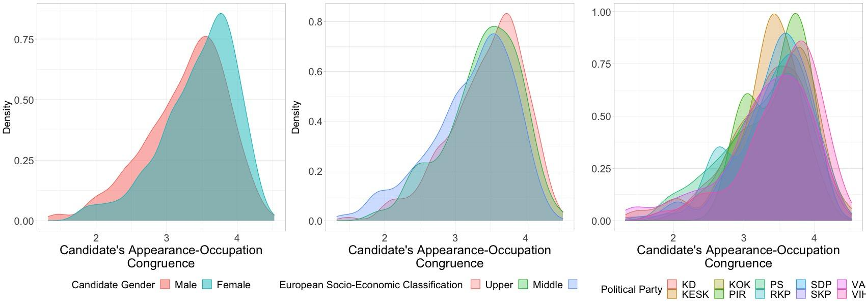
Edited paragraphs that explain in detail our measurement procedure (pp. 8-10 in the edited version of the paper):
“
In addition, we constructed a novel dataset of physical-appearance ratings using a representative sample of Finnish citizens. First, we drew a random sample of 26,500 Finnish-speaking Finns, aged 18–64 years old, from the Finnish population census. During the fall of 2020, these potential respondents were sent one postal invitation and one postal reminder to participate in an online survey. Respondents received a different survey URL in the invitations. In total, 7,920 raters participated in the survey.
Ideally, we would have directly asked the 7,920 raters to evaluate whether candidates looked as if they came from the working, middle, or upper class. However, that would have introduced social-desirability biases into our responses. This widely studied effect appears in other contexts where subjects avoid answering truthfully, due to social pressure, especially when the questions ask about drug use (Druckman et al., 2015), sexual preferences (LaBrie & Earleywine, 2000), attitudes toward race (Kuklinski et al., 1997; Redlawsk et al., 2010) or vote buying (Blair & Imai, 2012; González-Ocantos et al., 2012; Bahamonde, 2022). We believe that directly asking raters to make inferences about the candidates' social classes based on physical appearances constituted an inappropriate question in the Finnish context. Furthermore, the term “social class” is not very often used among the general population because of the “equal Finland” narrative. Thus, to elicit truthful answers, our empirical strategy considered instead asking this question indirectly, that is, asking raters to evaluate the extent to which a member of a category (in this case, a person representing a certain occupation) fits a more generally shared idea or image of the meaning of the category name (cf. Rosch & Mervis, 1975), only then matching those occupations within the three social classes.

To avoid fatigue effects, we asked raters to assess a random subsample of candidates according to several attributes (see Table 1). Sample 1 evaluated the congruence between the candidate’s physical appearance and occupation, Sample 2 evaluated the candidate’s attractiveness; Sample 3 evaluated the candidate’s masculinity; Sample 4 evaluated the candidate’s femininity. Consequently, the attribute on which raters evaluated their random sample of photographs differed among the four samples. In practice, each of the 7,920 raters evaluated 50 candidate photographs assigned at random.
Importantly, data from the raters show high levels of intraclass correlation: 0.24 for male and 0.22 for female candidates for occupation-congruent appearance, 0.14 for male and 0.22 for female candidates for femininity, 0.15 for male and 0.10 for female candidates for masculinity, and 0.28 for male and 0.35 for female candidates for attractiveness (anonymized). All in all, correlations are consistent with those in widely used data, such as the Add Health data, where the attractiveness correlations range between 0.17 and 0.20 (McClintock, 2014).”
We really hope the added paragraph and these detailed responses are good enough in the eyes of R1. However, if you think we should clarify things even more, we would happily do so. Thanks again for your constructive criticism.
- What is the connection between perceived occupational status and real occupational status? In other words, do working class candidates also look more working class?
Thank you. We think this is an excellent clarificatory question, and we see it as an opportunity to provide greater internal validity to our claims. Ideally, we would like to see two things. First, (1) Finnish voters perceive working class candidates as working class individuals, middle class candidates as middle class individuals, and so on. Otherwise, it would mean that voters have wrong perceptions of Finnish candidates. If that were the case, that would seriously compromise our empirical claims. Second, (2) we would like to see that candidates that look like they have working class occupations are actually working class individuals, and so on. Similarly, having otherwise would mean that there is a serious mismatch between class and appearance, again, compromising our empirical claims.
To make sure that (1) and (2) hold, we show in a new added figure that Finnish candidates are scored with an average of 3.3 (a score of 5 is the maximum congruence between physical appearance and occupation). In simple, Finnish voters find that 66% of the time, candidates do look like they belong to the class the candidates actually belong to. If we take the r2 statistic as a reference, this would be similar to an r2 of .66, a score traditionally considered “high.” The figure also shows that candidates that look like they have working class occupations are actually working class individuals, and so on. Importantly, these levels are consistent for both male and female candidates.
Thus, to answer R1’s question more directly (i.e., “do working class candidates also look more working class”), the answer is yes: working class candidates (X-axis) look more working class (Y-axis); the same applies to the other two classes.
We sincerely hope that this new figure, the additional paragraph in the revised version of the paper (see below in blue) and the explanatory figure note answers R1’s question. Now, if you think additional analyses are required to make a stronger case for consistency, we would gladly provide it. We thank you once again for the comment.
Added Figure 2 and an additional explanation in the edited version of the paper (p. 11):
Added paragraph in the edited version of the paper (p. 11-12):
“
For internal consistency, we would also like to see Finnish voters perceiving working-class candidates as working-class individuals, middle-class candidates as middle-class individuals, and so on. Similarly, we would like to see that Finnish candidates who look as though they have working-class occupations actually are working-class individuals, candidates who look as though they have middle-class occupations actually are middle-class individuals, and so on. Other results would mean that either Finnish voters have a hard time assessing the occupation (class) of the candidate based on the candidate’s appearance, or candidates systematically look different from what they are. Either way, one or both assumptions failing to hold would seriously compromise our empirical claims.
To verify these assumptions, we show in Figure 2 that Finnish candidates scored an average of 3.3 (see Table 1; a score of 5 is the maximum congruence between physical appearance and occupation). This implies that Finnish voters find that 66% of the time, candidates do look like they belong to the class to which they actually belong. The figure also shows that candidates who look like they have working-class occupations are actually working-class individuals, and so on. Importantly, these levels are consistent for both male and female candidates.”
- I wonder what the correlation between attractiveness and occupational status is?
Thank you for this question. In the motivation of the paper (p. 2) we state that the literature has convincingly shown that attractiveness has played an important role in explaining voting intention. That is why we’ve made sure to control for attractiveness in the original (and edited) version of the manuscript (see models 4, 6, 7, 8, 11 and 12 in Table 3, p. 17). Thus we find the question relevant to our paper.
To answer the reviewer’s question more precisely, the correlation between attractiveness and occupational status is zero. The figure below shows a simple linear OLS model that correlates attractiveness levels of the candidates as a function of their occupational status. In particular, the figure shows beta coefficients that represent the correlation between these two variables (having “upper class” as the reference category).
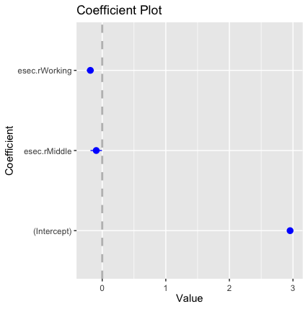
We don’t include this bivariate correlation plot in the paper (but if the reviewer wants us to do so, we would happily do it). What we already had in the paper was panel E of Figure 1 (p. 10). (See figure detail below for quick reference). The figure conveys the same information: there is no association between class and attractiveness.
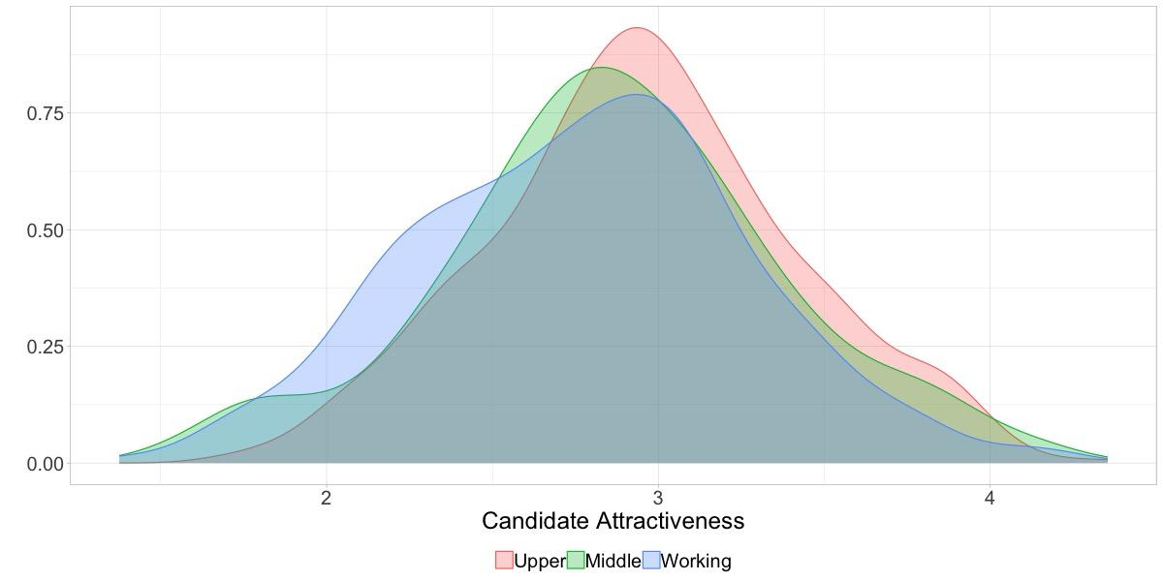
These null results–we believe–stress two important ideas. First, there are no self-selection biases in our data-generating process. Having otherwise would mean that, for example, high-status occupations are systematically perceived as more attractive. In other words–and continuing with the same example–attractive candidates might self-select themselves into high-status occupations (“upper class” occupations, in the figure above). Second, since we are including both covariates in the same equation (e.g., attractiveness and occupational status) we would like both processes to be orthogonal, i.e., mutual statistical independence). Having otherwise would violate the statistical assumption of statistical independence, seriously inflating our standard errors (i.e., multicollinearity issues).
To be sure, in the paper we now discuss this issue more efficiently as follows (p. 10 in the paper). See also the figure (same page) we had included in the original submission of our manuscript for reference (which we paste into here for quick reference):
“
This methodology might raise a concern about self-selection bias if, e.g., high-status-occupation candidates, usually perceived as more attractive, were thought to indicate that attractive candidates self-select themselves into high-status occupations; or if, for example, “politicians on the right look more beautiful” (Berggren et al., 2010, 2017; see also, Price et al., 2011; Belmi & Neale, 2014; Olivola et al., 2018). Figure 1 presents several distributions after averaging all raters’ scores of the 1,415 candidates (see also Rosar et al., 2008, p. 71; Berggren et al., 2010, p. 11). The figure shows these densities broken down by relevant criteria. Since none of the subcategories differ statistically between these groups, the figure strongly suggests that self-selection biases are not a concern in our study.
”
For reference, we also paste below Figure 1 (already included in our original submission). Please see Panel E–which we also referenced above):
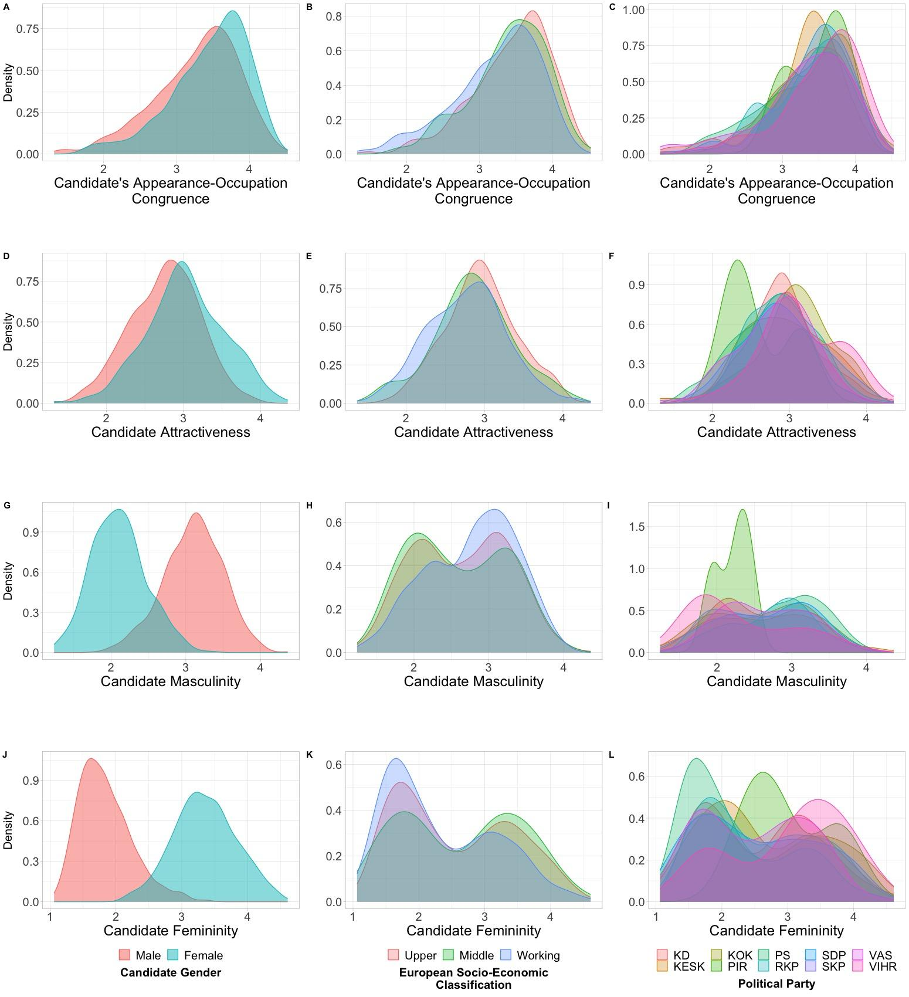
We do hope the edited paragraph (in blue above) and Figure 1 answer the reviewers’ comment. As we now note in Footnote #12, we acknowledged the reviewer’s comment for encouraging this discussion in the edited version of the paper. Thank you once again for your comment.
- The models are rather hypothetical, as they do not control for many important features such as electoral capital, party ideology, campaign spending, whether the seat is safe or not etc... I wonder how strongly the perceived occupational status matters after we control for these features.
Thank you for this suggestion, and we apologize in advance for the confusion. Those factors were already considered in our models. As the note of the regression tables 2 and 3 state (pp. 16-17), we considered the party of the candidate plus city fixed effects in all models. While the models do consider both sets of variables, we excluded them from the table (just to have a clean-looking table).
First, controlling for party should suffice to capture the statistical effect of “party ideology” (the variable R1 suggested). While a really good suggestion, we consider it best to consider party fixed effects because they enter into the models as separate intercepts, without making any empirical assumptions about, for example, where those parties locate in the ideological spectrum, or whether they can be classified at all in the ideological spectrum (for example, the “Finns Party” are considered a populist party, which rises concerns if one’s purpose is to classify them in the traditional left-right spectrum). To check the actual parties in our sample, please refer to footnote #16 in p. 12 of the manuscript.
Second, to capture the statistical effects of “electoral capital [...] campaign spending, [and] whether the seat is safe or not etc” (as suggested by R1) we had adopted the standard empirical strategy of including city fixed effects. We think that R1 is completely right in that we should control for those effects. At the same time, we believe that factors such as electoral capital, campaign spending and whether the seat is safe or not, among others, are particular to each city. In effect, it is very likely that each city will have its own electoral dynamics, with its own contestability and campaign structures, history and strength of incumbents, and in the case of Finland, language and city/urban cleavages, among many other sources of heterogeneity.
We believe the advantage of having city fixed effects in all our models is that it controls not only for the factors R1 correctly mentions, but also for other hard-to-measure but potentially important sources of heterogeneity. This strategy has been widely used in the literature before. For example, Hainmueller and Hangartner in the “Who Gets a Swiss Passport?” paper (American Political Science Review, 2013, 107(1), 159-187) explain that they use city “fixed effects so that the effects of the applicant characteristics are identified purely based on the within-municipality variation” (p. 12). We follow them in that all political, cultural, economic, and geographical effects particular to every city are captured in our vector of city fixed effects (see Angrist and Pischke, “Mostly Harmless Econometrics” for a reference).
What follows is a paragraph that was (and still is) in the original version of the paper in p. 13:
Finally, to account for unobserved but fixed omitted variables, we included “city” fixed effects in all models. By pursuing this econometric strategy, the model aims at controlling for city-specific factors, such as population size, different political cleavages (e.g., urban/rural, language) local party competition issues, and possible incumbency/contestation dynamics, among other hard-to-measure confounding factors (Angrist & Pischke, 2009). .”
We truly hope that R1 is satisfied with this set of answers. If not, we are truly open to discuss other possible alternatives. Once again, we thank you for your important question.
- The authors should discuss whether they use real or hypothetical candidates. If they use real candidates, face recognition could skew peoples’ evaluations.
We believe this is another excellent question. In the original version of the paper (and the revised too) we go in extenso about discussing our data. We pasted the relevant sections below (making sure we reference the page so R1 can cross-check our responses). Thus, we limit this paragraph to give short answers.
Yes, we used real candidates (see longer explanations below in blue). Also, face recognition is a real threat, as R1 correctly points out. To deal with these potential sources of bias, we designed a proprietary software that randomly assigned candidate faces to Finnish voters. The software dealt with face recognition because (1) it “contrasted the candidate’s electoral district with the respondent’s electoral district and ruled out pictures of candidates from the respondent’s electoral district,” and also (2) “to further minimize recognition, images for which over half of the respondents chose the option ‘I recognize the person in the photograph’ were excluded from the analysis (N = 4). These included political “superstars,” which respondents seemed to recognise based on their past membership in the Finnish Parliament.” See detailed explanation below.
We used real candidates (see pp. 7-8 in the paper):
“We exploited several data sources. First, in the context of Finnish municipal elections, political campaigns use headshots of the candidates running for office, along with the candidate’s name, party affiliation, and occupation. This information is public and appears in city centers, bus stops, public squares, and other highly frequented places, including voting booths (Berggren et al., 2010, p. 12). Importantly, newspaper ads also display the same photos (Berggren et al., 2010, p. 10), and “each municipality is obliged by law to provide each party with the same number of slots for posters” (Berggren et al., 2017, p. 83). Second, the Department for Democracy and Public Law (http://www.vaalit.fi) collects this visual information, along with each candidate’s vote count, electoral district, age, and occupation (declared by the candidates). Thus, for the 2017 Finnish municipal elections, a subsample of candidates was collected. Out of a universe of 33,618 candidates, we collected over 10,000 photographs. From among the available pictures, we randomly selected 1,500 images, a subsample to maximize statistical representativeness at the national level regarding gender and occupation and, particularly, the share of women in any given occupation. To satisfy the latter criteria, we analyzed data from the Official Statistics of Finland Office (2017) (https://www.stat.fi) in parallel. The final dataset consisted of 1,415 photographs. Then, taking the candidates’ occupational data as a starting point, we followed the European Socioeconomic Classification (Harrison & Rose, 2006) and coded each candidate’s occupation by class (i.e., “upper,” “middle,” or “working class”).”
How we dealt with face recognition (see p. 11-12 in the paper):
“
Moving forward to randomly assign pictures to raters, a survey rating tool was specially developed to ensure anonymization. The software presented respondents with random photographs from the pool of images, favoring images that had been rated fewer times. The software contrasted the candidate’s electoral district with the respondent’s electoral district and ruled out pictures of candidates from the respondent’s electoral district. In addition, to further minimize recognition bias, images for which over half of the respondents chose the option “I recognize the person in the photograph” were excluded from the analysis (N = 4). Also, to minimize spillover effects (i.e., to isolate evaluations between the different photographs), a neutral screen with a simple black university logo on a white background appeared. Our design set no time limit for evaluating each picture.
”
We truly hope these paragraphs (that were already included in the original version of the paper) satisfy R1’s comment. Now, if R1 wants us to explain these two issues even further, we would happily do so. Thanks again for your suggestions.
Overall comments: Thank you very much for your comments and suggestions. We have answered and implemented every single one of them. Hopefully they are satisfactory to you. Please let us know if there is anything else we could do.

Reviewer #2

We wanted to thank you for your comments and suggestions. We believe your constructive criticism really improved our paper. Below you will find that we’ve done all we could to implement all your suggestions.
- As you can see, we’ve grouped the streamlining suggestions in one point. “I would suggest streamlining the introduction and theory to the main contribution.” “[R]elegate data processing choices to the methods section.” “I would suggest starting with [the role of “physical appearance as social class”] section and then only include what is relevant from the existing literature on heuristics and biases to highlight this contribution.” “Outlining separate sections with only the most relevant content would be great” (i.e., do not “mix presentation of the case, the data, analyses and results,” “the Finnish case” which “includes both case selection, data sources, and discussion of operationalization of constructs'' nor “The section “statistical analysis” [which] includes both results and discussion of methodology”).
We think this is an excellent suggestion and we’ve made sure to implement it in full. Since this in practice involved streamlining the whole paper, for simplicity we do not reproduce the edited paragraphs here in the memo. If necessary, the reviewer is kindly invited to check the edited version of the paper to cross-check our response.
- “It would probably be easier for a reader to follow the models if the baseline models are models without any interactions and then add these in a second step.”
Yes–thanks so much for this suggestion. We think it adds more transparency to our results. We’ve added a new table (Table 2 in p. 16) where we have added the same models that we had included in the original table (now Table 3 in the edited version of the paper), but without the interaction term. Please also see the table below in this memo.
As Table 2 shows, our main variables of interest remain statistically significant on their own, regardless of the controls. They also show the expected signs. Please notice that all these specifications (just like the models in the main table) do include party and city fixed effects.
New table added. Now Table 2 shows what R2 suggested, i.e. all specifications without the interaction term (p. 16 of the revised version of the paper):
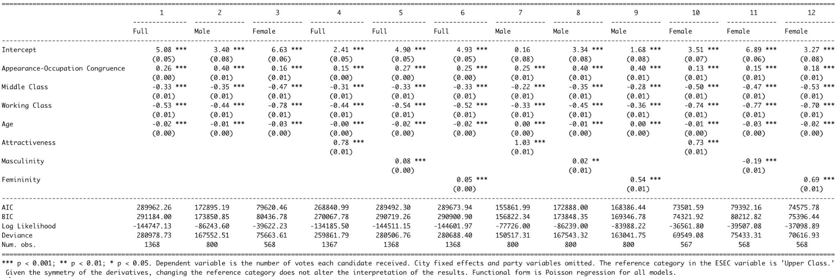
We have also added the paragraph below (pp. 13-14 in the paper) where we discuss the importance of having such a table–one with all the models but without the interaction term. We made sure to thank you for your contribution in footnote #18 in the paper.
We also added a brief discussion about the new table (pp. 13-14 of the revised version of the paper):
“Before introducing our main results (Table 3 and Figure 3), we show our baseline models in Table 2. These models show the same variables considered in the main regression table but without the interaction term. The idea is to suggest that our main interactive results are not a statistical artifact. As Table 2 suggests, all relevant variables are statistically significant and have a sizable effect and the expected sign.
We thank you for your suggestion, and truly hope we answered to your comment satisfactorily.
- “In the regression table the $times$ also looks weird.”
Yes, we have fixed this issue. Thank you for your suggestion. Please check the table below.
We have edited the main regression table (now Table 3), which no longer has that typo (p. 17 of the revised paper):
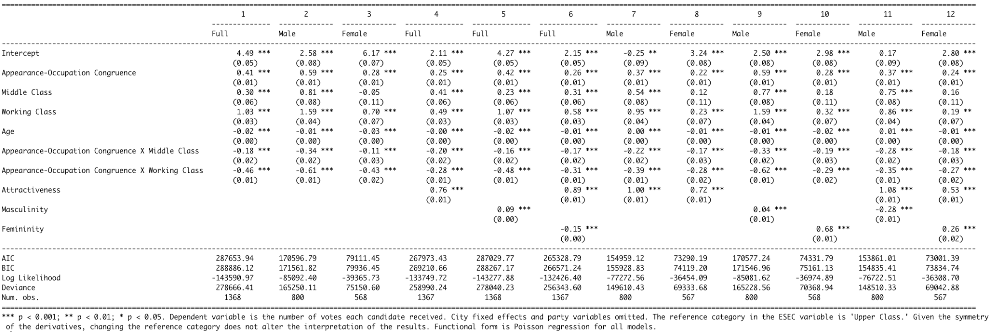
- “[S]ince [the equation is] not included it is in fact difficult to exactly see what is being estimated and what is being calculated.”
Thank you, we can’t agree more. We have now introduced Equation 1 which represents the main model (models 1, 2 and 3 in Table 3; please see p. 17 in the paper).
We have added the main equation that was estimated (see Equation 1 in pp. 12-13) plus a brief description:
“Following the statistical literature, we identify the data-generating process of the dependent variable as a Poisson process (Long, 1997). […] More formally, we fit the following Poisson model
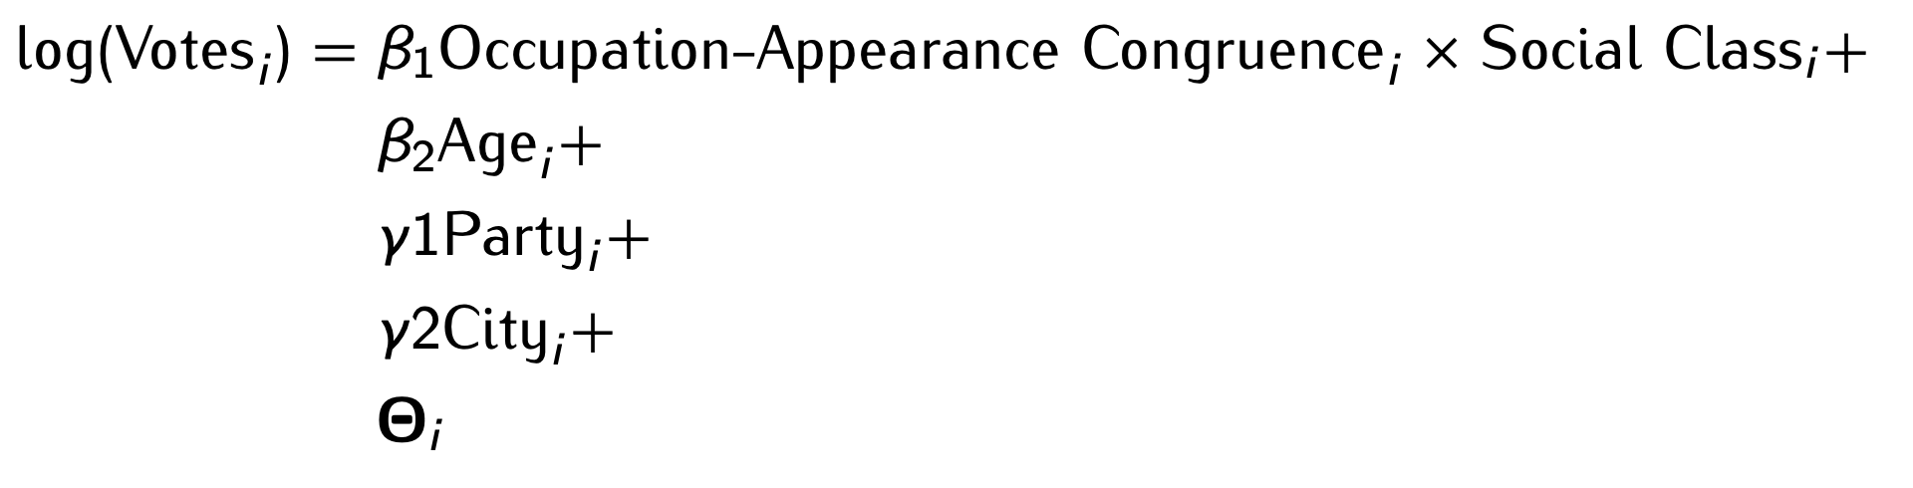 | (1)

where the number of Votes of every candidate i is estimated as a function of the interaction between the levels of Appearance-Occupation Congruence and Social Class, for every candidate i (captured by coefficient $β_{1}$), the age of candidate i (captured by coefficient $β_{2}$), plus the Party of candidate i and the City where candidate i ran (captured by fixed effects $γ_{1}$ and $γ_{2},$ respectively). In addition, we considered extended control variables (i.e., attractiveness, masculinity and femininity levels) in the vector of observables $Θ$. We also estimated several other combinations as robustness checks.
”
We hope these answers clarify and answer your questions. We thank you once again for your constructive criticism.
“[I]t is typical to distinguish between ‘marginal effects,’ the partial derivative, and ‘predicted values,’ simply plugging values into the estimated equations using interesting values for all variables. Here we are presented with ‘predicted marginal effects’ which is almost self-contradictory.”
Yes, you’re absolutely right, and we’re sorry for the confusion. We always meant “marginal effects.” To clarify the issue even further, we have done two things. First, we reference the R package that computed the marginal effects (see below added paragraph). The package clearly states that it calculates and plots the marginal effects (if necessary, see online manual of R package in PDF, page is p. 28 in the online manual). We think that referencing this package will add more clarity to the calculations being presented in our paper. Second, we have modified the title and axis of Figure 3 and made explicit that we are talking about marginal effects. Thus,
We have referenced the R package so our readers know exactly the mechanics of the the calculations being made (see p. 13 of the paper):
“Following Brambor et al. (2006), the equation included both the multiplicative and constitutive terms. We also analyzed the marginal effects plot (in Figure 2; see Lüdecke, 2021)”
We have modified the title and axis titles of Figure 3 (see p. 16 of the paper):
“Figure 3: Marginal Effects of the Interaction Term Between Physical Appearance-Occupation Congruence and Social Class on Votes Received”
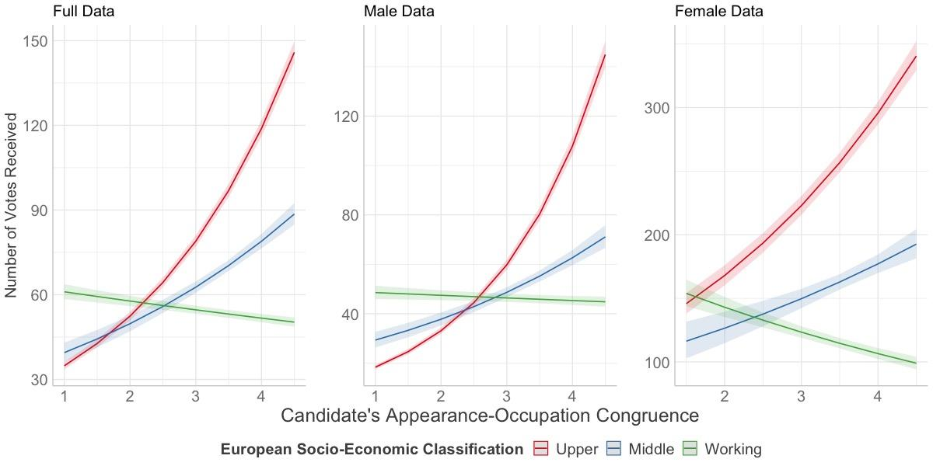
We truly hope these responses clarify your point. If not, please let us know, and we would happily provide more details.
Overall comments: Thank you very much for your comments and suggestions. We have answered and implemented every single one of them. Hopefully they are satisfactory to you. Please let us know if there is anything else we could do.

However, the nomination process might differ significantly between larger and smaller municipalities (Kestilä-Kekkonen et al., 2018). For example, for the 2017 Finnish Municipal Elections, Helsinki had 7,500 inhabitants per counselor, while in smaller municipalities the ratio was around 50 inhabitants per counselor (Borg & Pikkala, 2017).
We thank one of the reviewers for encouraging this discussion.
We thank one of the reviewers for encouraging this discussion.
We thank one of the reviewers for encouraging this discussion.
Masculinity was defined for respondents using the definition of the official Dictionary of Contemporary Finnish (Kielitoimiston sanakirja), a dictionary of standard Finnish compiled by the Institute for the Languages of Finland: “masculinity refers to manly, mannish.” The respondents were also reminded that both men and women can be perceived as masculine.
Femininity was defined as “womanly, effeminate” according to the official Dictionary of Contemporary Finnish. The respondents were also reminded that both men and women can be perceived as feminine/masculine.
We thank one of the reviewers for encouraging this discussion.
We thank one of the reviewers for encouraging this discussion.
Although in principle all photographs ought to be properly archived and publicly available (Act on Cultural Resources in Finland [1433] 2007), gathering the photographs proved laborious. They were processed in GIMP to remove any identifying information. Additionally, to test the usability of the images, we conducted a pilot study, removing images of insufficient quality from the sample. However, Lenz and Lawson (2011) explain that the physical appearance effect holds even when “differences in image quality and other aspects of the pictures, such as visible light, are taken into account” (p. 575).
These included political “superstars” whom respondents seemed to recognize because of their membership in the Finnish Parliament.
The literature on candidate evaluation consistently affirms that “photographs allow voters to form first impressions” about candidates (Banducci et al., 2008, p. 904). Importantly, voters do not update their initial inferences, even when new information is available (Antonakis & Dalgas, 2009, p. 1183). This “perceptual bias” has been identified in studies with 1-second exposure to facial appearance (Todorov et al., 2005, p. 1623). In fact, Mattes et al. (2010, p. 43) find that “judgments made at 100 milliseconds correlated highly with judgments with no time constraints.” Antonakis and Dalgas (2009) report that children have the same (and sometimes even better) predicting skills when choosing winning political candidates. Therefore, perceptual biases are invariant to the duration of exposure and are not corrected by increasing levels of political knowledge or age.
We thank one of the reviewers for this suggestion.
In Poisson processes, the mean of the outcome variable equals the variance of the outcome variable (Long, 1997, p. 218). In our case, voting shows some evidence of overdispersion. To relax the equidispersion assumption, both negative binomial and quasi-Poisson specifications were estimated (Fox & Weisberg, 2011). The substantive results remain intact. These analyses are available upon request.

