Atypical looks, unequal votes?
Gendered electoral inequality in a natural experiment
Outi Sarpila  outi.sarpila@utu.fi  Department of Social Research  University of Turku | Hector Bahamonde  hector.bahamonde@utu.fi  INVEST Research Flagship Centre  University of Turku  Social Science Research Institute  Åbo Akademi University

VERSION DATE  October 27, 2026 | MANUSCRIPT  8,509 words | ABSTRACT  211 words
Manuscript count excludes references and Online Appendix.
Download the latest version
Abstract
Does departure from gender stereotypes carry an electoral penalty, and does that penalty depend on political context? We examine these questions as a problem of gender inequality in the opportunities to benefit from appearance. We exploit an observational natural experiment under the assumption that naturally arising facial variation introduces a probabilistic component into gendered appearance beyond candidates’ precise control. We built an original dataset linking separate femininity, masculinity, and attractiveness ratings to official personal-vote counts in Finland’s 2017 open-list municipal elections. Exploiting complete records for 1384 candidates, we estimate Poisson conditional-mean models with municipality and party fixed effects, adjusting for age and attractiveness. A one-standard-deviation increase in a within-gender index of gender-atypical appearance is associated with differences in expected votes of 20.7% (95% CI 8.0% to 35.0%) for men and -8.8% (95% CI -31.1% to 20.8%) for women. Appearance-associated vote inequality favors more gender-atypical male profiles. The female association is inconclusive. Party comparisons reveal variation in within-gender appearance associations across electoral contexts. We interpret these patterns through the possibility that men have greater latitude to turn departure from gender expectations into an electoral resource, while women face competing demands for feminine warmth and leadership authority. This perspective connects inequalities within gender categories to the constraints women encounter in competition for representation.
Keywords electoral inequality, gender typicality, natural experiment, candidate appearance, personal votes, Finland.

1 The problem of inequality within gender categories
If attractive candidates tend to receive more votes (Berggren et al. 2010), can a departure from gender stereotypes nevertheless carry an electoral penalty? Consider a woman with a relatively masculine face or a man with a relatively feminine face: both may be attractive, yet their appearances depart from the cues expected of their gender. This departure raises a question about who benefits from appearance, beyond who is considered “good-looking.” The distinction matters because appearance advantages are already distributed unequally by gender. In Finnish municipal elections, Bahamonde and Sarpila (2024) find that attractiveness is more strongly associated with votes among men. The qualities associated with electoral success also depend on the candidates being compared. In US state and local contests, Ditonto and Mattes (2018, pp. 441–443) find that attractiveness predicts winners in women-only races, whereas perceived competence predicts winners in men-only races. These asymmetries motivate asking whether conformity to gender stereotypes is itself a source of unequal support among candidates within each gender category.
Moreover, does a penalty for gender-atypical appearance persist across ideological audiences, or can political context turn the same departure into an advantage? There is reason to expect the answer to vary: beauty premiums differ across political camps (Berggren et al. 2017), and the electoral associations of facial sex typicality differ by candidate gender and party (Carpinella, Hehman, et al. 2016). Audience ideology also changes the value of facial dominance (Laustsen and Petersen 2016). These findings suggest that a cue’s electoral meaning depends on who evaluates it and what they expect from political leaders. A uniform conformity penalty may therefore miss contexts in which a gender-atypical cue conveys a desirable leadership trait.
This possibility connects differences within gender categories to a broader question of inequality against women. Men and women may face different constraints on which appearance profiles become electoral assets. A man could gain support from feminine cues that suggest warmth, while a woman whose masculine cues suggest authority could also face expectations of feminine warmth. The issue is therefore whether candidates have unequal latitude to depart from gender expectations. Monk (2022)’s infracategorical perspective makes this question visible because shared category membership need not imply shared opportunities or evaluations. Comparing appearance profiles within each gender category allows us to ask which men and which women receive more support, and whether the opportunities to benefit from departure differ across political settings.
Existing research provides the measurements needed to investigate this question. Hehman et al. (2014) relate competition between perceived gender categories to female politicians’ electoral outcomes, while studies of gender expression document associations with election returns (Wojcik and Mullenax 2024) and experimentally induced presentation penalties for male candidates (Naunov 2026). These penalties show that departure can also constrain men, making the setting and form of presentation central to the comparison. Park and Joo (2023) further show how separately rated masculinity and femininity in campaign photographs relate to vote share. Building on these approaches, we construct a continuous within-gender contrast of greater femininity relative to masculinity among men and greater masculinity relative to femininity among women. This contrast allows us to examine the electoral rewards attached to departing from each gender’s appearance expectations.
To connect that comparison to electoral inequality, we built an original dataset combining separate appearance ratings with candidate characteristics and official personal-vote counts in Finland’s 2017 municipal elections. We exploit this dataset in a setting where voters select individual candidates within party lists. Because personal votes determine candidates’ rank within those lists, while list totals determine the allocation of seats, unequal personal support can matter for access to representation (Bahamonde and Sarpila 2024, Holli and Wass 2010, Söderlund and von Schoultz 2024). The separate ratings and linked returns allow us to examine inequality within gender and then within gender–class and gender–party groups, conditional on other candidate attributes and electoral context.
We exploit naturally arising variation in gendered appearance as an observational natural experiment (Titiunik 2021, pp. 118–119). This classification rests on the assignment assumption that inherited and developmental variation introduces an element of chance into candidates’ appearance beyond their precise control. Finnish municipal recruitment and the prominence of headshots in campaigns provide a setting in which such differences can enter electoral competition (Bahamonde and Sarpila 2024, pp. 628–629). We develop the assignment argument in Section 4.1 and exploit the linked ratings and returns to estimate conditional differences in personal support.
Our argument is that gendered expectations can give candidates unequal opportunities to turn appearance into electoral support. Where voters value cooperation, feminine cues may benefit men by adding warmth to a category already associated with leadership. Women can face a more restrictive combination of expectations because an appearance suggesting authority may conflict with demands for feminine warmth (Eagly and Karau 2002, Rudman and Glick 2001). A departure from gender expectations could consequently become an electoral resource for men while exposing women to competing standards. Because political audiences differ in the leadership qualities they value, the rewards and penalties associated with these departures should also depend on party context. We assess this argument against the alternative expectation that conformity to gendered appearance is rewarded among both men and women.
We assess these expectations by exploiting an original dataset linking separate appearance ratings to personal votes for 1384 candidates in 221 municipalities. We estimate Poisson count models with municipality and party fixed effects and adjust for candidate age and attractiveness. We first compare candidates within gender categories and then examine whether the returns to the separate appearance cues vary across occupational classes before allowing the cue contrast to differ by party. A one-standard-deviation increase in the gender-atypical index is associated with differences in expected personal votes of 20.7% (95% CI 8.0% to 35.0%) for men and -8.8% (95% CI -31.1% to 20.8%) for women. Within male candidacies, expected personal votes favor more gender-atypical cue profiles. The female association is inconclusive. Party comparisons reveal variation in within-gender appearance associations across electoral contexts. The substantive question is therefore how departure becomes a source of electoral advantage and whether women face different constraints on obtaining that advantage. Because personal votes help determine candidates’ positions on electoral lists, the distribution of these rewards matters for access to representation.
Our contribution is to examine whether candidates have unequal opportunities to benefit electorally from departing from their gender’s appearance expectations. This question connects inequalities within gender categories to the standards women face in political competition. Existing studies establish gender-by-party differences, but their measurement choices constrain the comparisons they can make. The human ratings in Carpinella, Hehman, et al. (2016, p. 26) use a scale from “1 = very masculine to 9 = very feminine”, placing the two cues at opposite ends of one dimension. Park and Joo (2023, pp. 6, 11–12) rate femininity and masculinity separately but report that “we exclude the traits with low agreement”, which excludes attractiveness from the traits available for their vote-share regressions. We exploit separately elicited, gender-referenced human ratings from a population-based survey and actual personal-vote counts to compare relative cue balance while accounting for measured attractiveness, age, party, and municipality. The male advantage is unexpected under a uniform conformity account because a departure from masculine appearance expectations is associated with greater support. The female estimate is inconclusive, directing attention to the possibility of unequal rewards for departure rather than a common conformity penalty. Class and party comparisons then show how social position and political setting change the substantive interpretation of these rewards.
This paper proceeds as follows. In Section 2, we connect gendered appearance to unequal expectations of political leaders and derive competing predictions. In Section 3, we describe the original dataset, the rating procedure, and the gender-atypical index. In Section 4, we develop the observational natural-experiment classification and explain the identification strategy and Poisson specification. In Section 5, we present the main findings, examine differences across occupational classes and parties, and assess whether measured attractiveness accounts for the observed appearance-associated inequality. In Section 6, we consider the implications for women and electoral representation, the limitations of the study, and directions for future research.

2 Gender typicality and electoral evaluation
Candidates who share a gender category can differ in how masculine and feminine they appear. These differences matter for inequality when they change which members of a category are valued, as Monk (2022)’s infracategorical perspective emphasizes. Applied to elections, the comparison concerns which male and female appearance profiles attract support and how these evaluations relate to the expectations placed on each gender. Research on gender variation supports measuring femininity and masculinity separately rather than reducing them to one male–female scale (Magliozzi et al. 2016). Separate ratings allow us to compare their relative balance within gender and, in turn, to ask why departure from gender expectations could become an asset for some candidates and a constraint for others.
One possibility is that voters reward candidates who conform to gendered appearance expectations by looking conventionally masculine as men or conventionally feminine as women. Under this category-conformity account, departure threatens an appearance advantage available to more typical members of either category. Men with more feminine-relative-to-masculine appearances and women with more masculine-relative-to-feminine appearances should therefore receive fewer votes than more gender-typical candidates of the same gender. This account predicts inequality within each category through a shared preference for conformity.
A preference for conformity could arise if appearances that match gender expectations make candidates easier to classify as male or female. Owen et al. (2016) show that faces combining gender cues can become less appealing when observers are required to categorize them. Yet difficulty assigning a face to a gender category need not produce disapproval, as Ansani and Olivera-La Rosa (2024) find positive judgments of androgynous faces despite uncertainty about their category. The relevant step is therefore whether uncertainty about a candidate’s apparent gender translates into an unfavorable evaluation. This distinction separates a possible penalty for violating category expectations from the electoral value of the leadership qualities conveyed by the same appearance.
An appearance that departs from gender expectations can also suggest desirable leadership qualities. The leadership fit account therefore directs attention to the match between qualities attributed to a candidate and those sought in a leader (Eagly and Karau 2002). Experiments by Walker and Wänke (2017, p. 1) illustrate the tradeoff that can arise. After manipulating the faces of clearly male and female targets, they report that “Masculine-looking persons were seen as colder and more competent than feminine-looking persons.” A masculine appearance can thus suggest competence while a feminine appearance suggests warmth. Because these qualities can both matter for leadership, their electoral value depends on what voters seek from candidates.
That tradeoff may place a particular constraint on women. An early study of political appearance anticipated the dilemma directly. Sigelman et al. (1987, p. 33) proposed that an attractive female candidate “may be considered too ‘feminine’ to possess such male-stereotyped strengths as assertiveness and boldness”. Role-congruity theory explains why such a dilemma can arise, since women are expected to display the agency associated with leadership while also satisfying prescriptions of feminine warmth (Eagly and Karau 2002). Experimental hiring research shows how these demands can conflict. Agentic women faced a disadvantage when a managerial role required communal qualities, whereas adding communal information removed the observed gender difference (Rudman and Glick 2001). Applied to appearance, this reasoning suggests that masculine cues could strengthen a woman’s perceived authority while weakening the warmth expected of her. The potential source of inequality against women is this narrower room to satisfy competing standards through the same appearance.
Men may face a different opportunity when feminine cues add a valued quality to their leadership profile. In politicians’ portraits, Carpinella and Johnson (2013, p. 775) found that less sex-typical, more feminine male liberal politicians were judged “as significantly warmer than their more sex-typical counterparts”. This route to advantage has a parallel in research on leadership behavior. Hentschel et al. (2018) found that men described as transformational leaders were rated more promotable than women displaying the same leadership style. Their experiments and field study connect communal leadership to unequal rewards, suggesting why a quality expected of women can become an additional asset for men. Together, these findings motivate an appearance-based expectation of unequal latitude to benefit from warmth.
Whether warmth or authority brings greater support also depends on the leadership task. Spisak et al. (2012, p. 5) tested mock elections that varied war and peacekeeping demands. They summarize their findings as follows. “In sum, irrespective of their sex, masculine-looking leaders were preferred during war and feminine-looking leaders during peacekeeping.” Because this preference varied across tasks for both male and female faces, feminine cues can have value beyond conformity to a female role. Where cooperation is valued, those cues could favor a gender-atypical male profile and a gender-typical female profile. The inequality question is whether the opportunity to benefit from the alternative profile is equally available to women when authority is valued.
Political audiences can differ in the leadership qualities they seek, giving the same appearance different value across settings. Laustsen and Petersen (2016) find that “a non-dominant face constitutes a winning face among liberal audiences”, while the advantage reverses among conservatives. Although dominance and our femininity–masculinity contrast are distinct, this result identifies a reason to expect context-dependent appearance rewards. Evidence from exit-poll respondents reinforces that expectation. Republican voters favored candidates with stereotypically conservative-looking faces, whereas Democratic voters showed no corresponding association (Olivola et al. 2018). If audiences place different weight on warmth and authority, the competing standards women face may consequently become more or less restrictive across party settings.
These studies connect unequal appearance rewards to gendered expectations of leadership. Feminine cues may allow some men to gain support through warmth, while women may have to balance that expectation against demands for authority. The value of departing from gender expectations should therefore depend on both candidate gender and political context. This argument concerns the traits suggested by appearance, whose implications can differ from those of other forms of presentation.

2.1 Theoretical expectations
The preceding accounts imply three expectations about inequality within gender categories. The conformity expectation predicts that a more gender-atypical appearance will be associated with fewer votes among both men and women. Men whose appearance is more feminine relative to masculine should receive less support than more conventionally masculine men. Women whose appearance is more masculine relative to feminine should receive less support than more conventionally feminine women. In each comparison, conformity would distinguish candidates who receive more support from others of the same gender.
Under the cooperative-leadership expectation, an appearance suggesting warmth or cooperation will be favored where voters seek those qualities. A preference for feminine-relative-to-masculine appearance would reward a more gender-atypical profile among men and a more gender-typical profile among women. The same leadership preference could therefore reward men’s departure while rewarding women’s conformity. Gendered prescriptions add a reason why the reverse opportunity may be more constrained for women, whose masculine cues could convey authority but also conflict with expected warmth (Eagly and Karau 2002, Rudman and Glick 2001). We consequently examine whether the male association is positive and the female association negative, while recognizing that the strength of either association depends on which qualities the political setting rewards.
The contextual expectation predicts that these appearance associations will vary across parties because their audiences may value different leadership qualities. Earlier candidate gender-by-party differences in facial typicality and campaign imagery provide grounds for this comparison (Carpinella, Hehman, et al. 2016, Park and Joo 2023). Party-specific estimates allow us to examine whether a pooled association conceals settings in which departure is rewarded and others in which it is associated with disadvantage. This comparison connects inequality within gender categories to the political conditions under which women may have more or less room to depart from feminine appearance expectations.
Unequal opportunities to benefit from appearance may also depend on candidates’ occupational positions. Monk (2022)’s perspective directs attention to differences among people who share a category but occupy different positions within broader hierarchies. Evidence that appearance-related rewards differ across occupational classes in Finnish municipal elections provides a reason to investigate this possibility (Bahamonde and Sarpila 2024). If occupational positions carry different expectations of leadership, the femininity and masculinity attributed to candidates could receive different electoral rewards across classes. We therefore extend the contextual expectation to ask whether the associations of these separate cues with support vary among men and women in different occupational classes.

3 Data and measurement
The argument requires measures of how citizens perceive candidates and electoral support for those same candidates. We therefore built an original dataset by linking official candidate records and personal-vote counts from Finland’s 2017 municipal elections to evaluations of campaign photographs. The Ministry of Justice’s returns provide the electoral information. The photographs are the official campaign portraits that candidates used on election posters and in newspaper advertisements alongside their names and party affiliations (Bahamonde and Sarpila 2024, Berggren et al. 2010, Berggren et al. 2017). Using these images connects the appearance measurements to the visual information available during an actual campaign.
The collection began with more than 10,000 photographs from a universe of 33,618 candidates. We randomly selected 1,500 photographs with the aim of covering candidate gender and backgrounds across Finland (Bahamonde and Sarpila 2024). Image editing removed identifying information, and a pilot excluded photographs of insufficient quality. These steps prepared a set of campaign portraits for evaluation without relying on names or party labels to convey the appearance attributes.
To obtain the evaluations, we fielded a population-based survey in 2020. Invitations and a reminder were sent to a random sample of 26,500 Finnish-speaking adults aged 18–64 from the population register. A total of 7,920 people participated. We exploit attractiveness, masculinity, and femininity ratings supplied by separate attribute-specific respondent groups. Each respondent evaluated 50 randomly assigned photographs for the assigned attribute (Bahamonde and Sarpila 2024). This procedure elicited the three attributes independently and distributed the photographs across raters.
Direct citizen ratings capture the perceptions central to our argument by assessing how masculine or feminine a candidate appears relative to others of the same age and gender. This approach measures citizens’ judgments of appearance directly, rather than inferring those judgments from software classifications of facial structure or sex. Recruiting raters from a population sample also widens the range of citizens contributing evaluations compared with the convenience samples common in earlier electoral appearance research (Mattes et al. 2010, Rosar et al. 2008, Wigginton and Stockemer 2021, Bahamonde and Sarpila 2024). The method thereby aligns the appearance measure with the kind of evaluation through which gendered expectations could shape electoral support.
The survey also took steps to reduce the influence of candidate recognition and uneven exposure. Respondents did not evaluate candidates from their own electoral district. Images recognized by a majority of their raters were excluded, amounting to 4 photographs. The assignment procedure gave priority to images that had received fewer ratings, helping distribute evaluations across the photograph pool. A neutral screen with a university logo appeared between images, and respondents could take as much time as needed to provide their judgments (Bahamonde and Sarpila 2024). These procedures supported evaluations of appearance while limiting cues from familiarity with the candidate.
The femininity and masculinity questions asked how the person looked relative to others of the same age and gender, using separate 1–5 scales (Bahamonde and Sarpila 2024, Hoss et al. 2005). Respondents were reminded that men and women can both appear masculine or feminine. These reference categories are central to our question: a high masculinity rating for a woman locates her relative to other women, while a high femininity rating for a man locates him relative to other men. The questions therefore describe variation within gender categories without treating the appearance ratings as measures of gender identity.
Attractiveness was rated relative to others of the same age and gender as a separate attribute, following the measurement precedents used in Bono et al. (2017), Griffin and Langlois (2006), and Tu et al. (2022). This separation is important because a gendered appearance might also be judged attractive. It allows us to exploit the original dataset to examine whether the appearance-associated difference in votes remains after accounting for measured attractiveness. Section 5.3 develops that comparison.
We average each attribute’s ratings for each candidate, following electoral appearance research that aggregates multiple observers’ judgments (Berggren et al. 2010). Matching the available candidate averages with electoral records gives an original dataset of 1389 candidates with separate appearance measurements and personal-vote counts. We exploit complete observations on the baseline model’s variables for 810 men and 574 women in 221 municipalities. Linking these judgments to support for the same candidates makes it possible to examine electoral inequality within gender and political context.
We construct the gender-atypical cue contrast in Equation 1 from femininity and masculinity ratings standardized separately within each gender category. Centering each trait on its gender-group mean and scaling it by its gender-group standard deviation yields candidate $i$’s scores $z_{i}^{F}$ and $z_{i}^{M}$. The direction factor $s_{g}=+1$ for men and $s_{g}=−1$ for women orients the contrast toward femininity relative to masculinity among men and masculinity relative to femininity among women. The resulting index is
$A_{i}=\frac{s_{g}(z_{i}^{F}−z_{i}^{M})}{{sd}_{g}(z^{F}−z^{M})}.$ (1)
Higher $A$ therefore captures a more feminine-relative-to-masculine appearance among men and a more masculine-relative-to-feminine appearance among women. Scaling the contrast by the within-gender standard deviation of $z^{F}−z^{M}$ expresses these departures in a common unit, with one unit of $A$ corresponding to one standard deviation within either gender category.
Figure 1 displays the separate ratings underlying the index in a single panel. Each point places a candidate according to perceived femininity on the horizontal axis and perceived masculinity on the vertical axis. Blue points represent men and pink points represent women, allowing the two distributions and the variation within each gender category to be inspected together. The overlay preserves the same-age and same-gender reference of the survey questions, so the index continues to locate each candidate within their gender category.
For illustration, a man whose masculinity rating is average among men and whose femininity rating is one standard deviation above the male average has $A=0.55$ in Equation 1. A woman whose femininity rating is average among women and whose masculinity rating is one standard deviation above the female average has $A=0.54$. These hypothetical profiles both yield positive index values, capturing the relatively feminine male appearance and the relatively masculine female appearance as departures from their respective gender groups’ appearance expectations.
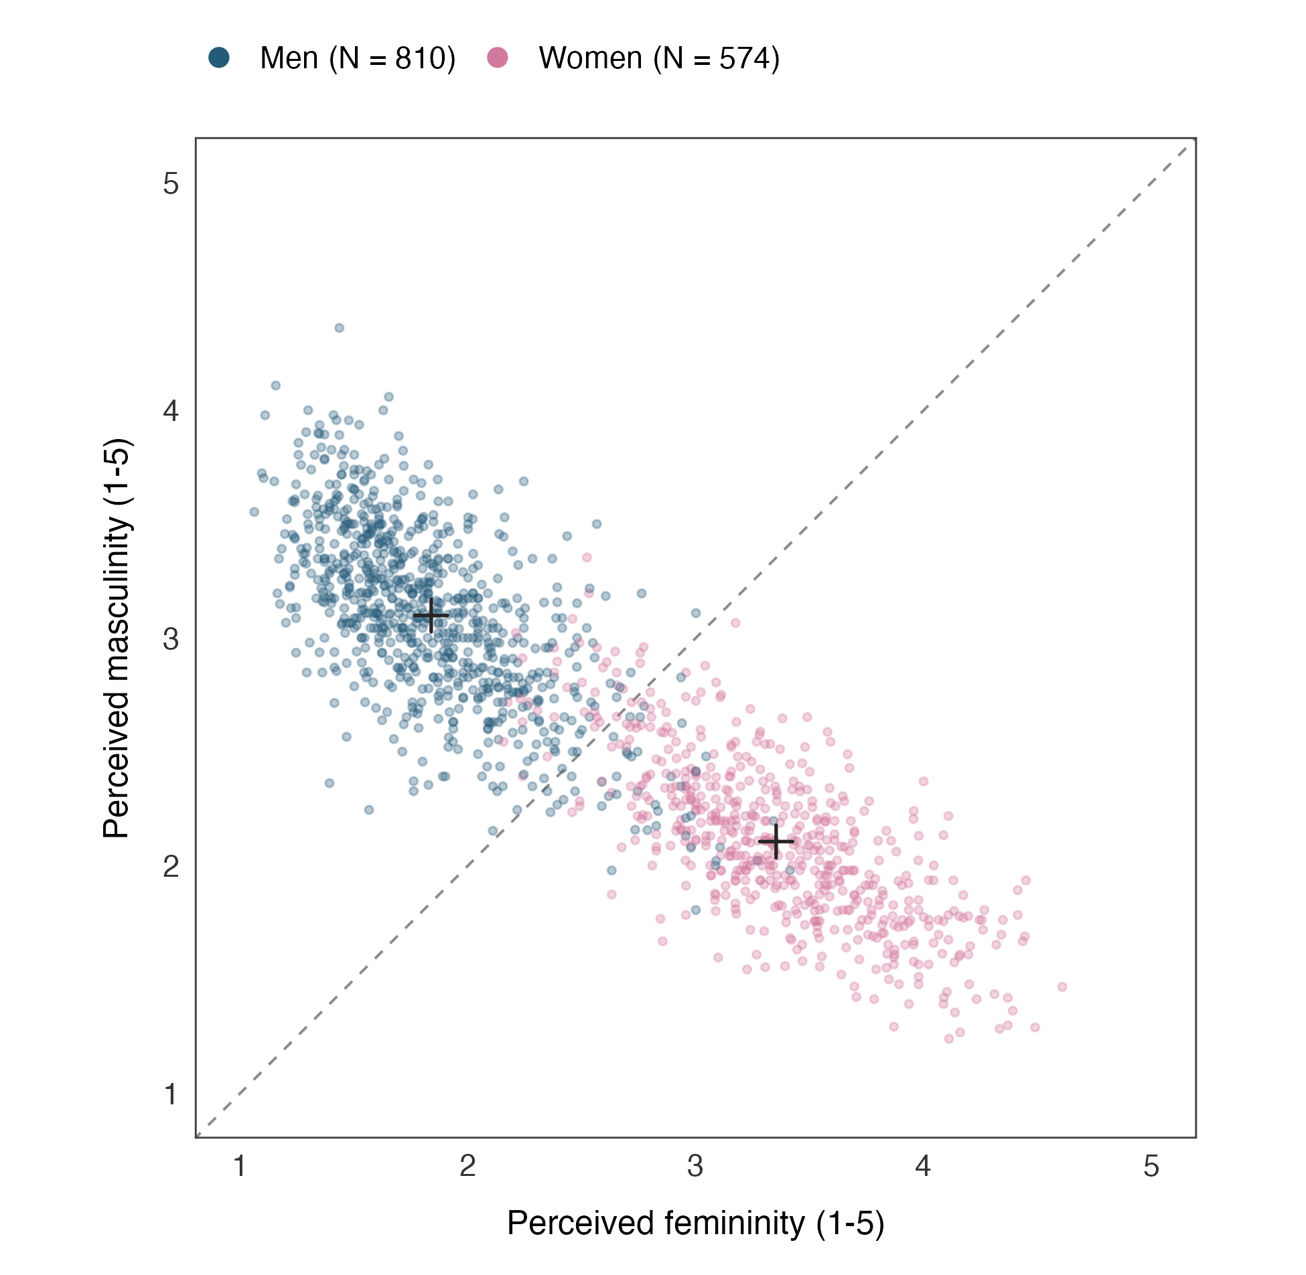
Figure 1. Perceived femininity and masculinity by candidate gender in a combined panel. Blue points show mean ratings for 810 men and pink points show mean ratings for 574 women. Ratings were elicited relative to others of the same age and gender. Crosses mark gender-group average ratings. The dashed diagonal marks equal raw ratings on the 1–5 scales. The gender-atypical contrast is standardized within gender using Equation 1.
Because the ratings are gender-referenced, $A=0$ denotes an average relative contrast within the candidate’s gender category. This reference point is determined by the gender-specific centering and scaling in Equation 1, whereas the diagonal in Figure 1 compares the two raw ratings. Zero on the index does not mark a boundary at which observers become uncertain about gender. The index thus measures one aspect of perceived appearance rather than gender identity or categorization difficulty.
Because the contrast locates candidates within their gender category, Table 1 reports the outcome, appearance measures, and covariates separately for men and women in the sample that we exploit below. This organization shows the variation within each category on which the subsequent comparison of electoral inequality rests.
Table 1. Summary statistics by candidate gender.
 | Men ($N=810$) |  |  | Women ($N=574$)
Variable | Mean | SD | Min.–Max. | Mean | SD | Min.–Max.
Personal votes | 88.93 | 267.74 | $1$–$4,653$ | 95.22 | 224.34 | $1$–$3,642$
Gender-atypical cue contrast ($A$) | 0.00 | 1.00 | $−2.33$–$3.70$ | 0.00 | 1.00 | $−2.49$–$2.78$
Femininity rating | 1.84 | 0.40 | $1.06$–$3.41$ | 3.35 | 0.47 | $2.16$–$4.61$
Masculinity rating | 3.10 | 0.40 | $1.80$–$4.36$ | 2.11 | 0.36 | $1.24$–$3.35$
Attractiveness rating | 2.76 | 0.45 | $1.44$–$4.02$ | 3.03 | 0.50 | $1.32$–$4.35$
Candidate age (years) | 46.20 | 10.62 | $18$–$63$ | 45.13 | 10.30 | $20$–$63$
$N=1,384$ candidates in 221 municipalities and 10 parties. Summary statistics include means, standard deviations (SD), and observed ranges (Min.–Max.). Appearance measures are candidate averages of 1–5 ratings. Appearance judgments are referenced to people of the same gender and age, so their means do not measure absolute differences between men and women. Within-gender standardization gives $A$ a mean of zero and a standard deviation of one in each category. Candidate age refers to the 2017 election. Personal votes have a median of 37.50 among men (first–third quartiles, 18.00–74.00) and 44.00 among women (19.00–97.75).
To examine occupational differences in these appearance rewards, we classify candidates using the European Socio-economic Classification, which distinguishes occupational positions through their associated employment relations (Rose and Harrison 2007). Following Bahamonde and Sarpila (2024), we combine the classifications into upper, middle, and working classes. The upper group contains managerial and professional occupations. In our sample, the middle group contains intermediate occupations and lower supervisors or technicians, while the working group contains lower sales and service, lower technical, and routine occupations. These categories describe candidates’ occupational positions rather than voters’ class or candidates’ income and wealth. Class information is available for 1367 candidates, comprising 800 men and 567 women. The class-specific analysis therefore excludes 17 candidates from the primary sample while retaining the primary sample’s within-gender scaling of appearance.

4 Empirical strategy

4.1 An observational natural experiment
We treat naturally arising gendered appearance as an observational natural experiment under the framework for an observational subtype defined by Titiunik (2021, pp. 118–119). Researchers neither designed nor implemented the appearance-generating process, and its full allocation probabilities are unknown and unrecoverable. The remaining assignment premise is that this process contains a probabilistic component outside candidates’ precise control. Candidates are the units, and their continuous gender-atypical cue contrast describes the appearance condition. Section OA 1 maps the application to these three defining conditions.
The external component in this application is naturally arising variation in inherited facial morphology and development. Genetic contributions to normal facial morphology are documented by Liu et al. (2012). We assume that an uncontrollable part of this variation contributes to the balance of gendered cues visible in campaign portraits, leaving candidates with more than one possible appearance condition ex ante. Grooming, expression, and portrait selection can shape the visible cues while remaining subject to features candidates cannot choose precisely. Under this assignment premise, external chance can coexist with systematic presentation choices (Titiunik 2021, pp. 118–119).
The Finnish municipal setting provides substantive grounds for expecting naturally arising differences to remain visible in electoral competition. Parties assemble extensive lists and actively recruit ordinary residents, including people who are not pursuing professional political careers (Bahamonde and Sarpila 2024, p. 628). An emphasis on functionality and frugality is reflected in portraits showing everyday clothing alongside formal attire. Campaign communication prominently relies on headshots in posters and newspaper advertisements, with limited individual television and radio campaigning (Bahamonde and Sarpila 2024, pp. 628–629) (Berggren et al. 2017, pp. 80, 83). These practices connect a broad candidate pool to routine representations of appearance, supporting the plausibility of the assignment premise within the population of candidates.
We exploit this observational natural experiment to characterize electoral inequality conditional on candidate attributes and electoral context. The classification concerns the origin of appearance variation, while statistical identification comes from comparisons after accounting for municipality, party, age, and attractiveness. We estimate conditional associations because the external assignment premise alone does not establish exchangeability of candidates with different appearance profiles (Titiunik 2021, pp. 119, 122–124).

4.2 Conditional vote-count specification
The outcome ${\text{Votes}}_{i}$ is the number of personal votes received by candidate $i$. Finnish municipal elections use open-list proportional representation. Each voter selects an individual candidate, and the vote also contributes to the candidate’s electoral list. Pooled list votes determine the allocation of seats, while personal votes determine candidates’ positions within the list (Holli and Wass 2010, pp. 604, 626). These rules make personal support important for competition among candidates on the same list and for access to representation (Söderlund and von Schoultz 2024, pp. 13, 16). This individual choice also makes the setting relevant to appearance-based evaluation. As Lawson et al. (2010, p. 566) argue, “Looks should matter more when elections are candidate centered, not party centered”. Personal-vote counts allow us to examine how support is distributed across appearance profiles within this competition, following appearance research using actual election returns (Efran and Patterson 1974, Bahamonde and Sarpila 2024).
We exploit the original dataset to estimate the expected number of votes conditional on candidate appearance and electoral context. Following Bahamonde and Sarpila (2024), we use Poisson pseudo-maximum likelihood (PPML) to estimate the conditional expected vote count. The Poisson specification relates that expectation to the gender-atypical index, while municipality fixed effects account for differences in the scale and shared context of local elections. Party fixed effects account for differences in support across parties. Age and attractiveness enter as candidate controls, and an interaction allows the association between atypicality and votes to differ between men and women.
$\begin{matrix}μ_{i}=E[{\text{Votes}}_{i}∣{\text{Atypicality}}_{i},{\text{Woman}}_{i},X_{i},c(i),p(i)], \\ logμ_{i}=α_{c(i)}+λ_{p(i)}+β_{1}{\text{Woman}}_{i}+β_{2}{\text{Atypicality}}_{i}+β_{3}({\text{Woman}}_{i}×{\text{Atypicality}}_{i}) \\ +β_{4}{\text{Age}}_{i}+β_{5}{\text{Attractiveness}}_{i}.\end{matrix}$ (2)
With Atypicality given by $A$ in Equation 1 and Woman indicating a female candidate, the index’s association with log expected votes is $β_{2}$ among men and $β_{2}+β_{3}$ among women. The log link yields positive expected vote counts and expresses the appearance association proportionally, allowing percentage differences in support to be compared across municipalities of different sizes. Estimation uses the observed vote counts in their original units.
Statistical identification of the model coefficients relies on variation in appearance and votes after accounting for municipality and party differences, mean-centered age, and measured attractiveness. These adjustments compare candidates facing shared electoral settings and differing in observed appearance. The resulting coefficients describe appearance-associated differences in expected support conditional on those attributes.
The Poisson specification targets this conditional mean without requiring the outcome’s entire distribution to be Poisson when the mean is correctly specified (Santos Silva and Tenreyro 2006). The conditional variance may therefore differ from the mean. We also allow outcomes to be dependent among candidates in the same municipality, using municipality-clustered sandwich standard errors with a finite-sample correction and $t_{G−1}$ intervals, where $G$ is the number of municipalities. These intervals condition on the candidate mean ratings used to construct the contrast and do not propagate uncertainty in those estimated means. Section OA 5 of the Online Appendix reports dispersion and sample diagnostics.
Figure 2 translates the fitted associations into expected personal votes, making the distribution of support across appearance profiles visible within each gender category. Comparing points along each curve therefore holds the group’s other observed characteristics constant.
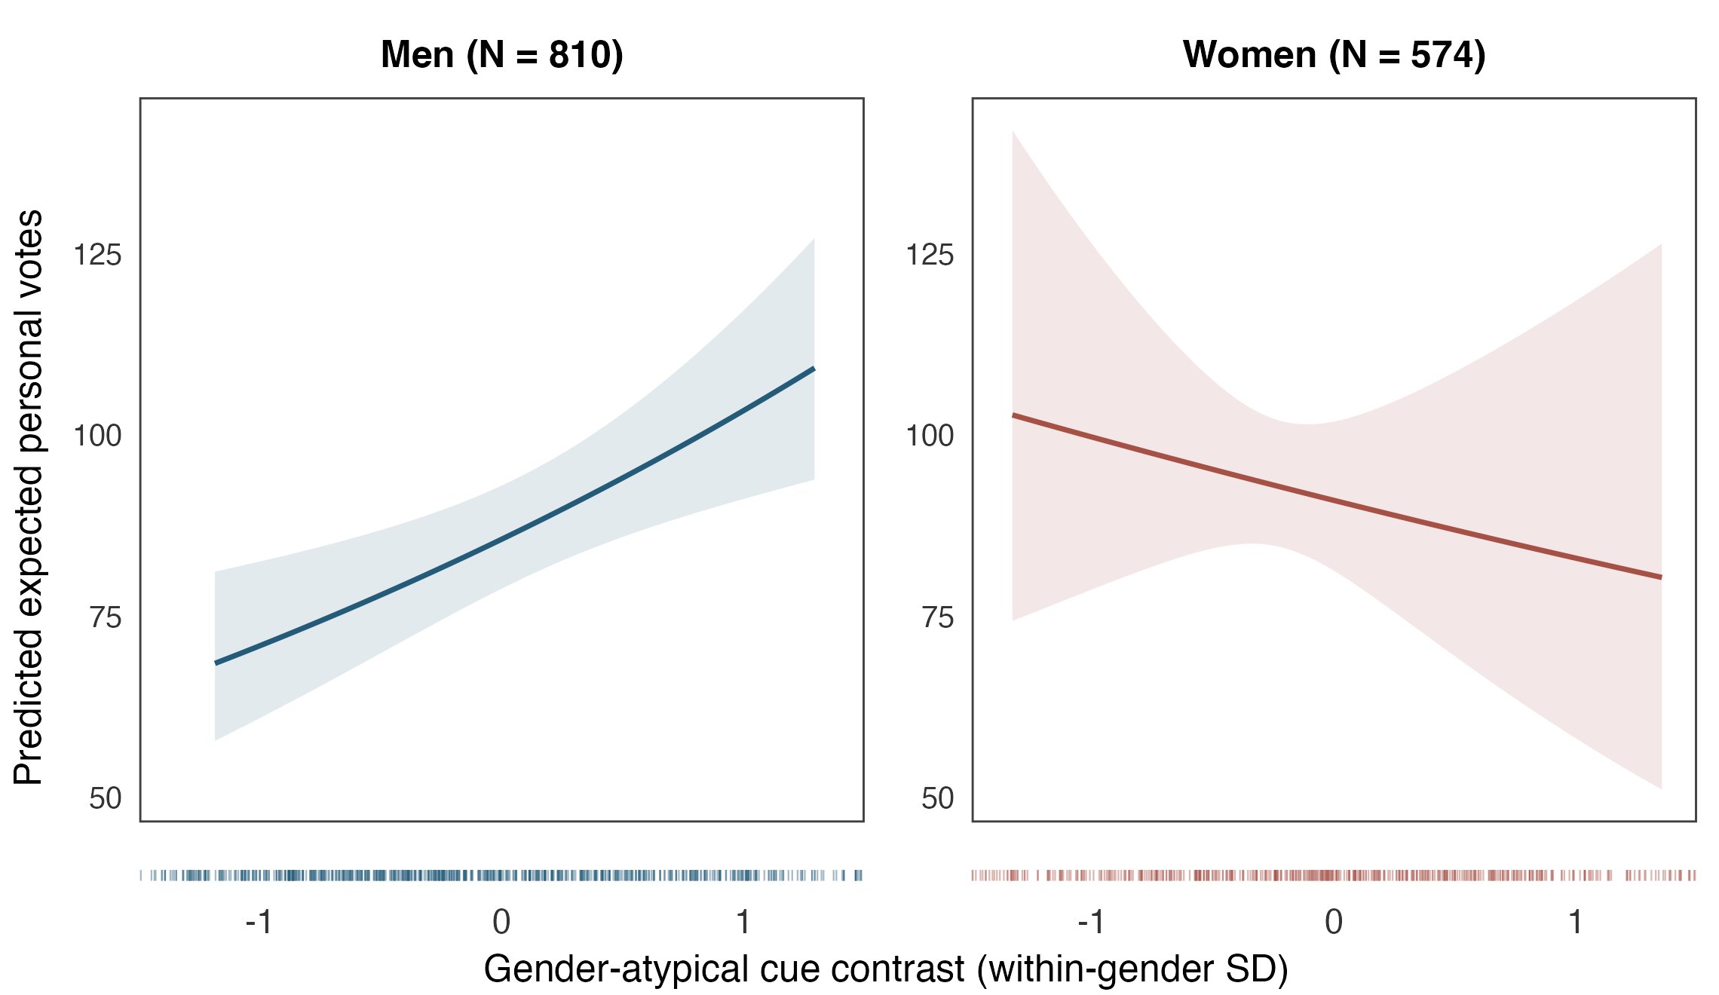
Figure 2. Predicted expected personal votes in the observational natural experiment, with baseline controls. Curves vary the atypical cue contrast over the within-gender 10th–90th percentile range and average over observed candidate characteristics, parties, and municipalities. Shading gives municipality-clustered 95% confidence intervals for the conditional mean. Rug strips beneath each panel show observed candidates within the displayed cue range. Panel headings report the full gender-group sample sizes.

5 Results
Figure 2 presents the main results as differences in expected personal support across appearance profiles. Table 2 quantifies those differences for a one-SD increase in the gender-atypical contrast. The estimated differences in expected votes are 20.7% (95% CI 8.0% to 35.0%) for men and -8.8% (95% CI -31.1% to 20.8%) for women. Within male candidacies, expected personal votes favor more gender-atypical cue profiles. The female association is inconclusive.
Table 2. Gender-atypical appearance and expected personal votes with baseline controls.
Cue | Men (%) | Women (%)
Gender-atypical contrast ($A$) | 20.7 [8.0, 35.0] | -8.8 [-31.1, 20.8]
Entries are percentage differences in expected votes for a one-SD increase in the atypical cue contrast, with municipality-clustered 95% confidence intervals in brackets. The model includes 1384 candidates in 221 municipalities, with municipality and party fixed effects, age, and attractiveness.
These results bring the inequality question into focus. Among men, the baseline model associates greater expected personal votes with more feminine-relative-to-masculine profiles, locating appearance-associated inequality within the gender category. This within-male advantage runs against the conformity expectation that departure from masculine appearance norms reduces personal support. This is consequential for inequality against women if men have more room to convert departure into a valued leadership profile, while women face tighter constraints on combining authority with expected warmth.
The cooperative-leadership account explains why such unequal latitude could arise. More feminine liberal men were judged warmer in Carpinella and Johnson (2013), and feminine-looking leaders gained value in peacekeeping scenarios in Spisak et al. (2012). If voters value cooperation, feminine cues can consequently offer men a route to greater support despite departing from masculine appearance expectations. This route has an inequality implication because communality can be rewarded as an additional quality in men while remaining an expectation placed on women. The male communality bonus in Hentschel et al. (2018) provides a parallel in leadership evaluations, while the competing prescriptions identified by Eagly and Karau (2002) and Rudman and Glick (2001) explain why women may have less latitude to gain from the opposite departure. The proposed source of inequality is therefore the gendered standard governing which departures become assets.
This interpretation concerns relative appearance within each gender category. Park and Joo (2023) report a positive association between perceived masculinity and US vote share, whereas we compare the balance of femininity and masculinity relative to same-gender peers. The two studies ask how different appearance profiles attract support. Distinguishing the two cues also allows us to ask whether each cue has the same electoral value across occupational positions. We first develop this class comparison and then return to the relative cue contrast to examine differences across parties.

5.1 Gendered appearance across occupational classes
The main finding locates an appearance-associated advantage among men, but a pooled comparison can conceal unequal opportunities among men in different occupational positions. The same issue arises among women if the returns to femininity and masculinity depend on class. We therefore partition the class-complete sample by gender and estimate a Poisson model for each subsample. Both models include femininity and masculinity jointly and interact occupational class with each cue. This specification allows each cue to have its own association, conditional on the other cue, while allowing those associations to differ across occupational positions.
For each gender $g∈\{Men,Women\}$, we estimate the same class-by-cue specification on that gender’s subsample
logμi(g)=αc(i)(g)+λp(i)(g)+βF(g)Femininityiz+βM(g)Masculinityiz +k∈{Middle,Working}​γk(g)Classik +k∈{Middle,Working}​δF,k(g)(Classik×Femininityiz) +k∈{Middle,Working}​δM,k(g)(Classik×Masculinityiz) +βage(g)Agei+βattr(g)Attractivenessi. (4)
With the upper class as the reference, ${\text{Class}}_{ik}$ indicates membership in the middle or working class. The $γ_{k}^{(g)}$ coefficients capture class differences in baseline support. The $δ_{F,k}^{(g)}$ and $δ_{M,k}^{(g)}$ terms explicitly interact class with femininity and masculinity, respectively. Each model therefore contains class main effects, both cue main effects, and both sets of interactions. The standardized ratings are the $z^{F}$ and $z^{M}$ scores used in Equation 1, preserving the primary sample’s within-gender scaling. Separate estimation allows every coefficient, including age, attractiveness, and municipality and party fixed effects, to differ between men and women. Statistical identification exploits residual variation in each cue within the respective gender’s candidate sample, comprising 800 men in 191 municipalities and 567 women in 177 municipalities.
Figure 3 displays the fitted associations in separate panels for each cue and gender. Within a panel, each curve varies the focal cue while holding the other cue at its gender-specific mean. Predictions average over the same observed distribution of the remaining candidate characteristics, parties, and municipalities within gender, so changing class does not change that reference distribution. We restrict the curves to cue profiles supported across all classes within each panel and quantify the change from the lower to the upper endpoint of that range. These endpoints capture variation represented in all classes while excluding isolated extremes and poorly supported combinations of femininity and masculinity. Using the same endpoints for every class and both specifications keeps the comparison focused on differences in electoral returns. Because ranges differ across gender and cue panels, the reported changes compare occupational classes within each panel.
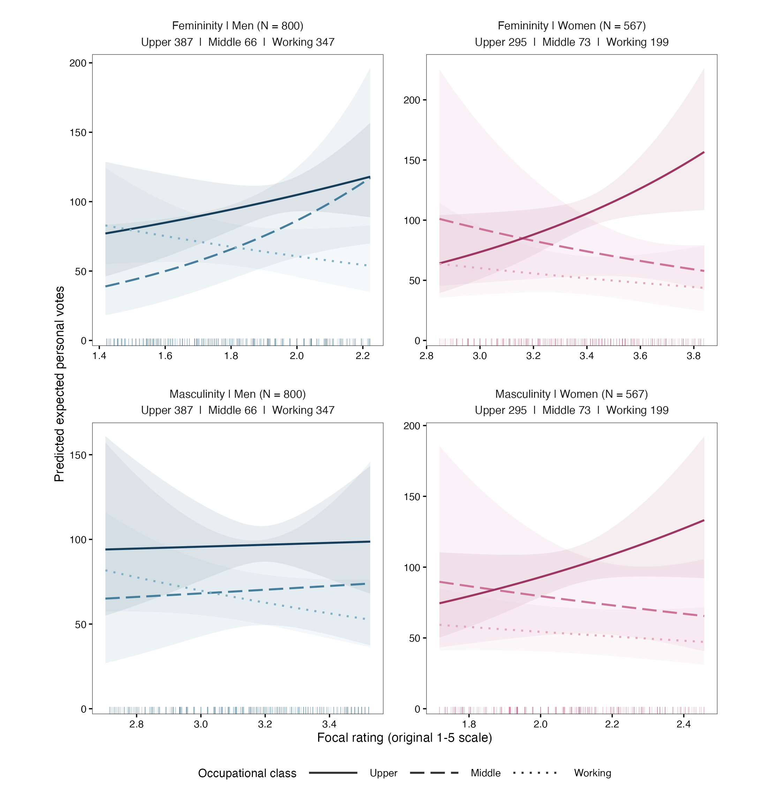
Figure 3. Predicted expected personal votes by gender, cue, and occupational class. Separate models for men and women include class interactions with both femininity and masculinity in Equation 4. Curves vary one cue on the original 1–5 rating scale over the supported range, holding the other at its gender-specific mean, and average over a common distribution of age, attractiveness, party, and municipality within gender. Reported contrasts compare the lower and upper endpoints of each panel’s shared supported range. Shading gives municipality-clustered 95% confidence intervals. Rugs show observed focal ratings, and headings give gender and class sample sizes. Blue denotes men, pink denotes women, and line types distinguish classes. Vertical scales differ between panels.
The clearest class differences concern femininity. Among men, the supported low-to-high femininity comparison spans 1.42–2.22 on the original rating scale. Holding masculinity at its gender-specific mean, this comparison yields point estimates of +53.1% in expected votes in the upper class, +201.0% in the middle class, and -35.1% in the working class. Among women, the corresponding comparison spans 2.85–3.84 and yields +144.5%, -42.8%, and -31.3% in the upper, middle, and working classes, respectively. Direct tests of equal femininity slopes across classes give $p=0.014$ for men and $p=0.0013$ for women. These tests compare class slopes directly rather than comparing whether separate class estimates are statistically significant. The corresponding tests for masculinity are inconclusive, with $p=0.368$ among men and $p=0.164$ among women.
These patterns extend the inequality argument from differences within gender to differences within gender–class combinations. The positive femininity point estimates among upper- and middle-class men are consistent with an opportunity to benefit from a cue that can suggest warmth (Carpinella and Johnson 2013). Its different association among working-class men indicates that this opportunity is socially stratified. Among women, the positive upper-class femininity association has an interval excluding zero, while the middle- and working-class estimates remain inconclusive. This pattern connects occupational position to the gendered distribution of appearance advantages. Most individual femininity intervals include zero, but the direct class comparisons establish differences in how this cue relates to support within each gender. Read through the leadership-fit account (Eagly and Karau 2002) and the infracategorical perspective (Monk 2022), the finding concerns unequal access to appearance rewards among candidates who share a gender but occupy different social positions. These differences qualify an interpretation based on uniform rewards to femininity and bring class into the question of women’s opportunities to convert gendered appearance into electoral support. Political audiences provide another setting in which those rewards may differ, motivating the party-specific comparison that follows.

5.2 Party-specific associations
The contextual expectation implies that inequality within a gender category may take a different direction or magnitude across political settings. We exploit the dataset’s party information to examine this implication, allowing cue slopes and gender intercepts to vary by candidate party while retaining the baseline controls. Let $logμ_{i}^{baseline}$ denote the linear predictor in Equation 2. The secondary specification is
logμiparty=logμibaseline+p≠p0​1(Partyi=p)δpWomani+κpAtypicalityi +τp(Womani×Atypicalityi), (5)
Relative to reference party $p_{0}$, the additional terms allow the atypicality association to vary across parties and by gender within each party. Re-estimating all coefficients retains the baseline log link and expresses these associations as proportional differences in expected votes. We keep the within-gender atypicality scale defined in Equation 1, so each party comparison uses the same unit of departure. The model includes 1380 candidates in 8 parties and 221 municipalities.
Figure 4 disaggregates the appearance-associated inequality summarized in Figure 2. Within the National Coalition Party, the fitted associations favor a more feminine-relative-to-masculine profile in both gender groups. The one-standard-deviation atypicality contrasts are 22.1% among men and -38.0% among women. The opposing index signs reflect departure from male appearance norms and conformity to female appearance norms.
Among women, the fitted association favors more masculine-relative-to-feminine profiles in the Centre Party and more feminine-relative-to-masculine profiles in the Green League. The one-standard-deviation atypicality contrasts are 63.0% in the Centre Party and -46.7% in the Green League. These opposing point estimates locate potential appearance advantages within gender and party contexts. These differences matter for the argument about inequality against women. The negative female point estimates locate settings in which departure from feminine appearance expectations is associated with less support, while the positive Centre Party estimate suggests a setting in which the same departure could become an asset. Political context may therefore change how restrictive the competing demands for warmth and authority are for women.
This variation connects the findings to the candidate gender-by-party differences reported by Carpinella, Hehman, et al. (2016). In their actual-election models, less masculine Republican men and more feminine Republican women were more likely to win. That pattern makes the gendered standards relevant to appearance rewards visible, since a feminine profile departs from male expectations while conforming to female expectations. Their vote-margin analysis yielded a different pattern, which makes the electoral outcome being studied part of the comparison. We exploit personal-vote counts to examine how these gendered rewards enter the allocation of support within Finnish party lists.
The party comparisons also clarify why the leadership interpretation must include the audience. Laustsen and Petersen (2016) show that liberal and conservative audiences place different electoral value on facial dominance. If party audiences likewise differ in the weight they place on warmth and authority, a feminine male profile or a masculine female profile could attract different rewards across settings. The substantive implication is that women’s opportunities to benefit from departure may depend on which political audience evaluates them.
Of the 16 party–gender contrasts, 9 are not statistically significant at the 5% level. We therefore use these point-estimate patterns to develop the contextual interpretation of inequality. The corresponding sensitivity checks show how adjustment for prior office and unusually high vote counts changes the party comparisons.
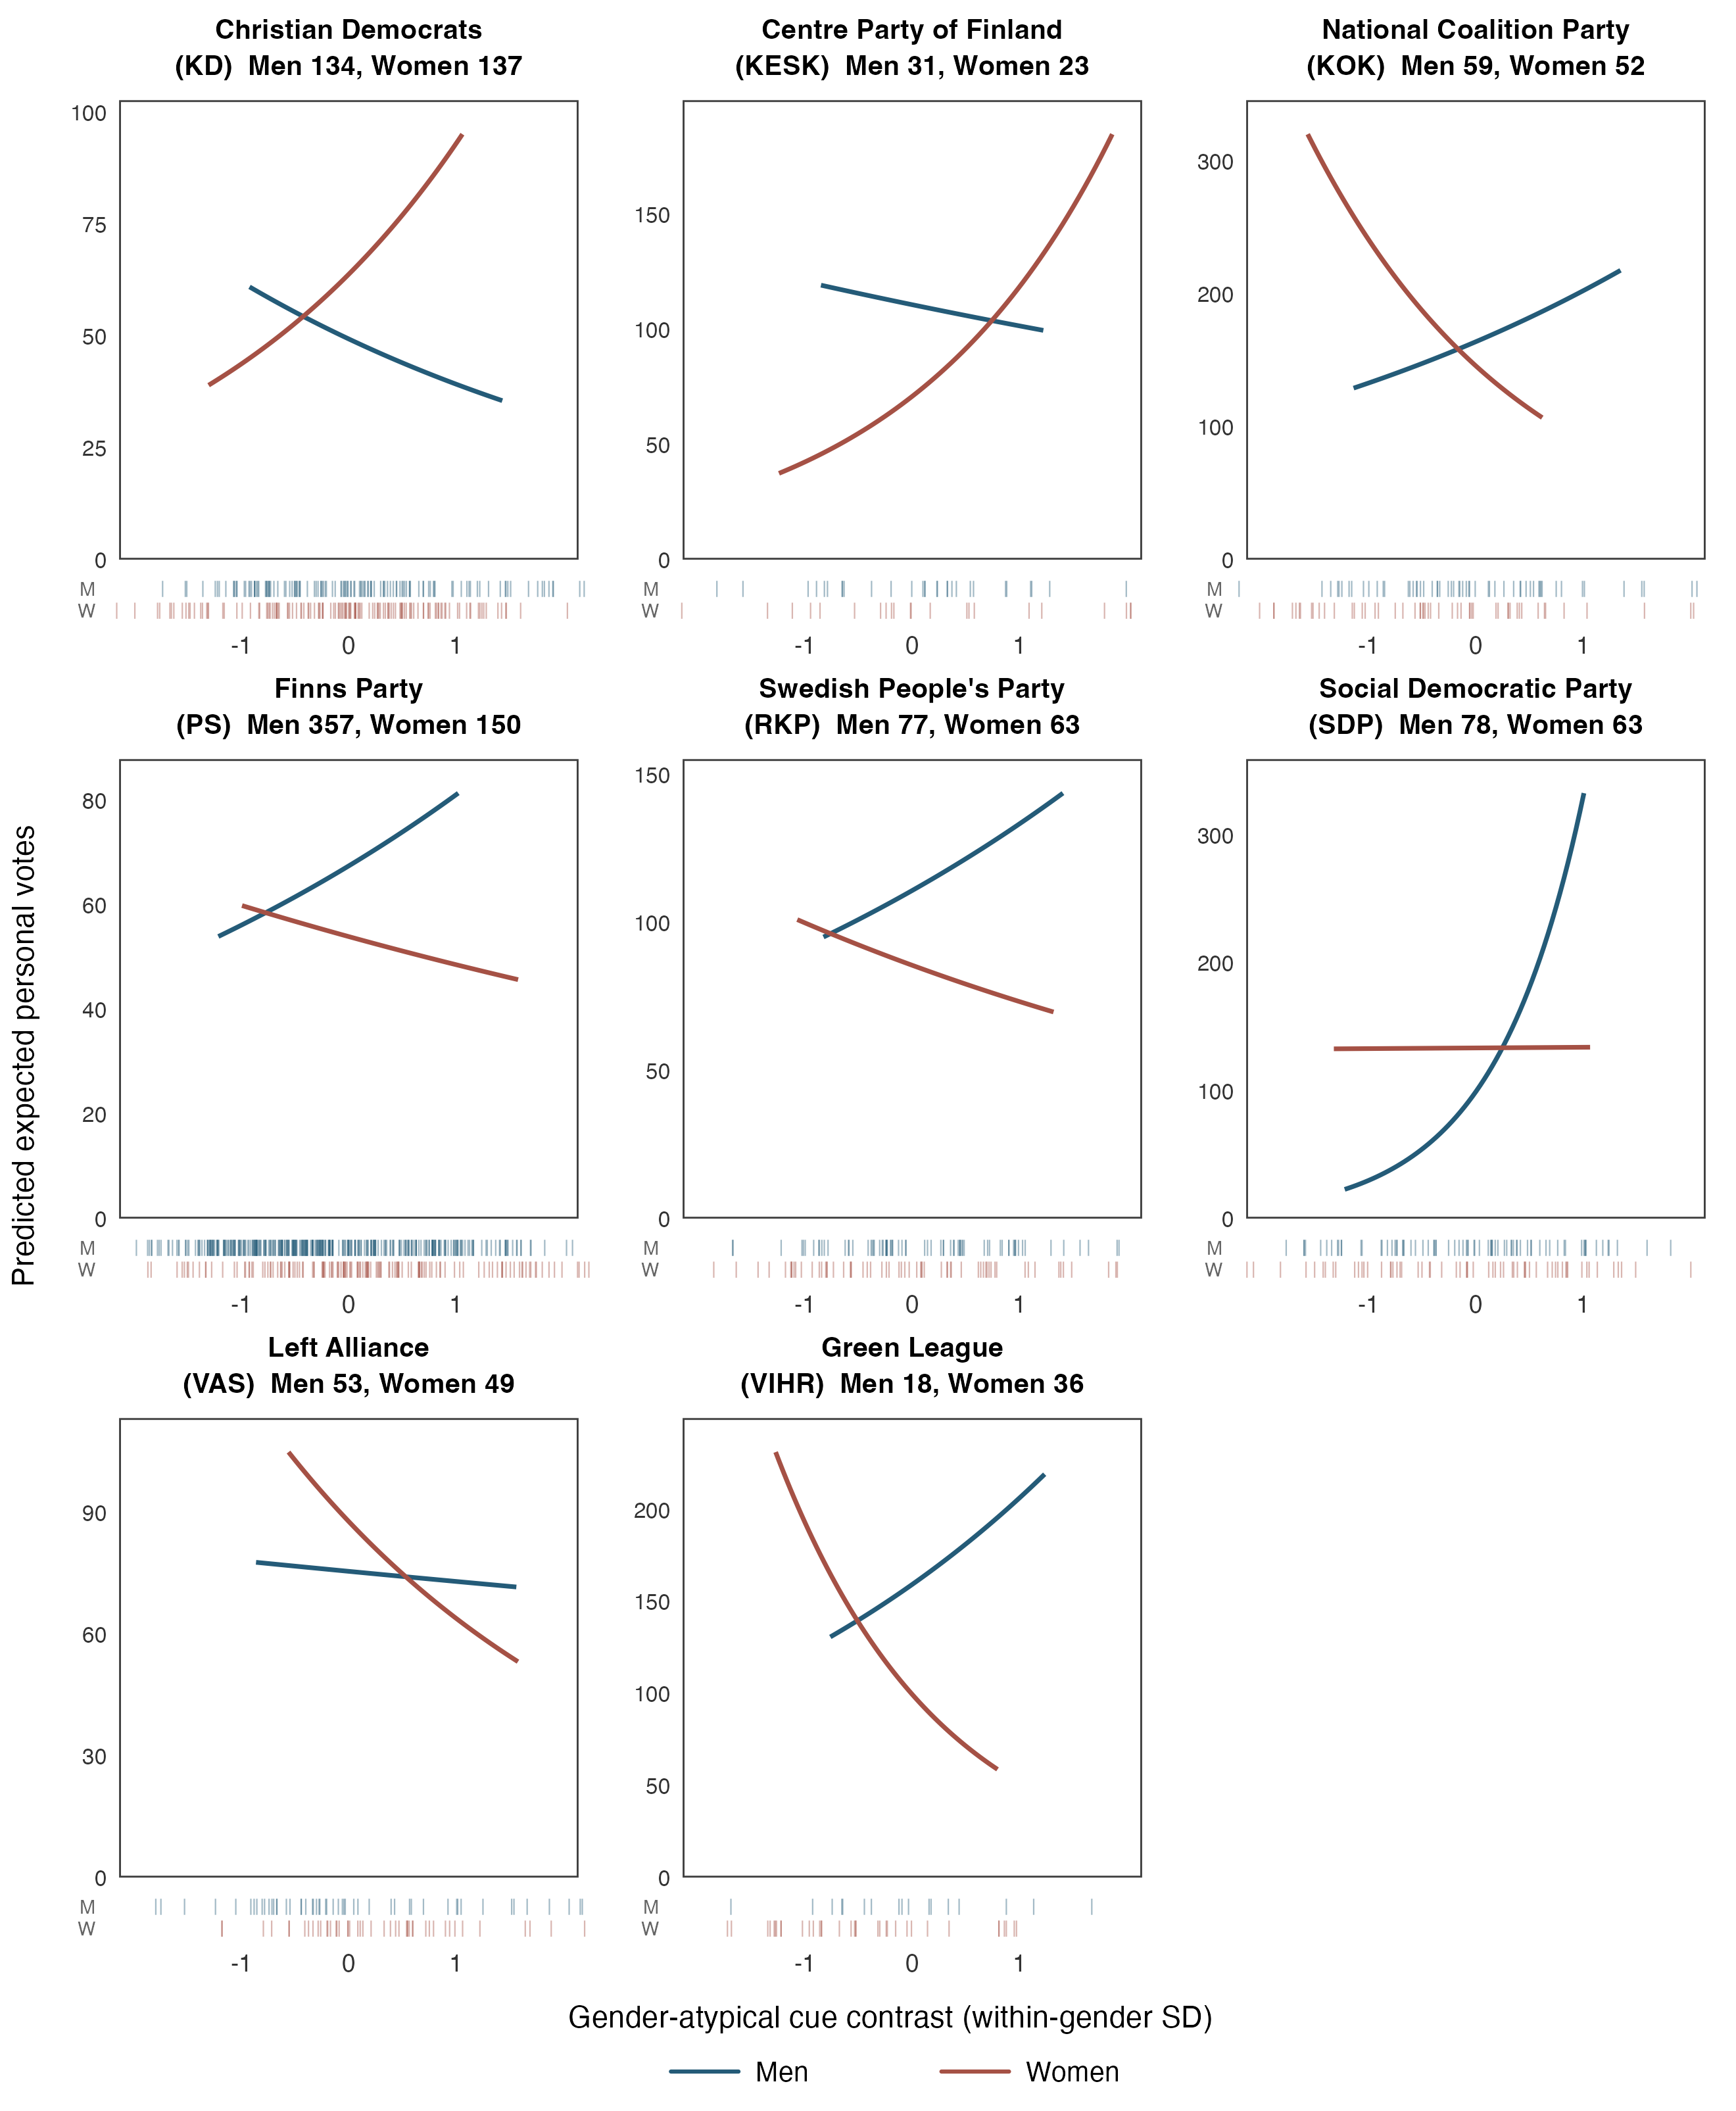
Figure 4. Predicted expected personal votes by party and gender, with baseline controls. Curves vary the cue contrast over each party–gender group’s 10th–90th percentile range and average over that group’s observed candidate contexts. Each solid curve shows the continuous fitted predictions throughout this range. Confidence bands are omitted. 9 of the 16 party–gender contrasts are not statistically significant at the 5% level. Online Appendix Table OA 6 reports intervals for the corresponding one-SD contrasts. Rug strips show observed candidates within the displayed cue range, with men (M) above women (W). Panel headings report full group sample sizes. Vertical scales differ between panels.

5.3 Distinguishing gendered appearance from attractiveness
Does the appearance-associated inequality simply reflect differences in attractiveness? This is a consequential alternative because attractive candidates can receive more votes (Berggren et al. 2010, Bahamonde and Sarpila 2024). If the gender-atypical index merely captured attractiveness, it would add little to the explanation of unequal support. Our original dataset allows us to examine that possibility directly because attractiveness, masculinity, and femininity were rated separately. We exploit these measurements to compare how the scores relate to one another and whether accounting for attractiveness explains the appearance-associated differences in votes.
Figure 5 pairs each candidate’s gender cue balance with that candidate’s attractiveness rating, separately for men and women. This comparison shows whether relatively feminine appearance is associated with greater measured attractiveness among candidates of the same gender. We use the signed cue balance $B=A$ among men and $B=−A$ among women. This orientation places relatively masculine profiles at lower values and relatively feminine profiles at higher values in both groups, with zero corresponding to each group’s average balance.
Among men, the two measurements have little linear or rank-order relationship. The Pearson correlation is 0.064, and the Spearman correlation is 0.056. A more feminine appearance relative to masculine appearance therefore does not simply pick out the men rated as more attractive. Among women, the corresponding correlations are 0.764 and 0.744. Women rated as more feminine relative to masculine are also commonly rated as more attractive. This overlap recalls Sigelman et al. (1987, pp. 42–43), whose female-candidate experiment linked perceived femininity to greater niceness and lower dynamism, with a favorable net association with support.
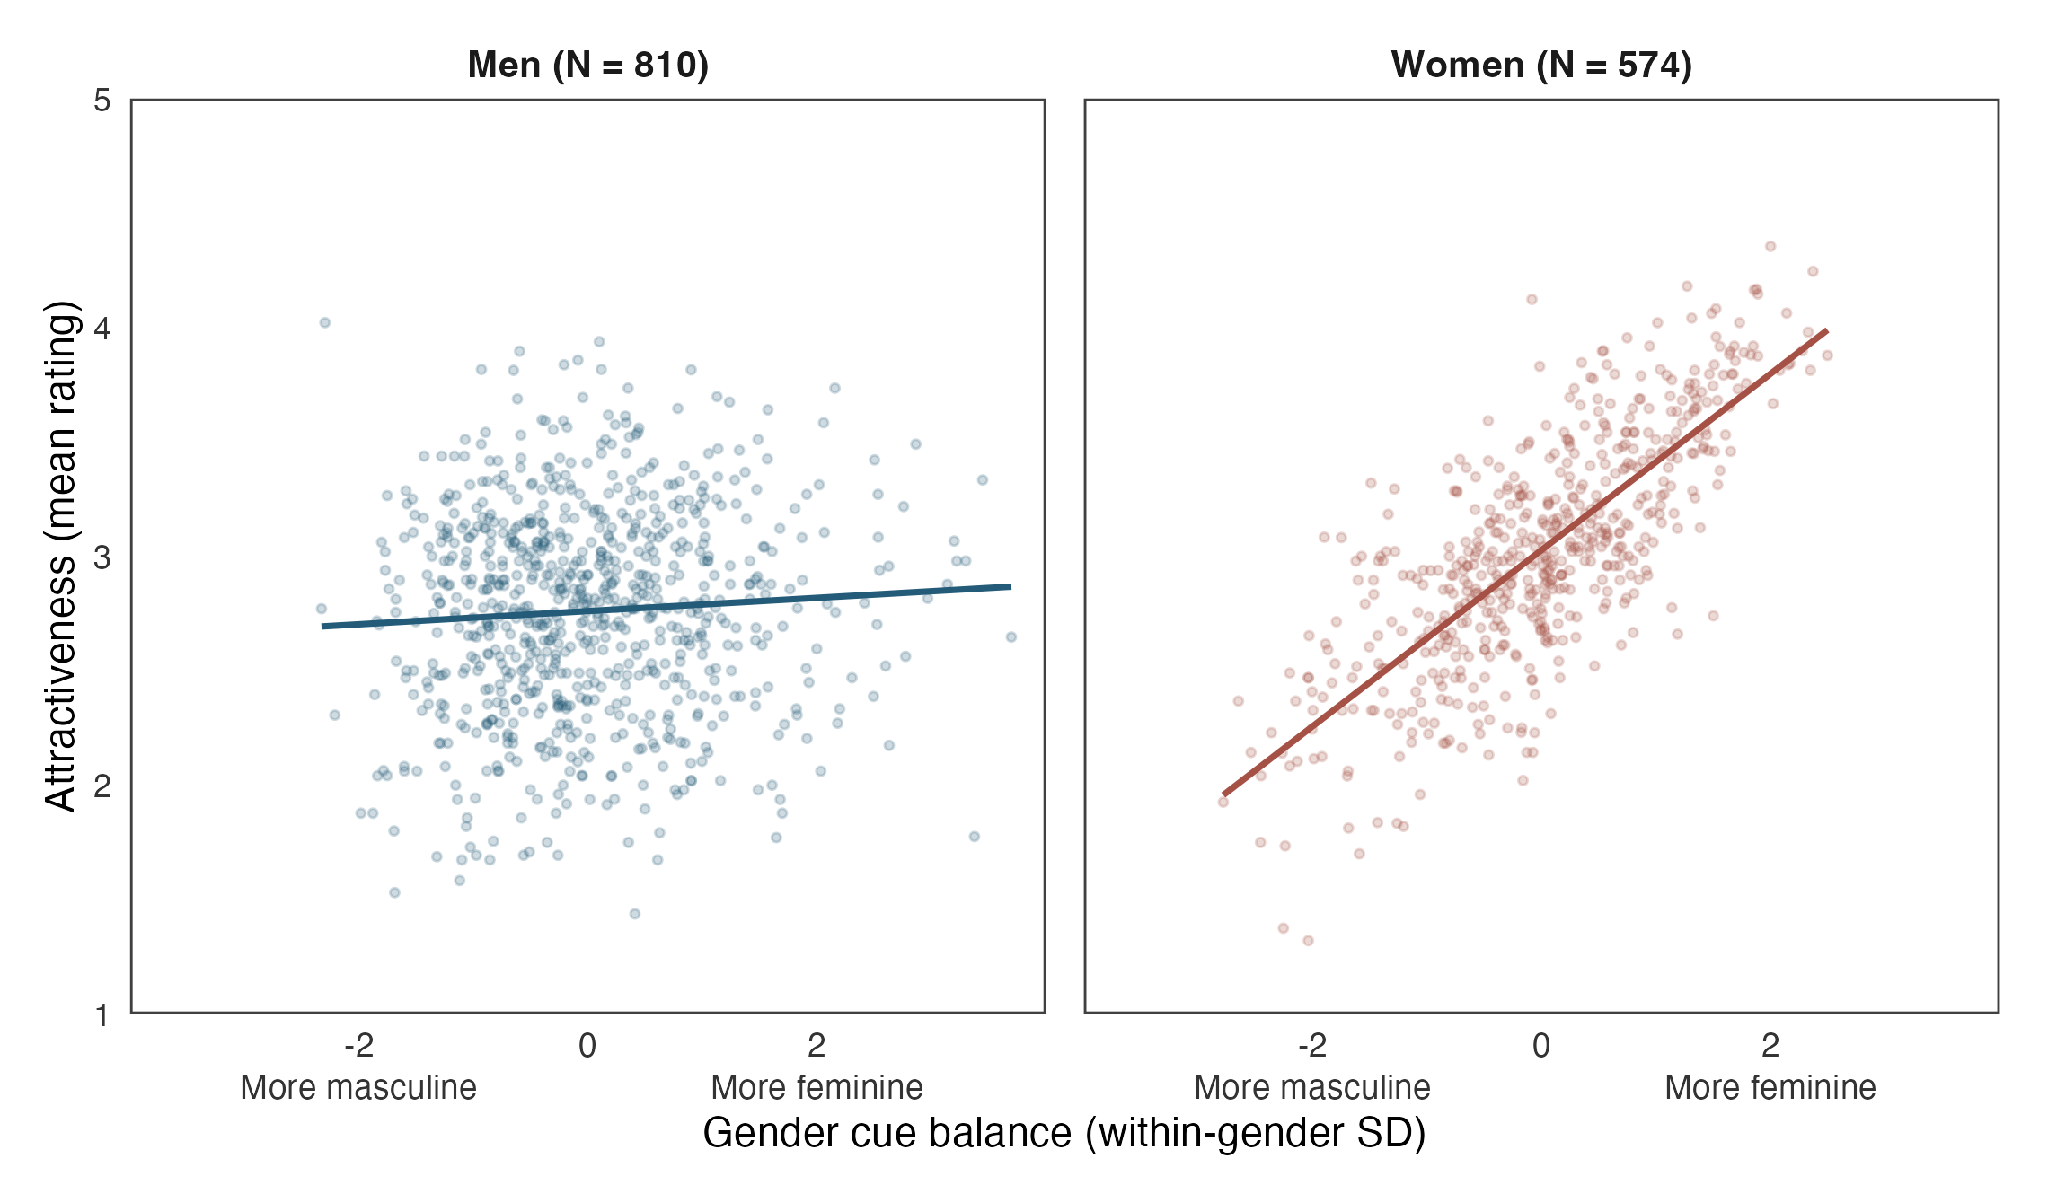
Figure 5. Gender cue balance and attractiveness by recorded gender. Each point pairs one candidate’s signed cue balance $B$ with that candidate’s mean attractiveness rating. Lines summarize the paired relationships using descriptive least-squares fits. $B$ increases with femininity relative to masculinity within either gender. $B=A$ for men and $B=−A$ for women. Headings report group sample sizes. Attractiveness uses the 1–5 rating scale.
The next comparison asks whether attractiveness adjustment accounts for the observed difference in electoral support. Table 3 compares three Poisson specifications on the same 1384 candidates. The first omits attractiveness, the baseline includes it as a linear control, and the third allows the attractiveness association to vary by gender and take a nonlinear form. The flexible specification uses natural cubic splines with 3 degrees of freedom, interacted with gender. All three retain the same age, party, and municipality controls and the same gender-atypical index. This comparison changes the treatment of measured attractiveness while holding the other parts of the comparison constant.
Table 3. Atypicality contrasts under alternative attractiveness adjustments.
Attractiveness adjustment | $N$​ | Men (%) | Women (%)
Attractiveness omitted | 1384 | 18.7 [3.7, 35.9] | -32.6 [-44.5, -18.2]
Baseline linear attractiveness | 1384 | 20.7 [8.0, 35.0] | -8.8 [-31.1, 20.8]
Gender-specific attractiveness spline | 1384 | 21.0 [8.1, 35.5] | -16.4 [-34.6, 7.0]
Entries are percentage differences in expected personal votes for a one-SD increase in $A$, with municipality-clustered 95% intervals in brackets. All specifications use the same 1384 candidates and retain all other baseline controls. The flexible adjustment uses gender-specific natural cubic splines for attractiveness.
Among men, the one-standard-deviation cue contrasts are 18.7% without attractiveness adjustment, 20.7% with the baseline adjustment, and 21.0% under gender-specific nonlinear attractiveness adjustment. Flexible attractiveness adjustment supports an appearance-associated advantage for more gender-atypical male profiles. This pattern is consistent with a cue association distinct from measured attractiveness.
Among women, the corresponding contrasts are -32.6% without attractiveness adjustment and -8.8% with the baseline adjustment. The flexible estimate is -16.4% (95% CI -34.6% to 7.0%). The adjusted female association is inconclusive.
The attractiveness comparisons help distinguish the proposed source of inequality from a general beauty premium. Among men, cue balance has little relationship with measured attractiveness, and the appearance-associated advantage persists after flexible attractiveness adjustment. The male reward for departure therefore extends beyond the beauty ratings in the dataset. Among women, femininity and attractiveness are more closely aligned, connecting the expectation of feminine appearance to another valued electoral attribute. This overlap makes those competing standards relevant to the interpretation, since the appearance theorized to convey feminine warmth is also commonly rated as attractive. The model comparisons consequently sharpen the argument about unequal opportunities to benefit from appearance.

6 Discussion
Does departure from gender stereotypes carry an electoral penalty? Exploiting an original dataset of separately rated appearance cues and linked electoral returns, we find that departure can be associated with electoral advantage among men, while the pooled female estimate is inconclusive. The inequality question is consequently about who has room to turn gender-atypical appearance into a resource. The male association directs attention to the possibility that men can benefit from feminine cues, while women face competing expectations of feminine warmth and leadership authority. Class and party comparisons develop this interpretation by locating social and political settings with different appearance rewards.
This interpretation connects inequalities within gender categories to the competing standards women face. Monk (2022)’s perspective reveals why category membership alone cannot describe the distribution of rewards among candidates. Combining that perspective with gendered leadership expectations asks whether some departures become assets for men while others expose women to conflicting standards (Eagly and Karau 2002, Rudman and Glick 2001). Warmth provides a possible route to such unequal rewards because a quality expected of women can become an additional leadership asset for men (Carpinella and Johnson 2013, Hentschel et al. 2018). The party patterns make the political audience part of this account, suggesting that women’s latitude to depart may depend on which leadership qualities are valued in their setting.
The class analysis shows why unequal rewards cannot be described through gender alone. Its baseline results locate different femininity associations among candidates who share a gender but occupy different occupational positions. The femininity point estimates are positive among upper- and middle-class men and negative among working-class men. Among women, the upper-class femininity association is positive, while the middle- and working-class estimates remain inconclusive. These separate comparisons connect gendered leadership expectations to the social distribution of opportunities to benefit from appearance (Monk 2022, Bahamonde and Sarpila 2024). This pattern also sharpens the question facing research on inequality against women, since the association of perceived femininity with support may differ across women’s occupational positions.
These appearance rewards matter for representation because personal votes determine candidates’ positions within electoral lists (Holli and Wass 2010, Söderlund and von Schoultz 2024). When a profile receives greater support, candidates who display it gain an advantage in that competition. Gender inequality can therefore operate through the standards governing which appearances become electoral assets, as well as through differences in support between men and women overall. Focusing on these standards links within-category comparisons to the opportunities women face when seeking political office.
The study’s observational design sets the scope of this interpretation. The natural-experiment classification rests on an assumed external probabilistic component in appearance, whose assignment law is unrecoverable (Titiunik 2021, pp. 118–119). Grooming and portrait selection shape the observed cues, while entry into candidacy, recognition, and campaign resources can relate appearance to electoral prospects. The fixed effects and controls identify conditional associations rather than causal effects of changing appearance. Attractiveness adjustment likewise describes an association conditional on measured beauty, leaving the underlying perceptual pathway for further investigation.
The scope of the evidence also depends on the sample and measurements. Estimates vary with prior-office adjustment and the treatment of unusually high-vote candidates. The post-election ratings reflect Finnish-speaking adults in the survey’s age range, while voters’ own trait inferences and ideology are unobserved. The vote-model intervals condition on candidates’ mean ratings. These features make direct tests of voter perceptions and replication across electorates the next steps in assessing unequal latitude to depart from gender expectations.
Future research can test that argument by independently varying femininity, masculinity, and attractiveness in matched candidate portraits. Measuring warmth and competence would then show which impressions connect appearance to support, while cooperative and competitive leadership tasks would establish when each impression matters. Varying party labels and measuring voter ideology would further identify the audiences under which women face tighter or looser constraints on appearance. Crossing the same portraits with occupational information would test whether candidate class changes which leadership qualities voters infer and reward. Repeated portraits and information on prospective candidates could establish how presentation and recruitment shape the appearance profiles that reach elections. Together, these designs would clarify when departure becomes an asset for men and whether women face penalties or fewer opportunities to gain the same advantage.

References
Ansani, A. and A. Olivera-La Rosa (2024). Moral inferences from androgynous faces are beyond categorical uncertainty: Evidence of a positive bias towards androgynous targets. European Journal of Social Psychology 54.4, pp. 797–812. doi 10.1002/ejsp.3048.
Bahamonde, H. and O. Sarpila (2024). Physical appearance and elections: An inequality perspective. Political Psychology 45.3, pp. 623–642. doi 10.1111/pops.12940.
Berggren, N., H. Jordahl, and P. Poutvaara (2010). The looks of a winner: Beauty and electoral success. Journal of Public Economics 94.1–2, pp. 8–15. doi 10.1016/j.jpubeco.2009.11.002.
— (2017). The right look: Conservative politicians look better and voters reward it. Journal of Public Economics 146, pp. 79–86. doi 10.1016/j.jpubeco.2016.12.008.
Bono, J. E., P. W. Braddy, Y. Liu, E. K. Gilbert, J. W. Fleenor, L. N. Quast, and B. A. Center (2017). Dropped on the way to the top: Gender and managerial derailment. Personnel Psychology 70.4, pp. 729–768. doi 10.1111/peps.12184.
Carpinella, C. M., E. Hehman, J. B. Freeman, and K. L. Johnson (2016). The Gendered Face of Partisan Politics: Consequences of Facial Sex Typicality for Vote Choice. Political Communication 33.1, pp. 21–38. doi 10.1080/10584609.2014.958260.
Carpinella, C. M. and K. L. Johnson (2013). Politics of the Face: The Role of Sex-Typicality in Trait Assessments of Politicians. Social Cognition 31.6, pp. 770–779. doi 10.1521/soco.2013.31.6.770.
Ditonto, T. and K. Mattes (2018). Differences in Appearance-Based Trait Inferences for Male and Female Political Candidates. Journal of Women, Politics & Policy 39.4, pp. 430–450. doi 10.1080/1554477X.2018.1506206.
Eagly, A. H. and S. J. Karau (2002). Role congruity theory of prejudice toward female leaders. Psychological Review 109.3, pp. 573–598. doi 10.1037/0033-295X.109.3.573.
Efran, M. G. and E. W. J. Patterson (1974). Voters vote beautiful: The effect of physical appearance on a national election. Canadian Journal of Behavioural Science 6.4, pp. 352–356. doi 10.1037/h0081881.
Griffin, A. M. and J. H. Langlois (2006). Stereotype directionality and attractiveness stereotyping: Is beauty good or is ugly bad? Social Cognition 24.2, pp. 187–206. doi 10.1521/soco.2006.24.2.187.
Hehman, E., C. M. Carpinella, K. L. Johnson, J. B. Leitner, and J. B. Freeman (2014). Early Processing of Gendered Facial Cues Predicts the Electoral Success of Female Politicians. Social Psychological and Personality Science 5.7, pp. 815–824. doi 10.1177/1948550614534701.
Hentschel, T., S. Braun, C. Peus, and D. Frey (2018). The Communality-Bonus Effect for Male Transformational Leaders—Leadership Style, Gender, and Promotability. European Journal of Work and Organizational Psychology 27.1, pp. 112–125. doi 10.1080/1359432X.2017.1402759.
Holli, A. M. and H. Wass (2010). Gender-based voting in the parliamentary elections of 2007 in Finland. European Journal of Political Research 49.5, pp. 598–630. doi 10.1111/j.1475-6765.2009.01910.x.
Hoss, R. A., J. L. Ramsey, A. M. Griffin, and J. H. Langlois (2005). The Role of Facial Attractiveness and Facial Masculinity/Femininity in Sex Classification of Faces. Perception 34.12, pp. 1459–1474. doi 10.1068/p5154.
Laustsen, L. and M. B. Petersen (2016). Winning Faces Vary by Ideology: How Nonverbal Source Cues Influence Election and Communication Success in Politics. Political Communication 33.2, pp. 188–211. doi 10.1080/10584609.2015.1050565.
Lawson, C., G. S. Lenz, A. Baker, and M. Myers (2010). Looking Like a Winner: Candidate Appearance and Electoral Success in New Democracies. World Politics 62.4, pp. 561–593. doi 10.1017/S0043887110000195.
Liu, F., F. van der Lijn, C. Schurmann, G. Zhu, M. M. Chakravarty, P. G. Hysi, A. Wollstein, O. Lao, M. de Bruijne, M. A. Ikram, et al. (2012). A Genome-Wide Association Study Identifies Five Loci Influencing Facial Morphology in Europeans. PLOS Genetics 8.9, e1002932. doi 10.1371/journal.pgen.1002932.
Magliozzi, D., A. Saperstein, and L. Westbrook (2016). Scaling Up: Representing Gender Diversity in Survey Research. Socius 2, pp. 1–11. doi 10.1177/2378023116664352.
Mattes, K., M. Spezio, H. Kim, A. Todorov, R. Adolphs, and R. M. Alvarez (2010). Predicting election outcomes from positive and negative trait assessments of candidate images. Political Psychology 31.1, pp. 41–58. doi 10.1111/j.1467-9221.2009.00745.x.
Monk Jr., E. P. (2022). Inequality without Groups: Contemporary Theories of Categories, Intersectional Typicality, and the Disaggregation of Difference. Sociological Theory 40.1, pp. 3–27. doi 10.1177/07352751221076863.
Naunov, M. (2026). The Right Kind of (Gay) Man? Sexuality, Gender Presentation, and Heteronormative Constraints on Electability. The Journal of Politics 88.4, pp. 1555–1572. doi 10.1086/736697.
Olivola, C. Y., D. Tingley, and A. Todorov (2018). Republican Voters Prefer Candidates Who Have Conservative-Looking Faces: New Evidence From Exit Polls. Political Psychology 39.5, pp. 1157–1171. doi 10.1111/pops.12489.
Owen, H. E., J. Halberstadt, E. W. Carr, and P. Winkielman (2016). Johnny Depp, Reconsidered: How Category-Relative Processing Fluency Determines the Appeal of Gender Ambiguity. PLOS ONE 11.2, e0146328. doi 10.1371/journal.pone.0146328.
Park, K. and J. Joo (2023). Perceived masculinity from Facebook photographs of candidates predicts electoral success. EPJ Data Science 12.1, p. 32. doi 10.1140/epjds/s13688-023-00404-7.
Rosar, U., M. Klein, and T. Beckers (2008). The frog pond beauty contest: Physical attractiveness and electoral success of the constituency candidates at the North Rhine-Westphalia state election of 2005. European Journal of Political Research 47.1, pp. 64–79. doi 10.1111/j.1475-6765.2007.00720.x.
Rose, D. and E. Harrison (2007). The European Socio-economic Classification: A New Social Class Schema for Comparative European Research. European Societies 9.3, pp. 459–490. doi 10.1080/14616690701336518.
Rudman, L. A. and P. Glick (2001). Prescriptive Gender Stereotypes and Backlash Toward Agentic Women. Journal of Social Issues 57.4, pp. 743–762. doi 10.1111/0022-4537.00239.
Santos Silva, J. M. C. and S. Tenreyro (2006). The Log of Gravity. The Review of Economics and Statistics 88.4, pp. 641–658. doi 10.1162/rest.88.4.641.
Sigelman, L., C. K. Sigelman, and C. Fowler (1987). A Bird of a Different Feather? An Experimental Investigation of Physical Attractiveness and the Electability of Female Candidates. Social Psychology Quarterly 50.1, pp. 32–43. doi 10.2307/2786888.
Söderlund, P. and Å. von Schoultz (2024). Trajectories of the personal vote under open-list proportional representation: Evidence from Finland, 1999–2019. Party Politics 30.1, pp. 12–23. doi 10.1177/13540688231177558.
Spisak, B. R., P. H. Dekker, M. Krüger, and M. van Vugt (2012). Warriors and Peacekeepers: Testing a Biosocial Implicit Leadership Hypothesis of Intergroup Relations Using Masculine and Feminine Faces. PLOS ONE 7.1, e30399. doi 10.1371/journal.pone.0030399.
Titiunik, R. (2021). “Natural Experiments”. Advances in Experimental Political Science. Ed. by J. N. Druckman and D. P. Green. Cambridge University Press, pp. 103–129. doi 10.1017/9781108777919.008.
Tu, M. H., E. K. Gilbert, and J. E. Bono (2022). Is beauty more than skin deep? Attractiveness, power, and nonverbal presence in evaluations of hirability. Personnel Psychology 75.1, pp. 119–146. doi 10.1111/peps.12469.
Walker, M. and M. Wänke (2017). Caring or daring? Exploring the impact of facial masculinity/femininity and gender category information on first impressions. PLOS ONE 12.10, e0181306. doi 10.1371/journal.pone.0181306.
Wang, D., J. L. Merolla, and A. Manganiello (2023). The Effect of Counterstereotypic Gender Strategies on Candidate Evaluations in American Elections. Politics & Gender 19.4, pp. 1180–1203. doi 10.1017/S1743923X23000314.
Wigginton, M. and D. Stockemer (2021). The limits of the attractiveness premium in elections. Electoral Studies 70, p. 102274. doi 10.1016/j.electstud.2020.102274.
Wojcik, S. and S. Mullenax (2024). Facing Voters: Gender Expression, Gender Stereotypes, and Vote Choice. The Journal of Politics 86.4, pp. 1115–1128. doi 10.1086/729958.

Online Appendix

OA 1 A natural experiment as a subtype of observational study
Titiunik (2021, pp. 118–119) defines a natural experiment as a special kind of observational study through three conditions on the assignment mechanism. Researchers neither design nor implement assignment, its full probability law is unknown and unknowable to them, and an external factor outside the units’ direct control makes assignment probabilistic. Her Definition NE denotes these conditions by $\tilde{D}$, $\tilde{K}$, and $\tilde{P}$. We apply each condition to the process generating candidates’ gendered appearance. Candidates are the units, their appearance condition is summarized by the continuous within-gender contrast $A_{i}$ in Equation 1, and personal votes are the outcome. Let $A_{g}$ collect the appearance conditions of the candidates in gender category $g$ represented in the dataset, and let $Q_{g}$ denote their joint assignment law. Following Definition NE, this law is conditional on predetermined characteristics and the potential-outcome schedule, with the conditioning suppressed below.

OA 1.1 Assignment outside the researchers’ control
Condition $\tilde{D}$ requires that researchers neither design nor implement the assignment mechanism. In our study, the facial characteristics visible in campaign portraits arose before and independently of the research project. We observed existing candidates and their portraits without allocating facial features or directing how candidates presented themselves in the election. The process assigning gendered appearance therefore operated outside the researchers’ control, satisfying the first condition.

OA 1.2 An unknown and unrecoverable assignment mechanism
Condition $\tilde{K}$ requires that the assignment mechanism be unknown and unknowable to the researchers. In this application, $Q_{g}$ is the full law governing alternative allocations of appearance conditions across candidates. No recoverable allocation protocol supplies the probabilities that particular candidates would have received alternative facial profiles. The portraits and electoral records contain the realized appearance conditions, while the full probabilities generating those conditions remain inaccessible. Knowing the formula for the index or the distribution of observed scores does not recover $Q_{g}$. The appearance-assignment mechanism is therefore unknown and unrecoverable for this design, which places the study within the observational category in the framework.

OA 1.3 A probabilistic component arising from an external factor
Condition $\tilde{P}$ requires probabilistic assignment arising from an external event or intervention outside the units’ direct control. Our external factor is naturally arising variation in inherited facial morphology and development. Genetic contributions to normal facial morphology are documented by Liu et al. (2012). We assume that an uncontrollable component of this variation contributes to the gendered cue contrast among the candidates represented in the dataset. Candidates can choose grooming, facial expression, and portraits while lacking precise control over all the facial features those portraits display. Such presentation choices can coexist with the external chance component contemplated by the definition (Titiunik 2021, pp. 118–119).
To express this mapping, let $E_{i}$ denote the external component and $L_{i}$ denote presentation choices, with $A_{i}=ψ_{g}(E_{i},L_{i})$ summarizing their contribution to gendered appearance. The assignment premise is that variation in $E_{i}$ leaves more than one possible value of the contrast for candidate $i$. The original binary formulation expresses probabilistic assignment through a positive probability of either condition (Titiunik 2021, p. 108). Our continuous counterpart uses disjoint neighborhoods $B_{i0}$ and $B_{i1}$ of possible contrast values. If $Q_{ig}$ denotes candidate $i$’s marginal law under $Q_{g}$, the premise is
$0<Q_{ig}(B_{ik})<1, B_{i0}∩B_{i1}=⌀, k∈\{0,1\}.$ (OA 1)
This condition concerns positive probabilities over distinct ranges of appearance, rather than positive probability at each exact real-valued score. It states the probabilistic appearance-assignment assumption underlying our application of $\tilde{P}$.
Finnish municipal recruitment and campaign practices provide the setting in which this external variation enters electoral competition. Parties recruit ordinary residents to extensive candidate lists, and headshots feature prominently in campaign communication (Bahamonde and Sarpila 2024, pp. 628–629). These practices support the premise that naturally arising differences remain visible in the candidate portraits. Under the stated probabilistic-assignment premise, the case satisfies the three conditions together. Appearance is assigned outside the research project, the full allocation probabilities are unrecoverable, and an external component beyond candidates’ precise control contributes chance variation to their gendered cue profiles. The study is therefore a natural experiment within this framework for observational studies.

OA 2 Balance between raw ratings
An alternative specification assesses whether balance between the raw femininity and masculinity ratings is associated with electoral support. It replaces the directional contrast of within-gender standardized ratings with raw cue balance and raw cue intensity, defined in Equation OA 2.
$\begin{matrix}{\text{RawBalance}}_{i}=1−\frac{|F_{i}−M_{i}|}{4}, \\ {\text{RawIntensity}}_{i}=(F_{i}+M_{i})/2.\end{matrix}$ (OA 2)
We standardize each index within gender. The balance associations are 39.0% (95% CI 17.2% to 64.8%) for men and -10.3% (95% CI -30.9% to 16.4%) for women. This alternative concerns equality of raw ratings, which is distinct from equality relative to gender-specific means and does not establish categorical uncertainty.

OA 3 Joint cue level as an additional adjustment
The directional contrast summarizes relative cue balance but omits the combined rating level. Candidates can have the same directional difference while their combined femininity and masculinity rating levels vary. To assess whether this additional variation changes the atypicality association, we define joint cue level as
$S_{i}=\frac{z_{i}^{F}+z_{i}^{M}}{{sd}_{g}(z^{F}+z^{M})}.$ (OA 3)
As a standardized sum, $S$ can be elevated when either rating exceeds its gender-specific mean, even if the other falls below it. Conditional on a fixed atypicality contrast, an increase in $S$ corresponds to equal increases in both standardized ratings. The adjusted specification includes $S$ and its gender interaction.
$\begin{matrix}logμ_{i}^{joint}=logμ_{i}^{baseline}+ρ_{1}{\text{JointCueLevel}}_{i} \\ +ρ_{2}({\text{Woman}}_{i}×{\text{JointCueLevel}}_{i}).\end{matrix}$ (OA 4)
All baseline coefficients are re-estimated. This adjustment relaxes the equal-magnitude, opposite associations assigned to standardized femininity and masculinity by the primary contrast specification. The adjusted atypicality associations are 20.4% (95% CI 7.9% to 34.4%) for men and -13.5% (95% CI -37.7% to 20.3%) for women. The joint-level associations are 8.9% (95% CI -11.0% to 33.1%) and 15.6% (95% CI -10.1% to 48.5%), respectively. Figures OA 1 and OA 2 compare the predictions from both specifications. Table OA 8 reports the corresponding atypicality contrasts. Holding joint cue level constant, the estimated gradient favors more gender-atypical profiles within male candidacies. The separate joint-level associations are inconclusive in both gender groups.
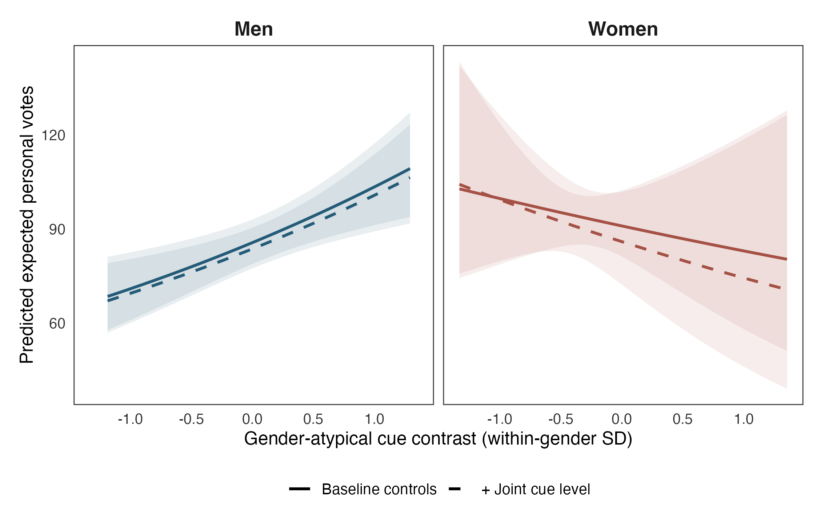
Figure OA 1. Predicted expected personal votes with and without joint cue level. The adjusted curve holds $S=0$. The baseline model does not include $S$. Both specifications average predictions over the same gender-specific observed candidate contexts. Shading denotes municipality-clustered 95% confidence intervals.
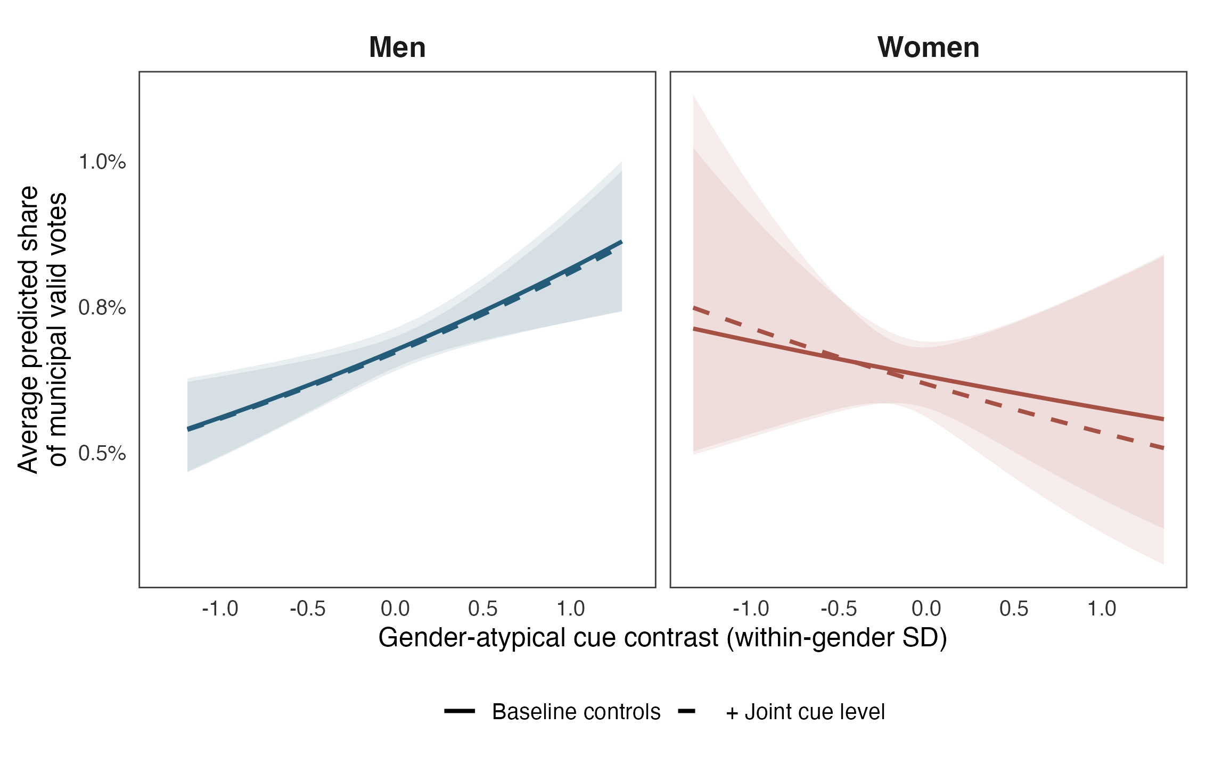
Figure OA 2. Average predicted municipal vote share with and without joint cue level. Predictions and confidence intervals follow Figure OA 1. Denominators include all valid personal votes in each municipality.

OA 4 Quadratic cue configurations
The joint-level adjustment permits the directional contrast and combined rating level to vary independently. Its linear predictor nevertheless estimates constant slopes of log expected votes for both cue indices within gender. To allow curvature and an atypicality slope that varies with joint level, the quadratic specification adds squared indices, their product, and gender interactions to Equation OA 4.
$\begin{matrix}logμ_{i}^{quadratic}=logμ_{i}^{joint}+η_{1}{\text{Atypicality}}_{i}^{2}+η_{2}{\text{JointCueLevel}}_{i}^{2} \\ +η_{3}{\text{Atypicality}}_{i}{\text{JointCueLevel}}_{i} \\ +{\text{Woman}}_{i}\left(η_{4}{\text{Atypicality}}_{i}^{2}+η_{5}{\text{JointCueLevel}}_{i}^{2}\right) \\ +η_{6}{\text{Woman}}_{i}{\text{Atypicality}}_{i}{\text{JointCueLevel}}_{i}.\end{matrix}$ (OA 5)
All coefficients of the joint-level-adjusted linear predictor are re-estimated, so the added terms describe curvature and interaction conditional on the same controls. Table OA 1 reports these nonlinear coefficients by gender. A joint Wald test evaluates whether the 6 added terms equal zero. It gives $F=2.50$ with 6 and 220 degrees of freedom ($p=0.023$). Table OA 2 applies the same test after upper-tail exclusions, connecting the assessment of nonlinearity to dependence on high-vote candidates. Figure OA 3 shows the fitted cue surface only where nearby candidate profiles provide empirical support. Figure 1 shows the underlying raw ratings. The full-sample joint test supports added quadratic or interaction terms. The joint test is inconclusive under both upper-tail exclusions. This omnibus test concerns the added terms jointly across genders.
Table OA 1. Quadratic cue coefficients by candidate gender.
Gender | Term | Coefficient | Cluster SE | $p$​
Men | $A^{2}$​ | -0.143 | 0.058 | 0.014
Men | $S^{2}$​ | 0.012 | 0.066 | 0.855
Men | $AS$​ | 0.108 | 0.088 | 0.221
Women | $A^{2}$​ | -0.036 | 0.049 | 0.469
Women | $S^{2}$​ | -0.040 | 0.044 | 0.362
Women | $AS$​ | -0.196 | 0.103 | 0.059
Coefficients are on the log conditional-mean scale. Female coefficients combine each nonlinear term with its gender interaction. Standard errors and $p$-values use the full municipality-clustered covariance matrix. The model includes 1384 candidates in 221 municipalities.
Table OA 2. Joint tests of the quadratic terms.
Specification | $N$​ | $F$​ | $df_{1}$​ | $df_{2}$​ | $p$​
Quadratic, full sample | 1384 | 2.504 | 6 | 220 | 0.023
Excluding top 1% of votes | 1370 | 1.654 | 6 | 220 | 0.134
Excluding top 5% of votes | 1314 | 1.058 | 6 | 220 | 0.389
Wald $F$ tests use municipality-clustered standard errors and the joint null that all added quadratic terms equal zero. The numerator degrees of freedom equal the number of tested terms. Denominator degrees of freedom equal $G−1$.
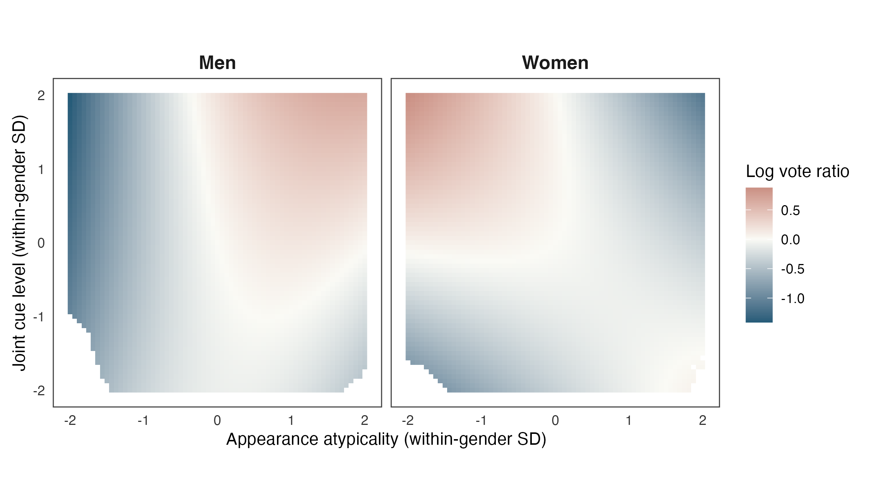
Figure OA 3. Quadratic cue surface. Colors represent the log expected-vote ratio relative to mean within-gender cues, at the same values of other covariates. Displayed configurations have at least 5 candidates within radius 0.65 in the standardized cue space.

OA 5 Dispersion and sample diagnostics
The conditional-mean approach also requires inference that allows overdispersion. The baseline-controls model’s Pearson dispersion is 186.8, which describes variation beyond the Poisson mean–variance restriction. Municipality-clustered inference allows this variation and dependence among candidates in the same municipality. There are also 42 singleton municipalities in the primary sample. Removing them leaves 1342 candidates across 179 municipalities that contribute slope information.

OA 6 Municipal vote-share representation
The main analysis presents unequal expected personal support in vote-count units. To express the same fitted model relative to the size of each local electorate, we divide each candidate-context prediction by the municipality’s valid-vote total $N_{c}$ and average within gender.
pg(a)=1ngi:g(i)=g​μi(a)Nc(i). (OA 6)
The contextual share expresses the modeled probability that a valid municipal ballot is cast for a candidate. Averaging these shares weights candidates’ observed contexts equally. It does not give the probability for a randomly sampled Finnish voter or the probability of winning a council seat. Because normalization occurs before averaging, municipalities enter with different scaling than in the vote-count representation. Figure OA 4 therefore provides an alternative electoral scale for the baseline association, without constituting a separate model or an independent test of the appearance–support relationship.
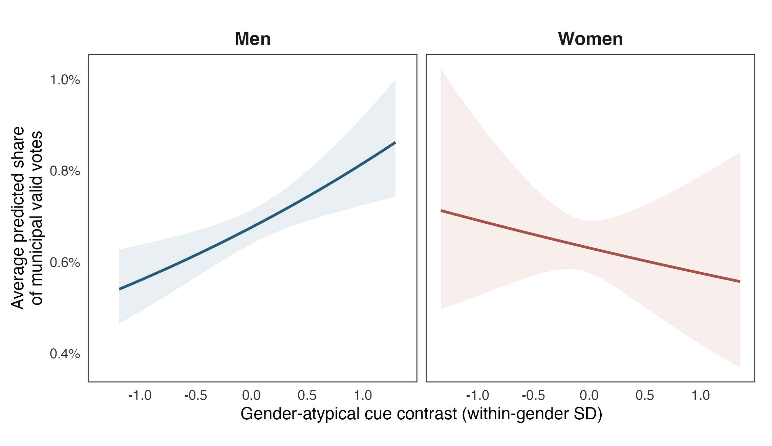
Figure OA 4. Average predicted municipal vote share with baseline controls. Denominators include all valid personal votes in each municipality. Curves and municipality-clustered 95% confidence intervals follow Figure 2.

OA 7 Baseline regression underlying the main results
Table OA 3 reports the estimated coefficients of Equation 2, the baseline Poisson model used to construct the predictions in Figure 2. On the log conditional-mean scale, the male atypicality association is the coefficient on Atypicality, while the female association is its sum with the Woman $×$ Atypicality coefficient. Table 2 translates these associations into percentage differences in expected personal votes, whereas Figure 2 shows the resulting inequality in expected personal support across cue values.
Table OA 3. Baseline Poisson regression corresponding to Figure 2.
Variable | Coefficient | Clustered SE | 95% CI | $p$​
Atypicality | 0.188 | 0.057 | [0.077, 0.300] | 0.001
Woman | -0.312 | 0.125 | [-0.558, -0.066] | 0.013
Woman $×$ Atypicality | -0.280 | 0.145 | [-0.566, 0.005] | 0.054
Age (mean centered) | 0.005 | 0.007 | [-0.008, 0.019] | 0.411
Attractiveness | 1.048 | 0.140 | [0.771, 1.324] | $<0.001$​
Municipality fixed effects | Yes
Party fixed effects | Yes
Candidates ($N$) | 1,384
Municipalities ($G$) | 221
The dependent variable is personal votes. Coefficients and confidence intervals are on the log conditional-mean scale. Municipality-clustered standard errors (SE) incorporate a finite-sample correction. Confidence intervals (CI) and two-sided $p$-values use a $t$ reference distribution with 220 degrees of freedom. Woman indicates female candidates, with men as the reference category. Its coefficient compares genders at $A=0$. Age is centered at the sample mean of 45.76 years. Attractiveness enters in its original rating units. Municipality and party coefficients and the intercept are omitted from the table. The female atypicality association is the sum of the Atypicality and interaction coefficients. Its uncertainty uses their full covariance.

OA 8 Occupational-class contrasts and prior-office adjustment
The class specification in Equation 4 is estimated separately for male and female candidates. Within each subsample, it includes class main effects, both cue main effects, and interactions between class and each cue. Age, attractiveness, and municipality and party fixed effects are estimated separately in each model. The two cues enter jointly without a femininity-by-masculinity interaction. The analysis exploits 1367 candidates in 221 municipalities, including 800 men and 567 women. The male model exploits 191 municipalities and the female model 177 municipalities. The class-complete sample excludes 17 candidates from the primary sample. Both cue scores retain the primary sample’s within-gender standardization.
Table OA 4 translates the cell-specific cue slopes into percentage differences in expected personal votes from the lower to the upper endpoint of the supported range shown in each panel of Figure 3. The nonfocal cue remains at its gender-specific mean, and the endpoint pair is identical across classes and specifications within a panel. On the original rating scale, femininity spans 1.42–2.22 for men and 2.85–3.84 for women. Masculinity spans 2.70–3.53 for men and 1.72–2.46 for women. The baseline column corresponds to Figure 3. The prior-office column adds indicators for incumbent municipal councillors and members of the national parliament to the same specification and sample. Comparing these columns shows how adjustment for established political positions changes the appearance-associated returns across occupational groups.
Table OA 4. Supported low-to-high cue contrasts before and after prior-office adjustment.
Gender | Class | $N$​ | Cue | Baseline (%) | + Prior office (%)
Men | Upper | 387 | Femininity | 53.1 [-28.8, 229.0] | -13.2 [-45.1, 37.2]
Men | Upper | 387 | Masculinity | 4.9 [-56.6, 154.0] | -21.9 [-49.5, 20.7]
Men | Middle | 66 | Femininity | 201.0 [5.8, 756.2] | -29.4 [-63.7, 37.3]
Men | Middle | 66 | Masculinity | 13.7 [-71.8, 357.7] | -44.9 [-75.5, 24.0]
Men | Working | 347 | Femininity | -35.1 [-68.2, 32.5] | -31.9 [-57.5, 9.0]
Men | Working | 347 | Masculinity | -35.7 [-63.4, 13.0] | -19.1 [-44.0, 16.9]
Women | Upper | 295 | Femininity | 144.5 [7.6, 455.5] | 187.4 [33.4, 519.3]
Women | Upper | 295 | Masculinity | 78.9 [-12.7, 266.5] | 97.1 [2.5, 279.3]
Women | Middle | 73 | Femininity | -42.8 [-78.4, 51.4] | -9.4 [-58.9, 99.6]
Women | Middle | 73 | Masculinity | -27.0 [-72.7, 95.7] | -16.4 [-64.2, 95.4]
Women | Working | 199 | Femininity | -31.3 [-75.1, 89.2] | 34.9 [-37.6, 191.6]
Women | Working | 199 | Masculinity | -20.3 [-52.1, 32.3] | 27.2 [-16.6, 94.1]
Entries are percentage differences in expected personal votes comparing the lower and upper plotted endpoints for the indicated cue, with the other cue at its gender-specific mean. Each panel uses the same endpoints across classes and specifications. Brackets give municipality-clustered 95% confidence intervals. Cell $N$ counts candidates in each gender–class group. Both models include municipality and party fixed effects, centered age, and attractiveness. The additional prior-office controls are incumbent-councillor and national-MP indicators. The intervals use each model’s full coefficient covariance and a $t$ reference distribution with 190 degrees of freedom for men and 176 for women.
The class comparison is evaluated through joint tests of equal cue slopes across upper, middle, and working classes within each gender. These tests retain the standardized slope unit, while the preceding table reports the change across each panel’s supported range. Table OA 5 reports these tests and a joint test of both sets of class interactions within each gender. The joint test evaluates whether all class interactions for both cues jointly equal zero. Each test uses the full municipality-clustered coefficient covariance, with finite-sample correction. Baseline femininity differences give $p=0.014$ among men and $p=0.0013$ among women. With prior office included, these become $p=0.564$ and $p=0.018$, respectively. The male class comparison becomes inconclusive, whereas differences in the femininity association remain evident among women. In particular, the upper-class female femininity contrast is 187.4% (95% CI 33.4 to 519.3%) after prior-office adjustment. These results locate the sensitivity among men alongside a female upper-class appearance advantage that persists in this adjustment.
Table OA 5. Joint tests of occupational-class differences in cue associations.
Test | $df_{1}$​ | $df_{2}$​ | Baseline $F$ | $p$​ | + Prior office $F$ | $p$​
Men femininity | 2 | 190 | 4.35 | 0.014 | 0.58 | 0.564
Men masculinity | 2 | 190 | 1.00 | 0.368 | 0.52 | 0.597
Men both cues jointly | 4 | 190 | 2.75 | 0.030 | 0.86 | 0.487
Women femininity | 2 | 176 | 6.89 | 0.001 | 4.11 | 0.018
Women masculinity | 2 | 176 | 1.83 | 0.164 | 1.32 | 0.270
Women both cues jointly | 4 | 176 | 3.93 | 0.004 | 2.11 | 0.081
Each cue test compares the middle- and working-class slopes with the upper-class slope jointly. The within-gender joint test evaluates both sets of class interactions together. Tests concern standardized cue slopes. Numerator degrees of freedom count the restrictions, while the denominator is 190 for the male models and 176 for the female models. Baseline and prior-office models exploit the same 800 male or 567 female observations, respectively.
Figure 3 uses a common reference distribution within gender. We set the nonfocal standardized cue to zero and average predictions over the gender group’s observed age, attractiveness, municipality, and party, assigning each class in turn. To limit unsupported cue combinations, each class must contribute a focal value within its 10th–90th percentile range, inside its joint femininity–masculinity convex hull, and with at least 5 candidates within a radius of 0.65 in the standardized cue space. We retain the contiguous supported segment containing zero and intersect the three class ranges within each panel. Pointwise confidence intervals for the average conditional mean use the delta method with the municipality-clustered covariance. Rugs display the observed focal ratings rather than only candidates whose nonfocal cue is at its mean.

OA 9 Party-specific contrasts and sensitivity analyses
The baseline model pools the appearance-associated inequality across parties. The party-specific specification in Equation 5 allows the cue association and gender intercept to differ across parties. Table OA 6 reports the corresponding one-SD contrasts from the full municipality-clustered covariance matrix. Candidate and municipality counts describe the observations available within each party–gender cell. Inference uses the pooled model’s 221 municipality clusters.
Because individual intervals do not test a common slope across parties, we also test whether the atypicality slopes are equal within each gender, using the full municipality-clustered covariance matrix. The joint test gives $F_{14,220}=10.07$ ($p<0.001$). The corresponding tests within men and women give $F_{7,220}=5.98$ ($p<0.001$) and $F_{7,220}=9.73$ ($p<0.001$), respectively. The joint test indicates that appearance-associated inequality varies across parties within one or both gender categories.
Table OA 6. Party-specific atypicality contrasts.
Party | Gender | Candidates | Cell cities | Association (%) | $p$​
KD | Men | 134 | 66 | -19.6 [-41.2, 10.0] | 0.172
KD | Women | 137 | 92 | 43.1 [-5.5, 116.9] | 0.090
KESK | Men | 31 | 9 | -7.9 [-27.3, 16.7] | 0.493
KESK | Women | 23 | 10 | 63.0 [30.8, 103.1] | $<0.001$​
KOK | Men | 59 | 17 | 22.1 [4.2, 43.1] | 0.014
KOK | Women | 52 | 14 | -38.0 [-56.6, -11.4] | 0.009
PS | Men | 357 | 154 | 19.1 [-5.6, 50.3] | 0.140
PS | Women | 150 | 100 | -9.5 [-37.7, 31.4] | 0.598
RKP | Men | 77 | 31 | 19.2 [-21.3, 80.7] | 0.405
RKP | Women | 63 | 26 | -13.7 [-49.3, 46.8] | 0.585
SDP | Men | 78 | 26 | 213.5 [84.9, 431.7] | $<0.001$​
SDP | Women | 63 | 27 | 0.4 [-27.6, 39.1] | 0.982
VAS | Men | 53 | 17 | -3.1 [-21.3, 19.3] | 0.762
VAS | Women | 49 | 18 | -26.1 [-42.8, -4.4] | 0.021
VIHR | Men | 18 | 5 | 27.9 [11.5, 46.7] | $<0.001$​
VIHR | Women | 36 | 9 | -46.7 [-68.1, -11.2] | 0.016
Associations are percentage differences in expected personal votes for a one-SD increase in the cue contrast, with pointwise municipality-clustered 95% intervals in brackets. The model uses 1380 candidates in 8 parties. Cell cities count municipalities represented in each gender–party group. Party codes correspond to the names in Figure 4.
A joint difference across parties can coexist with sensitivity in any one party’s estimated magnitude. Table OA 7 therefore examines whether party heterogeneity and the male contrasts discussed in the main text depend on prior political office or candidates with unusually many votes. Panel A reports the heterogeneity tests. Panel B compares the Social Democratic, National Coalition, and Green male contrasts. The office adjustment adds incumbent-councillor and national-MP indicators. The upper-tail exclusion uses the vote cutoff from the 99th percentile of the primary sample. Both retain the eligible party set and the primary sample’s within-gender atypicality scaling. Party heterogeneity persists under both adjustments, although individual contrasts change in magnitude.
Table OA 7. Sensitivity of the party-specific specification.
Panel A. Party heterogeneity tests
Specification | $N$​ | Cities | Joint $p$ | Men $p$ | Women $p$
Party-specific baseline | 1380 | 221 | $<0.001$​ | $<0.001$​ | $<0.001$​
+ Incumbency and parliamentary office | 1380 | 221 | $<0.001$​ | 0.006 | $<0.001$​
Excluding top 1% of votes | 1366 | 221 | $<0.001$​ | $<0.001$​ | $<0.001$​
Panel B. Selected male contrasts (%)
Specification | Social Democrats | National Coalition | Green League
Party-specific baseline | 213.5 [84.9, 431.7] | 22.1 [4.2, 43.1] | 27.9 [11.5, 46.7]
+ Incumbency and parliamentary office | 28.9 [-8.6, 81.7] | -4.9 [-18.4, 10.8] | 24.6 [7.7, 44.1]
Excluding top 1% of votes | 79.8 [18.3, 173.1] | 23.0 [0.5, 50.7] | -27.7 [-40.8, -11.6]
Heterogeneity tests use the full municipality-clustered covariance and test equal cue slopes across parties within gender. Each model includes $N$ candidates in $G$ municipality clusters. Panel B entries are percentage differences in expected votes with 95% intervals. Adjustments do not identify a causal appearance effect.

OA 10 Sensitivity analyses
The pooled inequality may also depend on the comparison setting, target sample, and restrictions on control coefficients. Table OA 8 varies these features. Municipality-by-party fixed effects restrict comparisons to candidates on the same local party list. Singleton lists consequently do not identify cue slopes. To assess dependence on candidates with unusually many votes, upper-tail exclusions remove 14 candidates above the 99th percentile and 70 above the 95th percentile. These exclusions change the candidate population represented by the estimate. Finally, separate-gender models allow all coefficients, including the control associations, to differ between men and women.
Table OA 8. Atypical cue contrast under alternative adjustments.
Specification | $N$​ | Cities | Men (%) | Women (%)
Baseline controls | 1384 | 221 | 20.7 [8.0, 35.0] | -8.8 [-31.1, 20.8]
+ Joint cue level | 1384 | 221 | 20.4 [7.9, 34.4] | -13.5 [-37.7, 20.3]
+ Incumbency and parliamentary office | 1384 | 221 | 0.6 [-7.2, 9.1] | -10.7 [-26.2, 8.1]
Municipality-by-party fixed effects | 1211 | 160 | 31.4 [13.2, 52.6] | -8.8 [-40.0, 38.4]
Excluding top 1% of votes | 1370 | 221 | 9.1 [-2.3, 21.8] | -7.0 [-21.9, 10.7]
Excluding top 5% of votes | 1314 | 221 | -4.8 [-11.5, 2.3] | -7.0 [-15.9, 2.8]
Separate model for men | 810 | 191 | 20.2 [6.0, 36.3] | –
Separate model for women | 574 | 178 | – | -7.0 [-29.9, 23.4]
Entries are percentage differences in expected votes for a one-SD increase in the atypical cue contrast, with municipality-clustered 95% confidence intervals. Each model includes $N$ candidates in $G$ municipalities.

OA 11 Political-experience adjustment
Political experience provides a further reason candidates may attract different numbers of votes even conditional on age, appearance ratings, party, and municipality. We therefore add indicators for incumbent municipal councillors and members of the national parliament, referring to office held before the election. Holding the sample and baseline controls fixed, the expanded specification adds
$logμ_{i}^{office}=logμ_{i}^{baseline}+ρ_{1}{\text{IncumbentCouncillor}}_{i}+ρ_{2}{\text{NationalMP}}_{i}.$ (OA 7)
The baseline linear predictor $logμ_{i}^{baseline}$ follows Equation 2, with all coefficients re-estimated in the expanded specification. The resulting one-SD atypicality associations are 0.6% (95% CI -7.2% to 9.1%) for men and -10.7% (95% CI -26.2% to 8.1%) for women. Figures OA 5 and OA 6 express these associations as expected votes and municipal vote shares alongside the baseline predictions. Both specifications average over the same observed candidate contexts. The male appearance association is inconclusive after prior-office adjustment. Evidence for the baseline gradient is sensitive to this conditioning choice. Its point estimate lies closer to zero than in the baseline model.
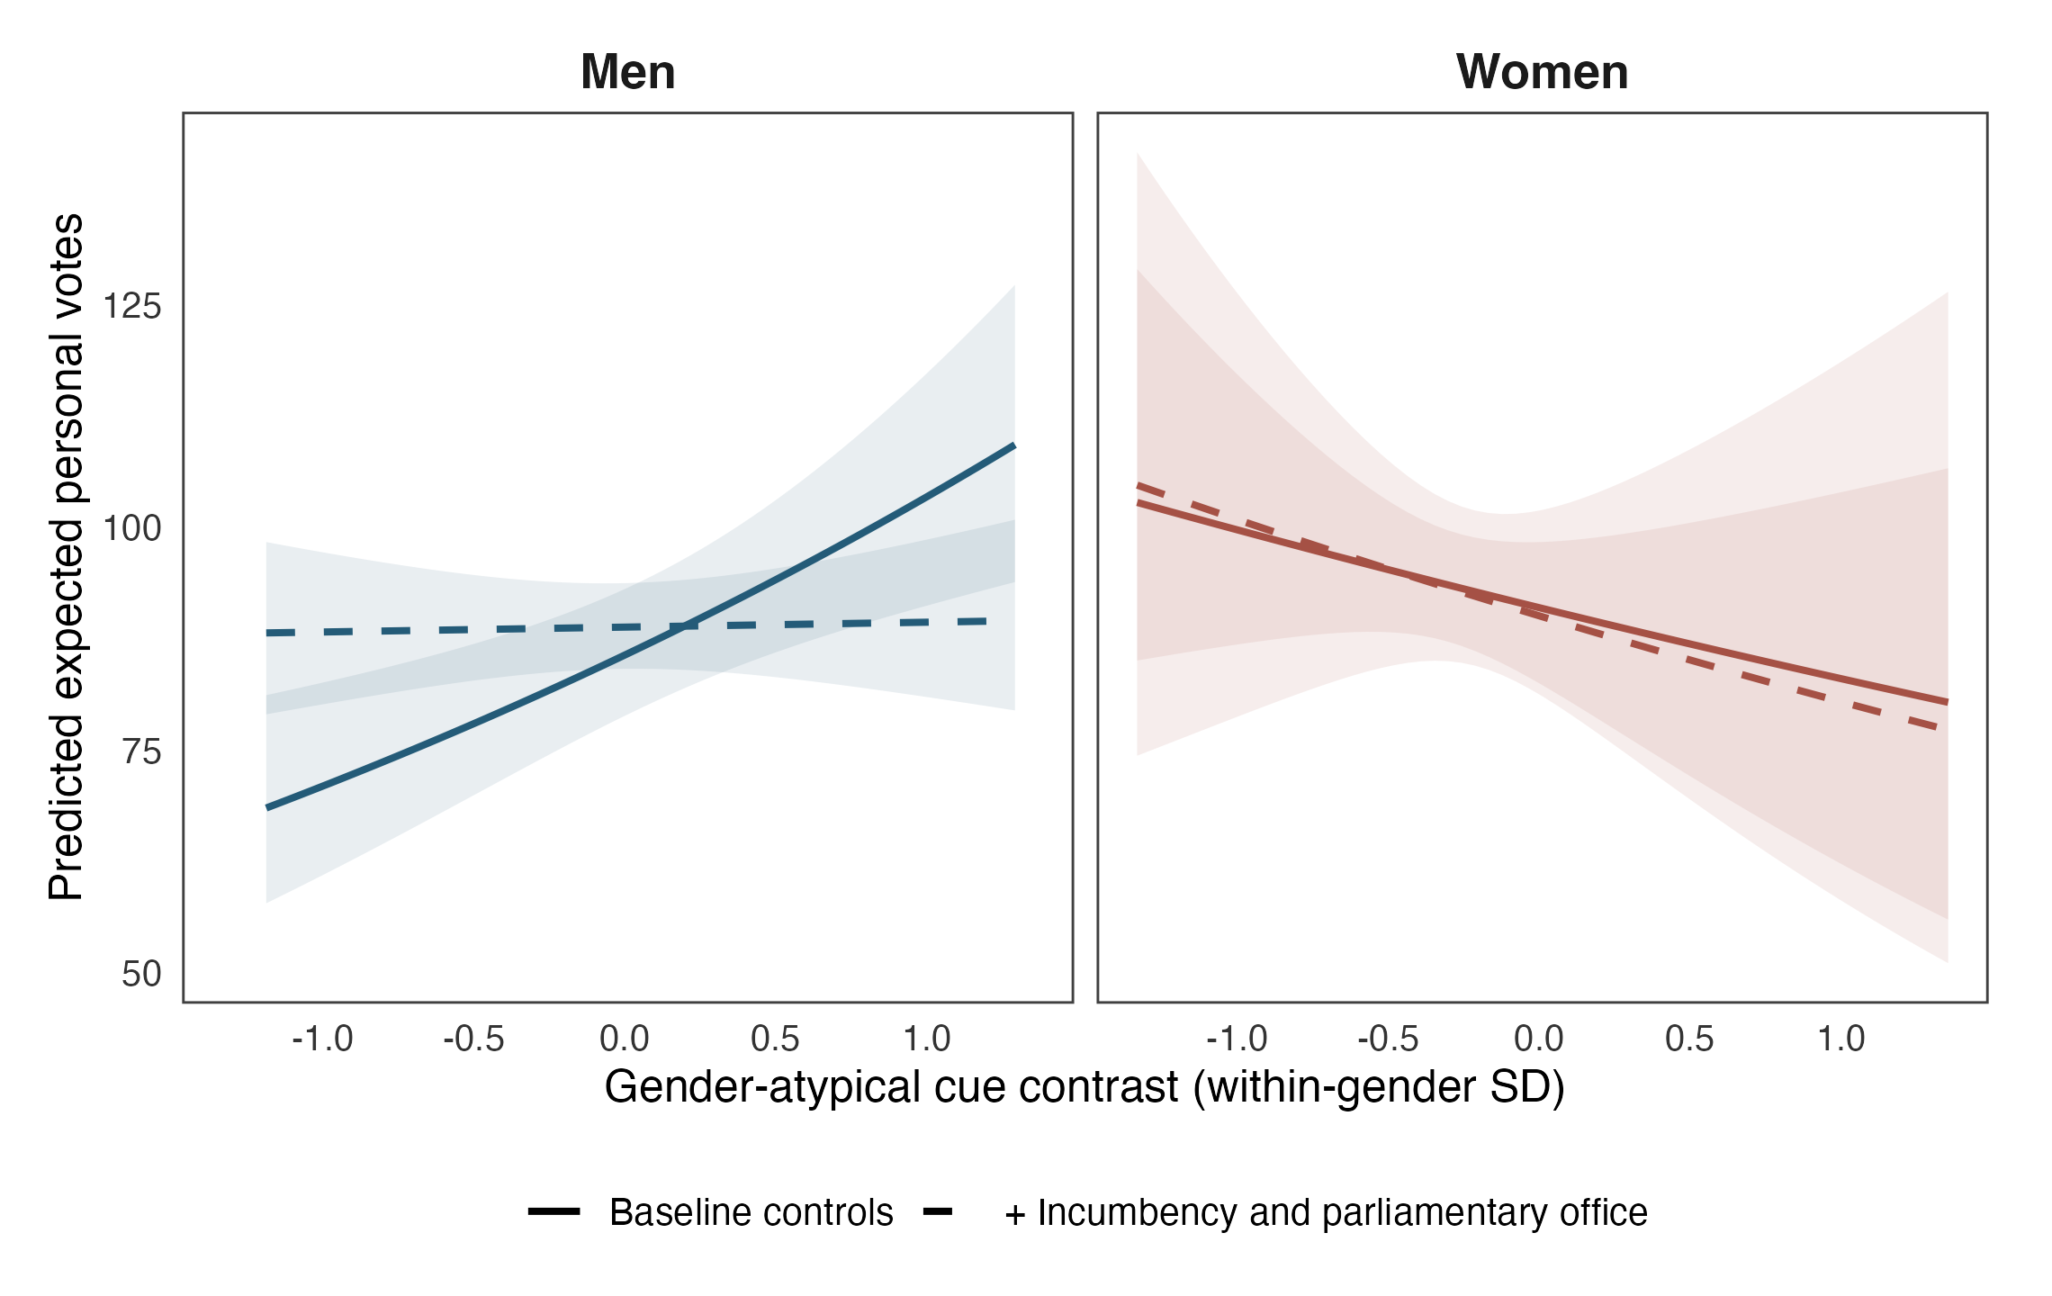
Figure OA 5. Predicted expected personal votes with and without incumbency and parliamentary-office controls. Predictions are standardized over the same gender-specific observed candidate contexts. Shading denotes municipality-clustered 95% confidence intervals.
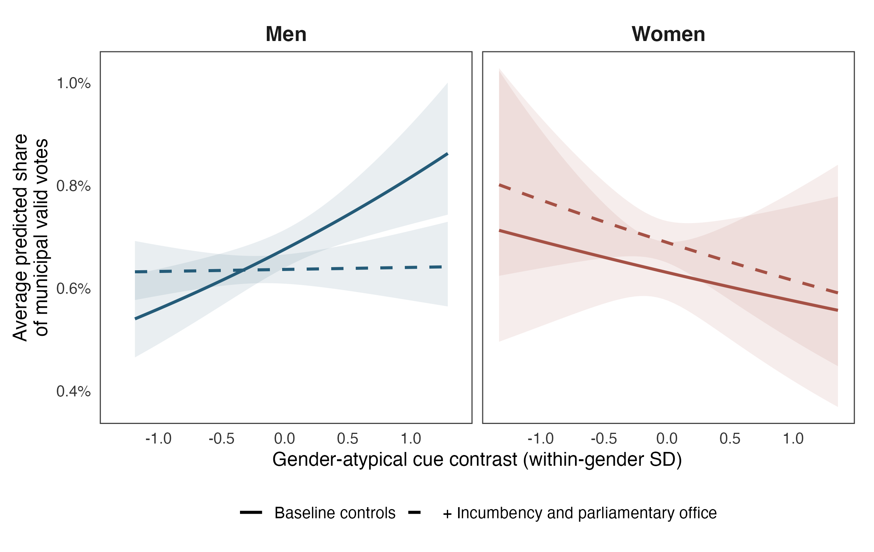
Figure OA 6. Average predicted municipal vote share with and without incumbency and parliamentary-office controls. Denominators include all valid personal votes in each municipality. Predictions and confidence intervals follow Figure OA 5.

Section OA 1 of the Online Appendix maps the study to the three conditions defining a natural experiment as a subtype of observational study.
In experiments on campaign language, Wang et al. (2023, p. 1195) found that presenting male candidates in communal terms emphasizing relationships and others’ needs reduced overall warmth and likability without a significant vote-choice effect. Together with the male presentation penalties in Naunov (2026), this result makes the form and context of departure central to the argument.
Ministry of Justice, 2017 municipal-election results are available in the candidate-level electoral data.
We also estimate balance between the raw ratings, controlling for their mean intensity. Section OA 2 of the Online Appendix provides this alternative measure’s definition and estimates.
We also adjust for joint cue level, separating the combined rating levels from their contrast in Online Appendix Figures OA 1 and OA 2. Quadratic terms allow the appearance association to change across index values and depend on how the cues combine. Table OA 1 reports the coefficients, Table OA 2 their joint tests, and Figure OA 3 the fitted surface.
At each index value $a$, we predict votes for each candidate while retaining observed age, attractiveness, party, and municipality. Averaging over the $n_{g}$ candidates in gender group $g$ gives μg(a)=1ngi:g(i)=g​μi(a). (3) The curves describe expected personal votes rather than seat-winning probabilities.
Online Appendix Equation OA 6 defines average municipal vote shares, and Figure OA 4 expresses the same fitted model on that scale.
Table OA 3 in the Online Appendix presents the corresponding Poisson regression table, reporting coefficients and municipality-clustered standard errors for the baseline model underlying Figure 2.
The direct test of the difference between the gender-specific associations gives $p=0.054$.
Our index can increase through higher femininity, lower masculinity, or both. Park and Joo (2023) evaluate whole campaign photographs and enter the cues separately. Their masculinity coefficient and our within-gender cue contrast therefore describe different comparisons.
Online Appendix Tables OA 4 and OA 5 report the contrasts and joint tests. With prior-office adjustment, the class differences in femininity become inconclusive among men ($p=0.564$), while evidence of class differences remains among women ($p=0.018$).
We restrict party-specific comparisons to parties with at least 5 candidates in each gender category. This excludes PIR (2 men, 1 woman) and SKP (1 man, 0 women), totaling 4 candidates. They remain in the primary analysis. Online Appendix Table OA 6 reports the party-specific contrasts and candidate and municipality counts. Candidate party identifies the political setting, while voters’ individual ideologies are unobserved.
Predictions average over observed candidate characteristics and municipalities within each party and gender. Rug strips show observed cue profiles. Confidence bands are omitted to emphasize substantive point-estimate patterns. Municipality-clustered intervals and joint heterogeneity tests appear in Section OA 9 of the Online Appendix. Panels use separate vertical scales, and their levels reflect group composition. Table OA 6 provides the proportional contrasts for comparing slopes.
Online Appendix Table OA 7 reports these comparisons. The National Coalition male contrast changes from 22.1% to -4.9% with prior-office controls. The Green male contrast changes from 27.9% to -27.7% after excluding the highest-vote 1% of candidates. Within Social Democratic male candidacies, the fitted one-SD contrast in expected personal votes changes from 213.5% to 28.9% after prior-office adjustment.
Online Appendix Table OA 8 compares municipality-by-party fixed effects, separate-gender specifications, and upper-tail vote exclusions. Figures OA 5 and OA 6 compare predictions with and without incumbency and parliamentary-office controls. Table OA 7 reports the corresponding party comparisons.

