Abstract Template for the fourth international workshop on human brain and artificial intelligence (Times New Roman 16)
First Author ¹, Second Author ^{2, *} (Times New Roman 12)
¹ Princeton University, Princeton NJ 08544, USA
² Springer Heidelberg, Tiergartenstr. 17, 69121 Heidelberg, Germany
abde@gmail.com (Times New Roman 11)

Abstract should include sections on the Objective, Method, Results, Conclusion. It should have at least one figure/table. The submitted abstract should be either a Microsoft Office Word file (*.doc, *.docx) or a .pdf file (which can be complied with latex). The total length of submission, including figures and references, should not exceed two pages.[Delete]
Objective: the background, motivations or goals of this study (Times New Roman 11).
Method: the methodology proposed in this work, including framework/algorithms/data/experiments, and analytical/statistical methods.
Results: the main experimental findings of the study.
Conclusion: the main conclusion or implication of the research.
Keywords: First Keyword, Second Keyword, Third Keyword.
Poster Presentation: (Yes/No) 'Yes' if you agree to present your poster on spot in Jeju island; 'No' if you are unable to present.
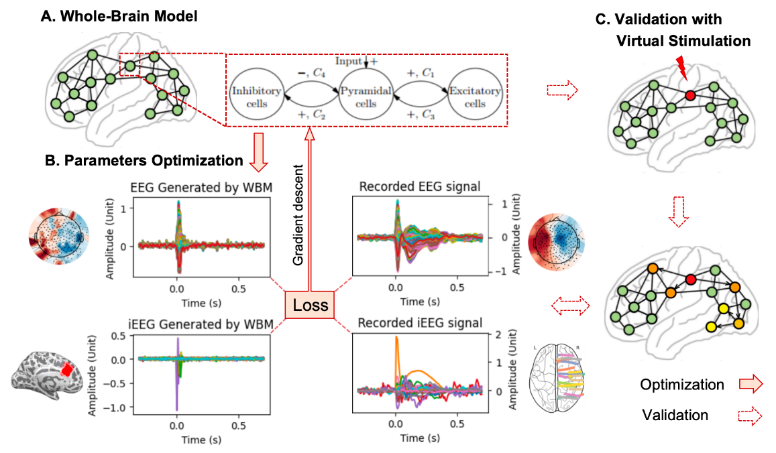
Fig. 1. Figure caption is placed below the illustration. A, xxx. B, xxx. C, xxx.

Table 1. Table captions should be placed above the tables.
Example | Example | Example
Example | Example | Example
Example | Example | Example
Example | Example | Example
Example | Example | Example
Example | Example | Example

References
- Author, F.: Article title. Journal 2(5), 99–110 (2016)
- Author, F., Author, S.: Title of a proceedings paper. In: Editor, F., Editor, S. (eds.) CONFERENCE 2016, LNCS, vol. 9999, pp. 1–13. Springer, Heidelberg (2016)
- Author, F., Author, S., Author, T.: Book title. 2nd edn. Publisher, Location (1999)
- Author, F.: Contribution title. In: 9th International Proceedings on Proceedings, pp. 1–2. Publisher, Location (2010)
- LNCS Homepage, http://www.springer.com/lncs, last accessed 2023/10/25

