Contact PR-AYC-G Run 1 - Master Comprehensive Suite Reanalysis v1.1
Amended anchor classification: conceptually predeclared / not runner-registered
Boundary: This is a private exploratory analysis report. K_HT-topo is treated as a human-scale network-state proxy. This report does not claim cellular OSM, microtubules, biophotons, consciousness proof, or a molecular hidden variable.

1. Executive verdict
- ALS fullscreen black-white-black start-pulse validation passed for Control, Target, and Contextual Override.
- The Contact anchor family was conceptually predeclared in planning, but not loaded into PRAYCG1.9 before acquisition; the run is therefore not machine-registered confirmatory.
- Target was the strongest meaning branch by both self-report and phase-level MeaningGamma/TSP.
- Two Target-local CandidateLocal K_HT-topo / MRED event locks appeared around 161-166 seconds after Target onset.
- The correct claim level is strong exploratory / future-freeze candidate, not strict pre-registered confirmation.
- OCM025 did not produce an Override-wide cue-update pass; RSM showed useful arithmetic/guess-risk structure in the Override branch.
- The topological-network interpretation is stronger than cellular OSM language for this human EEG run.

2. Run identity and anchor classification
Run metadata summary
field | value
participant_id | hoyt
session_id | S001
run_label | Contact
protocol_version | 1.900
control_video | C:/Users/hoytb/Desktop/PRAYCGStimulus/Contact/cuedals2/Contact_final_scene_MediaPrep_v1_6S_20260810_162501/stimulus_control_cued_phase_scrambled_Contact_final_scene_v1_6S.mp4
target_video | C:/Users/hoytb/Desktop/PRAYCGStimulus/Contact/cuedals2/Contact_final_scene_MediaPrep_v1_6S_20260810_162501/stimulus_target_cued_Contact_final_scene_v1_6S.mp4
override_video | C:/Users/hoytb/Desktop/PRAYCGStimulus/Contact/cuedals2/Contact_final_scene_MediaPrep_v1_6S_20260810_162501/stimulus_override_cued_Contact_final_scene_v1_6S.mp4
target_override_hash_match | True
cue_count | 99
expected_sum | 515
entered_override_sum | 502
override_sum_correct | False
baseline_seconds | 120.000
washout_seconds | 120.000
final_reflection_baseline_seconds | 120.000
channel_map_confirmed | True
channel_map_confidence | LOCKED
predeclared_anchor_file
anchor_schedule_not_loaded | True
analysis_note | Continuous physiology was aligned to event markers using the three ALS fullscreen start pulses and sample-index timebase.
Anchor classification is amended to: conceptually predeclared / not runner-registered. The Contact A1-A4 anchor family existed in planning, but the machine record did not contain a loaded anchor schedule. This distinction matters because strict confirmatory language requires the locked anchor file to be selected in the runner and emitted into StasisMarkers before acquisition.
Amended anchor classification
field | value
anchor_classification | CONCEPTUALLY_PREDECLARED / NOT_RUNNER_REGISTERED
strict_runner_registered_confirmatory | False
anchor_schedule_loaded_marker_present | False
anchor_schedule_not_loaded_marker_present | True
predeclared_anchor_file_in_run_config
recommended_claim_level | strong exploratory / future-freeze candidate, not strict confirmatory anchor pass
anchor_family_prior_planning | CONTACT_A1_PENSACOLA_REALIZATION; CONTACT_A2_AVATAR_FATHER_RECOGNITION; CONTACT_A3_EXISTENTIAL_PAYLOAD_ONSET; CONTACT_A4_SMALL_MOVES_TAPER_RELEASE
Anchor audit evidence
check | value
ANCHOR_SCHEDULE_LOADED marker present | False
ANCHOR_SCHEDULE_NOT_LOADED marker present | True
Number of event-log markers starting ANCHOR_ | 1
ANCHOR_ markers found | ANCHOR_SCHEDULE_NOT_LOADED
predeclared_anchor_file in run_config_media_selection.json | ''
True Contact anchor schedule file found in runfiles/qc | False
Anchor schedule file candidates
Analysis interpretation includes predeclared_anchor_file values | ['']

3. Acquisition and ALS timing
Stream coverage summary
name | type | channel_count | nominal_srate | n_samples | covers_baseline1 | covers_control | covers_target | covers_override
OpenBCIStatusMarkers | Markers | 1 | 0.000 | 421 | True | True | True | True
PolarHRV | ECG | 1 | 0.000 | 2699 | True | True | True | True
OpenBCIAnalogAux | AnalogAux | 3 | 125.000 | 270000 | True | True | True | True
StasisMarkers | Markers | 1 | 0.000 | 696 | True | True | True | True
VernierRespirationBelt | Respiration | 1 | 20.000 | 22167 | True | False | False | False
ALS_PT19_Timing | LightSensor | 1 | 125.000 | 270000 | True | True | True | True
obci_eeg1 | EEG | 16 | 125.000 | 270000 | True | True | True | True
ALS fullscreen movie-start pulse QC
branch | detected | onset_minus_marker_sec | pulse_duration_sec_est | max_value | mean_value | pass_basic
CONTROL_1 | True | -0.075 | 0.737 | 88.000 | 68.223 | True
TARGET_1 | True | 0.145 | 0.745 | 87.500 | 67.801 | True
CONTEXTUAL_OVERRIDE_1 | True | -0.070 | 0.737 | 87.000 | 68.348 | True
Interpretation: all three movie starts passed the ALS start-pulse criterion. The continuous streams were aligned using the validated ALS pulse timebase and sample-index alignment. This improves timing confidence relative to earlier runs with missed or non-marker-locked ALS pulses.
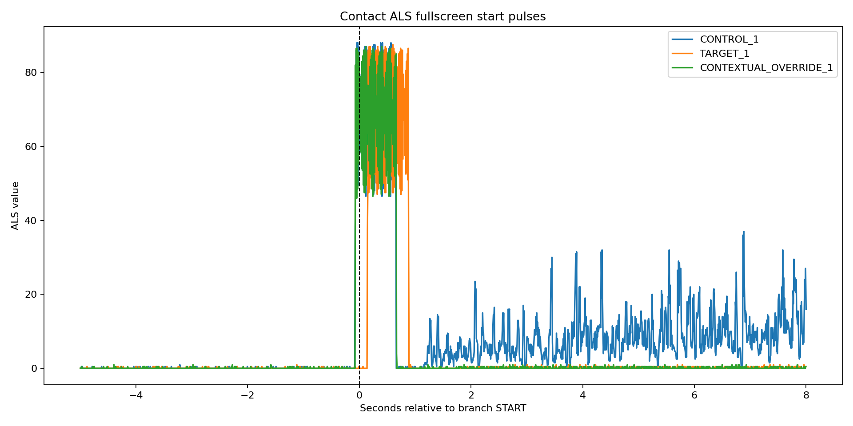

4. Subjective and confound reports
Final master subjective report
branch | Meaning | Empathy | Absorption | EmotionalAfterglow | StoryActiveWashout | AnalyticEffort | NumberCueDistraction | TaskCompliance | frozen_note
CONTROL | 1 | 1 | 1 | 1 | 1 | 1 | 0 | 7 | none
OVERRIDE | 4 | 4 | 3 | 3 | 4 | 8 | 8 | 8 | none, billions of years resonated again slightly but way less so than target.
TARGET | 7 | 7 | 7 | 6 | 6 | 2 | 1 | 7 | the initial scene where she realizes its her father and it actually is his consciousness but its not. that was meaningful to me. also, when the dad says near the end of the clip, this is the way it has been for billions of years, i found this mean...
Branch confound registry
branch | rating_AudioVideoSyncProblem | rating_AudioComprehensionDifficulty | rating_ExternalNoiseIntrusion | rating_ExternalNoiseDistraction | rating_CueLegibilityProblem | rating_CueBlurProblem | rating_EyeStrainOrSquintNeed | note_audio_video_sync | note_external_noise | note_running_sum
Control | 0 | 0 | 0 | 2 | 0 | 0 | 0 | animal chirps 2/3rd thru washout | see before
Target | 1 | 2 | 2 | 2 | 1 | 1 | 1 | audio/video is slightly desynced by about a 1/4 second, it wasnt particularly distracting more than 1-2 times. | birds cawing on occasion, little distraction
Override | 2 | 2 | 1 | 1 | 1 | 1 | 1 | same audio desync as target, it was not distracting this time | birds cawing, not distracting | yes, i had to guess 2-3 times in order to stay on task. i stalled 4-5 times but only guessed 2-3
Interpretation: Target was subjectively meaning-rich and had low analytic effort. Override was task-loaded and subjectively less absorbed. Mild audio-video sync and external bird-noise confounds were reported but not at disqualifying intensity. These should remain covariates and caution flags.

5. Phase-level feature summary
Phase-level Topo-OSM / PR-AYC-G features
condition | meaninggamma_score | tsp_z | taskgamma_score | theta_integration_z | alpha_posterior_z | nas_score | artifact_score | gamma_visual_30_45_z
BASELINE_1 | 0.762 | 0.098 | 2.022 | 7.177 | 2.068 | -1.827 | 2.875 | 4.426
BASELINE_2_REFLECTION | 1.456 | 1.255 | 0.370 | 0.347 | 0.900 | -0.005 | 1.023 | 1.343
CONTEXTUAL_OVERRIDE_1 | -0.247 | -0.364 | 0.205 | 0.298 | 0.455 | -0.448 | 0.200 | 0.779
CONTROL_1 | -0.392 | -0.413 | 0.074 | 0.808 | 0.960 | -0.653 | 0.674 | 0.140
TARGET_1 | 1.010 | 1.039 | -0.215 | 0.804 | 1.230 | 0.094 | 0.562 | -0.198
WASHOUT_1 | -0.592 | -0.530 | -0.106 | 0.747 | 0.403 | -0.387 | 0.238 | -0.412
WASHOUT_2 | 0.391 | 0.506 | -0.439 | 0.142 | 1.158 | 0.024 | 0.088 | -0.767
WASHOUT_3 | -0.167 | -0.182 | 0.164 | 0.552 | 0.713 | -0.414 | 0.346 | 0.102
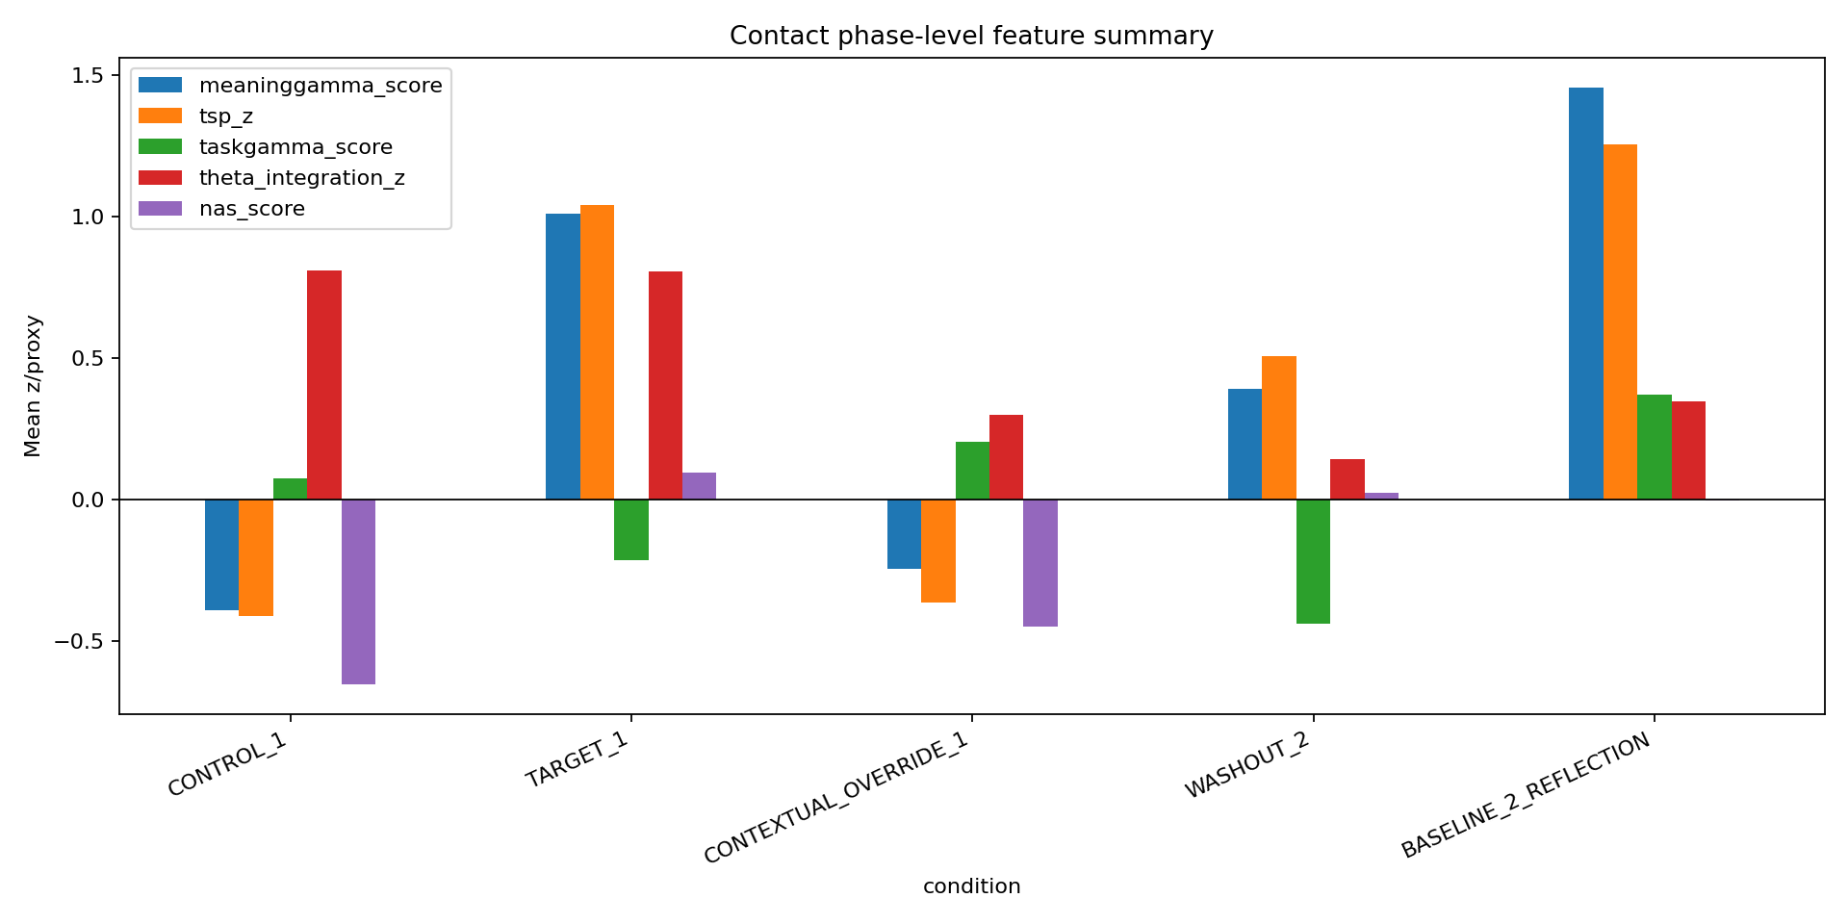
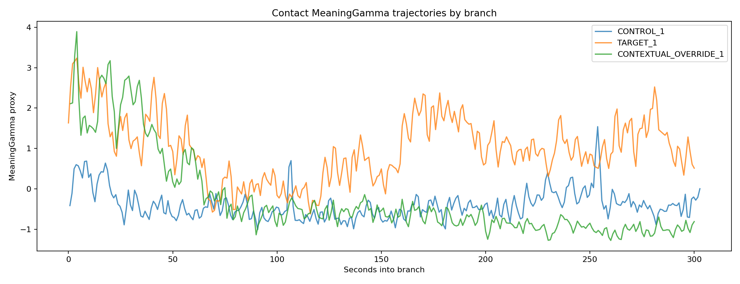
Key direction: Target MeaningGamma=1.010 and TSP=1.039, versus Control MeaningGamma=-0.392, TSP=-0.413, and Override MeaningGamma=-0.247, TSP=-0.364. Target also had lower taskgamma than Override. This supports a Target-specific meaning-recognition profile, but not a mechanism-level OSM claim.

6. CandidateLocal K_HT-topo and MRED
Exploratory event locks
condition | anchor_source | anchor_metric | condition_offset_sec | peak_score | K_HT_topo_local | K_percentile_by_condition | theta_delta_0_10 | theta_delta_10_30 | MR_score | ENC_score | mred_quadrant | event_lock_candidate
TARGET_1 | physiology_exploratory | meaninggamma_score | 161.007 | 1.864 | 4.375 | 100.000 | -0.649 | 2.171 | 2.357 | 1.038 | MR_HIGH_ENC_HIGH | True
TARGET_1 | physiology_exploratory | tsp_z | 166.007 | 2.330 | 3.511 | 96.000 | -1.933 | 1.872 | 2.115 | 0.375 | MR_HIGH_ENC_LOW | True
Interpretation: the two event locks are both in Target around 161-166 s. The first is a MeaningGamma event with K_HT-topo percentile 100 and positive delayed theta. The second is a TSP event with K_HT-topo percentile 96 and positive delayed theta. Because anchor registration was not present in the run files, these are anchor-consistent exploratory / future-freeze candidates, not strict machine-registered confirmations.
Top Target CandidateLocal/MRED rows by K_HT-topo
condition | anchor_source | anchor_metric | condition_offset_sec | peak_score | K_HT_topo_local | K_percentile_by_condition | theta_delta_0_10 | theta_delta_10_30 | MR_score | ENC_score | mred_quadrant | event_lock_candidate
TARGET_1 | physiology_exploratory | meaninggamma_score | 161.007 | 1.864 | 4.375 | 100.000 | -0.649 | 2.171 | 2.357 | 1.038 | MR_HIGH_ENC_HIGH | True
TARGET_1 | physiology_exploratory | tsp_z | 166.007 | 2.330 | 3.511 | 96.000 | -1.933 | 1.872 | 2.115 | 0.375 | MR_HIGH_ENC_LOW | True
TARGET_1 | physiology_exploratory | meaninggamma_score | 170.007 | 2.351 | 3.106 | 92.000 | -1.672 | 2.624 | 1.913 | 0.902 | MR_HIGH_ENC_HIGH | False
TARGET_1 | physiology_exploratory | tsp_z | 28.007 | 1.838 | 2.523 | 86.000 | 0.002 | 0.345 | 1.382 | 0.250 | MR_HIGH_ENC_LOW | False
TARGET_1 | physiology_exploratory | meaninggamma_score | 28.007 | 1.869 | 2.523 | 86.000 | 0.002 | 0.345 | 1.396 | 0.250 | MR_HIGH_ENC_LOW | False
TARGET_1 | physiology_exploratory | meaninggamma_score | 281.007 | 2.524 | 2.153 | 78.000 | 0.832 | 0.370 | 1.495 | 0.584 | MR_HIGH_ENC_LOW | False
TARGET_1 | physiology_exploratory | tsp_z | 281.007 | 2.744 | 2.153 | 78.000 | 0.832 | 0.370 | 1.592 | 0.584 | MR_HIGH_ENC_LOW | False
TARGET_1 | physiology_exploratory | tsp_z | 263.007 | 2.222 | 1.604 | 70.000 | 1.287 | 1.541 | 1.075 | 1.424 | MR_HIGH_ENC_HIGH | False
TARGET_1 | physiology_exploratory | meaninggamma_score | 263.007 | 1.978 | 1.604 | 70.000 | 1.287 | 1.541 | 0.967 | 1.424 | MR_HIGH_ENC_HIGH | False
TARGET_1 | physiology_exploratory | tsp_z | 14.007 | 3.045 | 1.579 | 62.000 | -1.308 | -0.877 | 1.428 | -0.947 | MR_HIGH_ENC_LOW | False
TARGET_1 | physiology_exploratory | meaninggamma_score | 14.007 | 3.003 | 1.579 | 62.000 | -1.308 | -0.877 | 1.409 | -0.947 | MR_HIGH_ENC_LOW | False
TARGET_1 | physiology_exploratory | meaninggamma_score | 57.007 | 1.827 | 0.496 | 54.000 | 0.372 | 0.702 | 0.323 | 0.596 | MR_LOW_ENC_LOW | False

7. NAST - Narrative Absorption State Transition
NAST phase transitions
transition | pre_phase | post_phase | pre_alpha_posterior_z | post_alpha_posterior_z | delta_alpha_posterior_z | pre_alpha_drop_proxy_z | post_alpha_drop_proxy_z | delta_alpha_drop_proxy_z | pre_meaninggamma_score | post_meaninggamma_score | delta_meaninggamma_score | pre_tsp_z | post_tsp_z | delta_tsp_z | pre_taskgamma_score | post_taskgamma_score | delta_taskgamma_score | pre_theta_integration_z | post_theta_integration_z | delta_theta_integration_z | pre_nas_score | post_nas_score | delta_nas_score | pre_artifact_score | post_artifact_score | delta_artifact_score
BASELINE_1 -> CONTROL_1 | BASELINE_1 | CONTROL_1 | 0.736 | -0.507 | -1.242 | -0.736 | 0.507 | 1.242 | -0.676 | 0.076 | 0.753 | -0.829 | -0.019 | 0.810 | 0.732 | 0.329 | -0.403 | 2.030 | -0.481 | -2.511 | -1.146 | -0.243 | 0.903 | 1.507 | 1.401 | -0.106
WASHOUT_1 -> TARGET_1 | WASHOUT_1 | TARGET_1 | -0.431 | -0.004 | 0.427 | 0.431 | 0.004 | -0.427 | -1.044 | 2.154 | 3.198 | -0.933 | 1.849 | 2.781 | -0.422 | 2.031 | 2.453 | -0.419 | 0.304 | 0.722 | -0.242 | 0.123 | 0.365 | 0.179 | 1.342 | 1.163
WASHOUT_2 -> CONTEXTUAL_OVERRIDE_1 | WASHOUT_2 | CONTEXTUAL_OVERRIDE_1 | 1.032 | -0.098 | -1.130 | -1.032 | 0.098 | 1.130 | -0.330 | 2.214 | 2.544 | -0.206 | 1.842 | 2.048 | -0.201 | 1.506 | 1.706 | -0.156 | 0.895 | 1.051 | -0.336 | 0.246 | 0.582 | 0.076 | 1.241 | 1.166
Top NAST onset candidates
condition | time_lsl | condition_offset_sec | nas_score | alpha_drop_proxy_z | meaninggamma_score | tsp_z | taskgamma_score | artifact_score
CONTEXTUAL_OVERRIDE_1 | 2453.214 | 28.992 | 1.546 | 0.417 | 2.793 | 2.701 | -0.894 | 0.355
CONTEXTUAL_OVERRIDE_1 | 2464.214 | 39.992 | 1.214 | 0.822 | 1.596 | 1.671 | -0.944 | 0.439
CONTEXTUAL_OVERRIDE_1 | 2443.214 | 18.992 | 0.938 | 0.482 | 3.078 | 2.774 | 1.620 | 0.710
CONTEXTUAL_OVERRIDE_1 | 2429.214 | 4.992 | 0.919 | 0.473 | 2.231 | 2.003 | -0.653 | 1.297
TARGET_1 | 1935.214 | 46.007 | 1.713 | 1.191 | 2.361 | 2.351 | -1.296 | 0.380
TARGET_1 | 2152.214 | 263.007 | 1.636 | 0.980 | 1.978 | 2.222 | -0.731 | 0.083
TARGET_1 | 2078.214 | 189.007 | 1.631 | 1.026 | 2.083 | 2.299 | -1.038 | 0.617
TARGET_1 | 1903.214 | 14.007 | 1.598 | 0.665 | 3.003 | 3.045 | 0.335 | 0.372
TARGET_1 | 2168.214 | 279.007 | 1.577 | 1.106 | 1.970 | 2.188 | -0.636 | 0.337
TARGET_1 | 2067.214 | 178.007 | 1.436 | 0.444 | 2.376 | 2.517 | -0.896 | 0.968
TARGET_1 | 2125.214 | 236.007 | 1.400 | 1.029 | 1.817 | 1.888 | -0.590 | 0.000
TARGET_1 | 2186.214 | 297.007 | 1.303 | 0.499 | 1.286 | 1.469 | -1.711 | 0.000
TARGET_1 | 1945.214 | 56.007 | 1.250 | 0.283 | 1.564 | 1.664 | -1.701 | 0.242
TARGET_1 | 1916.214 | 27.007 | 1.232 | 0.766 | 1.757 | 1.770 | -0.823 | 0.262
TARGET_1 | 2086.214 | 197.007 | 1.142 | 0.562 | 1.384 | 1.658 | -0.321 | 0.170
Interpretation: Target shows a strong increase in MeaningGamma and TSP relative to Washout 1, but NAST is not simply an alpha-drop story. Override also shows early semantic/task activity, suggesting analytic stance plus residual semantic access rather than a clean task-only state.

8. Topo-OSM network-state layer
Topo-OSM phase state vectors
condition | n_windows | theta_integration_z | alpha_posterior_z | meaninggamma_score | tsp_z | taskgamma_score | gamma_visual_30_45_z | artifact_score
BASELINE_1 | 120 | 7.177 | 2.068 | 0.762 | 0.098 | 2.022 | 4.426 | 2.875
CONTROL_1 | 303 | 0.808 | 0.960 | -0.392 | -0.413 | 0.074 | 0.140 | 0.674
WASHOUT_1 | 120 | 0.747 | 0.403 | -0.592 | -0.530 | -0.106 | -0.412 | 0.238
TARGET_1 | 301 | 0.804 | 1.230 | 1.010 | 1.039 | -0.215 | -0.198 | 0.562
WASHOUT_2 | 120 | 0.142 | 1.158 | 0.391 | 0.506 | -0.439 | -0.767 | 0.088
CONTEXTUAL_OVERRIDE_1 | 300 | 0.298 | 0.455 | -0.247 | -0.364 | 0.205 | 0.779 | 0.200
WASHOUT_3 | 120 | 0.552 | 0.713 | -0.167 | -0.182 | 0.164 | 0.102 | 0.346
BASELINE_2_REFLECTION | 119 | 0.347 | 0.900 | 1.456 | 1.255 | 0.370 | 1.343 | 1.023
Topo-OSM transition distances
transition | topo_state_distance
BASELINE_1 -> CONTROL_1 | 8.390
WASHOUT_1 -> TARGET_1 | 2.424
WASHOUT_2 -> CONTEXTUAL_OVERRIDE_1 | 2.121
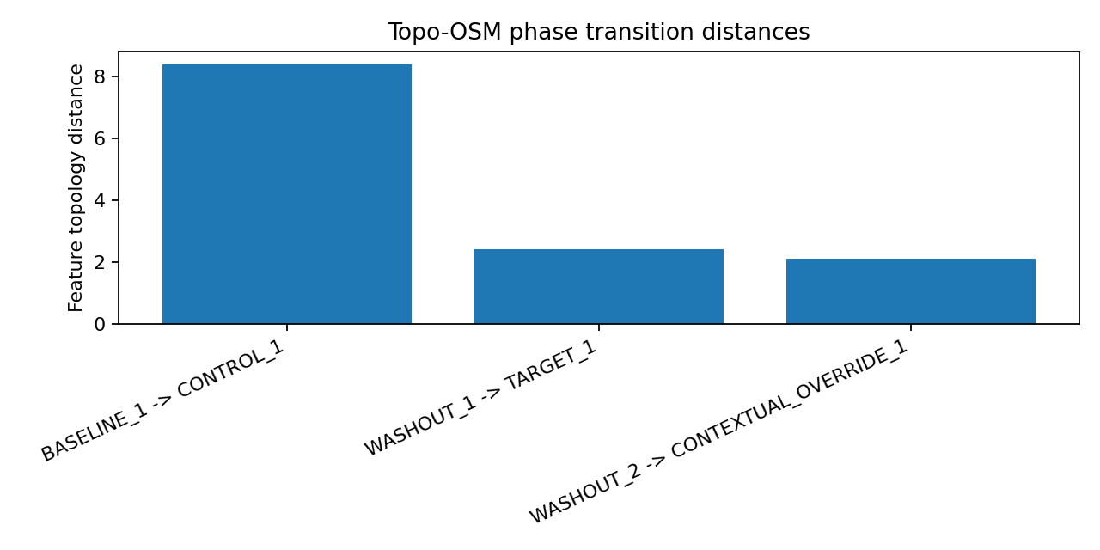
Interpretation: Topo-OSM here means network-state topology, not cellular or molecular OSM. The state-vector distances show the largest transition from Baseline to Control, with smaller but interpretable transitions into Target and Override. Target remains distinct because of MeaningGamma/TSP elevation and lower taskgamma relative to Override.

9. OCM025 / RSM / CVB / SquintProxy
OCM025 phase summary
condition | DR_gamma_z | WMU_theta_z | MAINT_theta_z | OCM_score | OCM_event_vs_target_control_null | compute_stall_score | cue_visibility_burden | squint_proxy | latent_guess_risk
CONTEXTUAL_OVERRIDE_1 | 0.019 | -0.213 | -0.083 | -0.212 | 1 | -0.239 | -0.149 | 0.440 | 0.449
CONTROL_1 | 0.381 | -0.194 | -0.043 | -0.030 | 0 | -0.203 | -0.223 | 0.203 | 0.442
TARGET_1 | -0.177 | 0.436 | -0.045 | -0.046 | 0 | -0.028 | -0.063 | 0.412 | 0.460
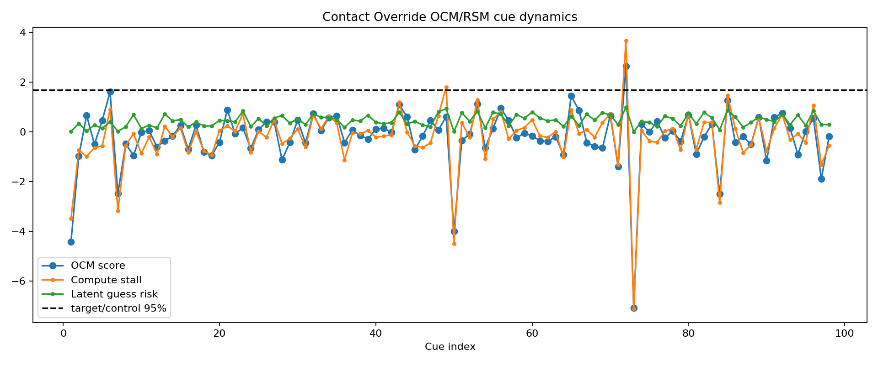
Top Override cue microstate candidates
condition | cue_index | value | cue_start_sec | cue_start_lsl | content_start_sec | pre_taskgamma | rec_taskgamma | pre_tasktheta | upd_tasktheta | maint_tasktheta | rec_visualgamma | upd_visualgamma | maint_visualgamma | fp1_hf | artifact_hf | DR_gamma | WMU_theta | MAINT_theta | visual_search_upd | visual_search_maint | contrast_pre_badge_0_1 | DR_gamma_z | WMU_theta_z | MAINT_theta_z | visual_search_upd_z | visual_search_maint_z | fp1_hf_z | artifact_hf_z | artifact_score | OCM_score | OCM_event_vs_target_control_null | prior_sum | new_sum | prior_units | carry_required | high_carry_load | hard9_pattern | large_sum_load | large_sum_load_z | carry_required_z | high_carry_load_z | hard9_pattern_z | arithmetic_compute_load | compute_stall_score | cue_visibility_burden | squint_proxy | latent_guess_risk
CONTEXTUAL_OVERRIDE_1 | 72 | 3 | 217.235 | 2641.457 | 216.000 | 0.780 | 0.667 | 3.110 | 5.927 | 13.806 | 1.410 | 1.261 | 1.444 | 1.161 | 0.849 | -0.113 | 2.817 | 10.696 | -0.149 | 0.034 | 1.000 | -0.610 | 2.635 | 10.122 | -0.592 | 0.150 | 1.949 | -0.748 | 0.975 | 2.640 | True | 384 | 387 | 4 | 0 | 0 | 0 | 5.953 | 0.527 | -2.001 | -0.674 | 0.000 | -0.484 | 3.667 | 3.352 | 1.267 | 0.985
CONTEXTUAL_OVERRIDE_1 | 6 | 3 | 19.235 | 2443.457 | 18.000 | 0.847 | 1.210 | 2.428 | 3.093 | 6.684 | 1.809 | 1.592 | 2.024 | 0.923 | 1.144 | 0.363 | 0.665 | 4.256 | -0.217 | 0.214 | 1.000 | 1.817 | 0.545 | 4.001 | -0.890 | 0.820 | 0.116 | 1.271 | 0.693 | 1.606 | False | 32 | 35 | 2 | 0 | 0 | 0 | 3.497 | -3.084 | -2.001 | -0.674 | 0.000 | -1.748 | 0.903 | 0.720 | 0.520 | 0.402
CONTEXTUAL_OVERRIDE_1 | 65 | 3 | 196.235 | 2620.457 | 195.000 | 0.592 | 0.922 | 1.940 | 3.723 | 2.798 | 1.777 | 1.525 | 1.288 | 0.934 | 0.834 | 0.330 | 1.783 | 0.858 | -0.252 | -0.489 | 1.000 | 1.649 | 1.630 | 0.771 | -1.042 | -1.785 | 0.201 | -0.847 | 0.100 | 1.446 | False | 349 | 352 | 9 | 1 | 3 | 0 | 5.858 | 0.387 | 0.000 | 1.349 | 0.000 | 0.473 | 0.876 | -0.288 | 0.130 | 0.621
CONTEXTUAL_OVERRIDE_1 | 85 | 5 | 256.235 | 2680.457 | 255.000 | 0.655 | 0.523 | 2.429 | 6.602 | 2.542 | 1.205 | 1.514 | 1.248 | 0.977 | 0.791 | -0.132 | 4.172 | 0.113 | 0.309 | 0.043 | 1.000 | -0.710 | 3.952 | 0.063 | 1.425 | 0.185 | 0.533 | -1.141 | 0.266 | 1.256 | False | 447 | 452 | 7 | 1 | 3 | 0 | 6.105 | 0.750 | 0.000 | 1.349 | 0.000 | 0.600 | 1.469 | 0.396 | 0.346 | 0.869
CONTEXTUAL_OVERRIDE_1 | 53 | 10 | 160.235 | 2584.457 | 159.000 | 0.884 | 0.791 | 2.104 | 5.359 | 3.121 | 1.285 | 1.413 | 1.450 | 0.941 | 1.063 | -0.093 | 3.256 | 1.017 | 0.128 | 0.165 | 1.000 | -0.510 | 3.061 | 0.923 | 0.629 | 0.637 | 0.249 | 0.720 | 0.484 | 1.108 | False | 281 | 291 | 1 | 1 | 2 | 0 | 5.642 | 0.069 | 0.000 | 0.674 | 0.000 | 0.193 | 1.290 | 0.454 | 0.414 | 0.816
CONTEXTUAL_OVERRIDE_1 | 43 | 4 | 130.235 | 2554.457 | 129.000 | 0.762 | 0.692 | 2.498 | 5.643 | 2.894 | 1.521 | 1.446 | 1.428 | 0.884 | 0.939 | -0.070 | 3.145 | 0.396 | -0.075 | -0.093 | 1.000 | -0.391 | 2.954 | 0.333 | -0.263 | -0.320 | -0.192 | -0.131 | 0.000 | 1.092 | False | 228 | 232 | 8 | 1 | 3 | 0 | 5.434 | -0.237 | 0.000 | 1.349 | 0.000 | 0.254 | 1.185 | 0.142 | -0.125 | 0.785
CONTEXTUAL_OVERRIDE_1 | 56 | 9 | 169.235 | 2593.457 | 168.000 | 0.722 | 0.834 | 2.874 | 4.894 | 2.850 | 1.525 | 1.195 | 1.172 | 0.841 | 0.859 | 0.112 | 2.020 | -0.024 | -0.331 | -0.354 | 1.000 | 0.534 | 1.861 | -0.066 | -1.389 | -1.285 | -0.522 | -0.676 | 0.000 | 0.945 | False | 306 | 315 | 6 | 1 | 6 | 0 | 5.727 | 0.194 | 0.000 | 3.372 | 0.000 | 0.911 | 0.814 | -0.408 | -0.340 | 0.714
CONTEXTUAL_OVERRIDE_1 | 21 | 7 | 64.235 | 2488.457 | 63.000 | 0.593 | 0.893 | 2.037 | 3.092 | 2.255 | 1.232 | 1.615 | 1.204 | 0.821 | 1.132 | 0.299 | 1.055 | 0.217 | 0.383 | -0.028 | 1.000 | 1.492 | 0.923 | 0.163 | 1.751 | -0.077 | -0.677 | 1.187 | 0.593 | 0.880 | False | 115 | 122 | 5 | 1 | 3 | 0 | 4.754 | -1.236 | 0.000 | 1.349 | 0.000 | -0.095 | 0.234 | -0.010 | -0.025 | 0.443
Significant RSM correlations in Override
x | y | spearman_rho | p_value | n
arithmetic_compute_load | latent_guess_risk | 0.556 | 0.000 | 99
high_carry_load | latent_guess_risk | 0.411 | 0.000 | 99
carry_required | latent_guess_risk | 0.382 | 0.000 | 99
large_sum_load | squint_proxy | -0.297 | 0.003 | 99
arithmetic_compute_load | compute_stall_score | 0.279 | 0.005 | 99
arithmetic_compute_load | squint_proxy | -0.258 | 0.010 | 99
large_sum_load | latent_guess_risk | 0.247 | 0.014 | 99
hard9_pattern | latent_guess_risk | 0.232 | 0.022 | 99
Interpretation: OCM025 did not show a clean Override-wide working-memory-update pass. However, RSM showed that latent guess-risk tracked arithmetic compute load, carry-required status, high-carry load, hard9 pattern, and large-sum load. This matches the self-report of several stalls and 2-3 guesses to stay on task. SquintProxy is retained only as an artifact/visual-strain covariate, not a direct eye-tracking measure.

10. Full module registry and claim-level map
Master Comprehensive Suite v1.4.7/1.4.8-style module registry for Contact Run 1
module | status | interpretation
Run metadata and media identity | PASS | Loaded runfiles, media hashes, cue schedule, branch timing, and channel-map status.
Stream inventory / timebase | PASS_WITH_ALS_ALIGNMENT | Continuous EEG/ALS aligned by sample-index timebase and validated ALS pulses.
ALS-PT19 fullscreen start-pulse QC | PASS | All three movie starts detected within +/-0.25 s of markers.
Anchor audit | CONCEPTUALLY_PREDECLARED_NOT_RUNNER_REGISTERED | Prior Contact anchors existed in planning, but event log/config show anchor file was not loaded.
Subjective report | TARGET_STRONG | Final ratings favored Target: Meaning/Empathy/Absorption all 7; Control 1; Override task-loaded.
Confound registry | MILD_CONFOUND_COVARIATES | Mild A/V sync, audio comprehension, and external noise ratings; not disqualifying.
GammaScalpel / MeaningGamma / TaskGamma | TARGET_MEANING_DIRECTIONAL | Target MeaningGamma and TSP exceeded Control and Override; Override had higher taskgamma than Target.
TemporalSemanticProxy | TARGET_DIRECTIONAL | Target TSP positive and greater than Control/Override.
CandidateLocal_KHT-topo | TARGET_LOCAL_LOCKS_EXPLORATORY | Two Target-local event locks around 161-166 s, not runner-registered confirmatory.
MRED_v0.1 | TARGET_MR_ENC_CLUSTER | Target 161-166 s cluster shows MR_HIGH_ENC_HIGH / MR_HIGH_ENC_LOW pattern.
NAST_v0.1 | MIXED_USEFUL | Target showed large MeaningGamma/TSP increase from W1; not simple alpha-drop-only.
OCM025_v0.2 | NO_CLEAN_OVERRIDE_WIDE_PASS | Only one Override OCM event above Target/Control null.
RSM/CVB/SquintProxy | RSM_INFORMATIVE | Latent guess-risk tracked arithmetic load/carry/hard9; SquintProxy is only a covariate.
TopoOSM_NetworkState | DIRECTIONAL_EXPLORATORY | Target forms a distinct network-state vector; transition distances reported.
LSO/SPM Subtitle Override | NOT_APPLICABLE | No subtitle override condition or subtitle file was present.
LSO/SPM Subtitle Override modules were not applicable because this Contact run did not include a subtitle override condition or subtitle timing/gaze file. Anchor registration modules produced the amended classification: conceptually predeclared, not runner-registered.

11. Updated conclusion
- Contact Run 1 is the strongest ALS-validated, Target-favoring exploratory PR-AYC-G run currently summarized here.
- The physiological event cluster around 161-166 s is consistent with prior Contact anchor expectations, especially the father/avatar recognition family, but it is not runner-registered confirmatory.
- The strict future standard is PRAYCG1.9C with a MediaPrep-generated LOCKED anchor JSON loaded before acquisition.
- The next Contact run should explicitly load the Contact A1-A4 anchor file, emit ANCHOR_DEF and scheduled anchor markers, and then re-test the 161-166 s family prospectively.
- The human-scale interpretation is Topo-OSM / network-state topology. No cellular OSM or hidden molecular Y claim is supported by this run.

