Contact Run 1 - NIP / BIT / CII / IAQ / CET-EET Deep Analysis
Narrative Immersion Proxy, Bivariate Immersion Threshold, Continuous Immersion Index, Immersion Attenuation Quotient, Cinematic Entrainment, Residualization, and Endogenous Echo Tracking
Interpretive boundary: This is a macroscopic PR-AYC-G proxy analysis. It does not measure dopamine, oxytocin, microtubules, biophotons, OSM biology, consciousness, or hidden cellular Y. It estimates whether the Contact target branch showed a stronger attention-plus-integration immersion proxy than control or contextual override, and whether that pattern survives the limited available exogenous tracking regressors.

1. Executive summary
- Mean NIP density was Target 0.551, Control 0.028, and Override 0.016.
- Strict BIT produced 1 pass, located at the Target ~161 s MeaningGamma father/avatar recognition event.
- CII/IAQ showed Target greater than both Control and Override for 5 of 5 conceptual Contact anchors.
- CET cue tracking was weak at the 1 Hz feature-table resolution; available cue-train correlations were small. The optional visualizer-derived Target visual proxy produced moderate visual tracking correlations but is not a substitute for raw stimulus audio/visual fingerprint extraction.
- CET-R residualization explained little of the NIP variance. The Target anchor CII pattern remained positive after available cue/visual proxies were modeled.
- EET is best read as state-vector echo analysis. It does not prove replay or memory; it estimates whether the Target anchor state geometry resembles subsequent washout or Baseline 2 periods.

2. Method formalization
NIP_v0.1 defines semantic attention A_sem from MeaningGamma, TSP, NAST/alpha-drop, and penalties for visual drive and artifact. It defines integration/resonance R_int from delayed theta/topological carryover and local state availability. NIP density is the product of positive A_sem and positive R_int with artifact and visual penalties.
BIT_v0.1 is a gate, not an average. It requires attention, resonance, K/topological coupling, artifact pass, MRED MR_HIGH_ENC_HIGH, and PRAYCG event-lock status for strict pass.
CII_v0.1 is the mean NIP density inside a predefined/annotation anchor window. It is duration-normalized. IAQ_v0.1 compares Target and Override CII values: positive IAQ means Override attenuated the NIP proxy relative to Target.
CET_EET_v0.1 separates exogenous tracking from candidate meaning/integration effects. In this run, raw source media/audio were not available inside the analysis container, so CET used the cue schedule and the top stimulus region from the uploaded visualizer MP4 as a Target-only visual proxy. This is useful, but not final media-level CET.

3. NIP branch summary
condition | mean_NIP_density
TARGET_1 | 0.551
CONTROL_1 | 0.028
CONTEXTUAL_OVERRIDE_1 | 0.016
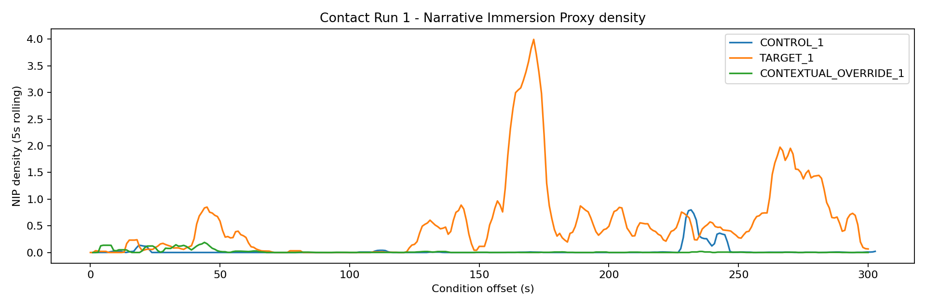

4. CII / IAQ anchor results
anchor_id | scene_label | CII_Target | CII_Control | CII_Override | Target_minus_Override_CII | IAQ_Target_vs_Override | Target_greater_Control | Target_greater_Override
CONTACT_A1_PENSACOLA_REALIZATION | Pensacola realization | 0.379 | 0.000 | 0.068 | 0.311 | 0.820 | True | True
CONTACT_A2B_AVATAR_FATHER_RECOGNITION_TSP_CLUSTER | Father/avatar recognition TSP follow-through | 1.191 | 0.001 | 0.003 | 1.188 | 0.997 | True | True
CONTACT_A2_AVATAR_FATHER_RECOGNITION | Father/avatar recognition | 1.652 | 0.002 | 0.002 | 1.650 | 0.999 | True | True
CONTACT_A3_EXISTENTIAL_PAYLOAD_ONSET | Existential payload onset | 0.633 | 0.015 | 0.037 | 0.596 | 0.941 | True | True
CONTACT_A4_SMALL_MOVES_TAPER_RELEASE_OR_LATE_PAYLOAD_RELEASE | Late payload / terminal release | 0.611 | 0.018 | 0.001 | 0.611 | 0.999 | True | True
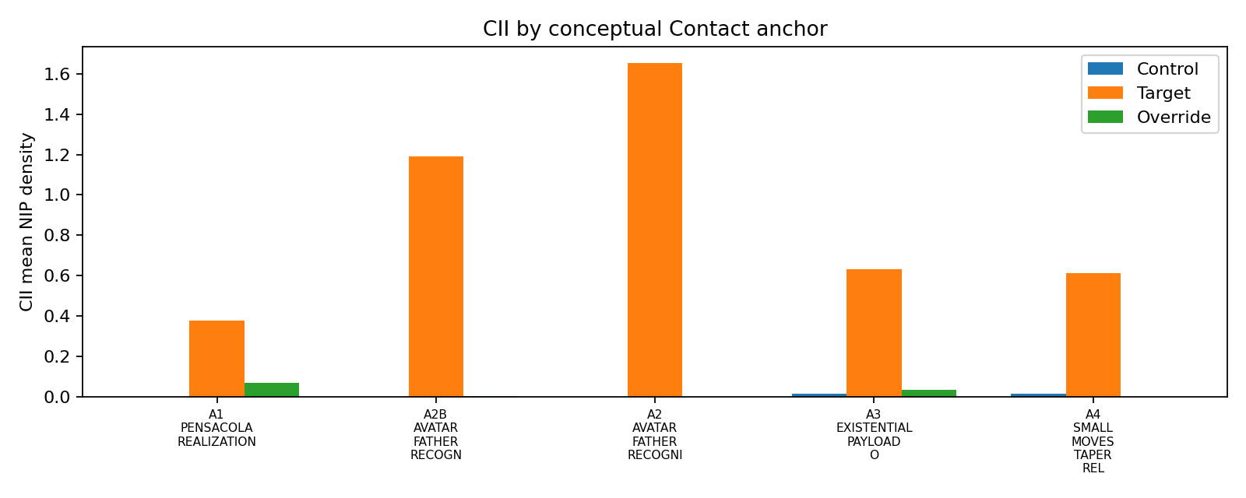

5. BIT event results
condition | condition_offset_sec | anchor_metric | K_HT_topo_local | theta_delta_10_30 | MR_score | ENC_score | mred_quadrant | BIT_pass_praycg_strict
TARGET_1 | 161.007 | meaninggamma_score | 4.375 | 2.171 | 2.357 | 1.038 | MR_HIGH_ENC_HIGH | True

6. CET tracking and CET-R residualization
Cue-train correlations were small in all three branches, which is expected at 1 Hz processed feature resolution for 0.85-second cues. This does not prove absence of cue tracking; it means cue-locked analysis needs OCM025/raw-XDF windows for cue microstates. CET-R here is most useful as a guardrail: the available exogenous regressors did not explain much NIP variance.
condition | stimulus_regressor | signal | max_abs_corr | lag_sec_signal_after_regressor | signal_dominant_freq_hz
CONTROL_1 | cue_on_3s | meaninggamma_score | -0.070 | 2 | 0.047
CONTROL_1 | cue_on_3s | tsp_z | -0.079 | 2 | 0.047
CONTROL_1 | cue_on_3s | taskgamma_score | -0.045 | 10 | 0.078
CONTROL_1 | cue_on_3s | theta_integration_z | -0.056 | -8 | 0.055
CONTROL_1 | cue_on_3s | gamma_visual_30_45_z | -0.055 | 10 | 0.094
CONTROL_1 | cue_on_3s | gamma_front_35_40_z | -0.051 | 10 | 0.078
CONTROL_1 | cue_on_3s | nas_score | 0.053 | -8 | 0.094
CONTROL_1 | cue_on_3s | NIP_density | 0.040 | 0 | 0.023
TARGET_1 | cue_on_3s | meaninggamma_score | -0.031 | 8 | 0.023
TARGET_1 | cue_on_3s | tsp_z | -0.022 | 3 | 0.023
TARGET_1 | cue_on_3s | taskgamma_score | -0.062 | -1 | 0.039
TARGET_1 | cue_on_3s | theta_integration_z | 0.032 | 10 | 0.109
TARGET_1 | cue_on_3s | gamma_visual_30_45_z | -0.061 | -1 | 0.062
TARGET_1 | cue_on_3s | gamma_front_35_40_z | -0.063 | -1 | 0.039
TARGET_1 | cue_on_3s | nas_score | 0.050 | -1 | 0.109
TARGET_1 | cue_on_3s | NIP_density | -0.015 | -10 | 0.023
CONTEXTUAL_OVERRIDE_1 | cue_on_3s | meaninggamma_score | -0.030 | 0 | 0.031
CONTEXTUAL_OVERRIDE_1 | cue_on_3s | tsp_z | -0.031 | 3 | 0.031
CONTEXTUAL_OVERRIDE_1 | cue_on_3s | taskgamma_score | -0.077 | 0 | 0.039
CONTEXTUAL_OVERRIDE_1 | cue_on_3s | theta_integration_z | -0.039 | 9 | 0.047
CONTEXTUAL_OVERRIDE_1 | cue_on_3s | gamma_visual_30_45_z | -0.070 | 1 | 0.039
CONTEXTUAL_OVERRIDE_1 | cue_on_3s | gamma_front_35_40_z | -0.076 | 0 | 0.023
CONTEXTUAL_OVERRIDE_1 | cue_on_3s | nas_score | 0.034 | 0 | 0.047
CONTEXTUAL_OVERRIDE_1 | cue_on_3s | NIP_density | -0.049 | -8 | 0.023
CET-R model summary:
condition | dependent | regressors | n_rows | r2_exogenous_tracking
CONTROL_1 | NIP_density | cue_on+cue_phase_sin+cue_phase_cos | 303 | 0.002
TARGET_1 | NIP_density | cue_on+cue_phase_sin+cue_phase_cos+video_luminance_z+video_change_z | 301 | 0.058
CONTEXTUAL_OVERRIDE_1 | NIP_density | cue_on+cue_phase_sin+cue_phase_cos | 300 | 0.003
Target visualizer-derived visual proxy tracking:
stimulus_regressor | signal | max_abs_corr | lag_sec_signal_after_regressor
video_luminance_z | meaninggamma_score | 0.242 | 7
video_luminance_z | tsp_z | 0.191 | 7
video_luminance_z | theta_integration_z | -0.122 | 4
video_luminance_z | gamma_visual_30_45_z | 0.294 | 1
video_luminance_z | NIP_density | -0.268 | -2
video_change_z | meaninggamma_score | 0.214 | 10
video_change_z | tsp_z | 0.194 | 10
video_change_z | theta_integration_z | 0.207 | 6
video_change_z | gamma_visual_30_45_z | 0.350 | 0
video_change_z | NIP_density | 0.170 | -9

7. EET after-state / echo analysis
EET estimates state-vector similarity between Target anchor windows and later washout / Baseline 2 windows. It is not proof of memory replay. The highest similarity rows suggest which Target anchor geometries most resembled later reflective state vectors.
anchor_id | scene_label | reference_window | cosine_similarity | euclidean_distance
CONTACT_A1_PENSACOLA_REALIZATION | Pensacola realization | WASHOUT_2_first60 | 0.957 | 1.245
CONTACT_A1_PENSACOLA_REALIZATION | Pensacola realization | WASHOUT_2_first45 | 0.930 | 1.228
CONTACT_A1_PENSACOLA_REALIZATION | Pensacola realization | WASHOUT_2_first30 | 0.923 | 1.137
CONTACT_A4_SMALL_MOVES_TAPER_RELEASE_OR_LATE_PAYLOAD_RELEASE | Late payload / terminal release | BASELINE_2_all | 0.830 | 2.135
CONTACT_A4_SMALL_MOVES_TAPER_RELEASE_OR_LATE_PAYLOAD_RELEASE | Late payload / terminal release | WASHOUT_2_first60 | 0.830 | 2.613
CONTACT_A4_SMALL_MOVES_TAPER_RELEASE_OR_LATE_PAYLOAD_RELEASE | Late payload / terminal release | WASHOUT_2_first30 | 0.825 | 2.405
CONTACT_A2B_AVATAR_FATHER_RECOGNITION_TSP_CLUSTER | Father/avatar recognition TSP follow-through | BASELINE_2_all | 0.818 | 2.644
CONTACT_A4_SMALL_MOVES_TAPER_RELEASE_OR_LATE_PAYLOAD_RELEASE | Late payload / terminal release | WASHOUT_2_first45 | 0.791 | 2.617
CONTACT_A2B_AVATAR_FATHER_RECOGNITION_TSP_CLUSTER | Father/avatar recognition TSP follow-through | WASHOUT_2_first30 | 0.786 | 3.162
CONTACT_A1_PENSACOLA_REALIZATION | Pensacola realization | BASELINE_2_all | 0.755 | 2.176
CONTACT_A2B_AVATAR_FATHER_RECOGNITION_TSP_CLUSTER | Father/avatar recognition TSP follow-through | WASHOUT_2_first60 | 0.751 | 3.462
CONTACT_A2B_AVATAR_FATHER_RECOGNITION_TSP_CLUSTER | Father/avatar recognition TSP follow-through | WASHOUT_2_first45 | 0.737 | 3.408

8. Interpretation
The Contact run remains a strong exploratory / future-freeze result. The NIP/CII/IAQ family agrees with the earlier MRED/TTI story: Target carried substantially more attention-plus-integration proxy density than Control or Override across the conceptual Contact anchors. The strict BIT gate is intentionally conservative and only passed the Target father/avatar recognition MeaningGamma event around 161 seconds.
CET did not overturn this pattern. Available exogenous regressors had limited explanatory power for NIP density. Because the raw source stimulus files were not available in the container, this CET pass is a proxy-level analysis, not final media-level entrainment correction. A future full pass should use MediaPrep/StimulusFingerprint time series for audio envelope, luminance, optical flow, cut train, and cue train in all branches.
The most cautious final statement is: Contact Run 1 shows a strong Target-specific macroscopic narrative immersion proxy, with one strict BIT event at the father/avatar region and positive CII/IAQ across the conceptual anchor family, while CET/EET remain exploratory and proxy-limited.

9. Recommended next steps
- Rerun Contact with PRAYCG2.0 and a LOCKED anchor JSON loaded in the runner.
- Generate full MediaPrep/StimulusFingerprint time-series regressors: audio envelope, luminance, optical flow, cut train, and cue train.
- Run CET-R with the full media regressors before interpreting CII/IAQ as meaning-specific.
- Use OCM025/raw-XDF cue analysis for cue entrainment rather than relying on 1 Hz feature tables.
- Render a new Public/TSC visualizer video with the v1.5.1 NIP/CET/EET overlays.

