# Amazon Prime Video Dashboard Using Power BI

## Preview

Amazon Prime Video Dashboard Preview

Dashboard Screenshot:

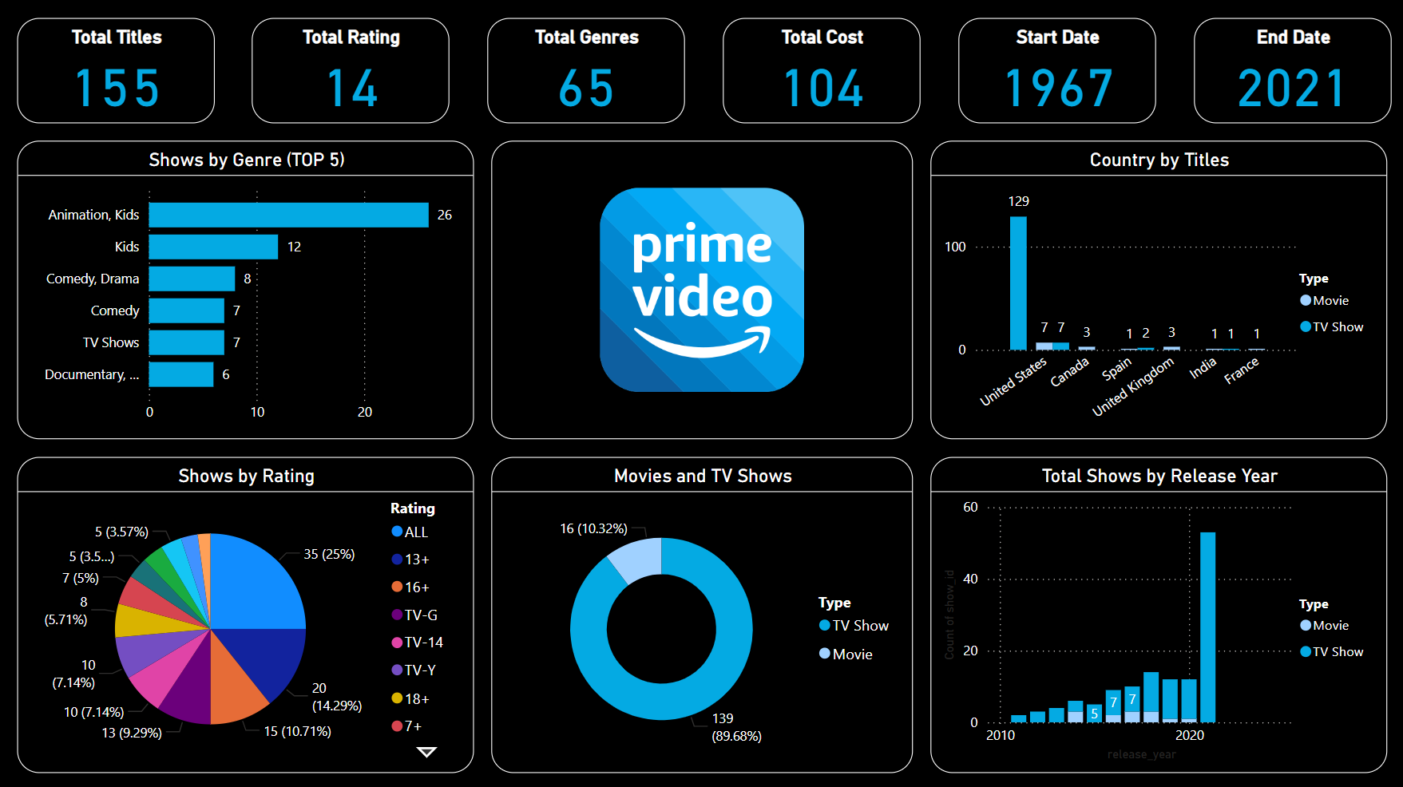

## Overview

This project provides an analysis of Amazon Prime Video's industry growth from 1920 to 2021, focusing on both TV shows and movies. The dashboard, created with Power BI, offers insights into total titles, aggregate ratings, genres, directors, and the timeline covered.

## Dataset

The dataset, sourced from Kaggle, includes information on Amazon Prime Video's movies and TV shows. Key statistics:  
- Total Titles: 9,655  
- Aggregate Ratings: 25  
- Array of Genres: 519  
- Directors on Board: 5,771  
- Spanning a Century: 1920-2021

## Tools Used

- Power BI

## Usage

To explore the dashboard:  
1. Download Power BI desktop application.  
2. Clone this repository.  
3. Open Amazon_Prime_Video_Dashboard.pbix with Power BI.  
4. Interact with the dashboard.

## Contact

For inquiries and collaborations, feel free to reach out to Harsh Banugariya.