# Heart Failure Insights Report

## Dashboard Overview

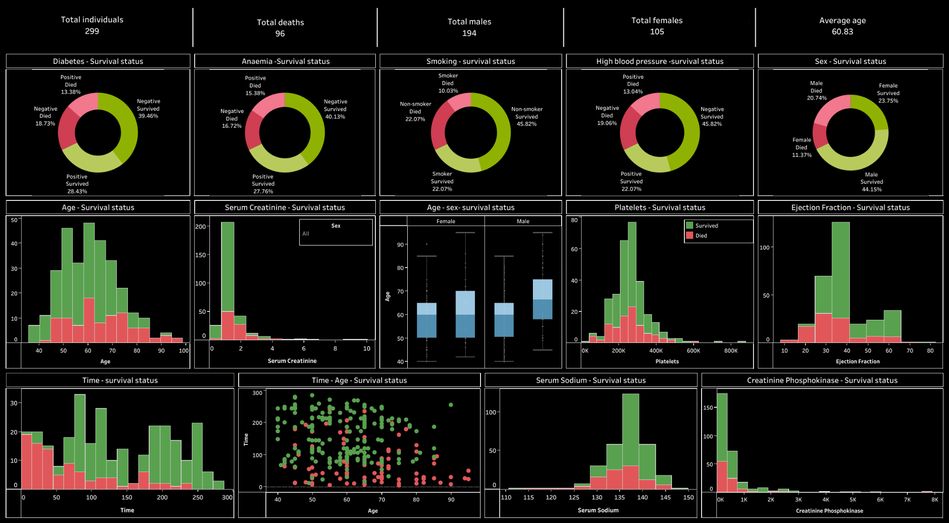

This dashboard summarizes the survival and clinical patterns observed among heart failure patients.

## Summary

The analysis of 299 heart failure patients reveals critical insights into factors affecting patient survival. With a 32% mortality rate, age, serum creatinine, and ejection fraction emerged as significant indicators of patient outcomes. Older age, reduced kidney function, and low heart efficiency correlate with higher mortality rates. The findings emphasize the importance of targeted interventions to improve survival rates among heart failure patients.

## Key Insights

* - Approximately 32% of the dataset did not survive the follow-up period, highlighting the severity of heart failure.
* - The average age of non-survivors was higher (65.2 years) compared to survivors (58.8 years), indicating age as a risk factor.
* - Higher serum creatinine levels were observed in non-survivors (1.84 mg/dL), showing kidney function's role in outcomes.
* - Survivors had a better ejection fraction (40.3%) compared to non-survivors (33.5%), emphasizing cardiac efficiency.
* - Comorbidities like diabetes, anaemia, and high blood pressure contributed differently to survival outcomes.

#### **Key Findings:**

1. **Survival Status:**
   1. 32% of individuals in the dataset (96 out of 299) did not survive the follow-up period, indicating a high mortality rate for heart failure patients.
   2. This highlights the importance of closely monitoring clinical indicators for early intervention.
2. **Age and Survival:**
   1. The average age of survivors is 58.8 years, while non-survivors average 65.2 years.
   2. Older age appears to correlate with higher mortality, emphasizing the need for targeted care for elderly patients.
3. **Clinical Indicators and Survival:**
   1. **Serum Creatinine Levels:**
      1. Non-survivors had a higher average serum creatinine level (1.84 mg/dL) compared to survivors (1.18 mg/dL), suggesting kidney function may be a critical factor.
   2. **Ejection Fraction:**
      1. Survivors had a higher average ejection fraction (40.3%) compared to non-survivors (33.5%), underscoring the importance of heart pumping efficiency in survival outcomes.
4. **Comorbidities:**
   1. Patients with diabetes, anaemia, or high blood pressure show varied survival rates, indicating these factors should be monitored for personalized care strategies.
5. **Time to Event:**
   1. The average follow-up time for all patients was 130 days, with non-survivors having shorter follow-up durations. This reflects the progression of heart failure and the urgency of interventions.

#### **Organizational Benefits:**

These insights can help healthcare organizations:

* **Identify High-Risk Patients:** Use clinical indicators to prioritize monitoring and treatment for patients with high serum creatinine, low ejection fraction, and advanced age.
* **Improve Patient Outcomes:** Develop targeted care plans and preventive measures to reduce mortality among heart failure patients.
* **Resource Allocation:** Allocate resources efficiently by focusing on patient demographics and risk factors that contribute most to mortality.