Name: Himal Basnet, Sailesh Thapa, Ujit Adhikari

ID: 1001659428, 1001659442,1001656385

README

\*\*\*\*\*\*\*\*\*\*

File included: FinalProject

\*\*\*\*\*\*\*\*\*\*

The purpose of this program is let people donate an item. Item has been grouped into Furniture, Electronics, and Others. In the View section of the program, people would be able to see the things that have been donated so far.

How to use program:

1) Need to login with username+@mavs.uta.edu

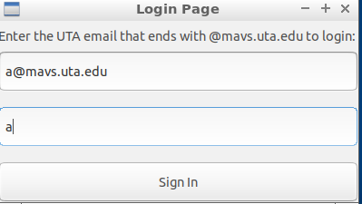

2) Index page pop-up

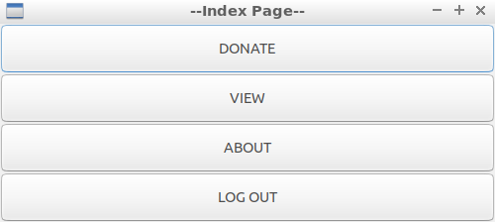

3) To donate things, donate button should be pressed.

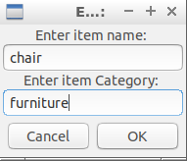

4) To view donated things view button on index page should be pressed.

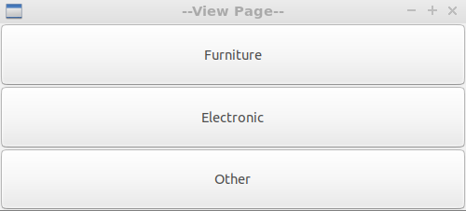

5) View Items are grouped into categories. So Furniture will so only furniture items.

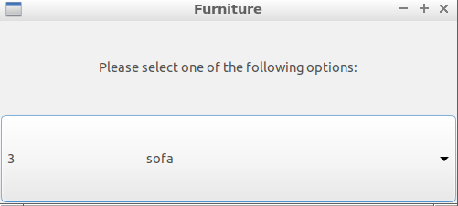

6) Log out button will terminate the program.

Compilation instructions:

