RESEARCH ARTICLE
Mature GPCR complexes carry distributed information about the captured G protein class
Hossein Batebi
Department of Physics, Freie Universität Berlin, 14195 Berlin, Germany
Correspondence: Hossein Batebi, Department of Physics, Freie Universität Berlin, 14195 Berlin, Germany. Email: hossein.batebi@fu-berlin.de | ORCID: 0000-0002-0714-9700

ABSTRACT

Background and Purpose

Structures of GPCR-G protein complexes are widely used to infer coupling selectivity, but receptor coordinates in mature complexes may contain information associated with the captured transducer. This study asked how captured-class information is represented in receptor coordinates, how it transfers across receptor families, and how receptor-only coordinate models relate to experimental specimen provenance.

Experimental Approach

The study analysed 1,360 experimental class A GPCR structures using receptor-grouped and sequence-cluster validation, an activation benchmark, functional-repertoire annotation and same-receptor tests. Candidate receptor-only references were defined from deposited polymer entities and audited separately at the specimen level.

Key Results

Across the archive-wide dataset, receptor sequence and geometry predicted the captured G protein class, but transfer declined with evolutionary separation. A same-receptor test showed that held-out receptor geometry retained captured-class information among receptors resolved with multiple transducer families, whereas sequence cannot distinguish different captured endpoints of the same receptor. In contrast, a compact receptor geometry recovered the annotated active/inactive structural state under both receptor-grouped and identity-cluster validation. Functional annotation and provenance auditing further separated captured structural class from functional repertoire and coordinate-level receptor-only status from experimentally partner-free specimens.

Conclusion and Implications

Receptor coordinates in mature class A GPCR complexes carry distributed, evolutionarily local information associated with the captured G protein class. Receptor-only coordinate status and experimentally partner-free specimen status are distinct, and captured structural class should not be interpreted as intrinsic or exclusive coupling preference.

Keywords
G protein coupled receptor; G protein coupling; structural pharmacology; biased signalling; molecular recognition; structural bioinformatics; machine learning

Abbreviations

AUC, area under the receiver operating characteristic curve; cryo-EM, cryogenic electron microscopy; GPCR, G protein coupled receptor; ICL2, intracellular loop 2; PDB, Protein Data Bank; ROC, receiver operating characteristic; TM, transmembrane helix.

What is already known
• GPCR structures are widely used to interpret G protein coupling and signalling selectivity.
• Bound partners can select and stabilise receptor conformations within dynamic signalling ensembles.

What this study adds

• Captured G protein class information is distributed and evolutionarily local; within the same receptor, endpoint geometry retains class information that receptor sequence cannot provide.

• Receptor-only coordinate models can originate from transducer-containing specimens, complicating partner-free comparisons.

• A bound GPCR structure reports a realised signalling endpoint, not its complete coupling repertoire.

Clinical significance

• A receptor resolved with a single G protein documents a realised signalling endpoint and should not by itself be used to assign that receptor’s preferred pathway in a target rationale; 5-HT4 with Gi/o, CCK2 with Gi/o, GPER with Gq/11 and H4 with Gq/11 are structures whose captured family is not supported in the reference coupling map, which is a reason for caution rather than evidence of an established atypical coupling.
• Pathway-selective claims for GPCR ligands are strongest when a structural assignment is paired with orthogonal functional coupling data, because 76 of the 156 directly mapped receptors (48.7%), accounting for 101 of 190 mapped units (53.2%), support more than one G protein family.

1 INTRODUCTION
G protein coupled receptors are major drug targets, and their pharmacology depends not only on ligand binding but also on the intracellular pathways that are engaged (Sriram & Insel, 2018; Hauser et al., 2017; Alexander et al., 2025). Experimental GPCR structures have transformed ligand discovery and mechanistic pharmacology by revealing receptor conformations, binding pockets and transducer interfaces linked to agonism, antagonism and pathway selective signalling (Shoichet & Kobilka, 2012; Congreve et al., 2020). Receptor G protein complexes are consequently used to interpret coupling selectivity and biased signalling.
A mature complex, however, is not a neutral picture of the receptor before coupling. Proteins occupy conformational ensembles, and binding can select, accommodate and stabilise subsets of those ensembles (Frauenfelder et al., 1991; Henzler-Wildman & Kern, 2007; Kobilka & Deupi, 2007; Deupi & Kobilka, 2010). In class A GPCRs, activation reorganises conserved microswitches and opens the intracellular cavity for engagement of the G protein C terminal α5 helix (Weis & Kobilka, 2018; Rasmussen et al., 2011; Zhou et al., 2019). Active receptors remain dynamic, and transducer engagement can alter receptor conformational populations (Nygaard et al., 2013; Manglik et al., 2015; Hilger et al., 2018; Ma et al., 2020).
Coupling selectivity is distinct from activation. Experimental profiling and structural analyses have identified receptor interface residues, Gα determinants, helix geometry and sequence patterns associated with Gs, Gi/o and Gq/11 coupling (Flock et al., 2017; Inoue et al., 2019; Okashah et al., 2019; Hauser et al., 2022; Masuho et al., 2023; Matic et al., 2023; Huang et al., 2022; Sandhu et al., 2022). Ligand bias also shows that agonists and transducers can stabilise overlapping but non identical receptor ensembles (Kenakin & Christopoulos, 2013; Smith et al., 2018). Mechanistic and time resolved studies separate receptor activation, G protein engagement, nucleotide release and complex dissociation into distinct stages (DeVree et al., 2016; Liu et al., 2019; Papasergi-Scott et al., 2024; Batebi et al., 2024). A resolved endpoint can therefore contain information present before recognition and information associated with the partner that was ultimately stabilised.
This distinction matters for structural pharmacology because resemblance to a Gs or Gi/o bound receptor is often interpreted as evidence about signalling preference. It also matters for computational models built from deposited structures, where evolutionary similarity and partner conditioned endpoints can yield predictive signals without establishing intrinsic recognition rules (Wallach & Heifets, 2018).

This study asked how information about the G protein class captured in mature complexes is represented in receptor coordinates, how far that information transfers across evolutionary distance, and how receptor-only coordinate models compare with G protein-bound endpoints. Here, a structural class label denotes the transducer class present in the deposited complex; it is not treated as the receptor's complete functional coupling repertoire. Three questions were addressed. First, how well do receptor sequence and geometry predict the captured class, and how does this transfer to evolutionarily distant receptors? Second, how does this compare with recovery of the annotated activation state, used here as a shared structural-state benchmark across receptor families? Third, in the same receptor, how does captured-class information in receptor-only coordinate models compare with bound endpoints, and what experimental specimen provenance underlies those receptor-only references? Figure 1 summarises the structural endpoint, archive-wide class dataset and receptor-side information used by the models, together with three complementary validation analyses.
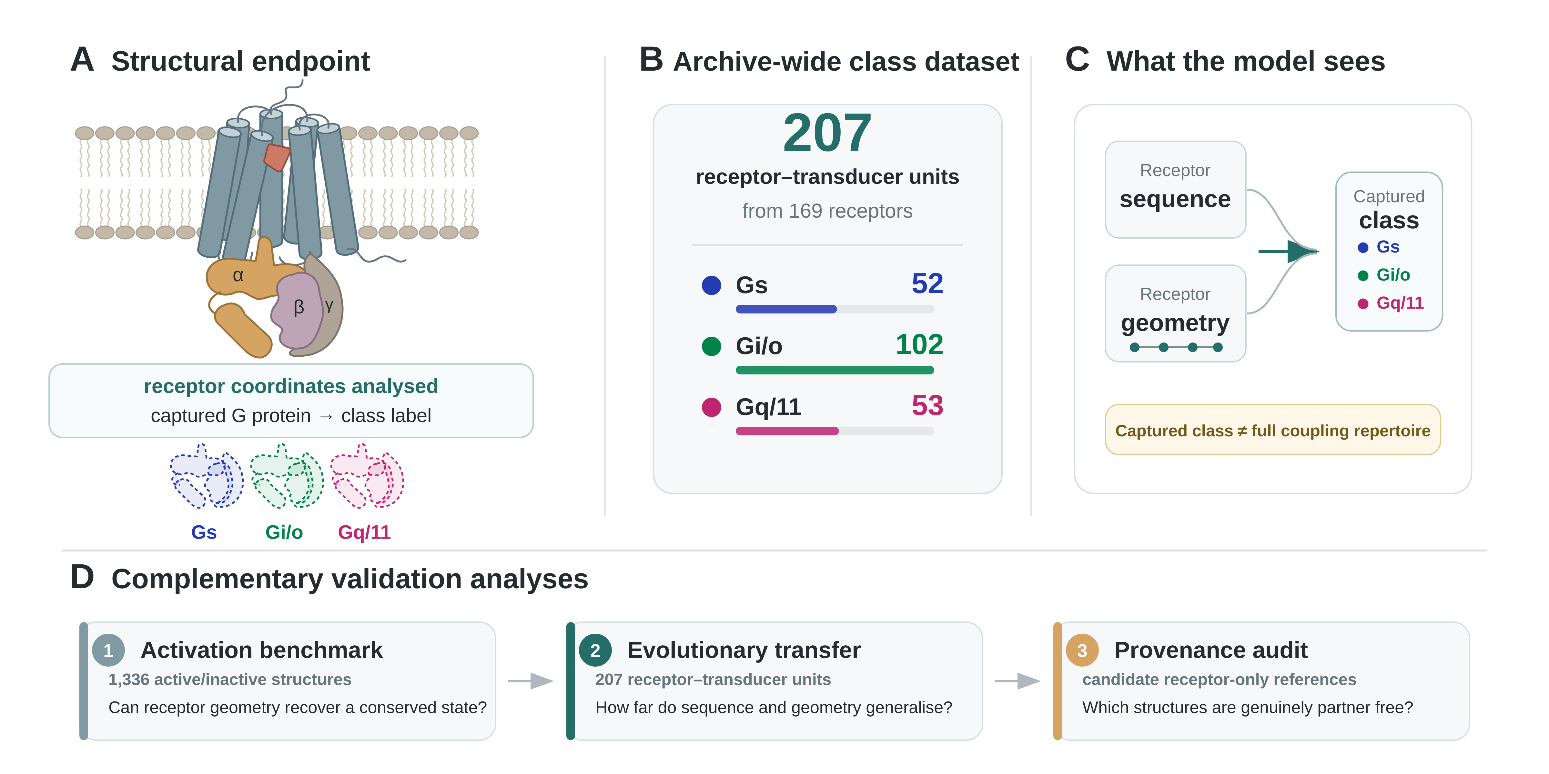
FIGURE 1 | Structural archive and analytical framework for captured G protein class information. (A) Mature GPCR-G protein endpoint: receptor coordinates are analysed and the transducer present in the deposited complex defines the structural class label. (B) Archive-wide three-class dataset of 207 receptor-transducer units from 169 receptors (52 Gs, 102 Gi/o and 53 Gq/11). (C) Predictive models use receptor sequence and receptor-side geometry to predict the captured class; that structural label is not equivalent to the receptor's complete functional coupling repertoire. (D) Three complementary validation analyses comprise an activation-state benchmark, evolutionary-transfer analysis and specimen-level provenance audit of candidate receptor-only references.

2 METHODS

2.1 Structural archive and annotations
Experimental class A GPCR entries were assembled from the Protein Data Bank and harmonised with GPCRdb and GproteinDb annotations (Pándy-Szekeres et al., 2023, 2024). Receptor residues were mapped to generic positions using the GPCRdb numbering scheme (Isberg et al., 2015), and coordinate processing used reproducible Python workflows that included Biotite (Kunzmann & Hamacher, 2018). Activation labels were taken directly from the harmonised GPCRdb structural-state annotation: only entries labelled active or inactive were included, ambiguous or unassigned states were excluded, and no activation label was inferred from the geometric measurements used by the classifier. The GPCRdb assignment itself draws on intracellular structural criteria, so the activation analysis is treated throughout as a positive structural-state benchmark rather than as independent biological validation. Activation analyses used 1,336 labelled structures from 199 receptors. Bound class analyses reduced repeated structures to 207 receptor transducer units from 169 receptors using predefined quality and representativeness rules. The three-class predictive analyses used Gs, Gi/o and Gq/11; the class label denotes the transducer captured in the deposited complex, not a unique functional preference. For this structural census, a receptor-transducer unit denotes a receptor paired with the G-protein-family-defining intracellular transducer present in the deposited complex, including engineered G-protein-derived constructs such as mini-G proteins or G-protein peptide mimetics where these encode the captured family; it does not imply that every unit contains a full heterotrimeric G protein. Construct context for the 207 bound units was audited separately from the class label, including fusion-protein and ICL2-associated ligand flags and deposited experimental metadata; the unit-level annotation is supplied in Source Data S15.

For a descriptive functional-repertoire analysis, human receptors were mapped by exact UniProt accession to the common GPCR-G protein coupling map of Hauser et al. (2022). Supported family couplings to Gs, Gi/o and Gq/11 were counted descriptively; lack of support in that map was not treated as proof of biological non-coupling. Non-human and viral receptors were left unannotated rather than projected to human orthologues. G12/13-bound class A structures were censused separately to assess whether a fourth-class matched analysis was feasible.

2.2 Experimental design and reference provenance audit

The study analysed public structural records rather than prospectively assigned interventions, so experimental randomisation and blinding were not applicable. Sex was not an experimental variable because the analysis concerns molecular structures and database annotations rather than experiments on organisms or participants. The analysis plan was not preregistered. To minimise selection bias and label leakage, inclusion and exclusion rules were defined independently of the captured G protein class. Candidate references were first defined at the coordinate level from mmCIF polymer entities: the ligand-permissive definition allowed extracellular peptide or protein ligands but excluded G proteins, arrestins, GRKs, intracellular binders, fusions and unresolved additional proteins, whereas the strict polymer-only definition required the receptor to be the sole polymer entity. Because receptor-only coordinate models can be produced by focused or local refinement of particles from transducer-containing cryo-EM specimens, coordinate-level candidates were then audited at the specimen level using the deposited entry title, EM sample description, EMDB and PDB relationships and particle counts together with the primary publication. A reference was classified as experimentally partner-free only when its specimen contained no intracellular transducer or stabilising partner and its primary publication did not describe the receptor as inactive.
The matched comparison was initially constructed at the coordinate level by pairing, for each receptor, a receptor-only active structure with a G protein-bound structure and evaluating them with a three-class, receptor-grouped design. This design requires each G protein class to be represented by at least two receptors, so that every held-out receptor has a same-class receptor in its training data. The matched population was not sampled from a larger eligible set; its size is set by the current experimental archive, and no prospective power calculation was performed. The specimen-level provenance criterion was applied to the strict inventory and to the prespecified terminal-fusion and ligand-permissive sensitivity inventories (Tables S22 to S24). For predictive analyses, n denotes independent receptor-state or receptor-transducer units after aggregation, not repeated deposited structures treated as independent replicates.

2.3 Structural descriptors and predictive models

The receptor-side representation combines sequence with structural descriptors of conserved activation microswitches, intracellular helices and loops, including ICL2, and the intracellular cavity (Figure 1C). The planned same-receptor comparison used 92 numeric receptor features measurable at both endpoints; their definitions are given here because the same descriptor families underlie the activation and archive-wide geometric analyses. Distance variables are reported in Å; names ending in min_distance denote minimum heavy-atom separation, whereas named residue-pair distances are Cα-Cα or explicitly defined atom/centroid distances. Side-chain χ1/χ2 and helix/loop orientation variables are angular measures in degrees. Displacements are positional changes after receptor alignment to conserved transmembrane reference coordinates. The intracellular cavity block quantifies the connected solvent-accessible region within a fixed receptor-centred intracellular envelope, including volume, surface and mouth areas, depth, width, bottleneck and inscribed radii, principal dimensions, shape/asymmetry and wall fractions. The compact four-feature activation code comprises the TM3 3.50-TM6 6.34 distance, TM3-TM7 distance, PIF 5.50-6.44 distance and Y7.53 displacement. A machine-readable dictionary of all 92 features, their units and generic-position provenance is supplied with the Supporting Information, and key conventions are summarised in Table S21.
The 92-feature matched representation was fully receptor-side and comprised 12 prespecified blocks. The activation-consensus score was the mean of seven canonical activation components: normalized active-versus-inactive reference distances for TM6, PIF, CWxP, NPxxY, the sodium pocket and TM7, plus a smooth DRY 3.50-6.30 score; it deliberately excluded ICL2 and the coupling-specific intracellular geometry. TM6 descriptors comprised the R3.50-6.30 and R3.50-6.34 C-alpha distances, aligned TM6 displacement, lower-versus-upper TM6 kink angle, TM6-versus-TM3 axis angle and the TM6-TM7 intracellular cavity width. TM7 descriptors comprised aligned displacement and rotation, the TM3-TM7 intracellular distance and the TM7-H8 angle. The DRY block contained the R3.50-6.30 minimum heavy-atom and C-alpha distances, the D3.49-R3.50 minimum heavy-atom distance, and R3.50 chi1/chi2. The PIF block contained pairwise C-alpha and minimum heavy-atom distances among positions 5.50, 3.40 and 6.44, the corresponding C-alpha triangle perimeter, and chi1/chi2 at 6.44. The CWxP block contained W6.48 chi1/chi2, aligned W6.48 displacement, the W6.48-6.44 distance and the 6.47-6.50 distance. The NPxxY block contained Y7.53 chi1/chi2, Y7.53-Y5.58 C-alpha and minimum heavy-atom distances, the N7.49-Y7.53 distance, local NPxxY C-alpha spread and aligned Y7.53 displacement. Sodium-pocket geometry comprised D2.50 distances to positions 3.39, 7.45, 7.46 and 7.49 plus the geometric volume and spread of these conserved pocket anchors. ICL2 contributed 13 numeric descriptors: the number of resolved generic-position C-alpha atoms across 34.50-34.57, end-to-end distance, centroid distances to R3.50, 5.61, 6.34 and 7.53, principal-axis angles to TM3 and TM5, aligned centroid displacement relative to the active-state reference, helical fraction, longest contiguous helical segment, and mean backbone phi and psi. TM5 intracellular geometry comprised the 5.53-5.68 cytoplasmic extension, a core-versus-lower-segment kink angle, R3.50-5.61 and R3.50-5.64 distances, TM5-TM6 cavity width and the TM5-TM3 axis angle. Helix 8 was represented by the 8.47-8.53 end-to-end distance and centroid distances to R3.50 and the TM6 intracellular anchor. Finally, 27 core-cavity descriptors quantified the connected solvent-accessible region formed from receptor atoms in TM3, ICL2, TM5, TM6, TM7 and H8: volume, mouth area, depth, area-equivalent maximum width, average cross-section, bottleneck area/radius, maximum inscribed radius, voxel-face surface area, centroid, principal dimensions and principal-axis orientation, eccentricity, sphericity, asymmetry, receptor-frame side fractions and regional wall fractions. Bound G-protein or arrestin atoms never entered these receptor measurements. Missing coordinates remained missing rather than being converted to structural zeros; imputation and scaling for predictive models were fitted only within training folds. ICL2 was retained as an activation-relevant receptor-side feature family because a separate structurome-wide analysis identified ICL2 folding as an activation-associated feature of class A GPCRs (Batebi, 2026c).
A single primary model was designated for each question before interpretation: the sparse four-feature geometry for activation-state recovery and endpoint receptor geometry for coordinate-based captured-class prediction; full receptor sequence was the prespecified non-coordinate comparator. Multiclass elastic-net logistic regression was the primary interpretable archive-wide model, with nested L2 logistic regression used for the evolutionary-transfer comparison. Preprocessing, imputation, scaling, feature filtering and hyperparameter selection were confined to training folds. Additional descriptor blocks and combined representations were treated as sensitivity or explanatory analyses rather than competing primary models.
The endpoint-geometry representation as fitted contains 11 non-coordinate acquisition inputs alongside the receptor descriptors: resolution, deposition year, experimental method, ligand type, fusion-protein annotation and ICL2 completeness indicators, which together carry 7.3% of the mean absolute coefficient mass. Because resolution and deposition year also vary within receptors, the archive-wide transfer analysis and the within-receptor test were repeated on a coordinate-only refit in which every acquisition input was removed, together with an acquisition-only model fitted on the same units and the same fold assignments. The refit is an independent reimplementation of the transfer-audit specification (nested L2 logistic regression with training-fold tuning of the regularisation strength) applied to the archived per-structure measurements and archived fold assignments; two inputs of the archived model, the activation-consensus score and its completeness count, are not present in the archived per-structure measurement table and were therefore omitted from both the reimplementation and the coordinate-only refit. No other model was refitted. These analyses are reported in Table S33 and Source Data S18.
Two control representations were used to quantify archive-level confounding. A missingness-only model used coordinate-availability and measurement-completeness indicators. A year-excluded metadata-only model used resolution, experimental method, species, ligand type, fusion-protein annotation and other available non-coordinate context variables. In addition to temporal holdouts, both controls were evaluated under 50% and 40% sequence-identity cluster splits. These controls were treated as measures of archive structure rather than receptor biology.

2.4 Data and Statistical Analysis
The data and statistical analysis comply with the recommendations on experimental design and analysis in pharmacology; please see our editorial for guidance (Curtis et al., 2025). Relevant reporting principles in the earlier BJP guidance were also followed where applicable (Curtis et al., 2018). Requirements concerning prospectively assigned experimental groups were not applicable to this archive-based computational study. Macro ROC AUC was the primary multiclass performance measure. Predictive comparisons used receptor grouped outer folds so that structures from the same receptor could not occur in both training and test data. Paired representation differences and uncertainty intervals used receptor clustered bootstrap resampling. Grouped permutation tests preserved receptor level dependence. Class specific one versus rest AUCs were reported with exact n values. Effect sizes, 95% confidence intervals and receptor level sensitivity analyses were emphasised. Full fold assignments, permutation results and bootstrap outputs are supplied in the Supporting Information and Source Data. The functional-repertoire annotation, G12/13 census and provenance audit were defined after the initial analyses and are reported descriptively.

Because this is an archive-based computational study, there were no prospectively assigned experimental groups or technical replicates requiring randomisation or blinded allocation. Statistical n denotes independent receptor-level units after aggregation; repeated deposited structures were not treated as independent observations. No statistical outliers were excluded: all exclusions followed predefined structural, entity-composition and measurement-quality criteria described above. No normalization to control-group values or transformation to enforce Gaussianity was applied. Numeric model features were standardized within training folds for model fitting, while descriptive structural quantities retain the physical units defined in Section 2.3. Parametric ANOVA and post hoc procedures were not used. Formal inferential tests were restricted to analyses with at least five independent receptor-level values; smaller class-specific summaries are reported descriptively only. Where inferential P values are reported, a two-sided P < 0.05 threshold was used.

Receptor grouped outer folds were used for all predictive analyses, so that all structures and units of a receptor were held out together, and every class had to be represented in both training and test data. The archive-wide bound-class comparisons used five receptor grouped outer folds on the 207 units; sequence-cluster validation additionally grouped receptors at 50%, 40% and 30% sequence identity. Fold assignments and per-fold receptor and class counts are supplied with Source Data S3 and S11. A prespecified same-receptor multiclass diagnostic then restricted the existing out-of-fold predictions to receptors represented by at least two captured classes. For each unit, prediction was evaluated only among classes observed for that receptor; accuracy and the true-class-minus-best-alternative probability margin were compared with 2,000 within-receptor label permutations, preserving each receptor’s class composition.

2.5 Software and reproducibility

Core analyses were implemented with GPCR SelectivityMap v0.3.1 in Python 3.12. The archived environment specifies NumPy, pandas, SciPy, scikit learn, Biopython, Matplotlib and PyYAML dependencies and preserves the analysis configuration; structural workflows additionally used Biotite. GPCR SelectivityMap records entity and label provenance, generic-position mapping, structural descriptors, fold assignments, predictions, uncertainty estimates and transfer analyses. Random seeds, feature definitions, source hashes, fold assignments and convergence audits are archived with the release (Batebi, 2026a). Revision-specific analyses, including the specimen-level provenance audit, finalized functional-repertoire annotation and Supporting Source Data S14, are archived in GPCR SelectivityMap v0.4.0 (Batebi, 2026b; https://doi.org/10.5281/zenodo.22959127).

2.6 Nomenclature of Targets and Ligands
Key protein targets and ligands in this article are hyperlinked to corresponding entries in the IUPHAR/BPS Guide to PHARMACOLOGY and are permanently archived in the Concise Guide to PHARMACOLOGY 2025/26 (Alexander et al., 2025). GPCR and G protein nomenclature follows IUPHAR/BPS recommendations. Generic receptor residue positions follow the GPCRdb numbering scheme.

3 RESULTS

3.1 A compact receptor geometry recovers the annotated activation state across receptor families

Activation was evaluated as a positive structural-state benchmark using the harmonised GPCRdb active/inactive annotation, not as independent biological validation. Of the 1,360 harmonised class A structures, 1,336 from 199 receptors carried an unambiguous active or inactive structural-state annotation and entered the activation analysis, aggregated to 265 receptor-state units; separately, 207 receptor-transducer units from 169 receptors carried a resolved G protein complex with an assignable Gs, Gi/o or Gq/11 class and formed the captured-class dataset. The compact four-feature geometric code was the designated primary activation model and provided near-complete discrimination: ROC AUC 0.996 evaluated at receptor-state level and 0.998 evaluated at structure level (Figure 2; Tables S3 and S27). To test evolutionary leakage directly, the same four measurements were rerun at structure level on the 169-receptor overlap used by the captured-class analysis with identity-cluster-held-out folds: ROC AUC was 0.998 at both the 50% and 40% identity thresholds, unchanged from the structure-level receptor-grouped value (Table S27; Source Data S15). Because the GPCRdb active/inactive assignment is itself informed by intracellular receptor geometry, this analysis measures the consistency between a compact geometric code and an existing structural annotation and is not independent biological validation of activation.

The recurrent measurements in the four feature code were the TM3 3.50 to TM6 6.34 distance, the TM3 to TM7 distance, the PIF 5.50 to 6.44 distance and displacement of Y7.53. Metadata provided useful discrimination, whereas feature availability was weak. ICL2 alone was also weak (ROC AUC 0.555; 95% CI 0.496 to 0.629); despite independent evidence that ICL2 folding is activation-associated (Batebi, 2026c), it is therefore used here as one receptor-side feature family rather than as a standalone activation classifier.

Shared activation geometry across Gs, Gi/o and Gq/11 complexes and the corresponding descriptor distributions are shown in Figure S1.

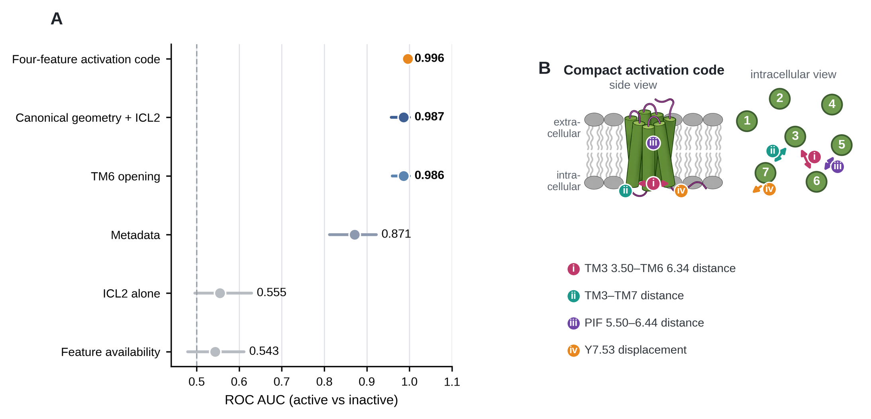
FIGURE 2 | The annotated activation state is almost completely recovered by a compact receptor geometry. (A) ROC AUC and receptor-clustered 95% confidence intervals for the four-feature activation code, canonical geometry plus intracellular loop 2, TM6 opening, metadata, intracellular loop 2 alone, and feature availability. The analysis includes 1,336 structures from 199 receptors, aggregated to 265 receptor-state units for leave-one-receptor-out evaluation. (B) The four recurrent measurements comprising the sparse activation code. Numbered circles denote transmembrane helices TM1 to TM7; roman numerals i to iv identify the four measurements listed in the key.

3.2 Sequence and receptor geometry transfer differently across evolutionary distance

The wider bound-complex analysis asked how well sequence and receptor geometry transfer to receptors not seen during model fitting. It used 207 receptor-transducer units from 169 receptors spanning Gs, Gi/o and Gq/11. Under ordinary receptor-grouped validation, full sequence reached macro ROC AUC 0.790 (95% CI 0.744 to 0.832), endpoint geometry 0.776 (0.726 to 0.826), and a global sequence-identity nearest-neighbour baseline 0.802 (0.756 to 0.844). The paired full-sequence-minus-geometry difference was 0.014 (95% CI -0.037 to 0.065). Thus, when close evolutionary neighbours remain available across folds, global sequence similarity alone captures substantial captured-class structure and neither learned representation is uniformly superior (Figure 3; Table S15).

Separating training and test receptors by sequence identity changed this pattern. At 50% identity, endpoint geometry reached macro ROC AUC 0.731 compared with 0.638 for full sequence and 0.570 for the identity nearest-neighbour baseline; the paired full-sequence-minus-geometry difference was -0.093 (95% CI -0.162 to -0.025). At 40% identity, the point estimate again favoured geometry (0.683 versus 0.612), but the paired interval included zero (difference -0.070, 95% CI -0.141 to 0.004; identity nearest-neighbour 0.552). At 30% identity, full sequence, geometry and identity nearest neighbours were all near chance (0.539, 0.517 and 0.550), only two unequal folds met class-coverage requirements, and the paired sequence-minus-geometry interval was also compatible with no difference (0.022, 95% CI -0.061 to 0.101). Evidence that receptor geometry transfers beyond full sequence is therefore strongest at the 50% separation threshold, weaker at 40%, and unresolved at 30%, where the validation itself becomes sparse (Figure 3; Figure S4; Tables S15 and S16).
Because the endpoint-geometry representation as fitted also contains non-coordinate acquisition inputs (Section 2.3), the archive-wide transfer analysis was repeated after removing them. An independent reimplementation of the same specification reproduced the archived values to within 0.027 macro ROC AUC at every validation level, and to within 0.007 at the three levels with five valid folds: 0.783, 0.737, 0.680 and 0.494 against archived 0.776, 0.731, 0.683 and 0.517 under receptor-grouped and 50%, 40% and 30% identity-cluster validation. Refitting on receptor coordinates alone, with resolution, deposition year, experimental method, ligand type, fusion-protein annotation and ICL2 completeness removed, left the pattern unchanged: macro ROC AUC 0.781 under receptor-grouped validation, 0.741 at 50%, 0.678 at 40% and 0.490 at 30%. The paired full-sequence-minus-coordinate-only difference was +0.009 (95% CI -0.035 to +0.055) under receptor-grouped validation, -0.102 (-0.168 to -0.034) at 50%, -0.066 (-0.132 to -0.000) at 40% and +0.049 (-0.026 to +0.124) at 30%, reproducing the archived profile in which geometry exceeds sequence at 50% separation, is borderline at 40% and is indistinguishable elsewhere. A model built from the acquisition inputs alone reached 0.568, 0.489, 0.533 and 0.515 across the same four levels. The moderate-distance advantage of receptor geometry over sequence therefore rests on receptor coordinates rather than on acquisition context (Table S33; Source Data S18).

Because the identity of the stabilising antibody fragment is not annotated, the within-receptor test was also given an adversarial deletion ladder, in which receptors are removed in order of their contribution to the margin on the assumption that the most favourable ones are entirely construct-driven. The coordinate-only margin remains significant after deleting the four most influential of the 34 receptors (+0.004, P = 0.048) and loses significance at the fifth (-0.001, P = 0.075); in the archived primary model the margin survives three deletions (+0.015, P = 0.042) and the accuracy statistic survives four (56.3%, P = 0.015). A construct explanation of this result would therefore have to apply to at least five of the 34 receptors and remove their margin entirely. The effect is distributed across receptors rather than carried by one or two, and it is small (Table S33; Source Data S18). The within-receptor test was repeated on the same coordinate-only refit. Holding receptor identity fixed, the margin was +0.038 against -0.031 under within-receptor permutation (P = 0.006), with accuracy 55.6% against 47.2% (P = 0.018), under receptor-grouped validation, and +0.012 at 50% identity (P = 0.011); it was absent at 40% (-0.004, P = 0.099) and at 30% (-0.020, P = 0.78). Substituted into the same nine-representation ladder, the coordinate-only values give q = 0.045 for the margin and q = 0.094 for accuracy after Benjamini-Hochberg correction. Removing the acquisition inputs therefore preserves the direction and the identity-threshold profile of the within-receptor effect while reducing its magnitude at 50% identity, which is reported as attenuation rather than as an unchanged result. Within the construct strata, the coordinate-only margin was +0.063 across the 19 resolution-matched receptors (P = 0.016) and +0.061 across the 18 receptors resolved with both Gi/o and Gq/11 (P = 0.040), with the remaining strata too small to be informative on their own (Table S33; Source Data S18).A complementary within-receptor test removed receptor identity from the question entirely. Thirty-four receptors were represented by at least two captured classes, yielding 72 receptor-transducer units. Using the existing out-of-fold probabilities of the designated primary coordinate model and restricting each decision to the classes observed for that receptor, the mean true-class-minus-best-alternative probability margin was +0.065 for endpoint geometry versus -0.040 under within-receptor label permutation (one-sided P = 0.008); the corresponding accuracy was 55.6% versus a permutation expectation of 47.2% (P = 0.041). The margin is the load-bearing statistic for this model, because its observed accuracy coincides with the upper limit of the permutation distribution. The test was therefore repeated in a second pipeline, the evolutionary-transfer audit, which fits nested L2 logistic regression with lbfgs and training-fold tuning of the regularisation strength. The two pipelines share the same 107 input features and the identical fold assignment for all 207 units, and differ in estimator configuration; the archive-wide macro ROC AUC is 0.778 for the first and 0.776 for the second. Their fitted coefficients correlate at r = 0.96, their out-of-fold class probabilities at r = 0.97 to 0.98, and they assign the same predicted class to 195 of 207 units. The second pipeline reproduced the within-receptor result on both statistics: margin +0.051 versus -0.036 under permutation (P = 0.009), and accuracy 59.7% versus 47.2% (P = 0.001). The accuracy difference between the pipelines corresponds to three of the 72 units changing predicted class, which is a further reason to treat the margin rather than the accuracy as the load-bearing statistic. Across the nine representations evaluated in each pipeline, only the second survives Benjamini-Hochberg correction, and it does so on both statistics (q = 0.010 accuracy, q = 0.045 margin); neither statistic survives correction in the first (q = 0.072 margin, q = 0.37 accuracy). Because the study was not preregistered, "designated primary" means designated before the confound analyses reported below were run, not before the study began. Eleven of the 107 inputs to this model are non-coordinate acquisition variables rather than receptor geometry: experimental method, ligand type, fusion-protein annotation, ICL2 completeness, resolution and deposition year. They carry 7.3% of the mean absolute coefficient mass, with resolution ranked 32nd and deposition year 63rd of 107. Resolution and deposition year do vary within receptors, which is why the covariate analysis below is necessary rather than merely reassuring. Sequence alone cannot distinguish different captured endpoints of the same receptor, because its input is identical across those endpoints; it accordingly reproduced the permutation value exactly (P = 1.000) and serves as an internal negative control. Eight further representations were evaluated for transparency and none reached two-sided significance; all nine are reported in Table S28 and Source Data S15, and only the prespecified primary model is interpreted. This test therefore supports a coordinate-associated component beyond receptor identity while remaining an associative endpoint analysis. The identity-cluster confound control applied elsewhere in this study was then applied to the within-receptor test in the second pipeline, which is the only one with archived out-of-fold predictions under every validation scheme; the predictions were reused as archived and no model was refitted. No identity-cluster run of the first pipeline exists, so the ladder below characterises the second pipeline and is read against its own receptor-grouped value of +0.051; the two pipelines agree on 195 of 207 units, but they are not interchangeable. Against that reference, the margin was +0.061 under 50% identity-cluster validation (P = 0.006; receptor-level mean +0.071, 95% CI +0.003 to +0.139, positive in 22 of 34 receptors), attenuated to +0.019 at 40% (P = 0.057) and was absent at 30% (P = 0.91). Full sequence, interface sequence and the identity-neighbour baseline reproduced the permutation value exactly at every threshold, as the design requires. The within-receptor result therefore follows the same identity-threshold profile as the archive-wide analysis: present under receptor-grouped and 50% validation, attenuating at 40% and absent at 30% (Table S31; Source Data S16). Because different captured classes of the same receptor are often solved with different stabilisation strategies, the within-receptor test was examined for construct confounding. Experimental method, species and ICL2 completeness are constant within every one of the 34 eligible receptors, and ligand type varies within only one, so those covariates cannot generate the effect. Resolution, deposition year, fusion-protein annotation and ICL2-associated ligand together explain 2.1% of the within-receptor variance in the margin, and adjusting for them leaves the mean margin unchanged. Restricting to receptors whose paired endpoints differ by no more than 0.3 A in resolution gives +0.074 across 19 receptors and 40 units (P = 0.033), and restricting to receptors whose endpoints come from a single publication gives +0.097 across 8 receptors and 16 units (P = 0.17, underpowered). Stratifying by class pair gives +0.085 for the 18 receptors resolved with both Gi/o and Gq/11 (P = 0.038), +0.101 for the 6 receptors resolved with Gq/11 and Gs (P = 0.060), +0.089 for the 6 resolved with Gi/o and Gs (P = 0.21), and -0.138 for the 4 receptors resolved with all three classes (P = 0.31), where the decision is between three rather than two classes. Only the first stratum has enough receptors to be informative on its own. It is also the stratum in which stabilisation chemistry is expected to be most closely matched, because Gq/11 complexes are routinely chimeric constructs engineered so that the same antibody fragment used for Gi/o complexes will bind. That expectation was verified by extracting antibody-fragment, nanobody and engineered-transducer identity from the polymer entity records of the deposited complexes. Of the 18 receptors resolved with both Gi/o and Gq/11, eight carry the same antibody fragment, scFv16, on both endpoints, and these eight are the only receptors in the whole eligible set whose captured-class endpoints share an identical stabiliser annotation. In that matched stratum the coordinate-only margin was +0.127 (P = 0.005) and the margin of the archived primary model was +0.183 (P = 0.008), both larger than across the full set; restricting further to the six receptors that also match on fusion and chimera annotation gives +0.138 (P = 0.031) and +0.200 (P = 0.045). Across the 26 receptors whose endpoints differ in stabiliser annotation the margin was smaller, +0.012 (P = 0.047) and +0.013 (P = 0.075). The effect is therefore strongest where stabilisation chemistry is held constant, which is the opposite of what a stabiliser-driven artefact predicts. Two limits are stated rather than implied: the matched stratum contains eight receptors and 16 units, and its accuracy statistic is at the permutation expectation (56.3%, P = 0.50), so the margin rather than the accuracy carries this stratum; and eight structures declare no antibody, nanobody or Fab entity at all, so “matched” for two of the 34 receptors means matched in the absence of one (Table S32; Table S33; Source Data S17; Source Data S18). Feature-level comparisons within the same multi-transducer receptors, and dataset-composition robustness checks, are shown in Figure S2.

The predefined intracellular interface did not provide a universal cross-family barcode. At 30% identity, interface sequence reached macro ROC AUC 0.552 and the matched noninterface control 0.556; their paired difference was -0.004 (95% CI -0.068 to 0.062). This does not support a transferable interface-specific advantage under the strictest available separation. Coefficient localisation, scrambling controls, temporal holdouts and learning curves are reported in Figures S3-S6 and Tables S6, S9 and S17-S19.

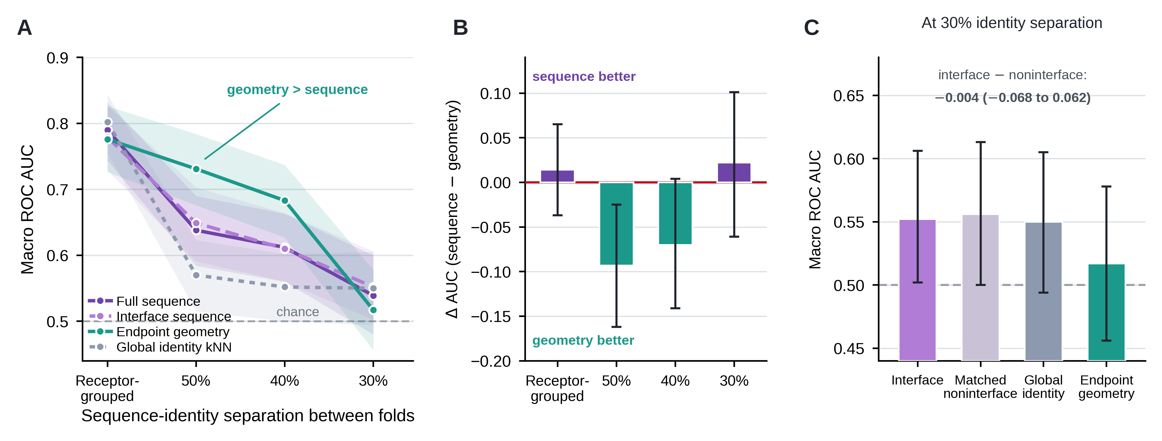

FIGURE 3 | Evolutionary separation reveals different transfer ranges for sequence and receptor geometry. (A) Macro ROC AUC for full sequence, predefined interface sequence, endpoint geometry and global sequence-identity nearest neighbours under receptor-grouped and 50%, 40% and 30% sequence-cluster validation. (B) Paired full-sequence-minus-geometry differences; negative values favour geometry. (C) Interface sequence, matched noninterface sequence, global identity nearest neighbours and endpoint geometry at 30% identity. Only two valid folds were available at the 30% threshold. (D) Within-receptor test on 34 receptors and 72 receptor-transducer units: mean true-class-minus-best-alternative probability margin for the primary coordinate model against the mean of 10,000 within-receptor label permutations, at each identity separation. Receptor identity is held fixed and each decision is restricted to the classes observed for that receptor, so receptor sequence is constant across a receptor’s units and cannot contribute. The 30% threshold has only two usable folds of unequal size and indicates absence of usable signal rather than a precise estimate.

3.3 Coupling class information is distributed across receptor properties
Additional receptor descriptors were evaluated on the same 207 units and receptor-grouped folds (Figure 4A,B; Tables S11 and S12). All four added descriptor families had point-estimate AUCs above missingness, but paired intervals supported an increment over missingness only for surface/electrostatics and for the combined new static representation; the combined representation remained below established geometry and sequence. Adding the static descriptors to sequence reduced performance by 0.054 AUC, which is consistent with overfitting in the combined models at this sample size rather than with a suppressive effect of the added features, and is one reason a single primary model was designated for each question. The small numerical differences between Figure 3 and Figure 4 reflect the independent nested-L2 model used for the evolutionary-transfer analysis rather than a change in the underlying 207-unit dataset; the elastic-net values for the same folds, and the paired differences between representations, are given in Tables S4 and S5, and all designated primary values are collected in Table S27.
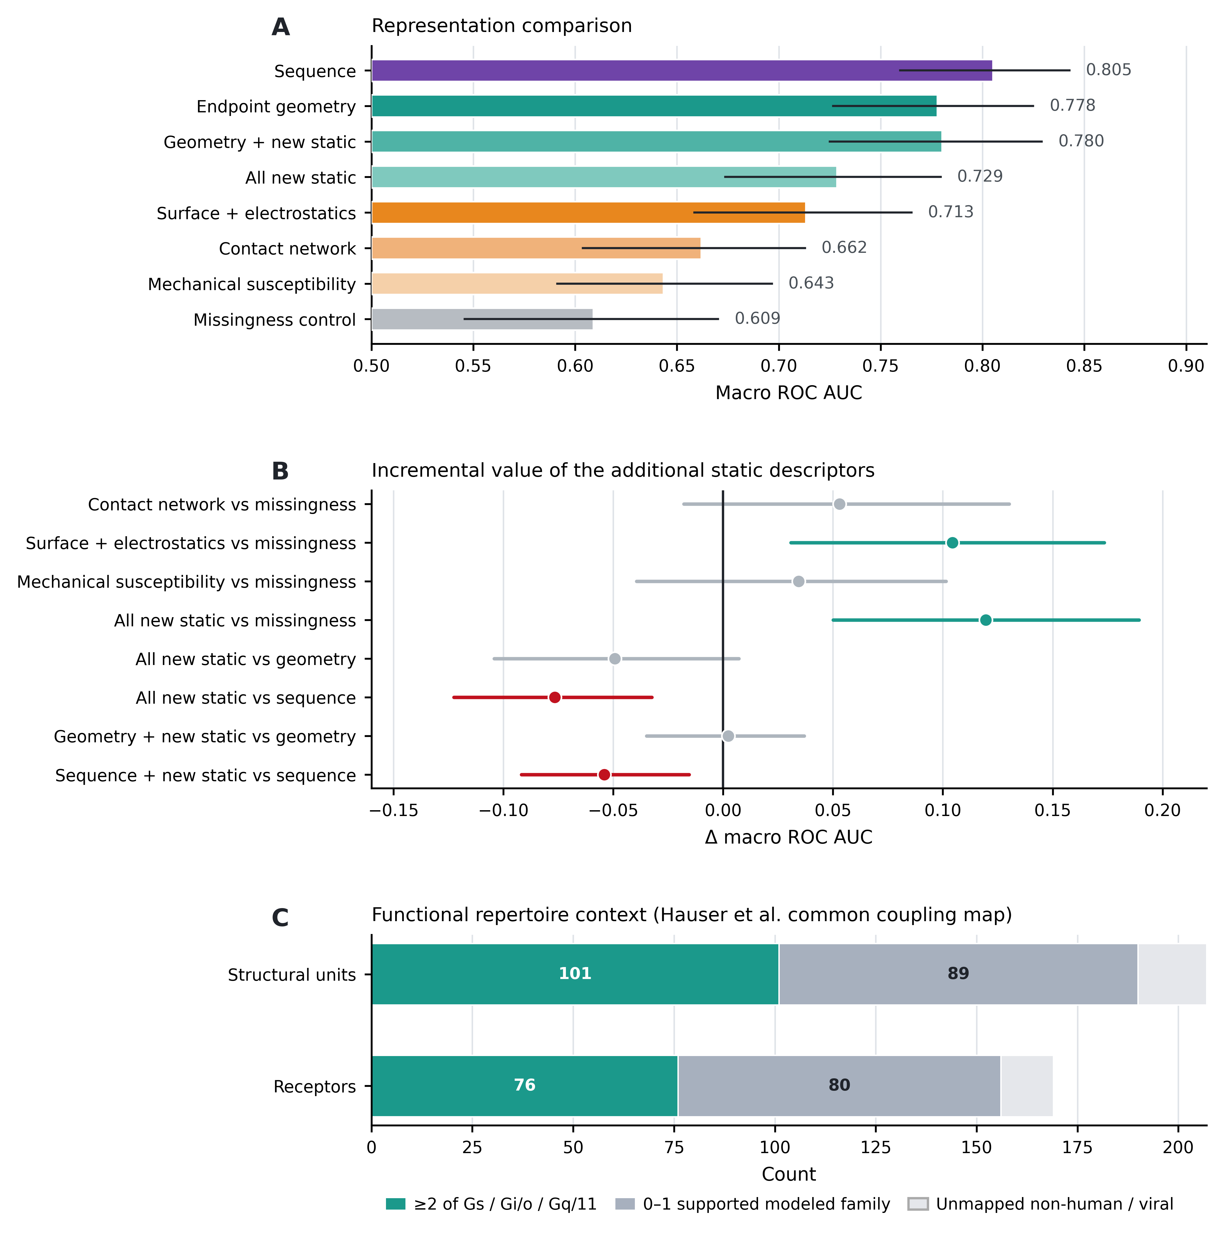
FIGURE 4 | G protein class information is distributed across overlapping receptor properties and should not be equated with a unique functional coupling repertoire. (A) Receptor-grouped macro ROC AUC for sequence, established endpoint geometry, additional static receptor descriptors and missingness controls in the 207-unit bound-complex dataset. (B) Paired incremental AUC differences for selected descriptor blocks. (C) Functional-repertoire context from the common coupling map of Hauser et al. (2022), matched to the structural archive by exact human UniProt accession. Among the 190 units mapped to the human common coupling map, 101 arise from receptors with supported coupling to at least two of the three modelled families (Gs, Gi/o and Gq/11); the remaining 17 of 207 structural units correspond to non-human or viral receptors and were not assigned human functional annotations.
Paired comparisons quantified this boundary: surface/electrostatics exceeded missingness by ΔAUC +0.104 (95% CI +0.031 to +0.174) and all new static features by +0.120 (+0.050 to +0.189), whereas contact networks (+0.053, -0.018 to +0.130) and mechanical susceptibility (+0.034, -0.039 to +0.101) had intervals crossing zero. Adding new static features to established geometry produced essentially no gain (ΔAUC +0.002, -0.035 to +0.037), while adding them to sequence reduced performance (ΔAUC -0.054, -0.092 to -0.016) (Figure 4; Table S12).
Under fixed-feature temporal holdouts, however, a missingness-only representation reached 0.675 for the 2023 cohort and 0.724 for 2024, close to endpoint geometry (0.703 and 0.744) and sequence (0.721 and 0.740), whereas a year-excluded metadata model reached only 0.527 and 0.582. Archive structure alone can therefore approach coordinate performance under a temporal split even though it is near chance under identity-cluster validation, and this is reported as a limit on how far the archive-wide comparison can be pushed (Table S6). Archive-context controls showed that data availability can carry class information under ordinary receptor-grouped evaluation, but this signal did not survive homology restriction. At 50% identity, the missingness-only and year-excluded metadata-only controls reached macro ROC AUC 0.515 and 0.546, respectively; at 40% identity they reached 0.493 and 0.562. These values were well below endpoint geometry (0.731 at 50% and 0.683 at 40%) and full sequence (0.638 and 0.612). Thus the moderate-distance transfer result is not reproduced by feature availability or the measured archive metadata, although unmeasured construct or experimental confounding cannot be excluded (Tables S6, S11, S12 and S27; Source Data S15).
Functional repertoire was assessed descriptively rather than used as an alternative class label. Exact UniProt matching to the common coupling map of Hauser et al. (2022) annotated 190 of the 207 structural units, representing 156 receptors. The captured family itself was supported in the common map for 162 of 190 mapped units (85.3%); 28 of 190 (14.7%) had a captured family not supported by the map. Lack of support was not treated as proof of biological non-coupling, because the common map is not an exhaustive negative catalogue. In addition, 101 of 190 mapped units (53.2%) came from receptors with supported coupling to at least two of Gs, Gi/o and Gq/11. Seventeen units from non-human or viral receptors were left unannotated rather than projected to human orthologues. These observations reinforce that the transducer captured in one structure should not be equated with a receptor's unique functional coupling repertoire (Figure 4C; Table S26). The 28 unsupported captured-family units, representing 25 receptors, are listed individually in Table S30 and Source Data S15; pharmacologically familiar examples include 5-HT4, CCK2, H4 and P2Y12, illustrating why absence from a frozen functional map should not be converted into a biological negative.

3.4 Receptor-only coordinate models and experimental specimen provenance
A same-receptor coordinate comparison asks whether class information visible in receptor coordinates differs between deposited receptor-only and G protein-bound endpoints. The initial coordinate-level screen identified active structures with no annotated transducer. Applying the polymer-entity criteria removed fusion constructs, transducer-containing entries, structures containing additional or unresolved polymers and auxiliary intracellular binders, leaving receptor-only coordinate models from 12 receptors that could be paired with bound structures of the same receptors (Tables S1, S2 and S10). The original endpoint-specific result, together with the archive-trained and homology-controlled sensitivity analyses, is reported only in the Supporting Information (Tables S7, S8, S13, S20 and S25) and is not used as a main-text argument.
A separate specimen-level provenance audit then asked which of these receptor-only coordinate models were actually obtained from partner-free experimental specimens. Most were receptor-focused or locally refined reconstructions from transducer-containing cryo-EM specimens, in several cases with particle counts identical to those of the corresponding full receptor-G protein complex, and one GPR34 structure is described in its primary publication as inactive (Figure 5A; Table S22). Experimentally partner-free active structures remained for only three receptors: the A2A receptor, the δ receptor and rhodopsin. Their bound counterparts represented Gs and Gi/o but not Gq/11 (Table S23). Because this specimen-level subset does not contain the class coverage required by the prespecified receptor-grouped design, a three-class model was not fitted for that subset. The prespecified terminal-fusion and ligand-permissive inventories were similarly insufficient for a balanced three-class comparison (Figure 5B; Table S24).
The weak performance of the feature-wise difference representation is consistent with the absence of a shared class-specific displacement through receptor feature space. Across the original coordinate-level matched set, standardized feature-difference vectors from same-class pairs exceeded different-class pairs in mean cosine similarity by only +0.022; a 10,000-permutation class-label null gave P = 0.263. The terminal-fusion sensitivity gave +0.035 (P = 0.120). Thus the small positive cosine contrast is compatible with chance under class-label permutation. Subtraction also combines variability from both structural endpoints, and the provenance audit shows that many receptor-only coordinate models are not specimen-level partner-free references (Table S28; Source Data S15).
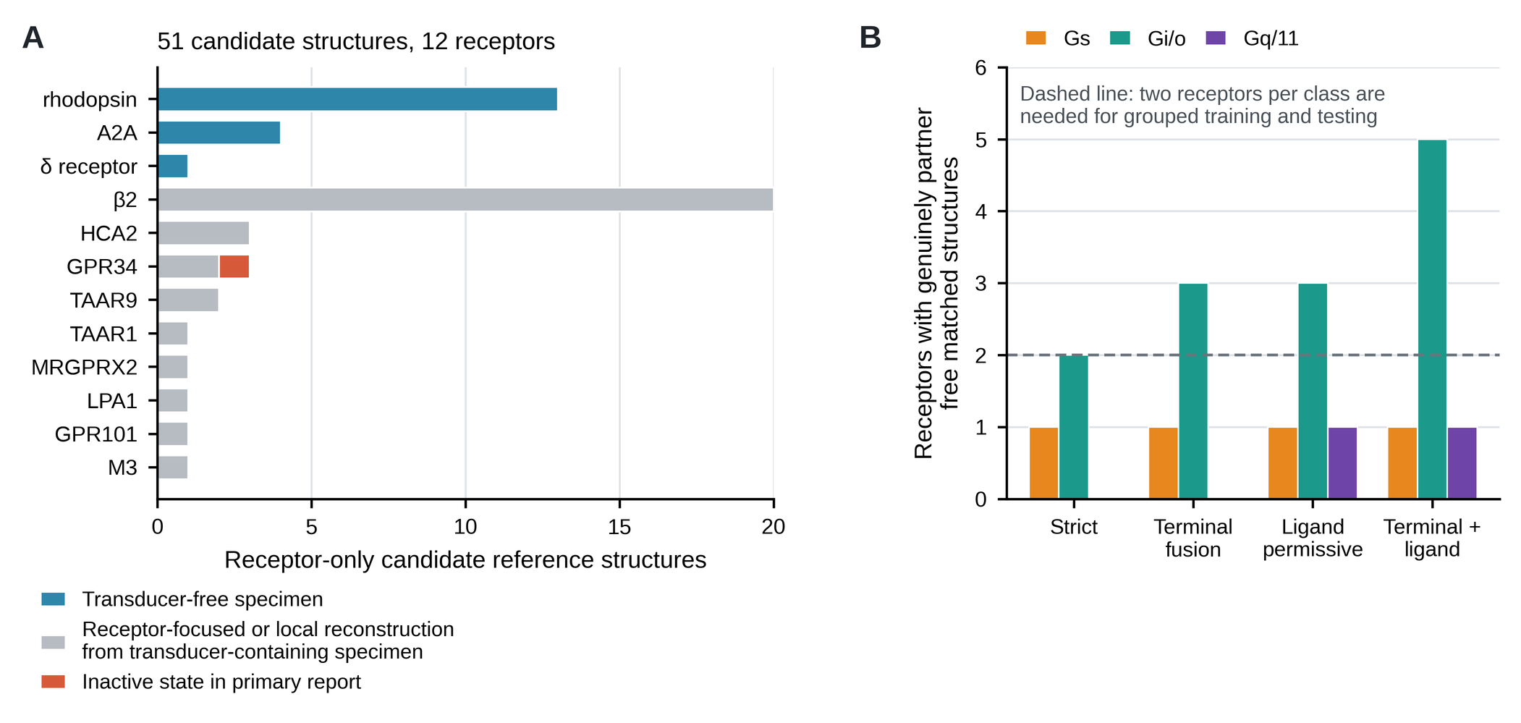
FIGURE 5 | Specimen-level provenance audit of receptor-only candidate reference structures. (A) The 51 receptor-only coordinate models from 12 receptors that passed the polymer-entity screen, classified by experimental specimen provenance: experimentally partner-free specimens, receptor-focused or local reconstructions from transducer-containing cryo-EM specimens, and one structure described as inactive in its primary publication. (B) Number of receptors with experimentally partner-free active structures matched to a G protein-bound structure, by captured G protein class, for the strict inventory and the prespecified terminal-fusion, ligand-permissive and combined inventories. Receptor-grouped three-class evaluation requires at least two receptors per class (dashed line). Class-specific receptor counts are not additive because a receptor represented with more than one captured class can contribute to more than one class column.

4 DISCUSSION AND CONCLUSIONS

Three conclusions emerge. First, the archive-wide analyses show that captured G protein class information is present in receptor sequence and geometry, with weaker signal also present in additional static descriptor families; the clearest paired increment over missingness is seen for surface/electrostatics and the combined static representation. The signal is strongly organised by evolutionary relatedness and yields no single interface rule that transfers across distant class A families. Second, functional annotation shows that the transducer captured in a mature structure is a realised signalling endpoint rather than the receptor's complete functional coupling repertoire. Third, the provenance audit shows that coordinate-level receptor-only status does not necessarily imply an experimentally partner-free specimen. The original 12-receptor coordinate-level comparison is therefore retained only as a secondary descriptive endpoint analysis; its magnitude attenuated under the stricter archive-trained homology-controlled sensitivity analysis.

The provenance result has a broader methodological implication for structural bioinformatics: receptor-only coordinate entries can be generated by focused or local refinement of transducer-containing particles, so coordinate composition and specimen history are distinct. Analyses using receptor-only models as partner-free references should therefore verify deposited sample descriptions, EMDB relationships and primary publications. In this archive, only three receptors remained under the experimentally partner-free definition, insufficient for the prespecified three-class receptor-grouped comparison; the versioned workflow allows future deposits to be reassessed under the same eligibility rules.

The activation benchmark defines a positive structural comparison rather than an independent biological validation. Using the harmonised GPCRdb active/inactive structural-state annotation, four geometric measurements recovered the annotated state with structure-level ROC AUC 0.998 across the full 199-receptor analysis (0.996 at receptor-state level), and the structure-level value was unchanged at 0.998 after holding out 50% or 40% sequence-identity clusters in the 169-receptor overlap. A shared archive-level structural state therefore projects onto a compact geometry even under homology restriction, although the annotation and the geometric code draw on overlapping structural criteria, so this is a consistency benchmark rather than independent validation. Captured G protein class behaved differently: endpoint geometry remained only moderately predictive under the same identity thresholds, and its 50% transfer coefficients were distributed across ICL2 orientation, microswitch, TM5/TM7 and sodium-pocket features rather than dominated by one universal motif (Table S29; Source Data S15).

The evolutionary transfer results also qualify simple sequence or interface explanations. Under ordinary receptor-grouped validation, the identity nearest-neighbour baseline reached macro ROC AUC 0.802, showing that close evolutionary neighbourhoods carry substantial captured-class information. With a 50% sequence-identity separation, endpoint geometry outperformed full sequence with a paired confidence interval excluding zero; at 40% the point estimate still favoured geometry but the interval included zero, and at 30% only two unequal folds were valid and neither representation was clearly superior. The predefined intracellular interface likewise did not outperform matched noninterface positions at the strictest available separation. Receptor geometry therefore retains additional transferable information under moderate homology restriction, but the present archive does not establish a geometry advantage at the most stringent separation or a universal interface sequence barcode across distant class A receptor families. Interface residues remain biologically important for coupling, as established experimentally (Flock et al., 2017; Huang et al., 2022).

Two analyses of different design converge on the same identity dependence. Across receptors, the coordinate advantage over sequence is present at 50% identity separation and gone by 30%; within receptors, holding receptor identity fixed, the coordinate margin follows the same profile. Neither analysis on its own would carry much weight at a single threshold, but their agreement indicates that the coordinate-associated component is real within evolutionary neighbourhoods and does not transfer beyond them. These findings matter for pathway selective pharmacology. The functional-repertoire annotation makes the practical point explicit: many receptors represented by a mature complex support coupling to more than one analysed G protein family. A receptor structure resolved with Gs, Gi/o or Gq/11 therefore documents a signalling-compatible state that was realised experimentally; it does not by itself establish that the receptor intrinsically or exclusively prefers that family. Such structures remain valuable for identifying conformations and interactions associated with a pathway, but claims of coupling preference are strongest when paired with orthogonal functional measurements because efficacy and transducer selection also depend on ensemble populations, energetic differences, membrane composition, encounter kinetics, transducer abundance and downstream context (Kenakin & Christopoulos, 2013; Smith et al., 2018; Wingler & Lefkowitz, 2020).

Accordingly, structural resemblance to a particular transducer-bound state should be interpreted as evidence for compatibility with that realised signalling state, while receptor-only coordinates used as pre-engagement references require independent specimen-provenance verification. This distinction can sharpen mechanistic interpretation when pathway-selective GPCR ligands are prioritised in drug discovery.
The same issue applies when deposited protein complexes are used to develop or evaluate computational models of molecular recognition. A model can successfully identify the partner represented in a mature complex by exploiting evolutionary similarity or structural consequences associated with that partner, without learning an intrinsic recognition rule. Holding out close homologues, controlling missingness and global similarity, and testing against provenance-verified partner-free or independently labelled material are therefore biological controls as well as computational benchmarks (Wallach & Heifets, 2018). GPCR SelectivityMap implements these comparisons so that bound complex association, evolutionary transfer and functional annotation remain distinguishable; its scope and claim boundary are stated explicitly in Table S14.

The coordinate-only refit removes the acquisition inputs from the endpoint-geometry representation itself and preserves both the moderate-distance transfer advantage and the within-receptor effect, so neither result is produced by acquisition context; construct variation that the deposited annotation does not encode remains outside this control.This study has several limitations. The coordinate-level matched analysis includes only 12 independent receptors and is retained in the Supporting Information rather than used as a main-text evidential pillar; specimen-level provenance further shows that most receptor-only coordinate models in that set were not obtained from experimentally partner-free specimens. Ligand, construct, experimental method and resolution vary across the archive. Under 50% and 40% identity-cluster validation, missingness-only and year-excluded metadata-only controls were near chance to weak, which reduces but does not eliminate concern about archive confounding; the available metadata do not encode every stabilising reagent or engineered transducer construct. Antibody-fragment, nanobody and engineered-transducer identity have now been extracted from the deposited polymer entity records, and the within-receptor effect is largest in the eight receptors whose captured-class endpoints share the same antibody fragment, so the result is not generated by mismatched stabilisation chemistry; the adversarial deletion ladder in Table S33 bounds what remains. The archive-wide analyses remain associative and do not estimate effects of G protein binding on receptor conformation. Functional coupling repertoires are broader than the structural labels used here, and the 28 mapped units whose captured family was unsupported in the frozen Hauser et al. (2022) map are therefore listed rather than treated as biological contradictions. The 30% sequence-identity transfer test was supported by only two unequal folds, and current G12/13 coverage is insufficient for a four-class model. Predicted receptor and receptor-G protein structures could expand coverage but require independent state and partner-provenance controls.

The same versioned workflow provides a direct route for future expansion and a clearly separated validation using predicted structures. Newly deposited experimentally partner-free structures can be incorporated under the same specimen-level eligibility criteria without changing the analysis design. In parallel, state-specific AlphaFold2 receptor models and AlphaFold2-multimer receptor-G protein models available through GPCRdb and GproteinDb (Pándy-Szekeres et al., 2023, 2024) could extend matched receptor coverage provided that their state and partner provenance is controlled. Such predictions should not be pooled uncritically with the experimental census because they may inherit state or partner information from training structures or templates.
Mature class A GPCR complexes therefore carry receptor-coordinate information associated with the G protein class captured in the resolved endpoint, and this information is distributed and evolutionarily local. The annotated activation state can be recovered from a compact receptor geometry across receptor families, whereas captured G protein class information is more distributed and more dependent on evolutionary context. The provenance audit establishes that receptor-only coordinate status and experimentally partner-free specimen status are distinct categories, so receptor-only versus full-complex coordinate comparisons should not be read as biological pre-engagement contrasts. For pharmacological interpretation, a bound structural endpoint is best treated as evidence about a realised signalling state, not as a direct measurement of intrinsic or exclusive coupling preference.

AUTHOR CONTRIBUTIONS
H.B.: Conceptualization; data curation; formal analysis; investigation; methodology; software; validation; visualization; writing, original draft; writing, review and editing.

ACKNOWLEDGEMENTS
Computational resources were provided by NHR@FAU under project c108cb. Preregistration: This study and its analysis plan were not preregistered. Use of artificial intelligence. OpenAI ChatGPT and Anthropic Claude were used as assistive tools for manuscript drafting and editing, code review, selected analysis and plotting workflows, figure preparation, and consistency checks between text and exported source tables. The author independently reviewed and verified all code, analyses, numerical results, citations, scientific interpretations and final text. No scientific data were generated by generative artificial intelligence.

FUNDING INFORMATION
This research received no specific grant from any funding agency in the public, commercial or not for profit sectors. Computational resources were provided by NHR@FAU under project c108cb.

CONFLICT OF INTEREST STATEMENT
The author declares no conflicts of interest.

DECLARATION OF TRANSPARENCY AND SCIENTIFIC RIGOUR
This Declaration acknowledges that this paper adheres to the principles for transparent reporting and scientific rigour of preclinical research as stated in the BJP guidelines for Design and Analysis, and as recommended by funding agencies, publishers and other organisations engaged with supporting research.

DATA AVAILABILITY STATEMENT

Core data and software supporting this study are openly available in Zenodo at https://doi.org/10.5281/zenodo.21820929 (GPCR SelectivityMap v0.3.1); the concept record is https://doi.org/10.5281/zenodo.21820928. Source code and reproduction workflows are also available at https://github.com/hbatebi/GPCR-SelectivityMap (Batebi, 2026a). Source Data S1-S13 support the core analyses. Source Data S14 contains the revision-specific provenance and functional-repertoire analyses and is archived in GPCR SelectivityMap v0.4.0 (https://doi.org/10.5281/zenodo.22959127). Source Data S15 to S18 accompany this revision and are not part of that immutable record; they will be deposited as a new versioned release of the same Zenodo concept record, whose version DOI will be supplied on acceptance. Source Data S15 contains the identity-cluster activation benchmark, the within-receptor multiclass test, the 50%/40% confound controls, the 50% geometry attribution, the deformation-cosine permutation null, the construct annotation and the unsupported captured-family list; Source Data S16 contains the within-receptor multiclass test under sequence-identity-cluster validation; Source Data S17 contains the construct-stratification, multiplicity and coefficient-stability analyses; and Source Data S18 contains the coordinate-only refit, its acquisition-only comparator and the reimplementation used to produce them. All analysed coordinates are public Protein Data Bank entries harmonised with GPCRdb and GproteinDb annotations.

REFERENCES
Alexander, S. P. H., Davenport, A. P., Kelly, E., Gibb, A. J., Mathie, A. A., Peach, C. J., Veale, E. L., Armstrong, J. F., Faccenda, E., Harding, S. D., Southan, C., Davies, J. A., Abbracchio, M. P., Abraham, G. R., Agoulnik, A., Alexander, W., Al-hosaini, K., Bäck, M., Baker, J. G., Barnes, N. M., Bathgate, R., Beaulieu, J.-M., Beck-Sickinger, A. G., Behrens, M., Bennett, K. A., Bernstein, K. E., Bettler, B., Birdsall, N. J. M., Blaho, V. A., Bonaventure, P., Boulay, F., Bousquet, C., Bräuner-Osborne, H., Brown, A. J., Burnstock, G., Busnelli, M., Caló, G., Caruso, V., Castaño, J. P., Catt, K. J., Ceruti, S., Chazot, P., Chiang, N., Chini, B., Christopoulos, A., Chun, J., Cianciulli, A., Civelli, O., Clapp, L. H., Couture, R., Cox, H. M., Csaba, Z., Dahlgren, C., Dautzenberg, F. M., Dent, G., Douglas, S. D., Dournaud, P., Dubocovich, M. L., Eguchi, S., Escher, E., Filardo, E. J., Fong, T., Forsman, H. F., Fumagalli, M., Gainetdinov, R. R., Garelja, M. L., de Gasparo, M., Gbahou, F., Gerard, C., Gershengorn, M., Glass, M., Gloriam, D. E., Gobeil, F., Goodfriend, T. L., Goudet, C., Grätz, L., Gregory, K. J., Gruber, C., Gundlach, A. L., Hamann, J., Hanson, J., Hartman, D. S., Hauger, R. L., Hay, D. L., Heinemann, A., Heitman, L., Herr, D. R., Hollenberg, M. D., Holliday, N. D., Holst, B., Horiuchi, M., Hoyer, D., Hunyady, L., Husain, A., IJzerman, A. P., Inagami, T., Insel, P. A., Jacobson, K. A., Jacobson, L. H., Jensen, R. T., Jockers, R., Jonnalagadda, D., Karnik, S., Kaupmann, K., Kemp, J., Kennedy, C., Kihara, Y., Kinsolving, J., Kitazawa, T., Kozielewicz, P., Kreienkamp, H.-J., Kukkonen, J. P., Laishram, L., Langenhan, T., Langmead, C. J., Larhammar, D., Leach, K., Lecca, D., Lee, J. D., Leeman, S. E., Leprince, J., Leurs, R., Li, X. X., Liebscher, I., Lolait, S. J., Lupp, A., Macrae, R., Maguire, J. J., Malfacini, D., Manning, M., Marangon, D., Martemyanov, K., Mazella, J., McArdle, C. A., Melmed, S., Michel, M. C., Miller, L. J., Mitolo, V., Mouillac, B., Müller, C. E., Murphy, P. M., Nahon, J.-L., Neubig, R. R., Ngo, T., Norel, X., Nyimanu, D., O'Carroll, A.-M., Offermanns, S., Panaro, M. A., Parmentier, M., Perry-Hauser, N., Pertwee, R. G., Pin, J.-P., Prossnitz, E. R., Qin, H. C., Quinn, M., Raffaele, S., Ramachandran, R., Ray, M., Reinscheid, R. K., Buzón, A. R., Rondard, P., Rosenkilde, M. M., Rovati, G. E., Ruzza, C., Sanger, G. J., Scholz, N., Schöneberg, T., Schulte, G., Schulz, S., Segaloff, D. L., Serhan, C. N., Shukla, A. K., Singh, K. D., Smith, C. M., Smith, N. J., Stäubert, C., Stoddart, L. A., Sugimoto, Y., Summers, R., Tan, V. P., Thal, D. M., Thomas, W. W., Timmermans, P. B. M. W. M., Tirupula, K., Toll, L., Tulipano, G., Unal, H., Unger, T., Valant, C., Vanderheyden, P., Vaudry, D., Vaudry, H., Verbalis, J. G., Vilardaga, J.-P., Walker, C. S., Wang, J. M., Ward, D. T., Wester, H.-J., Willars, G. B., Williams, T. L., Woodruff, T. M., Wu, H., Yang, C., Yao, C., Ye, R. D., & Zaidman, N. (2025). The Concise Guide to PHARMACOLOGY 2025/26: G protein-coupled receptors. British Journal of Pharmacology, 182(S1), S24–S151. https://doi.org/10.1111/bph.70230
Batebi, H. (2026a). GPCR SelectivityMap v0.3.1 [Software and data]. Zenodo. https://doi.org/10.5281/zenodo.21820929
Batebi, H. (2026b). GPCR SelectivityMap v0.4.0 [Software and data]. Zenodo. https://doi.org/10.5281/zenodo.22959127
Batebi, H. (2026c). Structurome-wide analysis reveals intracellular loop 2 folding as an activation-associated feature of class A GPCRs. Molecular Pharmacology. Published online September 23, 2026. https://molpharm.aspetjournals.org/article/S0026-895X(26)00056-8/fulltext
Batebi, H., Pérez-Hernández, G., Rahman, S. N., Lan, B., Kamprad, A., Shi, M., Speck, D., Tiemann, J. K. S., Guixà-González, R., Reinhardt, F., Stadler, P. F., Papasergi-Scott, M. M., Skiniotis, G., Scheerer, P., Kobilka, B. K., Mathiesen, J. M., Liu, X., & Hildebrand, P. W. (2024). Mechanistic insights into G-protein coupling with an agonist-bound G-protein-coupled receptor. Nature Structural & Molecular Biology, 31, 1692–1701.
Congreve, M., de Graaf, C., Swain, N. A., & Tate, C. G. (2020). Impact of GPCR structures on drug discovery. Cell, 181, 81–91.
Curtis, M. J., Alexander, S. P. H., Cirino, G., Docherty, J. R., George, C. H., Giembycz, M. A., Hoyer, D., Insel, P. A., Izzo, A. A., Ji, Y., MacEwan, D. A., Sobey, C. G., Stanford, S. C., Teixeira, M. M., Wonnacott, S., & Ahluwalia, A. (2018). Experimental design and analysis and their reporting II: updated and simplified guidance for authors and peer reviewers. British Journal of Pharmacology, 175, 987–993.
Curtis, M. J., Alexander, S. P. H., Cortese-Krott, M., Kendall, D. A., Martemyanov, K. A., Mauro, C., Panettieri, R. A., Papapetropoulos, A., Patel, H. H., Santo, E. E., Schulz, R., Stefanska, B., Stephens, G. J., Teixeira, M. M., Vergnolle, N., Wang, X. J., & Ferdinandy, P. (2025). Guidance on the planning and reporting of experimental design and analysis. British Journal of Pharmacology, 182, 1413–1415. https://doi.org/10.1111/bph.17441
Deupi, X., & Kobilka, B. K. (2010). Energy landscapes as a tool to integrate GPCR structure, dynamics, and function. Physiology, 25, 293–303.
DeVree, B. T., Mahoney, J. P., Vélez-Ruiz, G. A., Rasmussen, S. G. F., Kuszak, A. J., Edwald, E., Fung, J.-J., Manglik, A., Masureel, M., Du, Y., Matt, R. A., Pardon, E., Steyaert, J., Kobilka, B. K., & Sunahara, R. K. (2016). Allosteric coupling from G protein to the agonist-binding pocket in GPCRs. Nature, 535, 182–186.
Flock, T., Hauser, A. S., Lund, N., Gloriam, D. E., Balaji, S., & Babu, M. M. (2017). Selectivity determinants of GPCR–G-protein binding. Nature, 545, 317–322.
Frauenfelder, H., Sligar, S. G., & Wolynes, P. G. (1991). The energy landscapes and motions of proteins. Science, 254, 1598–1603.
Hauser, A. S., Attwood, M. M., Rask-Andersen, M., Schiöth, H. B., & Gloriam, D. E. (2017). Trends in GPCR drug discovery: New agents, targets and indications. Nature Reviews Drug Discovery, 16, 829–842.
Hauser, A. S., Avet, C., Normand, C., Mancini, A., Inoue, A., Bouvier, M., & Gloriam, D. E. (2022). Common coupling map advances GPCR–G protein selectivity. eLife, 11, e74107.
Henzler-Wildman, K. A., & Kern, D. (2007). Dynamic personalities of proteins. Nature, 450, 964–972.
Hilger, D., Masureel, M., & Kobilka, B. K. (2018). Structure and dynamics of GPCR signaling complexes. Nature Structural & Molecular Biology, 25, 4–12.
Huang, S., Xu, P., Shen, D.-D., Simon, I. A., Mao, C., Tan, Y., Zhang, H., Harpsøe, K., Li, H., Zhang, Y., You, C., Yu, X., Jiang, Y., Zhang, Y., Gloriam, D. E., & Xu, H. E. (2022). GPCRs steer Gi and Gs selectivity via TM5–TM6 switches as revealed by structures of serotonin receptors. Molecular Cell, 82, 2681–2695.e6.
Inoue, A., Raimondi, F., Ngako Kadji, F. M., Singh, G., Kishi, T., Uwamizu, A., Ono, Y., Shinjo, Y., Ishida, S., Arang, N., Kawakami, K., Gutkind, J. S., Aoki, J., & Russell, R. B. (2019). Illuminating G-protein-coupling selectivity of GPCRs. Cell, 177, 1933–1947.e25.
Isberg, V., de Graaf, C., Bortolato, A., Cherezov, V., Katritch, V., Marshall, F. H., Mordalski, S., Pin, J.-P., Stevens, R. C., Vriend, G., & Gloriam, D. E. (2015). Generic GPCR residue numbers: Aligning topology maps while minding the gaps. Trends in Pharmacological Sciences, 36, 22–31.
Kenakin, T., & Christopoulos, A. (2013). Signalling bias in new drug discovery: Detection, quantification and therapeutic impact. Nature Reviews Drug Discovery, 12, 205–216.
Kobilka, B. K., & Deupi, X. (2007). Conformational complexity of G-protein-coupled receptors. Trends in Pharmacological Sciences, 28, 397–406.
Kunzmann, P., & Hamacher, K. (2018). Biotite: A unifying open source computational biology framework in Python. BMC Bioinformatics, 19, 346.
Liu, X., Xu, X., Hilger, D., Aschauer, P., Tiemann, J. K. S., Du, Y., Liu, H., Hirata, K., Sun, X., Guixà-González, R., Mathiesen, J. M., Hildebrand, P. W., & Kobilka, B. K. (2019). Structural insights into the process of GPCR–G protein complex formation. Cell, 177, 1243–1251.e12.
Ma, X., Hu, Y., Batebi, H., Heng, J., Xu, J., Liu, X., Niu, X., Li, H., Hildebrand, P. W., Jin, C., & Kobilka, B. K. (2020). Analysis of β2AR–Gs and β2AR–Gi complex formation by NMR spectroscopy. Proceedings of the National Academy of Sciences of the United States of America, 117, 23096–23105.
Manglik, A., Kim, T. H., Masureel, M., Altenbach, C., Yang, Z., Hilger, D., Lerch, M. T., Kobilka, T. S., Thian, F. S., Hubbell, W. L., Prosser, R. S., & Kobilka, B. K. (2015). Structural insights into the dynamic process of β2-adrenergic receptor signaling. Cell, 161, 1101–1111.
Masuho, I., Kise, R., Gainza, P., Moo, E. V., Li, X., Tany, R., Wakasugi-Masuho, H., Correia, B. E., & Martemyanov, K. A. (2023). Rules and mechanisms governing G protein coupling selectivity of GPCRs. Cell Reports, 42, 113173.
Matic, M., Miglionico, P., Tatsumi, M., Inoue, A., & Raimondi, F. (2023). GPCRome-wide analysis of G-protein-coupling diversity using a computational biology approach. Nature Communications, 14, 4361.
Nygaard, R., Zou, Y., Dror, R. O., Mildorf, T. J., Arlow, D. H., Manglik, A., Pan, A. C., Liu, C. W., Fung, J. J., Bokoch, M. P., Thian, F. S., Kobilka, T. S., Shaw, D. E., Mueller, L., Prosser, R. S., & Kobilka, B. K. (2013). The dynamic process of β2-adrenergic receptor activation. Cell, 152, 532–542.
Okashah, N., Wan, Q., Ghosh, S., Sandhu, M., Inoue, A., Vaidehi, N., & Lambert, N. A. (2019). Variable G protein determinants of GPCR coupling selectivity. Proceedings of the National Academy of Sciences of the United States of America, 116, 12054–12059.
Pándy-Szekeres, G., Caroli, J., Mamyrbekov, A., Kermani, A. A., Keserű, G. M., Kooistra, A. J., & Gloriam, D. E. (2023). GPCRdb in 2023: State-specific structure models using AlphaFold2 and new ligand resources. Nucleic Acids Research, 51, D395–D402.
Pándy-Szekeres, G., Taracena Herrera, L. P., Caroli, J., Kermani, A. A., Kulkarni, Y., Keserű, G. M., & Gloriam, D. E. (2024). GproteinDb in 2024: New G protein–GPCR couplings, AlphaFold2-multimer models and interface interactions. Nucleic Acids Research, 52, D466–D475.
Papasergi-Scott, M. M., Pérez-Hernández, G., Batebi, H., Gao, Y., Eskici, G., Seven, A. B., Panova, O., Hilger, D., Casiraghi, M., He, F., Maul, L., Gmeiner, P., Kobilka, B. K., Hildebrand, P. W., & Skiniotis, G. (2024). Time-resolved cryo-EM of G-protein activation by a GPCR. Nature, 629, 1182–1191.
Rasmussen, S. G. F., DeVree, B. T., Zou, Y., Kruse, A. C., Chung, K. Y., Kobilka, T. S., Thian, F. S., Chae, P. S., Pardon, E., Calinski, D., Mathiesen, J. M., Shah, S. T. A., Lyons, J. A., Caffrey, M., Gellman, S. H., Steyaert, J., Skiniotis, G., Weis, W. I., Sunahara, R. K., & Kobilka, B. K. (2011). Crystal structure of the β2 adrenergic receptor–Gs protein complex. Nature, 477, 549–555.
Sandhu, M., Cho, A., Ma, N., Mukhaleva, E., Namkung, Y., Lee, S., Ghosh, S., Lee, J. H., Gloriam, D. E., Laporte, S. A., Babu, M. M., & Vaidehi, N. (2022). Dynamic spatiotemporal determinants modulate GPCR:G protein coupling selectivity and promiscuity. Nature Communications, 13, 7428.
Shoichet, B. K., & Kobilka, B. K. (2012). Structure-based drug screening for G protein-coupled receptors. Trends in Pharmacological Sciences, 33, 268–272.
Smith, J. S., Lefkowitz, R. J., & Rajagopal, S. (2018). Biased signalling: From simple switches to allosteric microprocessors. Nature Reviews Drug Discovery, 17, 243–260.
Sriram, K., & Insel, P. A. (2018). G protein-coupled receptors as targets for approved drugs: How many targets and how many drugs? Molecular Pharmacology, 93, 251–258.

Wallach, I., & Heifets, A. (2018). Most ligand-based classification benchmarks reward memorization rather than generalization. Journal of Chemical Information and Modeling, 58, 916–932.

Weis, W. I., & Kobilka, B. K. (2018). The molecular basis of G protein-coupled receptor activation. Annual Review of Biochemistry, 87, 897–919.

Wingler, L. M., & Lefkowitz, R. J. (2020). Conformational basis of G protein-coupled receptor signaling versatility. Trends in Cell Biology, 30, 736–747.

Zhou, Q., Yang, D., Wu, M., Guo, Y., Guo, W., Zhong, L., Cai, X., Dai, A., Jang, W., Shakhnovich, E. I., Liu, Z.-J., Stevens, R. C., Lambert, N. A., Babu, M. M., Wang, M.-W., & Zhao, S. (2019). Common activation mechanism of class A GPCRs. eLife, 8, e50279.

