SUPPORTING INFORMATION
Mature GPCR complexes carry distributed information about the captured G protein class
Hossein Batebi
Guide to the Supporting Information. This file contains the full computational methods, numerical results, robustness controls, figure panels, tables and source data definitions supporting the main manuscript. The coordinate-level receptor-only comparison is documented as a structural endpoint comparison together with a separate specimen-level provenance audit (Tables S22 to S25). The Supporting Information preserves the distinction between receptor-only coordinate status, experimental specimen provenance, association with the captured transducer and a causal effect of G protein binding.

SUPPORTING INFORMATION METHODS
Dataset assembly and state harmonization. Experimental class A GPCR structures were linked to receptor, species, activation state, ligand, transducer, construct, method, resolution, deposition year, and publication metadata. Active/inactive labels for the activation benchmark were taken from the harmonised GPCRdb structural-state annotation. Duplicate rows were retained only when they represented distinct receptor chains or annotated states. Intermediate and unknown states were not forced into the active versus inactive binary analysis. Receptor level evaluation used representative aggregation so that high coverage receptors did not dominate.
Generic numbering and coordinate quality control. GPCRdb generic positions were mapped from receptor UniProt sequences to modelled residues. Mapping failures, missing backbone atoms, alternate conformations, segment discontinuities, and measurement specific exclusions were recorded. Missing measurements were never replaced with structural zeros. Availability indicators were carried separately and were used in explicit negative control models.

Coordinate-level receptor-only screen and specimen-level provenance audit. Candidate active structures annotated as transducer none were first re-audited from mmCIF polymer entity descriptions. Categories were receptor-only under the strict coordinate criterion, receptor-only with a permitted extracellular polymeric ligand, transducer-containing, auxiliary intracellular binder, fusion construct, and unresolved additional protein. The ligand-permissive primary set excluded transducers, kinases, binders, fusions and unresolved proteins but permitted an extracellular ligand; the polymer-only sensitivity set retained the receptor as the sole polymer. Functional labels were joined only after the structural audit. Because receptor-only coordinate models can derive from focused or local refinement of transducer-containing cryo-EM specimens, all candidate references were then audited at the specimen level from the deposited entry title, EM sample description, EMDB and PDB relationships, particle counts and primary publications. A reference was classified as experimentally partner-free only if its specimen contained no intracellular transducer or stabilising partner and its primary publication did not describe the receptor as inactive (Tables S22 to S24).
Coordinate-level receptor-only comparison. This analysis directly compares receptor-only and full-complex coordinate representations; the specimen-level provenance audit is reported separately to determine which receptor-only coordinate models can additionally be described as experimentally partner-free (Table S25). Coordinate-level receptor-only references were matched by receptor to bound receptor-class units, with reference geometry selected independently of the bound class. Ninety-two numeric features common to both coordinate models were retained. Models used bound geometry, receptor-only reference geometry, the feature-wise bound-minus-reference difference, or reference geometry concatenated with that difference. Four outer folds met class-coverage requirements. The comparison was treated as transducer associated rather than causal because ligand, state, construct and experimental conditions were not uniformly matched. Robustness was evaluated from pooled out-of-fold predictions by removing all units belonging to each receptor in turn and recalculating macro ROC AUC without refitting the models. One-versus-rest ROC AUCs were calculated separately for Gs, Gi/o and Gq/11. For the receptor-level paired test, units belonging to the same receptor were averaged first. The classification margin was the primary receptor-level score. The null distribution was obtained by enumerating all 2^12 sign assignments of the paired differences. Probability of the true class, rank of the true class, the sign test and Wilcoxon signed-rank test were used as sensitivity analyses.
Activation feature sets. TM6 only comprised the receptor centred TM3 3.50 to TM6 6.34 opening measurement and aligned TM6 displacement. Canonical categorical and continuous blocks represented DRY, PIF, CWxP, NPxxY, sodium pocket, and TM7 rearrangements. ICL2 features described folding state, completeness, backbone geometry, and loop distances. Metadata and availability blocks were evaluated separately. Sparse feature selection occurred inside the outer training folds. Because the target is an existing structural-state annotation, this analysis was treated as a positive structural benchmark rather than as independent biological validation.
Coupling feature blocks and cavity construction. The shared activation block represented canonical opening geometry. The intracellular geometry block added distances, angles, loop and H8 measures, and continuous microswitch geometry. The core cavity block described the connected solvent accessible region inside a receptor centred intracellular envelope. Grid spacing, solvent probe, radial padding, cytoplasmic cap, and conserved anchor positions were fixed before the primary analysis. Low coverage complete cavity features were retained only for sensitivity analyses.
Representative selection and bound class modelling. Structures were reduced to receptor transducer units with a predefined quality and representativeness hierarchy. Receptors represented by more than one transducer family contributed multiple units, but receptor grouped folds prevented leakage. Multiclass elastic net logistic regression was the primary interpretable model. Imputation, scaling, feature filtering, and hyperparameter selection were performed within training folds. Confidence intervals used receptor clustered bootstrap resampling, and grouped permutations shuffled the receptor label vector while preserving rows belonging to each receptor. A receptor-transducer unit may contain a full heterotrimeric G protein or an engineered G-protein-derived construct, such as a mini-G protein or G-protein peptide mimetic, when the deposited construct defines the captured G-protein family; the unit label does not imply a full heterotrimer in every structure.
Same-receptor feature-by-class-pair audit. Among receptors represented in bound complexes with more than one transducer family, receptor-level feature values were compared within receptor for Gs versus Gi/o (10 eligible receptors), Gs versus Gq/11 (10) and Gi/o versus Gq/11 (22). Each of 136 structural features generated one row for each class pair (408 rows total); feature-specific paired n could be smaller because of missing measurements. Paired Wilcoxon signed-rank tests were used where estimable, and Benjamini-Hochberg correction was applied across all finite P values. The analysis is descriptive: modest paired sample sizes and missingness limit sensitivity, so absence of FDR significance is not interpreted as evidence of no structural differences.
Matched sequence and structure comparison. Five representations were evaluated on the same 207 receptor transducer units and identical receptor grouped fivefold outer splits: endpoint geometry, adjusted endpoint structure, sequence only, sequence plus structure, and missingness only. The primary sequence fingerprint comprised residue identities at 62 generic positions and used elastic net logistic regression. All five folds converged in the final analysis run. Paired differences used 2,000 receptor clustered bootstrap iterations. Because the apparent representation ranking could depend on model specification, the later phylogeny audit used an independent nested L2 formulation.
Sequence interface and phylogeny audit. A physically defined intracellular interface set contained 30 generic positions across ICL2 and the cytoplasmic portions of TM3, TM5, TM6, TM7, and helix 8. Thirty four remaining mapped positions formed the noninterface pool. Full sequence, interface sequence, noninterface sequence, endpoint geometry, coarse taxonomy, fine family labels, sequence plus geometry, and global sequence identity k nearest neighbours were compared under receptor grouped and 30%, 40%, and 50% sequence cluster holdouts. Primary sequence models used nested L2 logistic regression with C selected inside each outer training fold. Global identity k nearest neighbours used only training receptors. Interface positions were compared with 50 conservation and entropy matched noninterface sets, within receptor positional shuffles, and position wise shuffles across receptors. Coefficient localization was treated as descriptive and tested by permutation. All class centroids, scalers, feature selection steps, and controls were confined to training data. The existing representative frame already contained one structure per receptor and transducer family unit, so no further structure aggregation was required.
Fixed feature temporal holdout. Temporal analyses used 2023 and 2024 cutoffs and evaluated only receptors first represented after the historical training period. Feature lists were frozen across cutoffs. Geometry used 65 numeric and 1 categorical feature. Sequence used 62 categorical residue identities. Missingness used 39 numeric and 1 categorical feature. A year-excluded metadata control used five numeric variables (resolution and modeled/available feature counts) and three categorical variables (experimental method, ligand type and fusion-protein annotation); a geometry-plus-metadata model used the same control variables. Deposition year was excluded from the metadata control to avoid direct temporal leakage. Each model used 2,000 receptor clustered bootstraps and 1,000 grouped permutations.
Repeated learning curve. A stable nested L2 sensitivity analysis compared adjusted endpoint structure with sequence across nested samples of 50, 70, 90, 110, 130, 150, and 169 receptors. Each size used 20 repeated receptor orders and five receptor grouped outer folds. The lbfgs solver was used to avoid the fold convergence failures observed with small elastic net subsets. The analysis was designed to quantify observed range learning behaviour and did not estimate an asymptotic ceiling.
Static receptor feature extension. Four predefined receptor chain feature families were added. Contact features included generic position contacts, side chain distances, hydrogen bond candidates, salt bridges, aromatic interactions, cation pi candidates, network degree, clustering, betweenness, and orthosteric to intracellular paths. Surface features represented solvent accessible positive, negative, polar, and hydrophobic areas, donor and acceptor density, cavity wall composition, roughness, and patch continuity. Electrostatic features used a transparent approximate Coulombic model in a receptor centred frame. Mechanical susceptibility used an anisotropic network of mapped receptor Cα atoms and low frequency modes to estimate spectral softness, regional fluctuations, directional opening susceptibility, and orthosteric to intracellular mechanical coupling. These quantities are static structure proxies, not free energies or kinetic rates.
Static extension validation and external transfer. The predefined new feature blocks were compared with sequence, existing geometry, and missingness on the same 207 units and receptor grouped folds. All preprocessing and feature selection occurred inside training folds. One thousand grouped permutations and receptor clustered bootstrap intervals were used. Models trained on bound structures were then applied to coordinate-level ligand-permissive and polymer-only receptor-only sets. Functional targets were multi label Gs, Gi/o, and Gq/11 annotations. Unknown labels remained missing and were not converted to negatives.

Software and reproducibility. Core analyses were implemented with GPCR SelectivityMap v0.3.1 in Python 3.12. Revision-specific analyses are archived in GPCR SelectivityMap v0.4.0. Final Reviewer-2 follow-up sensitivities are supplied transparently in Source Data S15: identity-cluster activation benchmarking, a within-receptor multiclass test from frozen out-of-fold predictions, 50%/40% missingness and year-excluded metadata controls, 50% endpoint-geometry coefficient attribution, a deformation-cosine permutation null, construct/context annotation and the complete unsupported captured-family unit list.

SUPPORTING INFORMATION RESULTS
Coordinate-level receptor-only comparison. These values describe the direct comparison between receptor-only and full-complex coordinate representations. Specimen provenance is reported separately in Table S22; because many receptor-only coordinate models derive from transducer-containing specimens, this coordinate-level result is not interpreted as a biologically partner-free versus bound contrast (Table S25). Bound geometry reached macro ROC AUC 0.795 compared with 0.619 for receptor-only reference geometry. The paired increase was 0.176, with a 95% confidence interval from 0.025 to 0.412. At the level of independent receptors, the bound endpoint had the larger classification margin in 11 of 12 coordinate-level pairs; the mean paired difference was 0.389 with a 95% confidence interval from 0.095 to 0.682, and the exact two-sided sign-flip permutation gave P = 0.030. Removing each receptor in turn left a positive macro AUC difference in all 12 cases (delta 0.130 to 0.250), and all four outer folds favoured bound geometry. The 15 units comprised 5 Gs, 6 Gi/o and 4 Gq/11 examples. One-versus-rest AUC was 0.920 versus 0.610 for Gs, 0.852 versus 0.667 for Gi/o and 0.614 versus 0.580 for Gq/11. The bound-minus-reference difference representation reached 0.568 and was not supported by grouped permutation testing. Archive-trained sensitivity analysis (moved here from the main text). To test whether the coordinate-level direction depended on fitting endpoint-specific models, both endpoints were rescored with a single classifier trained on the archive-wide bound dataset. When the 12 matched receptors were excluded from training, 10 of 12 receptors retained a positive bound-minus-receptor-only margin (mean +0.396; 95% CI +0.107 to +0.718). Under the stricter sensitivity analysis excluding all training receptors sharing at least 50% sequence identity with any matched receptor, the direction attenuated to 8 of 12 receptors (mean +0.132; 95% CI -0.023 to +0.323; exact sign-flip P = 0.216; Source Data S14). That stricter analysis also reduces the training set from 192 units and 157 receptors to 96 units and 77 receptors, so the attenuation reflects the combined effect of homology removal and reduced training data and cannot be attributed to homology alone. A descriptive metadata audit of the same 12 receptors found experimental method matched at receptor level for 11 of 12 and little association between the margin gain and signed or absolute resolution differences, but the receptor-level margin gain did track the activation-state difference between the paired endpoints (Pearson r = +0.71 across 12 receptors), which is expected given that activation state is itself strongly readable from receptor geometry. The coordinate-level endpoint comparison is therefore reported descriptively only and supports no claim in the main text.
Activation benchmark. Across 1,336 active or inactive structures from 199 receptors, the four-feature receptor geometry reached ROC AUC 0.996, canonical geometry plus ICL2 reached 0.987, and TM6 opening alone reached 0.986. Metadata reached 0.871, availability reached 0.543, and ICL2 alone reached 0.555 (95% CI 0.496 to 0.629). Thus ICL2 is retained as one activation-relevant feature family rather than as a standalone activation classifier. Because the target labels are the harmonised GPCRdb active/inactive structural-state annotations, this result is a positive structural-state benchmark: it shows that endpoint coordinates recover the annotated state nearly completely when that state has a strong geometric projection, but it is not independent biological validation of activation.
Bound-class association and matched representations. The primary elastic-net comparison used 207 receptor–transducer units from 169 receptors and identical receptor-grouped folds. Sequence reached macro ROC AUC 0.797, adjusted endpoint structure reached 0.721, and missingness reached 0.630. Sequence exceeded adjusted structure by 0.075, while adjusted structure exceeded missingness by 0.091. In the nested L2 sensitivity analysis, sequence and geometry were statistically indistinguishable, showing that their relative ranking depends on model specification.
Phylogeny and interface controls. Global sequence-identity nearest neighbours reached macro ROC AUC 0.802 under receptor-grouped validation, compared with 0.790 for full sequence and 0.776 for endpoint geometry. Coarse taxonomy and fine family labels were weak. At 50% identity, endpoint geometry exceeded full sequence (0.731 versus 0.638) and the paired full-sequence-minus-geometry confidence interval excluded zero. At 40%, the geometry point estimate remained higher (0.683 versus 0.612), but the paired interval included zero. At 30% identity, full sequence, interface sequence, noninterface sequence, global identity, and geometry all approached chance. Only two valid folds were available at the strictest threshold.
Interface localization and scrambling. The fixed interface model was predictive under receptor-grouped validation, and positional scrambling disrupted the signal. Under 30% identity transfer, however, interface sequence did not outperform matched noninterface positions or global sequence identity. Coefficient localization at ICL2, TM5, TM6, TM7, and helix 8 is therefore descriptive of a family-associated barcode rather than evidence for a universal cross-family code.
Temporal transfer and learning curve. Fixed-feature temporal holdouts showed above-chance transfer but no consistent winner between sequence and geometry. The year-excluded metadata-only model was weak in both held-out cohorts, while missingness alone retained appreciable class signal and approached geometry and sequence in the 2024 cohort. These controls show that archive composition and feature availability can encode captured-class information and are therefore potential confounds, although metadata alone did not reproduce receptor-model performance. The stable repeated L2 learning curve showed that both representations improved as receptor coverage increased and both had diminishing gains near the upper end. The data do not support a structure-specific ceiling.
Static receptor feature extension. Sequence reached macro ROC AUC 0.805, existing geometry 0.778, all new static features 0.729, surface and electrostatics 0.713, contact networks 0.662, mechanical susceptibility 0.643, and missingness 0.609. In paired comparisons with missingness, surface/electrostatics (ΔAUC +0.104; 95% CI +0.031 to +0.174) and all new static features (+0.120; +0.050 to +0.189) had intervals excluding zero, whereas contact networks (+0.053; -0.018 to +0.130) and mechanical susceptibility (+0.034; -0.039 to +0.101) did not. The new static features did not outperform existing geometry or sequence, and they did not add incremental value when combined with those stronger representations.
Coordinate-level receptor-only functional transfer. This exploratory analysis used the coordinate-level receptor-only sets before the provenance audit and is not used for any conclusion. The external functional set contained 11 ligand-permissive and 9 polymer-only receptors with imbalanced multilabel targets. Sequence was directionally strongest, but all intervals were broad. These analyses are exploratory tests of transfer and do not establish calibrated partner-free coupling prediction.

SUPPORTING INFORMATION FIGURES

Representation comparisons and incremental value over each baseline are shown in main manuscript Figure 4. The provenance audit of receptor-only candidate references is shown in main manuscript Figure 5.
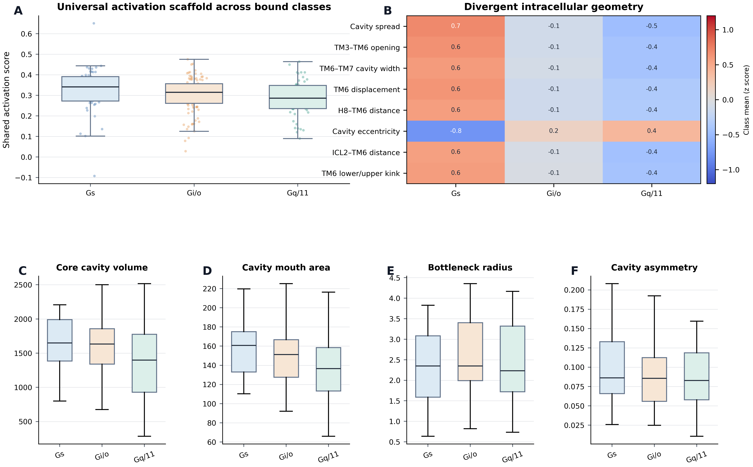
Figure S1 | Shared activation geometry coexists with broad class-dependent variation in the mature intracellular endpoint. (A) Gs, Gi/o, and Gq/11 complexes occupy overlapping distributions of a shared activation score. (B) Selected intracellular distances, displacements, loop geometry, and cavity descriptors show modest class-dependent shifts relative to broad within-class variation. (C–F) Core cavity volume, mouth area, bottleneck radius, and asymmetry distributions overlap across bound classes.
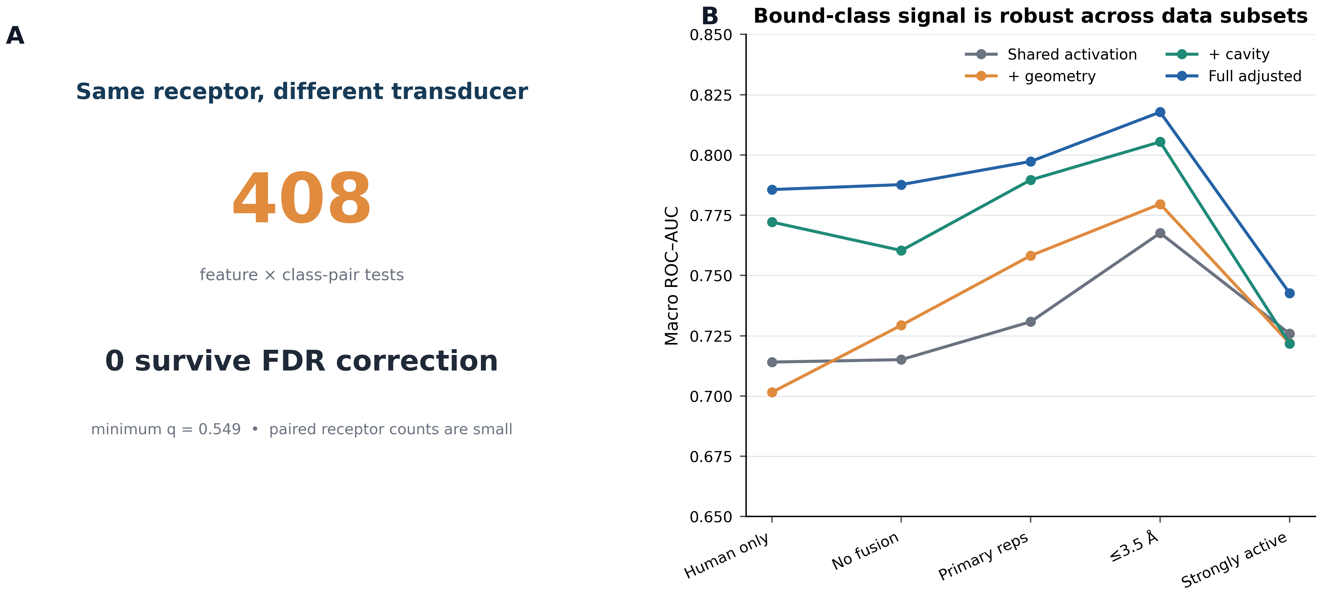

Figure S2 | Same-receptor tests and dataset robustness controls. (A) The 408 rows correspond to 136 structural features evaluated across three within-receptor captured-class pairs among receptors resolved with more than one transducer family. The eligible paired sets comprise 10 receptors for Gs versus Gi/o, 10 for Gs versus Gq/11 and 22 for Gi/o versus Gq/11; feature-specific n can be smaller because of missing measurements. Paired Wilcoxon signed-rank tests were used where estimable, with Benjamini-Hochberg correction across all finite P values. None survived false-discovery correction (minimum q = 0.549). Given the modest paired sample sizes and feature-specific missingness, this absence of FDR significance is not interpreted as evidence that no feature-level differences exist. Full per-comparison values and receptor inventories are supplied in Source Data S14. (B) Bound-class performance of shared activation, geometry, cavity and full adjusted representations across human-only, fusion-filtered, representative, resolution-filtered and strongly active subsets.
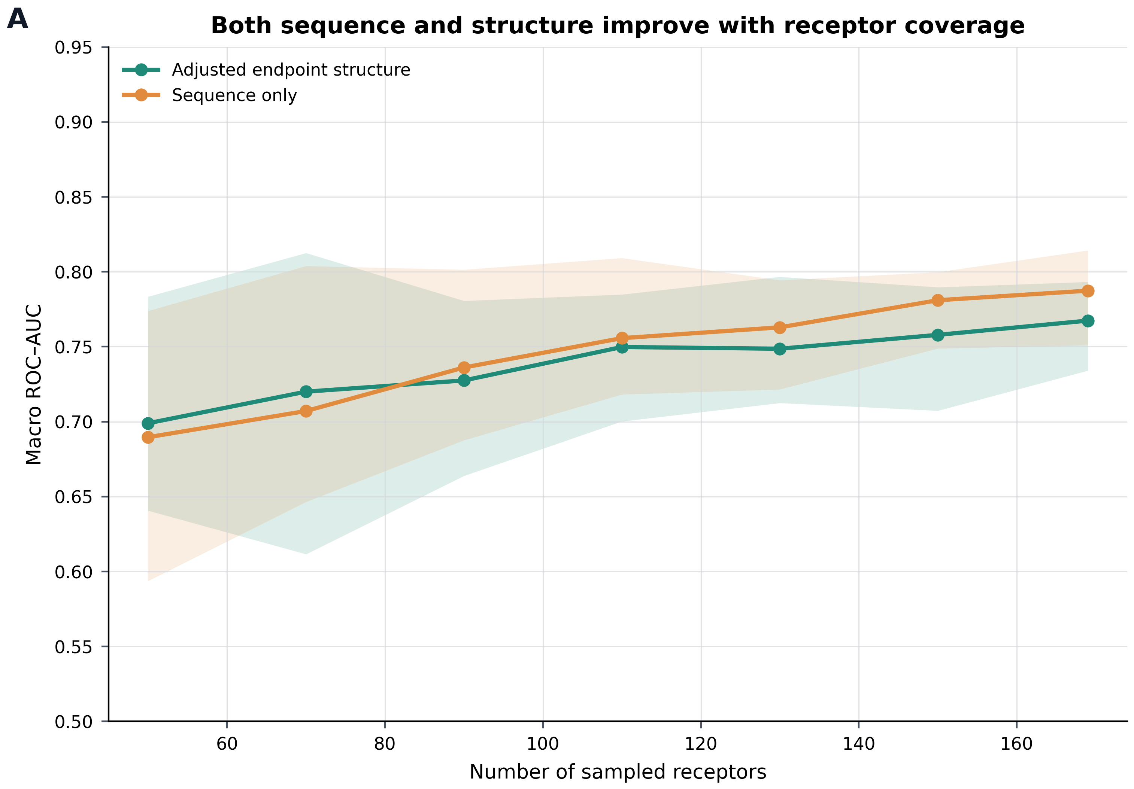
Figure S3 | Repeated nested L2 learning curve. Sequence and adjusted endpoint structure both improve with receptor coverage and show diminishing gains near the upper end of the observed range. Shaded regions show the empirical 95% intervals across repeated receptor samples; the analysis does not estimate an asymptotic ceiling.
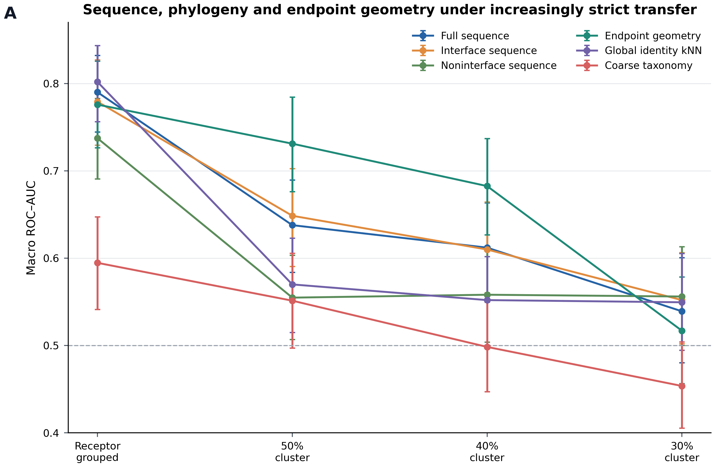
Figure S4 | Sequence, interface, phylogeny, and endpoint geometry under increasingly strict evolutionary transfer. Full sequence, interface sequence, noninterface sequence, endpoint geometry, global identity nearest neighbours, and coarse taxonomy are compared under receptor-grouped and sequence-cluster validation. Under ordinary receptor-grouped validation, the identity nearest-neighbour baseline is as strong as the learned representations, illustrating substantial evolutionary locality. At 50% identity, endpoint geometry exceeds full sequence with a paired interval excluding zero; at 40% the point estimate remains higher but the paired interval includes zero. At 30% identity, all representations are near chance and only two unequal folds satisfy class coverage, so this threshold is treated as an uncertainty limit rather than evidence for superiority of any representation.
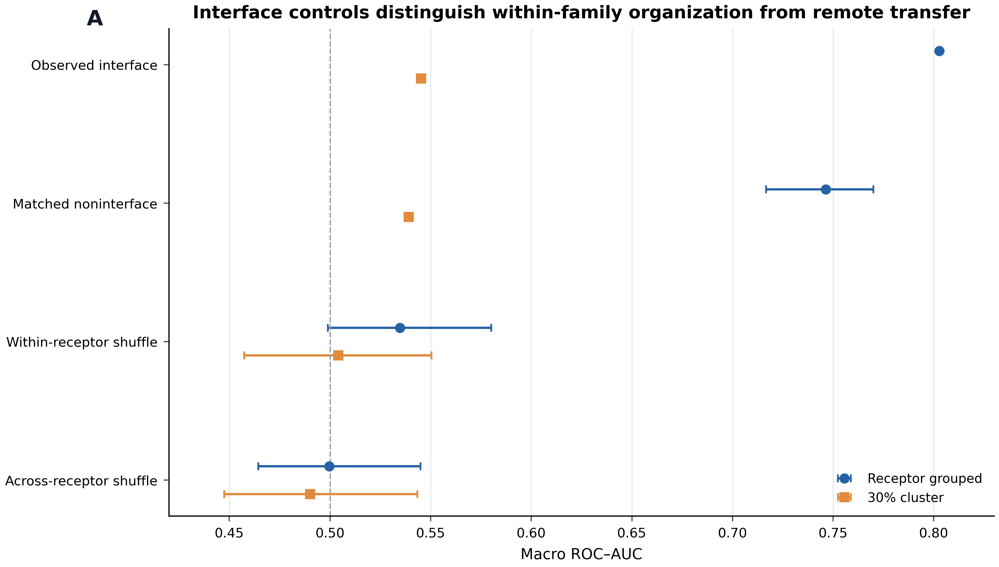
Figure S5 | Interface controls distinguish within-family organization from remote transfer. The observed interface sequence model is compared with conservation- and entropy-matched noninterface positions, within-receptor positional scrambling, and position-wise shuffling across receptors under receptor-grouped and 30% identity-cluster validation. The interface is organized within familiar evolutionary neighbourhoods but does not outperform the matched noninterface control under the strictest transfer.
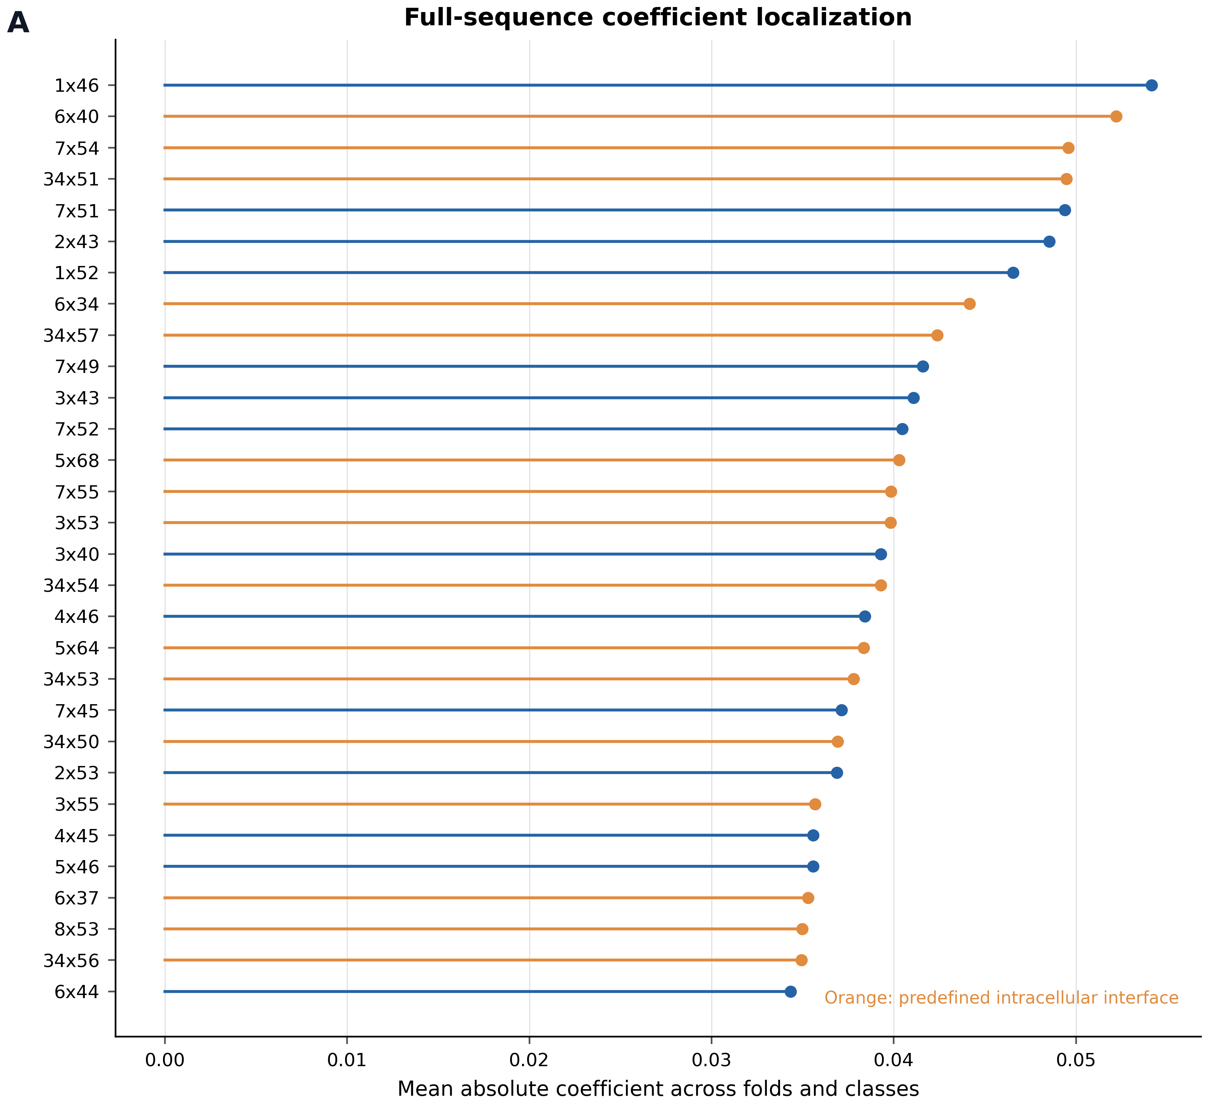
Figure S6 | Descriptive coefficient localization for the full-sequence model under receptor-grouped validation. The 30 positions with the largest mean absolute coefficients are shown; predefined intracellular interface positions are highlighted in orange. Localization is descriptive because enrichment is not stable across transfer conditions and is not interpreted as a universal causal code.

SUPPORTING INFORMATION TABLES

Table S1 | Complete derivation of the coordinate-level receptor-only set. Every class A GPCR structure in the record is accounted for at each stage. The initial coordinate-level screen yielded 15 receptor-class units from 12 receptors under the entity criteria; the specimen-level provenance audit added during revision is reported in Table S22.

Stage | Structures | Receptors | Basis
Experimental class A GPCR record | 1360 | - | PDB entries harmonised with GPCRdb/GproteinDb
Active or inactive state assigned | 1336 | 199 | activation analysis population
Active, no annotated transducer | 215 | 69 | candidates for receptor-only reference audit
Excluded: fusion construct | 76 | 33 | mmCIF polymer entity audit
Excluded: transducer contaminated | 36 | 19 | mmCIF polymer entity audit
Excluded: additional or unresolved polymer | 35 | 19 | mmCIF polymer entity audit
Excluded: auxiliary intracellular binder | 17 | 8 | mmCIF polymer entity audit
Strict receptor-only (coordinate-level) | 51 | 12 | receptor is sole polymer entity
Matched to a bound structure of the same receptor | 15 units | 12 | complete set; no further selection
Provenance audit: transducer-free specimen | 18 | 3 | deposited sample description, EMDB records and primary publication
Excluded: receptor-focused or local reconstruction from transducer-containing specimen | 32 | 9 | provenance audit (Table S22)
Excluded: inactive state in primary publication | 1 | 1 | provenance audit (Table S22)
Matched to a bound structure after provenance audit | 3 units | 3 | Gs 1, Gi/o 2, Gq/11 0; three-class comparison not estimable

Table S2 | Dataset populations and effective sample sizes.
Population | N | Definition
Structural record | 1360 | All experimental class A GPCR rows
Activation analysis | 1336 | Active or inactive structures
Activation receptors | 199 | Unique receptors
Bound class units | 207 | Gs, Gi/o, or Gq/11 receptor transducer units
Bound class receptors | 169 | Unique receptors
Ligand-permissive receptor-only | 58 | 15 receptors
Polymer-only receptor-only | 51 | 12 receptors
Functionally labelled receptor-only | 41 | 11 receptors

Table S3 | Recovery of the annotated receptor activation state.
Model | ROC AUC | CI low | CI high
Minimal four feature code | 0.996 | 0.989 | 1.000
Canonical geometry + ICL2 | 0.987 | 0.957 | 1.000
TM6 opening | 0.986 | 0.960 | 1.000
Metadata | 0.871 | 0.812 | 0.922
Availability | 0.543 | 0.479 | 0.612
ICL2 | 0.555 | 0.496 | 0.629

Table S4 | Matched sequence and endpoint structure models on identical receptor grouped folds.
Model | Macro ROC AUC | CI low | CI high | Log loss
geometry | 0.722 | 0.668 | 0.778 | 1.081
adjusted structure | 0.721 | 0.669 | 0.775 | 1.292
sequence | 0.797 | 0.754 | 0.840 | 0.844
sequence plus structure | 0.744 | 0.694 | 0.794 | 1.307
missingness | 0.630 | 0.573 | 0.683 | 1.056

Table S5 | Paired representation differences.
Baseline | Candidate | ΔAUC | CI low | CI high | Δ log loss
geometry | sequence | 0.075 | 0.020 | 0.128 | -0.236
adjusted structure | sequence | 0.075 | 0.023 | 0.130 | -0.447
sequence | sequence plus structure | -0.053 | -0.100 | -0.007 | 0.462
missingness | adjusted structure | 0.091 | 0.031 | 0.156 | 0.236

Table S6 | Fixed feature temporal holdout performance. Metadata models exclude deposition year.
Cutoff | Model | Train receptors | Test receptors | Macro ROC AUC | CI low | CI high
2023 | geometry | 90 | 79 | 0.703 | 0.630 | 0.778
2023 | sequence | 90 | 79 | 0.721 | 0.651 | 0.787
2023 | missingness | 90 | 79 | 0.675 | 0.593 | 0.753
2023 | metadata only (year excluded) | 90 | 79 | 0.527 | 0.453 | 0.606
2023 | geometry + metadata (year excluded) | 90 | 79 | 0.718 | 0.641 | 0.794
2024 | geometry | 134 | 35 | 0.744 | 0.642 | 0.851
2024 | sequence | 134 | 35 | 0.740 | 0.627 | 0.843
2024 | missingness | 134 | 35 | 0.724 | 0.576 | 0.843
2024 | metadata only (year excluded) | 134 | 35 | 0.582 | 0.443 | 0.717
2024 | geometry + metadata (year excluded) | 134 | 35 | 0.749 | 0.632 | 0.858

Table S7 | Bound and receptor-only coordinate representations. Original coordinate-level analysis; specimen provenance is reported separately in Tables S22 to S25.
Representation | Receptors | Macro ROC AUC | CI low | CI high
bound geometry | 12 | 0.795 | 0.655 | 0.944
receptor-only reference geometry | 12 | 0.619 | 0.414 | 0.792
deformation | 12 | 0.568 | 0.413 | 0.706
reference + difference | 12 | 0.637 | 0.437 | 0.878

Table S8 | Robustness and class composition of the bound versus receptor-only coordinate comparison. Original coordinate-level analysis; specimen provenance is reported separately in Tables S22 to S25.
Analysis | Gs | Gi/o | Gq/11 | Overall summary
Unit composition | 5 | 6 | 4 | 15 units from 12 receptors
Bound one-vs-rest ROC AUC | 0.920 | 0.852 | 0.614 | macro ROC AUC 0.795
Receptor-only reference one versus rest ROC AUC | 0.610 | 0.667 | 0.580 | macro ROC AUC 0.619
Bound minus reference delta AUC | 0.310 | 0.185 | 0.034 | macro delta AUC 0.176
Sensitivity analyses | — | — | — | 12/12 receptor omissions positive (0.130–0.250); 4/4 outer folds favoured bound geometry

Table S9 | Stable repeated L2 learning curve.
Model | Receptors | Mean AUC | Interval low | Interval high
sequence | 50 | 0.690 | 0.594 | 0.774
sequence | 70 | 0.707 | 0.646 | 0.804
sequence | 90 | 0.736 | 0.688 | 0.801
sequence | 110 | 0.756 | 0.718 | 0.809
sequence | 130 | 0.763 | 0.722 | 0.794
sequence | 150 | 0.781 | 0.749 | 0.800
sequence | 169 | 0.787 | 0.751 | 0.814
adjusted structure | 50 | 0.699 | 0.641 | 0.783
adjusted structure | 70 | 0.720 | 0.612 | 0.813
adjusted structure | 90 | 0.727 | 0.664 | 0.781
adjusted structure | 110 | 0.750 | 0.700 | 0.785
adjusted structure | 130 | 0.749 | 0.712 | 0.797
adjusted structure | 150 | 0.758 | 0.707 | 0.790
adjusted structure | 169 | 0.767 | 0.734 | 0.793

Table S10 | Coordinate-level receptor-only entity audit summary. Counts below are nonexclusive definitions or audit flags and should not be summed. The ordered, mutually exclusive attrition used to derive the strict matched population is reported in Table S1.
Audit category | Structures | Receptors
Original active transducer none candidates | 215 | 69
Strict polymer only | 51 | 12
Ligand-permissive receptor-only | 58 | 15
Functionally evaluable primary | 41 | 11
Auxiliary intracellular binder flag | 22 | 11
Fusion construct flag | 84 | 34
Transducer contamination flag | 51 | 22

Table S11 | Full static receptor feature extension.
Model | Macro ROC AUC | CI low | CI high | Log loss
existing geometry | 0.778 | 0.727 | 0.825 | 0.933
sequence | 0.805 | 0.760 | 0.843 | 0.801
missingness | 0.609 | 0.546 | 0.670 | 1.128
contact network | 0.662 | 0.604 | 0.713 | 1.029
surface / electrostatics | 0.713 | 0.658 | 0.765 | 0.994
mechanical susceptibility | 0.643 | 0.591 | 0.697 | 1.122
all new static | 0.729 | 0.674 | 0.779 | 1.008
sequence + new static | 0.751 | 0.697 | 0.803 | 1.015
geometry + new static | 0.780 | 0.725 | 0.829 | 0.887

Table S12 | Paired incremental value of the static feature extension.
Baseline | Candidate | ΔAUC | CI low | CI high | Δ log loss
missingness | contact network | 0.053 | -0.018 | 0.130 | -0.099
missingness | surface / electrostatics | 0.104 | 0.031 | 0.174 | -0.134
missingness | mechanical susceptibility | 0.034 | -0.039 | 0.101 | -0.006
missingness | all new static | 0.120 | 0.050 | 0.189 | -0.120
existing geometry | all new static | -0.049 | -0.104 | 0.007 | 0.075
sequence | all new static | -0.077 | -0.123 | -0.032 | 0.207
sequence | sequence + new static | -0.054 | -0.092 | -0.016 | 0.214
existing geometry | geometry + new static | 0.002 | -0.035 | 0.037 | -0.046

Table S13 | Exploratory transfer to coordinate-level receptor-only reference sets. Original coordinate-level analysis; specimen provenance is reported separately in Tables S22 to S25.
Definition | Model | Receptors | Macro ROC AUC | CI low | CI high
ligand permissive | all new static | 11 | 0.430 | 0.244 | 0.646
ligand permissive | existing geometry | 11 | 0.640 | 0.304 | 0.958
ligand permissive | mechanical susceptibility | 11 | 0.644 | 0.333 | 0.900
ligand permissive | sequence | 11 | 0.812 | 0.622 | 0.983
ligand permissive | surface / electrostatics | 11 | 0.596 | 0.394 | 0.822
polymer only | all new static | 9 | 0.383 | 0.153 | 0.595
polymer only | existing geometry | 9 | 0.644 | 0.276 | 0.944
polymer only | mechanical susceptibility | 9 | 0.622 | 0.333 | 0.867
polymer only | sequence | 9 | 0.820 | 0.579 | 1.000
polymer only | surface / electrostatics | 9 | 0.639 | 0.410 | 0.944

Table S14 | GPCR SelectivityMap scope and claim boundary.
Module | Status | Scope
Static geometry | Included | Endpoint distances, microswitches, ICL2, H8, and intracellular cavity
Contact networks | Included | Static receptor side chain and generic position interaction networks
Surface and electrostatics | Included | Static surface chemistry and transparent approximate Coulombic descriptors
Elastic network susceptibility | Included | Static low frequency mode summaries, not molecular dynamics
Molecular dynamics trajectories | Excluded | Reserved for independent trajectory based work
Rigid body motion and kinetics | Excluded | No helix rotation trajectories, transition rates, or Markov models
Functional coupling probabilities | Not claimed | Association and compatibility scores are not calibrated functional probabilities
Phylogeny-aware benchmarking | Included | Receptor grouping, 50%, 40%, and 30% identity clusters, identity kNN, taxonomy, and interface controls
Label provenance and interpretation gates | Included | Tracks evidence source and separates association, family constrained signal, transfer, and insufficient evidence
Receptor Gα physicochemical compatibility | Exploratory | Optional hydropathy, charge, and steric audit; not used for the central manuscript claim
Publication reporting | Included | CSV, TSV, JSON, SVG, PNG, HTML, manifests, figures, and audit tables

Table S15 | Sequence, global-identity baseline, and endpoint-geometry transfer performance under receptor-grouped and sequence-cluster validation.
Validation | Model | Macro ROC AUC | CI low | CI high | Valid folds
Receptor grouped | full sequence | 0.790 | 0.744 | 0.832 | 5
Receptor grouped | interface sequence | 0.779 | 0.729 | 0.827 | 5
Receptor grouped | noninterface sequence | 0.737 | 0.691 | 0.783 | 5
Receptor grouped | endpoint geometry | 0.776 | 0.726 | 0.826 | 5
Receptor grouped | identity kNN | 0.802 | 0.756 | 0.844 | 5
Receptor grouped | coarse taxonomy | 0.595 | 0.541 | 0.647 | 5
50% cluster | full sequence | 0.638 | 0.584 | 0.690 | 5
50% cluster | interface sequence | 0.649 | 0.591 | 0.703 | 5
50% cluster | noninterface sequence | 0.555 | 0.507 | 0.603 | 5
50% cluster | endpoint geometry | 0.731 | 0.676 | 0.784 | 5
50% cluster | identity kNN | 0.570 | 0.515 | 0.623 | 5
50% cluster | coarse taxonomy | 0.551 | 0.497 | 0.606 | 5
40% cluster | full sequence | 0.612 | 0.560 | 0.663 | 5
40% cluster | interface sequence | 0.610 | 0.560 | 0.664 | 5
40% cluster | noninterface sequence | 0.558 | 0.504 | 0.609 | 5
40% cluster | endpoint geometry | 0.683 | 0.627 | 0.737 | 5
40% cluster | identity kNN | 0.552 | 0.500 | 0.602 | 5
40% cluster | coarse taxonomy | 0.498 | 0.447 | 0.550 | 5
30% cluster | full sequence | 0.539 | 0.480 | 0.600 | 2
30% cluster | interface sequence | 0.552 | 0.502 | 0.606 | 2
30% cluster | noninterface sequence | 0.556 | 0.500 | 0.613 | 2
30% cluster | endpoint geometry | 0.517 | 0.456 | 0.578 | 2
30% cluster | identity kNN | 0.550 | 0.494 | 0.605 | 2
30% cluster | coarse taxonomy | 0.454 | 0.405 | 0.504 | 2

Table S16 | Paired representation differences. Negative full-sequence-minus-geometry values favour geometry. The 50% identity interval excludes zero; the 40% and 30% intervals do not. Only two valid folds were available at 30% identity.
Validation | Comparison | ΔAUC | CI low | CI high | Δ log loss
Receptor grouped | Full sequence minus geometry | 0.014 | -0.037 | 0.065 | -0.062
Receptor grouped | Interface minus noninterface | 0.042 | -0.005 | 0.090 | 0.048
Receptor grouped | Interface minus identity kNN | -0.023 | -0.063 | 0.019 | 0.113
30% cluster | Full sequence minus geometry | 0.022 | -0.061 | 0.101 | -0.020
30% cluster | Interface minus noninterface | -0.004 | -0.068 | 0.062 | -0.321
30% cluster | Interface minus identity kNN | 0.002 | -0.052 | 0.055 | -0.161
40% cluster | Full sequence minus geometry | -0.070 | -0.141 | 0.004 | 0.189
50% cluster | Full sequence minus geometry | -0.093 | -0.162 | -0.025 | 0.098

Table S17 | Interface matched and scrambling controls.
Validation | Control | Iterations | Mean AUC | Interval low | Interval high
Receptor grouped | Interface fixed L2 | 1 | 0.803 | 0.803 | 0.803
30% cluster | Interface fixed L2 | 1 | 0.545 | 0.545 | 0.545
Receptor grouped | Matched noninterface | 50 | 0.746 | 0.717 | 0.770
30% cluster | Matched noninterface | 50 | 0.539 | 0.539 | 0.539
Receptor grouped | Across receptor shuffle | 50 | 0.500 | 0.464 | 0.545
30% cluster | Across receptor shuffle | 50 | 0.490 | 0.447 | 0.543
Receptor grouped | Within receptor shuffle | 50 | 0.535 | 0.499 | 0.580
30% cluster | Within receptor shuffle | 50 | 0.504 | 0.457 | 0.550

Table S18 | Descriptive interface coefficient enrichment.
Model | Validation | Positions | Interface positions | Observed difference | Permutation p
Full sequence | Receptor grouped | 64 | 30 | 0.0021 | 0.188
Full sequence | 30% cluster | 64 | 30 | 0.0054 | 0.040
Full sequence | 40% cluster | 64 | 30 | 0.0006 | 0.413
Full sequence | 50% cluster | 64 | 30 | 0.0019 | 0.201
Full sequence, single transducer | single transducer receptor grouped | 64 | 30 | 0.0044 | 0.134
Sequence plus geometry | Receptor grouped | 77 | 28 | -0.0102 | 0.996
Sequence plus geometry | 30% cluster | 77 | 28 | -0.0089 | 0.997
Sequence plus geometry | 40% cluster | 77 | 28 | -0.0100 | 0.996
Sequence plus geometry | 50% cluster | 77 | 28 | -0.0124 | 0.996

Table S19 | Granularity and label provenance audit.
Item | Audit result | Interpretation
Primary bound class labels | Direct structural observation | G protein family physically present in each deposited complex
Representative unit | Receptor by transducer family | One selected bound structure per receptor and transducer family unit
Promiscuous receptors | Multiple rows with identical sequence | Identical receptor sequence may correspond to different bound classes
Functional receptor-only reference labels | Consensus and manual curation | Current table does not resolve direct measurement versus homology inference for every family label
30% sequence cluster transfer | Two valid folds | Interpreted as no evidence of remote transfer, not proof of absence

Table S20 | Paired per-receptor test of the coordinate-level receptor-only comparison. Original coordinate-level analysis; specimen provenance is reported separately in Tables S22 to S25.
Coordinate-level analysis. Units were averaged within receptor before testing, so n = 12 independent receptors. Classification margin is the primary receptor-level score. Positive counts are receptors with a larger score at the bound endpoint. The exact two-sided sign-flip permutation is the principal receptor-level inferential test; the sign test and Wilcoxon signed-rank test are reported as sensitivity analyses. These values quantify the receptor-only versus full-complex coordinate comparison and are not interpreted as an experimentally partner-free versus bound biological contrast.
Coordinate-level margin: 11 of 12 positive; mean difference 0.389; 95% CI 0.095 to 0.682; median 0.283; exact sign-flip permutation P = 0.030. Sensitivity tests: sign test P = 0.006; Wilcoxon signed-rank P = 0.021.
Probability of true class: 11 of 12 positive; mean difference 0.234; 95% CI 0.083 to 0.391; sign test P = 0.006; Wilcoxon signed rank P = 0.009.
Rank of true class: 6 of 6 effective comparisons positive, with 6 ties; mean difference 0.667; sign test P = 0.031.
Sensitivity, single unit receptors only (n = 9, excluding LPA1, MRGPRX2 and TAAR1, which share one partner-free reference across two units each): 8 of 9 positive; mean difference 0.488; Wilcoxon signed rank P = 0.074.
Per receptor values are provided in paired_per_receptor_deltas.csv and the exact analysis is reproduced by paired_analysis.py.

Table S21 | Structural descriptor conventions. The complete 92-feature dictionary, with block, quantity type, units, generic positions and missingness handling, is supplied as matched_92_feature_dictionary.tsv in Supporting Source Data.
Descriptor | Unit | Definition
Distance | Å | Residue-pair distances are Cα-Cα or explicitly named atom or centroid distances.
Minimum distance | Å | Features ending in min_distance are minimum heavy-atom separations.
χ1 / χ2 | degrees | Standard side-chain dihedral angles where the required atoms are resolved.
Aligned displacement | Å | Position change after alignment to conserved receptor transmembrane reference coordinates.
TM3 3.50-TM6 6.34 | Å | Distance between generic positions 3.50 and 6.34.
TM3-TM7 | Å | Intracellular TM3 to TM7 distance used in the compact activation code.
PIF 5.50-6.44 | Å | Distance between generic positions 5.50 and 6.44.
Y7.53 displacement | Å | Aligned displacement of the residue at generic position 7.53.
DRY 3.50-6.30 minimum | Å | Minimum heavy-atom separation between generic positions 3.50 and 6.30.
ICL2 helix fraction | fraction | Fraction of resolved ICL2 residues assigned to helical geometry.
ICL2 centroid-TM6 6.34 | Å | Distance from the resolved ICL2 centroid to generic position 6.34.
TM7-H8 angle | degrees | Orientation of the TM7 and helix 8 intracellular geometry.
Core cavity mouth area | Å² | Cross-sectional area of the connected solvent-accessible intracellular cavity at the mouth.
Other core cavity metrics | Å, Å², Å³ or dimensionless | Connected-cavity volume, surface area, depth, widths and radii, principal dimensions, shape and asymmetry, and wall fractions in a fixed receptor-centred envelope.

Table S22 | Specimen-level provenance audit of the 51 receptor-only coordinate models that passed the polymer-entity screen. Each structure is classified using the deposited entry title, EM sample description, EMDB and PDB relationships, particle counts and the primary publication. Row-level evidence, including deposited titles, sample descriptions, particle counts and source links, is supplied in Source Data S14.
Receptor | PDB:chain | Method | Classification | Evidence
A2A receptor | 2YDO:A | X-ray | Transducer-free specimen | Thermostabilised agonist-bound A2A receptor crystal; no intracellular transducer in specimen/model.
A2A receptor | 2YDV:A | X-ray | Transducer-free specimen | Thermostabilised agonist-bound A2A receptor crystal; no intracellular transducer in specimen/model.
A2A receptor | 4UG2:A | X-ray | Transducer-free specimen | Thermostabilised agonist-bound A2A receptor crystal; no intracellular transducer in specimen/model.
A2A receptor | 4UHR:A | X-ray | Transducer-free specimen | Thermostabilised agonist-bound A2A receptor crystal; no intracellular transducer in specimen/model.
GPR101 | 8W8S:R | Electron microscopy | Receptor-focused or local reconstruction, transducer-containing specimen | Locally refined AA14-GPR101 receptor model; particle count matches AA14-GPR101-Gs entry 8W8R.
GPR34 | 8IYX:C | Electron microscopy | Inactive in primary publication | Antagonist YL-365-bound GPR34 structure; primary publication explicitly describes it as inactive.
GPR34 | 8XBG:A | Electron microscopy | Receptor-focused or local reconstruction, transducer-containing specimen | PDB title explicitly identifies GPR34-Gi complex receptor-focused; particle count matches full complex 8XBE.
GPR34 | 8XBI:R | Electron microscopy | Receptor-focused or local reconstruction, transducer-containing specimen | PDB title explicitly identifies GPR34-Gi complex receptor-focused; particle count matches full complex 8XBH.
HCA2 receptor | 8K5B:A | Electron microscopy | Receptor-focused or local reconstruction, transducer-containing specimen | PDB title says local refinement; source paper reports three ligand-bound HCAR2-Gi signalling complexes.
HCA2 receptor | 8K5C:A | Electron microscopy | Receptor-focused or local reconstruction, transducer-containing specimen | Local HCAR2 refinement; particle count matches full HCAR2-Gi entry 8I7V.
HCA2 receptor | 8K5D:A | Electron microscopy | Receptor-focused or local reconstruction, transducer-containing specimen | Local HCAR2 refinement; particle count matches full HCAR2-Gi entry 8I7W.
LPA1 receptor | 7YU4:A | Electron microscopy | Receptor-focused or local reconstruction, transducer-containing specimen | PDB title explicitly identifies LPA1-Gi complex focused on receptor.
M3 receptor | 8EA0:A | Electron microscopy | Receptor-focused or local reconstruction, transducer-containing specimen | PDB title explicitly identifies miniGq-coupled M3 receptor local refinement.
MRGPRX2 | 7VV6:R | Electron microscopy | Receptor-focused or local reconstruction, transducer-containing specimen | MRGPRX2 receptor local reconstruction from a receptor-complex cryo-EM study; not an independent partner-free specimen.
TAAR1 | 8WCC:R | Electron microscopy | Receptor-focused or local reconstruction, transducer-containing specimen | CHA-mTAAR1 receptor reconstruction has the same 296,951 particles as CHA-mTAAR1-Gq entry 8WCB.
TAAR9 | 8IWE:R | Electron microscopy | Receptor-focused or local reconstruction, transducer-containing specimen | Receptor-focused TAAR9 reconstruction; particle count matches SPE-mTAAR9-Gs full-complex entry 8IW4.
TAAR9 | 8IWM:R | Electron microscopy | Receptor-focused or local reconstruction, transducer-containing specimen | Receptor-focused TAAR9 reconstruction; particle count matches PEA-mTAAR9-Gs full-complex entry 8IW7.
rhodopsin | 3CAP:A | X-ray | Transducer-free specimen | Native ligand-free opsin crystal; no intracellular transducer.
rhodopsin | 3PXO:A | X-ray | Transducer-free specimen | Metarhodopsin II-alone crystal; related peptide-bound structure is a separate PDB entry.
rhodopsin | 4BEZ:A | X-ray | Transducer-free specimen | G90D rhodopsin active-conformation crystal; no intracellular transducer.
rhodopsin | 5DYS:A | X-ray | Transducer-free specimen | T94I rhodopsin crystal; no intracellular transducer.
rhodopsin | 5TE3:A | X-ray | Transducer-free specimen | Opsin crystal; no intracellular transducer.
rhodopsin | 6FK6:A | X-ray | Transducer-free specimen | Pharmacologically stabilised opsin crystal; small-molecule ligand, no intracellular transducer.
rhodopsin | 6FK7:A | X-ray | Transducer-free specimen | Pharmacologically stabilised opsin crystal; small-molecule ligand, no intracellular transducer.
rhodopsin | 6FK8:A | X-ray | Transducer-free specimen | Pharmacologically stabilised opsin crystal; small-molecule ligand, no intracellular transducer.
rhodopsin | 6FK9:A | X-ray | Transducer-free specimen | Pharmacologically stabilised opsin crystal; small-molecule ligand, no intracellular transducer.
rhodopsin | 6FKA:A | X-ray | Transducer-free specimen | Pharmacologically stabilised opsin crystal; small-molecule ligand, no intracellular transducer.
rhodopsin | 6FKB:A | X-ray | Transducer-free specimen | Pharmacologically stabilised opsin crystal; small-molecule ligand, no intracellular transducer.
rhodopsin | 6FKC:A | X-ray | Transducer-free specimen | Pharmacologically stabilised opsin crystal; small-molecule ligand, no intracellular transducer.
rhodopsin | 6FKD:A | X-ray | Transducer-free specimen | Pharmacologically stabilised opsin crystal; small-molecule ligand, no intracellular transducer.
β2-adrenoceptor | 8GGI:R | Electron microscopy | Receptor-focused or local reconstruction, transducer-containing specimen | PDB title explicitly states locally refined receptor from beta2AR-Gs complex transition intermediate.
β2-adrenoceptor | 8GGJ:R | Electron microscopy | Receptor-focused or local reconstruction, transducer-containing specimen | PDB title explicitly states locally refined receptor from beta2AR-Gs complex transition intermediate.
β2-adrenoceptor | 8GGK:R | Electron microscopy | Receptor-focused or local reconstruction, transducer-containing specimen | PDB title explicitly states locally refined receptor from beta2AR-Gs complex transition intermediate.
β2-adrenoceptor | 8GGL:R | Electron microscopy | Receptor-focused or local reconstruction, transducer-containing specimen | PDB title explicitly states locally refined receptor from beta2AR-Gs complex transition intermediate.
β2-adrenoceptor | 8GGM:R | Electron microscopy | Receptor-focused or local reconstruction, transducer-containing specimen | PDB title explicitly states locally refined receptor from beta2AR-Gs complex transition intermediate.
β2-adrenoceptor | 8GGN:R | Electron microscopy | Receptor-focused or local reconstruction, transducer-containing specimen | PDB title explicitly states locally refined receptor from beta2AR-Gs complex transition intermediate.
β2-adrenoceptor | 8GGO:R | Electron microscopy | Receptor-focused or local reconstruction, transducer-containing specimen | PDB title explicitly states locally refined receptor from beta2AR-Gs complex transition intermediate.
β2-adrenoceptor | 8GGP:R | Electron microscopy | Receptor-focused or local reconstruction, transducer-containing specimen | PDB title explicitly states locally refined receptor from beta2AR-Gs complex transition intermediate.
β2-adrenoceptor | 8GGQ:R | Electron microscopy | Receptor-focused or local reconstruction, transducer-containing specimen | PDB title explicitly states locally refined receptor from beta2AR-Gs complex transition intermediate.
β2-adrenoceptor | 8GGR:R | Electron microscopy | Receptor-focused or local reconstruction, transducer-containing specimen | PDB title explicitly states locally refined receptor from beta2AR-Gs complex transition intermediate.
β2-adrenoceptor | 8GGS:R | Electron microscopy | Receptor-focused or local reconstruction, transducer-containing specimen | PDB title explicitly states locally refined receptor from beta2AR-Gs complex transition intermediate.
β2-adrenoceptor | 8GGT:R | Electron microscopy | Receptor-focused or local reconstruction, transducer-containing specimen | PDB title explicitly states locally refined receptor from beta2AR-Gs complex transition intermediate.
β2-adrenoceptor | 8GGU:R | Electron microscopy | Receptor-focused or local reconstruction, transducer-containing specimen | PDB title explicitly states locally refined receptor from beta2AR-Gs complex transition intermediate.
β2-adrenoceptor | 8GGV:R | Electron microscopy | Receptor-focused or local reconstruction, transducer-containing specimen | PDB title explicitly states locally refined receptor from beta2AR-Gs complex transition intermediate.
β2-adrenoceptor | 8GGW:R | Electron microscopy | Receptor-focused or local reconstruction, transducer-containing specimen | PDB title explicitly states locally refined receptor from beta2AR-Gs complex transition intermediate.
β2-adrenoceptor | 8GGX:R | Electron microscopy | Receptor-focused or local reconstruction, transducer-containing specimen | PDB title explicitly states locally refined receptor from beta2AR-Gs complex transition intermediate.
β2-adrenoceptor | 8GGY:R | Electron microscopy | Receptor-focused or local reconstruction, transducer-containing specimen | PDB title explicitly states locally refined receptor from beta2AR-Gs complex transition intermediate.
β2-adrenoceptor | 8GGZ:R | Electron microscopy | Receptor-focused or local reconstruction, transducer-containing specimen | PDB title explicitly states locally refined receptor from beta2AR-Gs complex transition intermediate.
β2-adrenoceptor | 8GH0:R | Electron microscopy | Receptor-focused or local reconstruction, transducer-containing specimen | PDB title explicitly states locally refined receptor from beta2AR-Gs complex transition intermediate.
β2-adrenoceptor | 8GH1:R | Electron microscopy | Receptor-focused or local reconstruction, transducer-containing specimen | PDB title explicitly states locally refined receptor from beta2AR-Gs complex transition intermediate.
δ receptor | 6PT3:A | X-ray | Transducer-free specimen | Active DOP crystal with small-molecule agonist DPI-287; no intracellular transducer.

Table S23 | PDB identifiers and chains for the originally audited receptor-level coordinate pairs, with specimen-provenance category of the receptor-only references. Under the stricter specimen-level definition, only the A2A receptor (Gs), the δ receptor (Gi/o) and rhodopsin (Gi/o) retain experimentally partner-free active references.
Receptor | Captured class | Bound PDB:chain | Receptor-only reference PDB:chain | Reference provenance
A2A receptor | Gs | 5G53:B | 2YDO:A; 2YDV:A; 4UG2:A; 4UHR:A | Transducer-free
M3 receptor | Gq/11 | 8E9W:A | 8EA0:A | Receptor-focused reconstruction, transducer-containing specimen
β2-adrenoceptor | Gs | 8GG0:R | 8GGI:R to 8GH1:R (20 structures, chain R) | Receptor-focused reconstruction, transducer-containing specimen
GPR101 | Gs | 8W8Q:C | 8W8S:R | Receptor-focused reconstruction, transducer-containing specimen
GPR34 | Gi/o | 8XBH:R | 8IYX:C; 8XBG:A; 8XBI:R | Mixed: receptor-focused and inactive
HCA2 receptor | Gi/o | 8J6J:R | 8K5B:A; 8K5C:A; 8K5D:A | Receptor-focused reconstruction, transducer-containing specimen
LPA1 receptor | Gi/o | 7TD0:R | 7YU4:A | Receptor-focused reconstruction, transducer-containing specimen
LPA1 receptor | Gq/11 | 9IZG:R | 7YU4:A | Receptor-focused reconstruction, transducer-containing specimen
MRGPRX2 | Gi/o | 7VV5:R | 7VV6:R | Receptor-focused reconstruction, transducer-containing specimen
MRGPRX2 | Gq/11 | 7S8L:R | 7VV6:R | Receptor-focused reconstruction, transducer-containing specimen
δ receptor | Gi/o | 8F7S:R | 6PT3:A | Transducer-free
rhodopsin | Gi/o | 4X1H:A | 3CAP:A; 3PXO:A; 4BEZ:A; 5DYS:A; 5TE3:A; 6FK6:A to 6FKD:A | Transducer-free
TAAR1 | Gq/11 | 8WCB:R | 8WCC:R | Receptor-focused reconstruction, transducer-containing specimen
TAAR1 | Gs | 8ZSV:R | 8WCC:R | Receptor-focused reconstruction, transducer-containing specimen
TAAR9 | Gs | 8IW9:R | 8IWE:R; 8IWM:R | Receptor-focused reconstruction, transducer-containing specimen

Table S24 | Feasibility of the three-class matched comparison under the strict specimen-level partner-free definition. Receptor-grouped evaluation requires each class to be represented by at least two receptors, so that every held-out receptor has a same-class receptor in its training data. The strict specimen-level subset contains three receptors (one Gs, two Gi/o and no Gq/11), so the prespecified three-class model was not fitted for that subset.
Inventory | Receptor-only reference structures | Receptors | Gs receptors | Gi/o receptors | Gq/11 receptors | Three-class comparison
Strict (polymer only) | 18 | 3 | 1 | 2 | 0 | Not estimable
Terminal-fusion sensitivity | 20 | 4 | 1 | 3 | 0 | Not estimable
Ligand-permissive sensitivity | 20 | 4 | 1 | 3 | 1 | Not estimable; Gs and Gq/11 each in one receptor
Terminal-fusion and ligand-permissive | 23 | 6 | 1 | 5 | 1 | Not estimable; Gs and Gq/11 each in one receptor
Note. Class-specific receptor counts are not additive because one receptor can contribute more than one captured-class unit. In the ligand-permissive inventory, US28 contributes both Gi/o and Gq/11, so 1 Gs + 3 Gi/o + 1 Gq/11 corresponds to 4 unique receptors. In the terminal-fusion and ligand-permissive inventory, the NTS1 receptor contributes both Gi/o and Gq/11, so 1 + 5 + 1 class-specific counts correspond to 6 unique receptors.

Table S25 | Description of the coordinate-level receptor result by specimen-provenance category, with same-particle controls. Values are receptor-level classification-margin differences (full complex minus receptor-only coordinate model). Exact sign-flip P values are reported only where at least five independent receptor-level values were available. The coordinate-level result is reported descriptively as a difference between deposited structural endpoints; it is not interpreted as an experimentally partner-free versus bound biological contrast or assigned specifically to specimen transducer status.
Group | Receptors | Positive | Mean difference | Sign-flip P
Original 12 receptors, receptor-only references versus full complexes | 12 | 11/12 | +0.389 | 0.030
Transducer-free references | 3 | 3/3 | +0.934 | n/a (descriptive; n=3)
Receptor-focused references from transducer-containing specimens | 8 | 7/8 | +0.148 | 0.31
Mixed references (GPR34) | 1 | 1/1 | +0.679 | n/a
Receptors whose references include same-particle reconstructions | 5 | 5/5 | +0.377 | 0.063
Same-particle focused versus full models, archive-trained 92-feature classifier | 5 | 2/5 | -0.160 | 0.75
As above, excluding training receptors with at least 50% identity | 5 | 2/5 | +0.002 | 0.88
Same-particle pairs, original two-model framework, 92 features | 5 | 4/5 | +0.124 | 0.69
Same-particle pairs, original two-model framework, four-feature code | 5 | 4/5 | +0.300 | 0.13
The positive direction was also present for receptors whose receptor-only coordinate models derive from transducer-containing specimens (7 of 8; mean difference +0.148; P = 0.31), where there is no experimentally partner-free versus bound contrast. For focused and full reconstructions of the same particles, the original two-model framework gave positive differences in 4 of 5 receptor pairs, whereas a single archive-trained 92-feature classifier did not show a consistent positive difference (2 of 5; mean difference -0.160; P = 0.75). These controls show why coordinate-level endpoint comparisons and specimen-level biological provenance should be distinguished; the same-particle analyses are descriptive controls and do not assign the 12-receptor difference specifically to specimen transducer status. The 5/5 row above is the original endpoint comparison restricted to the five receptors for which same-particle reconstructions are available; the 2/5 row is a different, direct focused-versus-full reconstruction comparison scored with one common archive-trained classifier.

Table S26 | Functional-repertoire and G12/13 structural context.
Item | Count | Interpretation
Bound structural archive | 207 units / 169 receptors | Gs, Gi/o and Gq/11 structural labels
Direct Hauser et al. (2022) human UniProt matches | 190 units / 156 receptors | Non-human and viral entries left unannotated
Mapped units with captured family supported in common map | 162 / 190 (85.3%) | 28 / 190 lacked map support for the captured family; absence of support is not proof of non-coupling
Units from receptors supporting at least two modelled families | 101 / 207 (48.8%) | Gs, Gi/o and Gq/11 support in the common coupling map
Mapped units from receptors supporting at least two modelled families | 101 / 190 (53.2%) | Denominator restricted to directly mapped human units
Unmapped functional repertoire | 17 units / 13 receptors | Non-human or viral; no orthologue substitution
G12/13 structural census | 7 structures / 5 receptors | GPR35, GPR55, LPA1, P2Y10, S1P2
G12/13 receptors with an experimentally partner-free active reference | 0 | The only entity-eligible reference (LPA1, 7YU4) is a receptor-focused reconstruction from an LPA1-Gi specimen

Table S27 | Master ROC AUC table for the designated primary benchmarks and identity-cluster confound controls. The activation identity-cluster analysis uses the 169-receptor overlap with available sequence-cluster assignments; captured-class rows use the frozen 207-unit archive.
Question | Validation | Model/control | ROC AUC | CI low | CI high | Population
Activation state | receptor-grouped LORO, structure level | four-feature geometry | 0.998 | 0.995 | 1.000 | 1,336 structures / 199 receptors
Activation state | 50% identity clusters | four-feature geometry | 0.998 | 0.992 | 1.000 | 1,230 structures / 169 receptors
Activation state | 40% identity clusters | four-feature geometry | 0.998 | 0.998 | 1.000 | 1,230 structures / 169 receptors
Captured class | receptor grouped | endpoint geometry | 0.776 | 0.726 | 0.826 | 207 units / 169 receptors
Captured class | receptor grouped | full sequence | 0.790 | 0.744 | 0.832 | 207 units / 169 receptors
Captured class | 50% identity clusters | endpoint geometry | 0.731 | 0.676 | 0.784 | 207 units / 169 receptors
Captured class | 50% identity clusters | full sequence | 0.638 | 0.584 | 0.690 | 207 units / 169 receptors
Captured class | 40% identity clusters | endpoint geometry | 0.683 | 0.627 | 0.737 | 207 units / 169 receptors
Captured class | 40% identity clusters | full sequence | 0.612 | 0.560 | 0.663 | 207 units / 169 receptors
Captured-class control | 40% identity clusters | metadata only | 0.562 | 0.497 | 0.626 | 207 units / 169 receptors
Captured-class control | 50% identity clusters | metadata only | 0.546 | 0.487 | 0.641 | 207 units / 169 receptors
Captured-class control | 40% identity clusters | missingness only | 0.493 | 0.391 | 0.577 | 207 units / 169 receptors
Captured-class control | 50% identity clusters | missingness only | 0.515 | 0.429 | 0.586 | 207 units / 169 receptors
Note. Activation rows are evaluated at structure level. The corresponding receptor-state-level value for the four-feature code under leave-one-receptor-out validation is ROC AUC 0.996 (95% CI 0.989 to 1.000) and is the value reported in Table S3 and Figure 2A; the two differ only in the aggregation level, not in the model or the fold structure. Captured-class rows use the designated primary models. Values reported elsewhere for nominally similar representations differ by model specification and feature set rather than by dataset: full sequence reaches macro ROC AUC 0.797 in the elastic-net matched-representation comparison (Table S4), 0.805 in the static-extension comparison, where the feature filter differs (Table S11), and 0.790 under the independent nested-L2 formulation used for the evolutionary-transfer analysis (Table S15). Endpoint geometry is 0.722, 0.778 and 0.776 in the same three settings. The last two values are not two feature sets: 0.778 is the archive-wide pipeline of Source Data S3 and 0.776 the evolutionary-transfer audit of Source Data S11, which share the same 107 inputs and folds and differ in estimator configuration (the latter declares nested L2 with lbfgs and training-fold tuning). The 0.722 value is the narrower matched-representation geometry model of Table S4, which excludes the acquisition variables and is a different feature set. All three use the 207 units and receptor-grouped folds; only the designated primary values in this table are used for interpretation.
Table S28 | Same-receptor and deformation-vector permutation diagnostics. P values are empirical one-sided permutation probabilities for the prespecified directional contrasts.
Diagnostic | Population | Representation | Observed | Permutation reference | P
Within-receptor captured-class accuracy | 34 receptors / 72 units | endpoint geometry | 0.556 | permutation mean 0.472 | P=0.041
Within-receptor probability margin | 34 receptors / 72 units | endpoint geometry | +0.065 | permutation mean -0.040 | P=0.008
Deformation cosine same-minus-different | P0_strict | 92-feature difference vectors | +0.022 | null 95% -0.068 to +0.082 | P=0.263
Deformation cosine same-minus-different | P1_terminal_strict | 92-feature difference vectors | +0.035 | null 95% -0.052 to +0.065 | P=0.120
Note. Endpoint geometry was the model designated in advance for coordinate-based captured-class prediction and is the only representation interpreted; no multiplicity adjustment was applied to it. Eight further representations were evaluated on the identical 72 units and the identical within-receptor permutation scheme and are reported here in full for transparency. One-sided permutation P values for the probability margin were: endpoint geometry 0.008; geometry plus new static descriptors 0.094; sequence plus new static descriptors 0.510; all new static descriptors 0.617; contact networks 0.690; mechanical susceptibility 0.719; surface and electrostatics 0.829; missingness only 0.901; sequence only 0.919. Corresponding within-receptor accuracies ranged from 0.403 to 0.556 against a permutation expectation near 0.472. None of the eight additional representations reached two-sided significance. Sequence only is an internal negative control rather than a competing model: because a receptor’s sequence input is identical across its captured-class units, its permutation distribution is degenerate and it reproduces the permutation value exactly (accuracy 0.472, P = 1.000). Complete per-model outputs are supplied in Source Data S15 (within_receptor_multiclass_test.tsv). The same test under sequence-identity-cluster validation is reported in Table S31 and Source Data S16.
Table S29 | Construct/context audit summary and leading coefficient attributions for endpoint geometry at 50% sequence identity. Coefficients are descriptive fold-averaged absolute model coefficients, not causal feature effects. The construct annotation covers fusion proteins, ICL2-associated ligands, experimental method, resolution, species and ligand type; thermostabilising and other engineered point mutations are not uniformly curated in the deposited metadata and are therefore not annotated, so residual construct confounding cannot be excluded. The coefficient attribution reported here is descriptive and unstable at this sample size: the model is dense, so all 107 features are retained in all five folds and selection frequency is uninformative, and the median sign consistency of coefficients across folds and class contrasts is 0.60. Individual coefficients should not be read as feature effects (Source Data S17).
Item | Value | Population | Interpretation
Construct context: no fusion/ICL2-associated ligand flagged | 164 | 207 bound units | Full unit-level annotation in Source Data S15
Construct context: fusion | 26 | 207 bound units | Full unit-level annotation in Source Data S15
Construct context: ICL2-associated ligand | 15 | 207 bound units | Full unit-level annotation in Source Data S15
Construct context: fusion + ICL2-associated ligand | 2 | 207 bound units | Full unit-level annotation in Source Data S15
icl2_axis_tm5_angle | 0.176 | 50% identity endpoint geometry | Mean absolute coefficient across folds/classes
r350_chi1 | 0.125 | 50% identity endpoint geometry | Mean absolute coefficient across folds/classes
cwxp_647_650_distance | 0.122 | 50% identity endpoint geometry | Mean absolute coefficient across folds/classes
tm5_axis_tm3_angle | 0.116 | 50% identity endpoint geometry | Mean absolute coefficient across folds/classes
icl2_longest_helix | 0.112 | 50% identity endpoint geometry | Mean absolute coefficient across folds/classes
sodium_d250_s746_distance | 0.109 | 50% identity endpoint geometry | Mean absolute coefficient across folds/classes
w648_chi2 | 0.106 | 50% identity endpoint geometry | Mean absolute coefficient across folds/classes
icl2_mean_phi | 0.099 | 50% identity endpoint geometry | Mean absolute coefficient across folds/classes
position_644_chi2 | 0.097 | 50% identity endpoint geometry | Mean absolute coefficient across folds/classes
icl2_centroid_to_tm7_753 | 0.095 | 50% identity endpoint geometry | Mean absolute coefficient across folds/classes
icl2_end_to_end_distance | 0.090 | 50% identity endpoint geometry | Mean absolute coefficient across folds/classes
r350_chi2 | 0.089 | 50% identity endpoint geometry | Mean absolute coefficient across folds/classes
Table S30 | The 28 directly mapped structural units (25 receptors) whose captured G protein family is not supported in the frozen Hauser et al. (2022) common coupling map.
PDB | IUPHAR receptor | Captured family | Families supported in frozen map
7XTA | 5-HT4 | Gi/o | Gs, G12/13
8IA8 | C3a | Gi/o | none in frozen map
8I9A | C3a | Gq/11 | none in frozen map
8JJP | GPR1 | Gi/o | none in frozen map
8H4I | FFA4 | Gs | Gi/o, Gq/11, G12/13
7F8V | CCK2 | Gi/o | Gq/11
8HQM | GPR132 | Gi/o | none in frozen map
7VUG | GPR139 | Gi/o | Gq/11
7VUH | GPR139 | Gs | Gq/11
8SMV | GPR161 | Gs | none in frozen map
7XV3 | GPR174 | Gs | none in frozen map
8XOF | GPER | Gq/11 | Gs, Gi/o
8ZQE | GPR15 | Gi/o | none in frozen map
8HMV | GPR21 | Gs | none in frozen map
8HMP | GPR52 | Gs | none in frozen map
8KGK | GPR61 | Gs | none in frozen map
7EJX | GPR88 | Gi/o | none in frozen map
7YFC | H4 | Gq/11 | Gi/o
8XGU | Kisspeptin | Gi/o | Gq/11
8JGB | MRGPRX1 | Gi/o | Gq/11
7XK8 | NMU2 | Gi/o | Gq/11
6CMO | Rhodopsin | Gi/o | none in frozen map
8IU2 | OPN1LW | Gi/o | none in frozen map
8WJX | P2Y1 | Gs | Gi/o, Gq/11
7XXI | P2Y12 | Gi/o | none in frozen map
8ZPS | PrRP | Gi/o | none in frozen map
8ZPT | PrRP | Gq/11 | none in frozen map
8JPP | Succinate | Gs | Gi/o, Gq/11
Clinical/pharmacological reading: this list includes established or actively investigated pharmacological targets such as 5-HT4, CCK2, H4 and P2Y12. It is provided to prevent a structural captured class from being mistaken for an exclusive functional preference. Absence of support in the frozen common map is not evidence of biological non-coupling and may reflect assay scope, context or later evidence.
Table S31 | Within-receptor multiclass test under sequence-identity-cluster validation. The same 34 receptors and 72 receptor-transducer units are used under every validation scheme, so the schemes are directly comparable; only the fold structure, and therefore the out-of-fold predictions, change. No model was refitted: the analysis reuses the frozen out-of-fold predictions supplied in Source Data S11, which cover every representation under receptor-grouped and 50%, 40% and 30% sequence-identity-cluster validation. P values are one-sided empirical probabilities from 10,000 within-receptor label permutations that preserve each receptor’s observed class composition. Full sequence is a degenerate negative control rather than a competing model, because a receptor’s sequence input is identical across its captured-class units; it reproduces the permutation value exactly at every threshold. Three further representations behave the same way and are reported in Source Data S16. These values come from the evolutionary-transfer audit (Source Data S11), whose endpoint-geometry model reaches macro ROC AUC 0.776 under receptor-grouped validation, and they must be read against that run’s own receptor-grouped margin of +0.051. The +0.065 margin quoted first in Results 3.2 comes from the archive-wide static-first-pass run (Source Data S3, macro ROC AUC 0.778), which has no identity-cluster equivalent; the two runs share their 107 inputs and their fold assignment but differ in estimator configuration, so their values are not interchangeable. The coordinate-only refit of this representation is reported in Table S33.
Validation | Representation | Within-receptor accuracy | Permutation accuracy | P (accuracy) | Mean margin | Permutation margin | P (margin)
Receptor-grouped | Endpoint geometry | 0.597 | 0.472 | 0.0011 | +0.051 | -0.036 | 0.0094
Receptor-grouped | Full sequence | 0.472 | 0.472 | 1.000 | -0.018 | -0.018 | 0.87
50% identity clusters | Endpoint geometry | 0.569 | 0.472 | 0.023 | +0.061 | -0.029 | 0.0061
50% identity clusters | Full sequence | 0.472 | 0.472 | 1.000 | -0.012 | -0.012 | 0.57
40% identity clusters | Endpoint geometry | 0.528 | 0.472 | 0.13 | +0.019 | -0.030 | 0.057
40% identity clusters | Full sequence | 0.472 | 0.472 | 1.000 | -0.027 | -0.027 | 0.71
30% identity clusters | Endpoint geometry | 0.458 | 0.472 | 0.77 | -0.034 | -0.015 | 0.91
30% identity clusters | Full sequence | 0.472 | 0.472 | 1.000 | -0.018 | -0.018 | 0.79
Note. This table and Table S28 come from two different pipelines. Table S28 uses the archive-wide pipeline of Source Data S3 (macro ROC AUC 0.778); this table uses the evolutionary-transfer audit of Source Data S11, whose run configuration declares nested L2 logistic regression with lbfgs and training-fold tuning of the regularisation strength (macro ROC AUC 0.776). The two share the same 107 input features and the identical fold assignment for all 207 units and differ in estimator configuration; their coefficients correlate at r = 0.96, their out-of-fold probabilities at r = 0.97 to 0.98, and they assign the same predicted class to 195 of 207 units. They are therefore closely related but not interchangeable, and the identity-cluster rows below are read against this table’s own receptor-grouped value of +0.051, never against the +0.065 in Table S28. No identity-cluster run of the Source Data S3 pipeline exists, so the ladder characterises the transfer-audit pipeline. Both pipelines are positive on the probability margin (+0.065, P = 0.008 in Table S28; +0.051, P = 0.009 here); the accuracy difference between them corresponds to three of the 72 units changing predicted class. Across the nine representations in each pipeline, only this one survives Benjamini-Hochberg correction, and it does so on both statistics (q = 0.010 accuracy, q = 0.045 margin); neither statistic survives in the Table S28 pipeline (q = 0.072 margin, q = 0.37 accuracy). Corrected values for every representation are in Source Data S17. The identity-threshold profile matches the archive-wide analysis: the coordinate advantage is present under receptor-grouped and 50% identity-cluster validation, attenuates at 40% and is absent at 30%. At 50% the receptor-level mean margin is +0.071 (95% CI +0.003 to +0.139 by receptor-level bootstrap; positive in 22 of 34 receptors), so the interval excludes zero narrowly. The 40% result (P = 0.057) is not significant at the prespecified threshold and is reported as attenuation rather than as a positive finding. The 30% threshold yields only two usable folds of markedly unequal size, so its row indicates absence of usable signal at that separation rather than a precise estimate, and it is not used as a headline result.
Table S32 | Construct stratification of the within-receptor test. All rows use the frozen out-of-fold predictions of the primary coordinate specification under receptor-grouped validation, joined to the construct annotation of Source Data S15; no model was refitted. P values are one-sided empirical probabilities from within-receptor label permutations. Experimental method, species and ICL2 completeness are constant within every one of the 34 eligible receptors and ligand type varies within only one, so those covariates cannot generate the effect. Resolution, deposition year, fusion-protein annotation and ICL2-associated ligand jointly explain 2.1% of the within-receptor variance in the margin, and adjusting for them leaves the mean margin at +0.051.
Coordinate-only refit. The endpoint-geometry representation as fitted contains 11 non-coordinate acquisition inputs (resolution, deposition year, experimental method, ligand type, fusion-protein annotation and ICL2 completeness indicators), which carry 7.3% of the mean absolute coefficient mass. To establish that the transfer and within-receptor results are carried by receptor coordinates rather than by acquisition context, the transfer-audit specification was reimplemented independently (nested L2 logistic regression, lbfgs, training-fold tuning of C over 11 logarithmically spaced values, median imputation and standardisation fitted inside training folds only) and applied to the archived per-structure measurements in Source Data S1 using the archived fold assignments in Source Data S11. Two inputs of the archived model, the activation-consensus score and its completeness count, are not present in the archived per-structure measurement table and were omitted from the reimplementation and from every model derived from it, leaving 105 of the 107 archived inputs. The reimplementation was validated against the archive before use: it reproduces the archived within-receptor statistics exactly (margin +0.051, accuracy 59.7%, one-sided P = 0.009 and P = 0.001) and the archived archive-wide macro ROC AUC to within 0.007 at every validation level with five valid folds. Three variants were then fitted on the same units and folds: a coordinate-only model with all acquisition inputs removed; a strict coordinate-only model that additionally removes the three completeness counts; and an acquisition-only model containing only the acquisition inputs. Confidence intervals are receptor-clustered bootstrap intervals over 2,000 resamples; within-receptor P values are one-sided empirical probabilities from 2,000 within-receptor label permutations preserving each receptor’s observed class composition. Results are given in Table S33 and Source Data S18.
Table S33 | Coordinate-only refit of the endpoint-geometry representation. Macro ROC AUC under receptor-grouped and 50%, 40% and 30% sequence-identity-cluster validation for the reimplemented full representation, the coordinate-only refit, the strict coordinate-only refit and an acquisition-only comparator, with the archived values for reference; paired full-sequence-minus-coordinate-only differences with receptor-clustered bootstrap intervals; and the within-receptor margin and accuracy of the coordinate-only refit at each threshold. The 30% level has only two unequal folds and is reported for completeness. Benjamini-Hochberg q values substitute the coordinate-only statistics into the same nine-representation ladder used in Table S28. Source Data S18.
Archive-wide macro ROC AUC | receptor-grouped | 50% identity | 40% identity | 30% identity
Archived endpoint geometry (Source Data S11) | 0.776 | 0.731 | 0.683 | 0.517
Reimplementation, all inputs | 0.783 | 0.737 | 0.680 | 0.494
Coordinate-only refit | 0.781 | 0.741 | 0.678 | 0.490
Strict coordinate-only refit | 0.775 | 0.737 | 0.678 | 0.493
Acquisition inputs only | 0.568 | 0.489 | 0.533 | 0.515
Full sequence (archived) | 0.790 | 0.638 | 0.612 | 0.539
Sequence minus coordinate-only (95% CI) | +0.009 (-0.035, +0.055) | -0.102 (-0.168, -0.034) | -0.066 (-0.132, -0.000) | +0.049 (-0.026, +0.124)
Within-receptor margin, coordinate-only | +0.038 (P = 0.006) | +0.012 (P = 0.011) | -0.004 (P = 0.099) | -0.020 (P = 0.78)
Within-receptor accuracy, coordinate-only | 55.6% (P = 0.018) | 50.0% (P = 0.26) | 47.2% (P = 1.00) | 47.2% (P = 1.00)
Permutation expectation, margin / accuracy | -0.031 / 47.2% | -0.022 / 47.3% | -0.015 / 47.2% | -0.014 / 47.2%
Within-receptor stratum (coordinate-only, receptor-grouped) | Receptors | Units | Margin | One-sided P
All eligible receptors | 34 | 72 | +0.038 | 0.006
Resolution matched within 0.3 A | 19 | 40 | +0.063 | 0.016
Endpoints from a single publication | 16 | 32 | +0.073 | 0.051
Gi/o and Gq/11 | 18 | 36 | +0.061 | 0.040
Gi/o and Gs | 6 | 12 | +0.101 | 0.11
Gq/11 and Gs | 6 | 12 | +0.062 | 0.13
All three classes | 4 | 12 | -0.118 | 0.27
Benjamini-Hochberg q values for the coordinate-only refit, substituted into the nine-representation ladder of Table S28: q = 0.045 for the margin and q = 0.094 for accuracy. The single-publication stratum is defined by a single deposited publication reference across a receptor’s captured-class endpoints and is broader than the eight-receptor stratum of Table S32, which additionally required complete reference metadata.
Adversarial sensitivity of the within-receptor test. Because antibody-fragment and nanobody identity are not annotated, the within-receptor test was recomputed along a deletion ladder in which receptors are removed in decreasing order of their contribution to the margin, which is the worst case for the result: it assumes that the receptors most favourable to the effect are entirely construct-driven. Permutation P values are recomputed at each step on the remaining receptors. The ladder is reported for the coordinate-only refit and for the archived primary model. A script that extracts antibody-fragment, nanobody and engineered-transducer identity from the deposited mmCIF polymer entity records and re-runs the within-receptor test on the receptors whose endpoints share the same stabilisation chemistry is supplied in Source Data S18; it is supplied ready to run rather than run here, because the deposited coordinate files are not part of Source Data.
Receptors deleted (most influential first) | Receptors | Coordinate-only margin | P | Archived margin / accuracy
0 | 34 | +0.038 | 0.003 | +0.051 (P = 0.005) / 59.7% (P = 0.002)
1 | 33 | +0.026 | 0.015 | +0.035 (P = 0.027) / 58.6% (P = 0.004)
2 | 32 | +0.017 | 0.016 | +0.023 (P = 0.031) / 58.8% (P = 0.003)
3 | 31 | +0.011 | 0.029 | +0.015 (P = 0.042) / 57.6% (P = 0.005)
4 | 30 | +0.004 | 0.048 | +0.008 (P = 0.084) / 56.3% (P = 0.015)
5 | 29 | -0.001 | 0.075 | not computed beyond this point
A construct explanation of the within-receptor result would have to apply to at least five of the 34 receptors and remove their margin entirely. Source Data S18.
Stabiliser annotation of the within-receptor set. Antibody-fragment, nanobody, mini-G, chimera and fusion identity were extracted from the polymer entity descriptions of the deposited mmCIF records of all 72 within-receptor units and classified by pattern match; the annotation and the classifier are in Source Data S18. Across the 72 units, 45 declare scFv16, 16 declare Nb35, 10 declare another nanobody, five declare another Fab or single-chain fragment and eight declare no antibody, nanobody or Fab entity; nine declare a mini-G or G protein chimera and ten a fusion tag. A receptor is called stabiliser-matched when its captured-class endpoints carry an identical stabiliser annotation. Eight receptors meet that definition and all eight are Gi/o + Gq/11 pairs sharing scFv16, which is the configuration the construct argument predicts. Permutation P values are one-sided, from 2,000 within-receptor label permutations on the receptors in each stratum.
Stabiliser stratum | Receptors | Units | Coordinate-only margin (P) | Archived margin (P)
All eligible receptors | 34 | 72 | +0.038 (0.006) | +0.051 (0.012)
Matched stabiliser annotation | 8 | 16 | +0.127 (0.005) | +0.183 (0.008)
Matched stabiliser and engineering | 6 | 12 | +0.138 (0.031) | +0.200 (0.045)
Mismatched stabiliser annotation | 26 | 56 | +0.012 (0.047) | +0.013 (0.075)
Accuracy in the matched stratum is at the permutation expectation (56.3%, P = 0.50 coordinate-only; 75.0%, P = 0.063 archived), so the margin rather than the accuracy carries this stratum, and the stratum is small. The eight matched receptors are C3aR, FFA2, KISS1R, MRGPRD, MRGPRX1, PAR1, PrRP and US28; the six that also match on engineering annotation exclude MRGPRD and PAR1. Source Data S18.
Stratum or control | Receptors | Units | Mean margin | Permutation mean | P
All eligible receptors | 34 | 72 | +0.051 | -0.036 | 0.0094
Gi/o + Gq/11 receptors | 18 | 36 | +0.085 | -0.000 | 0.038
Gq/11 + Gs receptors | 6 | 12 | +0.101 | -0.001 | 0.060
Gi/o + Gs receptors | 6 | 12 | +0.089 | +0.002 | 0.21
Three-class receptors | 4 | 12 | -0.138 | -0.214 | 0.31
Resolution matched to 0.3 A | 19 | 40 | +0.074 | -0.037 | 0.033
Endpoints from a single publication | 8 | 16 | +0.097 | -0.000 | 0.17
Note. The Gi/o + Gq/11 stratum is the most informative control for stabilisation chemistry, because Gq/11 complexes are routinely chimeric constructs engineered so that the antibody fragment used for Gi/o complexes will bind; stabiliser identity is therefore expected to be matched within that stratum. That expectation was not verified. Antibody-fragment and nanobody identity are separate polymer entities and were not extracted in the construct annotation used here, so they remain a residual confound that these data do not exclude; extracting them from the deposited entity records would be the direct test. Strata with fewer than 10 receptors are reported for completeness and are underpowered. Full outputs are in Source Data S17.

SOURCE DATA FILES

Source Data S16. Within-receptor multiclass test under sequence-identity-cluster validation: results for five representations under four validation schemes, and the analysis script. Derived entirely from the frozen out-of-fold predictions in Source Data S11; no model was refitted.
Source Data S17. Construct stratification of the within-receptor test, multiplicity corrections across the nine representations in both executions of the primary specification, and fold-level coefficient stability. Derived from the frozen predictions and fold coefficients in Source Data S3 and S11 joined to the construct annotation in Source Data S15; no model was refitted.
Source Data S18 | Coordinate-only refit. Reimplementation script, per-unit out-of-fold predictions for the full, coordinate-only, strict coordinate-only and acquisition-only models under all four validation schemes, archive-wide AUC table, paired bootstrap differences, within-receptor permutation results, construct strata and the validation of the reimplementation against the archived predictions.
Software release. GPCR SelectivityMap v0.3.1 is the archived core analysis release (version DOI 10.5281/zenodo.21820929; concept DOI 10.5281/zenodo.21820928) and is developed at https://github.com/hbatebi/GPCR-SelectivityMap. Source Data S1-S13 support the core analyses; Source Data S14 contains the specimen-provenance and functional-repertoire revision package; Source Data S15 contains the focused final-reviewer follow-up analyses described in Tables S27-S30.
Source Data S1: per structure metadata, generic numbering, and measurement quality.
Source Data S2: activation predictions, receptor state aggregation, and sparse feature selection.
Source Data S3: receptor transducer units, feature availability, fold assignments, predictions, and coefficients.
Source Data S4: matched sequence and structure predictions, paired bootstraps, and convergence audits.
Source Data S5: fixed feature temporal manifests, predictions, bootstraps, and permutation nulls.
Source Data S6: coordinate-level receptor-only entity audit and independent functional annotations.

Source Data S7: bound and receptor-only coordinate references, difference features, out-of-fold predictions, leave-one-receptor-out and class-specific robustness summaries, fold audits and permutation results from the original coordinate-level analysis; specimen-level provenance is supplied separately in Source Data S14.
Source Data S8: repeated learning curve checkpoints, summaries, and terminal gain estimates.
Source Data S9: static contact, surface, electrostatic, and mechanical feature tables.
Source Data S10: static extension model predictions, paired differences, permutations, and transfer to coordinate-level receptor-only reference sets.
Source Data S11: sequence interface audit, sequence cluster assignments, global identity neighbours, matched noninterface controls, scrambling controls, coefficient localization, paired differences, convergence audits, and label provenance.
Source Data S12: software and reproduction metadata, environment and configuration files, release identifiers, and manuscript reproduction instructions.

Source Data S13: receptor-level paired classification margins and exact sign-flip analysis script for the original coordinate-level comparison. These values quantify receptor-only versus full-complex coordinate representations; specimen-level provenance is supplied separately in Source Data S14.
Source Data S14: complete specimen-level provenance audit package, including row-level audits of the strict, terminal-fusion, ligand-permissive and combined receptor-only coordinate inventories; deposited entry titles, EM sample descriptions, EMDB/PDB relationships, particle counts, shared-particle evidence, corrected eligible sets and matched-reference membership, feasibility summaries, input hashes and build_provenance_audit.py; compact source tables for SI Tables S22-S26; provenance-stratified receptor margins and same-particle controls; matched_92_feature_dictionary.tsv; finalized exact-UniProt Hauser et al. (2022) mapping tables; g12_g13_structural_census.tsv; and the 408 same-receptor feature-by-class-pair comparison table.
Source Data S15: activation identity-cluster benchmark and predictions; within-receptor multiclass test; 50%/40% missingness-only and year-excluded metadata-only controls; master AUC table; 50% endpoint-geometry coefficient attribution; deformation-cosine permutation null; 207-unit construct/context annotation; and the complete list of 28 mapped units whose captured family is unsupported in the frozen Hauser et al. (2022) common coupling map.
Use of artificial intelligence. OpenAI ChatGPT and Anthropic Claude were used as assistive tools for manuscript drafting and editing, code review, selected analysis and plotting workflows, figure preparation, and consistency checks between text and exported source tables. The author independently reviewed and verified all code, analyses, numerical results, citations, scientific interpretations and final text. No scientific data were generated by generative artificial intelligence.

REFERENCES
References cited in the Supporting Information are listed in the main manuscript.

