<https://www.cnblogs.com/miracle77hp/articles/11163532.html>

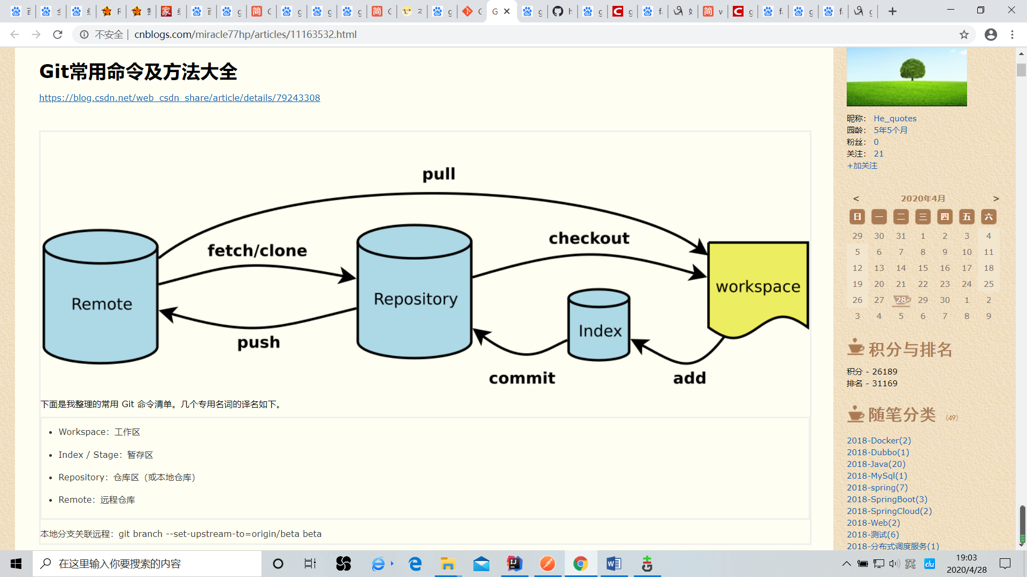

<https://git-scm.com/book/zh/v2/Git-%E5%9F%BA%E7%A1%80-%E8%BF%9C%E7%A8%8B%E4%BB%93%E5%BA%93%E7%9A%84%E4%BD%BF%E7%94%A8>