Presentation of « Solar system » application

Introduction

"Solar system" is an application to simulate the movement of stars in a solar system.
The animations of stars do not simulate the real physic laws; they are just simple rotations.

In this version of "Solar system", stars are simple cubes; the « sun » is the orange one, the « earth » is the blue one and the « moon » is the grey.
When 'Esc' button is pressed, a menu offers to continue or to quit the simulator.

The application is still under construction, and the final goal is to develop an editor of the univers where groups of planets are orbiting around suns, and each sun is flying its way in the univers. Suns can follow straight or curved paths. The camera can be controled to travel from one system to another.

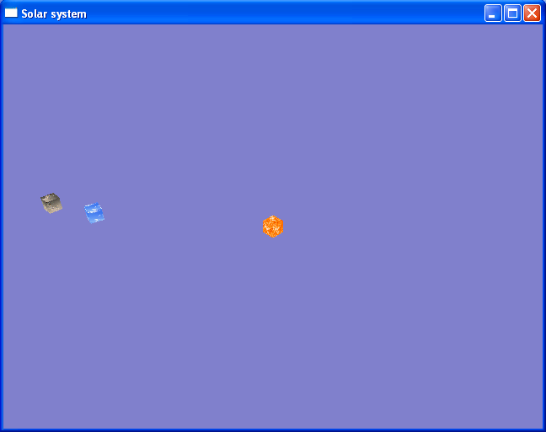

Compilation

Two projects were created in the « projects » directory, to compile the application.
The directory "vc6" for « Visual C++ 6.0 » and "vc9" for « Visual C++ 2008 Express Edition ».

The dll file "expat.dll" is needed to run the executable. This dll is found in « utilities\xml ».

The application needs some data to run. These are found in "data" directory.
The preprocessor definition « DataPath » can be adjusted and the program recompiled to fit to the relative path to "data" directory.

Developement

« Solar system » uses OpenGL, STL and boost library.

Part of its code was taken from internet:
-Its main file "solarsystem.cpp" is taken from an Nehe lesson.
-The xml file loader from http://www.flipcode.com/archives/XML_Parser.shtml
-The an8 file loader from http://sourceforge.net/projects/liban8/

Planet animations were made using the free tool « Anim8or »

Developed classes

Class | Description
Root | Contains and manages Scene class and Menu
Scene | Contains univers data loaded from data\map.xml
Menu | Offers to continue with the game of stop it
Camera | The class by which we see the univers
HEvent | Manages events sent and received by different objects in the game
HObject | Represents objets with position and orientation. It can manage children
HGraphicObj | Contains a geometic structure and a graphic
HAnimation | Contains animation data and play them on behalf of HGraphicObject
HButton | A button in the Menu
HVector | The 3D vector
HQuaternion | The quaternion to describ orientation
HMatrix | The matrix

Still to do

In ordre of priority :

*Work on memory issues :
-overload new and delete to protect against memory leaks.
-debug the cause of the message : HEAP[solarsystem.exe]: HEAP: Free Heap block 1aa5e0 modified at 1aa760 after it was freed
*Tackle the different « todo » in the code (in HAnimation, HObject, …)
*Click message should be received by HButton and not by Menu
*Events arguments should come in one structure ; this way, Event::handle functions will always have two arguments only.
*Correct the design of Scene to use HObject ::m_children instead of its own m_objects.
*Camera movements control by mouse
*Stars should be spheres
*Animate menu buttons
*Animation correction of the earth
*Display of as many solar system as desired.
*Camera trip to a solar system
*Light should come from the sun
*Shadow casting
*Editor

UML diagrams of the principal classes

Sequence diagram for Root, Scene and Menu classes

g_Root: Root
New
: Scene
New

: Menu
New

[m_active = Scene] Tick
Tick
[m_active = Menu] Tick

Draw
Draw

[m_active = Menu] Draw

Sequence diagram for Scene, HGraphicObj and HAnimation classes

: Scene
New

: GraphicsList
* : New

: HGraphicObj
: HAnimation
[animation exists] New

Tick
* : Tick
Update

SetOrientation
SetPosition

Draw
* : Draw

Sequence diagram for events management

: Menu
: HEvent
: Root

Registre « Menu::Click » to handle mouse click event
Register « Root::Pause » to handle pause event

Click
Click event fired

Pause event fired
Pause

General class diagram

