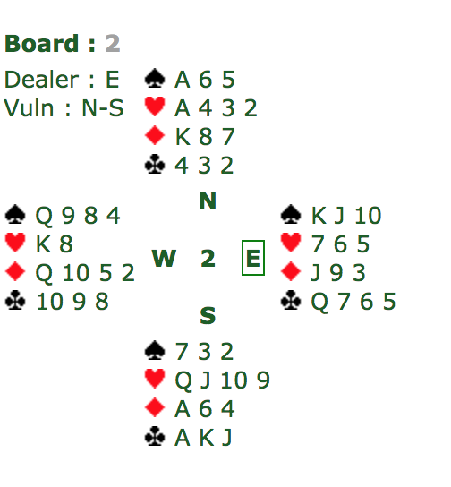

The theme of the first hand is *finessing*. North-South have 26 points between them — the best contract is 3NT. The auction should go 1NT-2c (Stayman) – 23 – 43 with East-West passing throughout. This puts West on lead. The key to this hand is finessing both hearts AND clubs. If the lead is a spade, win it in dummy. Then play a club to the Jc to finesse a club. Next, play the Q3 to finesse a heart. If West plays low to the Q3, play low from dummy. On the next round of hearts, West will be forced to play the K3 and you can take it with the A3. In the end, you should take 4 hearts, 2 diamonds, 3 clubs, and 1 spade for 10 tricks.

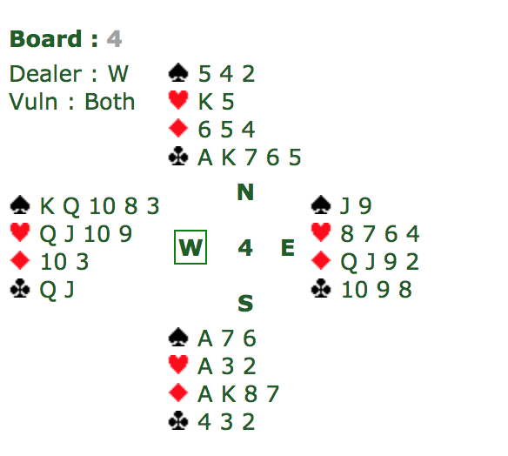

The theme of the second hand is *patience*. North-South have 25 points here, enough for game, the best game option being 3NT. The bidding will likely go with 1NT by South – 3NT by North. West will lead the KS. South should be wary that West can take 4 spade tricks after the AS is gone. If South takes the AS in trick one and tries to set up clubs, then East can lead back a spade when he gets in. Therefore, South must *hold up* or not take the first spade trick. When South takes the second spade and then plays 3 clubs (Ac, Kc, then little) to set up the last two clubs, East can no longer return a spade. South can win whatever East returns and take 4 clubs, 2 diamonds, 2 hearts, and 1 spade for 9 tricks.