A+ Computer Science STARFIGHTER IV

Lab Goal : This lab was designed to teach you more about OOP and using Abstract Classes and Interfaces.

Lab Description : Write a first person shooter game. You are the StarFighter and your job is to destroy all of the enemies that enter your space. The StarFighter ship and enemy ships will share lots of the same properties. This lab provides the perfect opportunity to use inheritance, abstract classes, and interfaces. You will also review ifs, loops, and ArrayList.

Task One – Write the MovingThing class. MovingThing will implement the Moveable interface. Make sure you think it through and that it compiles. Test it thoroughly.
Task Two – Extend the MovingThing class to make the Ship class.
Task Three – Use StarFighter and OuterSpace to test the Ship class. The Ship should move all around the screen in all 4
directions.
Task Four – Extend the MovingThing class to make the Alien class.
Task Five – Add two Aliens to the OuterSpace class. Do NOT use an ArrayList or Matrix to start. This will be added in later. Test the Alien class to make sure all method work. Alien movement can be determined later. Aliens may move side to side as well as moving down as the game progresses.
Task Six – Make your Ship shoot some type of Ammo. You must make an Ammo class that extends MovingThing. Start with just a single Ammo. An ArrayList of Ammo will be added once the single Ammo has been tested thoroughly.
Task Seven – Make your Ship shoot and destroy the Alien.
Task Eight – Make a new class called AlienHorde. AlienHorde should contain a list or matrix of Alien references.
Task Nine – Make a new class called Bullets. Bullets should contain a list of Ammo references.

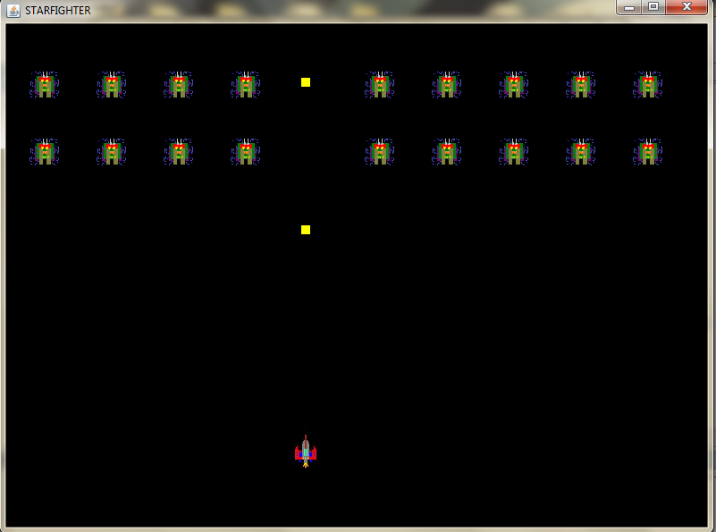

KEYS TO CONTROL THE SHIP

h - left
j - right
u - up
n - down

