INTRODUCTION
In this cross-sectional study, TyG, ABSI, TyG-ABSI, and FRS were compared as markers for identifying prevalent CVD.

FIGURES
Figure. Included participants
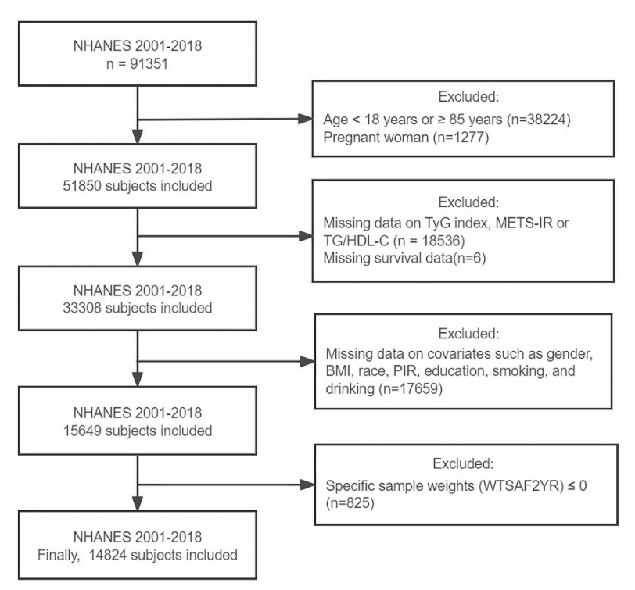

Figure. Trend of index and prevalent CVD
Figure. Prevalence of CVD by quartiles of index.
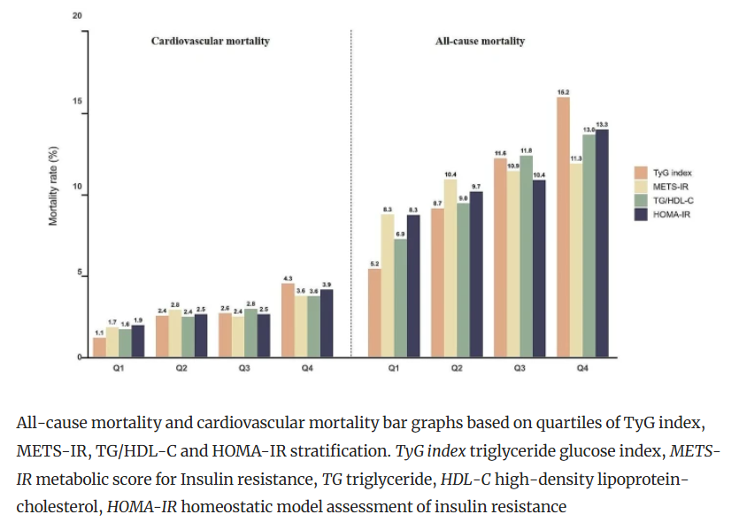

Figure. Curve between index (A, B, C, D) and prevalent CVD
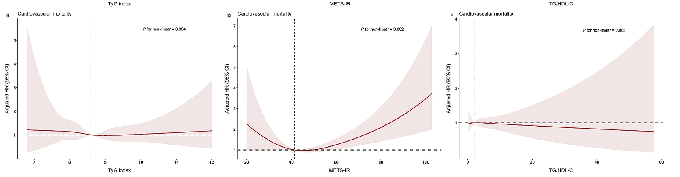

Figure. Association (OR)
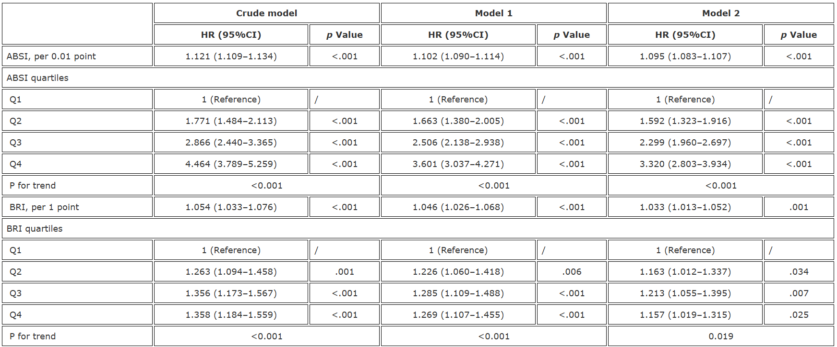
Figure. ROC (discrimination ability of each index)
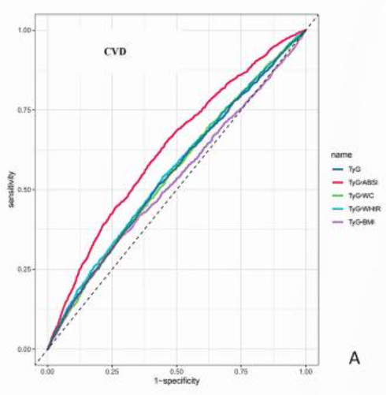
Table 1. Baseline characteristics

