Quantification of circulating and total Dilp2HF by sandwich ELISA
Always start with 3-day-old male flies that have spent the last 24 hours on new food.
Coating ELISA plates with FLAG antibody
- Assemble F8 Maxisorp loose Nunc-Immuno modules in a frame (Thermo Scientific 468667, framed or 469949, unframed), and number the strips from 1 to 12. Be sure not to touch the bottoms of the modules so that they stay clean for the ELISA plate reader.
- Add 50 µl of 2.5 µg/ml anti-FLAG (Sigma-Aldrich F1804) in coating buffer (0.2M sodium carbonate/bicarbonate buffer, pH9.4) ^{i}, Put the tip of the pipette against the top of the side of the well to make sure that the last drop of anti-FLAG gets deposited. After adding the anti-FLAG, tap the sides of the plate vigorously to make sure that the whole bottom of each well is thoroughly covered.
- Cover the plate with a lid and incubate for overnight at 4°C.
- Block the wells with 350 µl of PBS with 2%BSA (filter-sterilized) for overnight at 4°C. Don't try to dispense the last bit of liquid or bubbles will form. Hold the multi-pipette at an angle so that the tips are just touching the tops of the left-hand walls of the wells. Wells should be FULL.

Sample preparation
- Dissect the black posterior end of male abdomens away (Fig. A) (I tried to remove heads, but IPC projections to aorta remained in thorax).
- Transfer 10 dissected male bodies into the lid of a centrifuge tube containing 60 µl of PBS (Fig. B and C).Close and spin briefly to pull down.
- Vortex the tubes using micro-tube holder (Fisher Scientific 02215386) at the max speed for >10 minutes (Fig. D).
- Centrifuge the tubes at 1,000xg for 1 min, and transfer (avoid crushing heads) 50 µl of supernatant in PCR strips (to measure circulating Ilp2HF).
- Prepare FLAG(GS)HA peptides ^{iv} by adding 1 µl of the stock peptides (0 – 10 ng/mL; see the next page) to 50 µl of PBS in PCR strips

- Add 500 µL of PBS with 1% Triton-X100 to tubes with remaining flies, and grind them up using a pestle and cordless motor (VWR 47747-370).
- Vortex the tubes using micro-tube holder (Fisher Scientific 02215386) at the max speed for >5 minutes.
- Centrifuge the tubes at the max speed for 5 minutes (Fig. E), and save 50 µl of the supernatants in PCR strips (to measure total Ilp2HF content).
- Prepare second FLAG(GS)HA peptides by adding 1 µl of the stock peptides (0 – 10 ng/mL) to 50 µl of PBS with 1% Triton-X100 in PCR strips.

- Prepare anti-HA-Peroxidase, High Affinity (3F10) (Roche 12013819001; 25 µg/mL) in PBS with 2% Tween 20 at 1:500 dilution (500 µl for 96 wells).
- Dispense 5 µl of the diluted anti-HA-Peroxidase into PCR tubes or strips containing the samples or standards, vortex by holding rack on vortexer, and spin briefly on ISC Bio Express.

Sandwich ELISA
- Wash the blocked Nunc-Immuno modules with 200 µl PBTw0.2% three times, and blot the plate on a paper towel.
- Transfer the samples to Nunc-Immuno modules, and seal the plate with sealing tape (Thermo Scientific 232698) (Fig. F).
- Incubate the plate in a humid chamber (with a wet paper towel) for overnight at 4°C.
- Remove the samples using aspirator.
- Wash the plate with 350 µl PBTw0.2% six times. During each wash, flick off the buffer, and blot the plate on paper towels before refilling.
- Add 100 µl 1-Step Ultra TMB - ELISA Substrate (Thermo Scientific 34028) per well, and incubate for 30 min at room temp on shaking platform.
- Add 100 µl 2M sulfuric acid to stop the reaction, and immediately measure the absorbance at 450nm ^{v}.

A
B
C
D
E
F
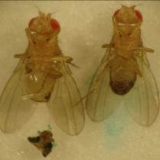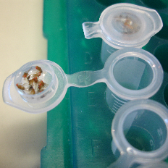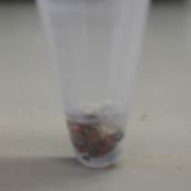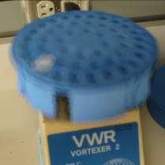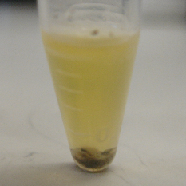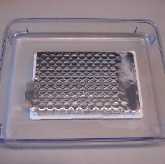
i. Dissolve 2.12 g of Na₂CO₃ and 6.72 g of NaHCO₃ in 500 ml of water, then filter-sterilize the solution.
ii. If you are unfamiliar with ELISA protocol, please watch http://www.youtube.com/watch?v=Tp61S-2F2B4.
iii. 155mM NaCl, 1.54mM KH₂PO₄, 2.7mM Na₂HPO₄, pH7.4, Life technologies 10010-049
iv. Peptide was synthesized in LifeTein LLC (lifetein.com): DYKDDDDKGGGGSYPYDVPDYA, Amidated, 1-4mg, crude (57.8%) purity at $87, MW = 2412.42 daltons
v. Blank wells should be reading at <0.05. If the reading is higher, seals for the overnight incubation may not have been air-tight, your washings may have been incomplete, or reagents (especially TMB) may be oxidized (do not use if it has a bluish tint).

Conversion of molar concentration to mass

Stock FLAG(GS)HA peptides | Diluted FLAG(GS)HA peptides in 50 µL PBS or PBS+1%Triton | pM of 2.412kD standard peptide | typical A450nm readings (peptides in PBS) | typical A450nm readings (peptides in PBS+1%Triton-X100)
0 ng/ml | 0 pg/50 µL | 0 | 0.0451 | 0.0443
0.1 ng/ml | 0.1 pg/50 µL | 0.83 | 0.0454 | 0.0436
0.2 ng/ml | 0.2 pg/50 µL | 1.66 | 0.0461 | 0.0452
0.5 ng/ml | 0.5 pg/50 µL | 4.15 | 0.0599 | 0.0544
1 ng/ml | 1.0 pg/50 µL | 8.29 | 0.1070 | 0.0920
2 ng/ml | 2.0 pg/50 µL | 16.58 | 0.1990 | 0.1916
5 ng/ml | 5.0 pg/50 µL | 41.45 | 0.7880 | 0.7342
10 ng/ml | 10 pg/50 µL | 82.91 | 1.6238 | 1.4268

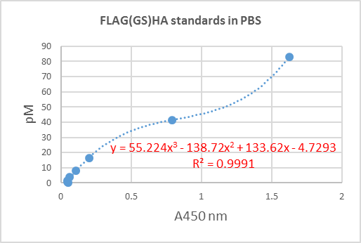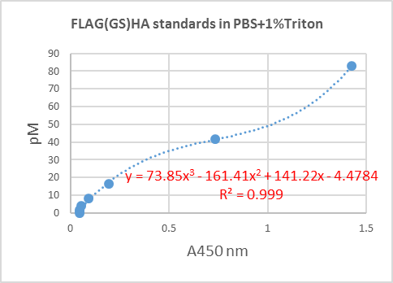

- There are two standards; one in PBS, the other in PBS+1%Triton. Use the first standard curve for the circulating Ilp2HF conversion and the second curve for the total Ilp2HF content conversion.
- Convert A450nm reading of sample to pM in Exel sheet. From the above example, unknown’s pM in PBS can be calcubated from A450nm by =55.22*POWER(A450nm,3)-138.72*POWER(A450nm,2)+133.62*A450nm-4.73
- Circulating Ilp2HF per fly can be calculated by =(pM*(7828.8*50)/1000000)/10, where 7828.8 is for MW for Ilp2HF, 50 for 50 µL sample, and 10 for 10 flies
- Total Ilp2HF content per fly can be calculated by =pM*(7828.8*50)/1000000.
- I usually report the circulating Ilp2HF (pg) per fly or the total Ilp2HF content (pg) per fly, and also normalize the circulating Ilp2HF leves to the total Ilp2HF content levels, resulting in % secreted (0.1% in day 1 to 0.5% in day 13).
- In 3 day-old homozygous Ilp2HF flies, typical circulating Ilp2HF per fly is 0.2 pg and total Ilp2HF content per fly is 50 pg. In 3 day-old heterozygous Ilp2HF flies, typical circulating Ilp2HF per fly is 0.1 pg and total Ilp2HF content is 25 pg. Age, food, feeding behavior, and genetic background will affect these numbers, so please control your experiments well, espicially use a proper genetic background control to determine the effect by your genes of interest. If your circulating Ilp2HF is unusually high, first check if you are crushing fly heads or thorax while dissecting.

 | 1 | 2 | 3 | 4 | 5 | 6 | 7 | 8 | 9 | 10 | 11 | 12
A
B
C
D
E
F
G
H

