**LAB 3 ANSWERS**

**Part 1: Practicing with arrays**

1.a) creating the arrays, reading in the data from the file, storing it into the arrays and printing it

Code:

OUTPUT:

1.b)Comparing dates

CODE:

Output:

1.c) Calculating total number of days between two dates

CODE:

OUTPUT:

1.d) See file HAB7588Lab3Part1.c for this question"

***PART 2:* *Practicing with arrays and strings***

2.a) “See file name people.txt for this answer”

2.b)

CODE:

2.c)

CODE:

OUTPUT:

2.d) See file HAS7588Lab3Part2.c for this question"

2.e)

CODE:

OUTPUT:

2.f)

CODE:

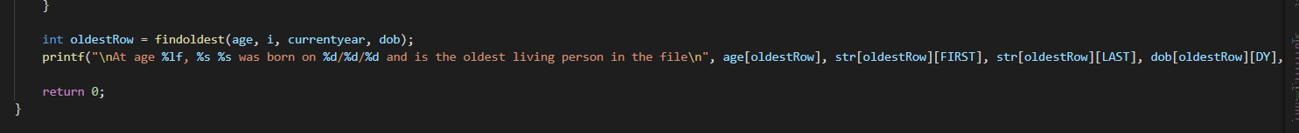

OUTPUT:

2.h) Check file “HAS7588Lab3Part2.c” for this question

Extra Credit 3. Check File “HAS7588Lab3ExtraCredit.c” for this answer.