**Overview:**  Creates a BeautifulSoup object from the HTML on Coinmarketcap.com for historical Ethereum prices. findAll() is used to narrow down to all <td> fields, which captures all the needed data. The .contents() of each <td> tag are extracted and moved into a regular python list so the .pop() function could be performed in the subsequent code.

**Code**

import requests

import csv

from bs4 import BeautifulSoup

#Get page

page = requests.get('https://coinmarketcap.com/currencies/ethereum/historical-data/')

#Create BeautifluSoup object. Case-sensitive!

soup = BeautifulSoup(page.text, 'html.parser')

#Find all td tags. Stores each table data in a list (array)

price_list_items = soup.findAll('td')

#Create new CSV file and write column headers

file = csv.writer(open('Monthly-Ethereum-Prices.csv', 'w', newline=''))

file.writerow(['MONTHLY ETHEREUM MARKET DATA'])

file.writerow(['Date', 'Open', 'High', 'Low', 'Close', 'Volume', 'Market Cap'])

#Get the Ethereum data contents from the <td> tags and move them into a list

all_stats_list = []

for price_only in price_list_items:

price = price_only.contents[0]

all_stats_list.append(price)

#Loop through 7 elements at a time and write the list to file

while all_stats_list:

one_line_of_stats = []

for stats in all_stats_list[0:7]:

stat = all_stats_list[0]

one_line_of_stats.append(stat)

all_stats_list.pop(0)

file.writerow(one_line_of_stats)

**Source Data**

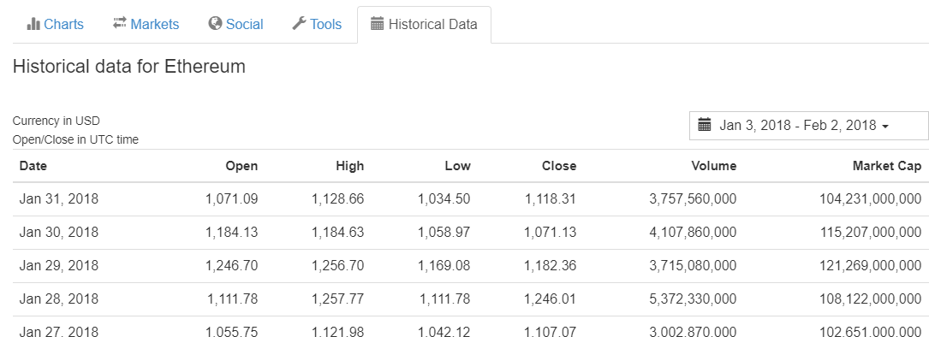

**Output – CSV file to directory where script is ran**

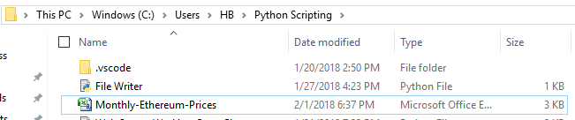

**Output – CSV file**

