Marisa Settimi & Haley Billson

Friday, February 7, 2020

FIP Research Paper 2 – Scotch Glitter Duct Tape (Rainbow)

**History**

Richard Drew was a college dropout from Minnesota who worked for a small sandpaper company called Minnesota Mining and Manufacturing, known later as 3M. He was born in St. Paul, Minnesota in 1899. He went to the University of Minnesota in the Mechanical Engineering program before he dropped out after one year.

In the 1920s, a two-tone paint job was popular for cars but hard for automotive painters. The painters would have to paint one side and then apply a barrier to the already painted portion and then paint the other section. Painters tried all different types of things to use as a barrier but nothing ever worked perfectly. Richard overheard this trouble while on a delivery and had an idea to create a new tape that would create a seal so that the paint would get through and once it was taken off it wouldn't leave a sticky residue. He used the adhesive that 3M used in their sandpaper and in 1925, after two years of experimenting he came up with the perfect combination that is now known as “Scotch” masking tape.

The scotch name came to be because of a complaint Richard got from someone that used the tape. The painter complained about the lack of adhesive and the term he used was “scotch” which was a term that meant something or someone was cheap or stingy. After the feedback was given he decided to add more adhesive and branded the tape “scotch”.

**Advertising throughout the years**

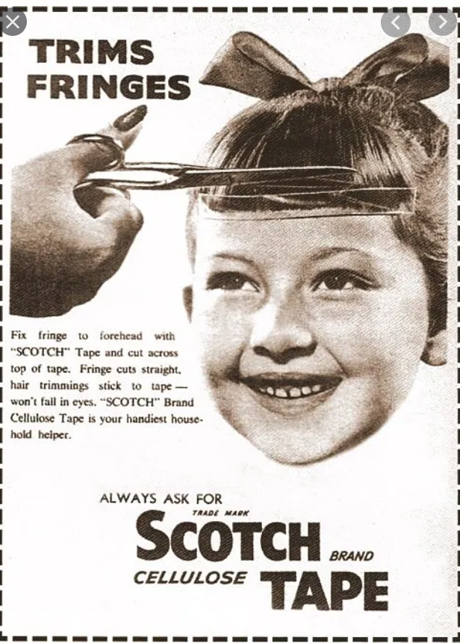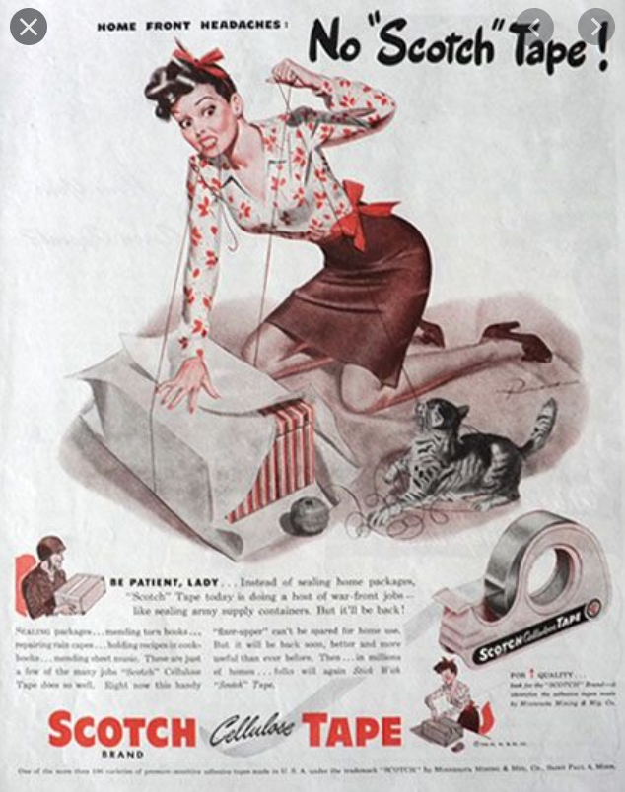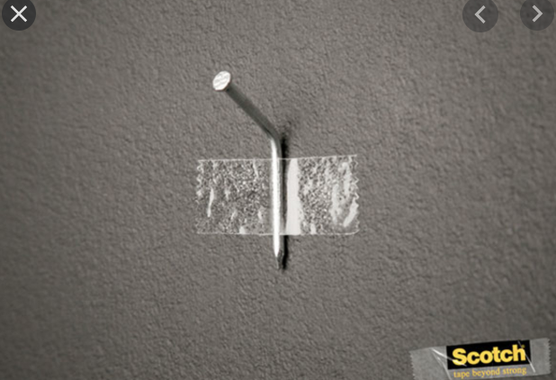

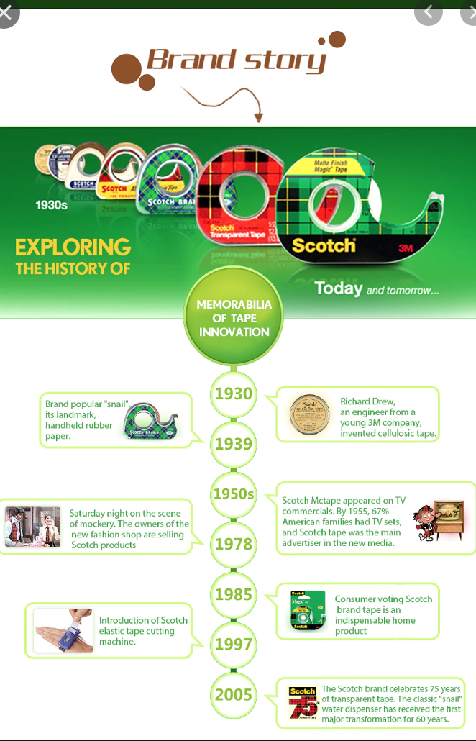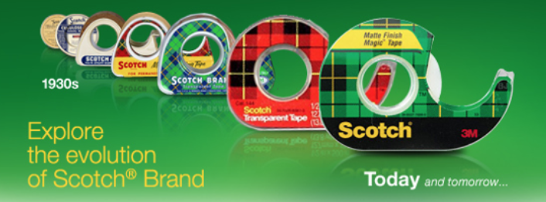

Over the years, Scotch has used their advertising to portray their products to be really good for anything someone could imagine. They show how Scotch can be used in random but useful ways.

Their branding on the products have changed as well as their logo. They have always had the classic bold font but all that really changed within the logo is the colouring and the font changed a couple times throughout the years.

**Different Products**

Scotch has many products that they sell but the main categories are tape, clear tape, decorative tape, packaging tape, laminating, cutting tools, glue/adhesives, fasteners, mounting, tape dispensers, and surface protection. More specifically the types of decorative tape that they have that includes the Glitter Duct tape (rainbow) are Scotch expression masking tape (mint green/mint mosaic/purple/lemon lime/orange/yellow), Scotch expression glitter tape (red/platinum/multi-coloured), Scotch glitter duct tape (aqua/prep cheveron/violet purple/black/hot pink/teal blue), Scotch duct tape (sunshine yellow).

**Brand Position**

Scotch tape is a widely known brand that so many people use in day to day life. Many people use the name scotch instead of adhesive not even realizing that scotch is the brand name.

**Unique Packaging Features**

The Scotch logo, a small black rectangle with yellow, sans serif font over it, is found somewhere on each product. The colours never change, despite the products being different with different colour schemes. For the Rainbow Duct Tape, the rest of the packaging is clear (to show the rainbow tape itself) or a light blue-purple colour fo the label.

**Unique Product Aspects**

Scotch makes the widest-available, most recognizable form of tape used in day-to-day life. In fact, most of the time when someone is asking for the thin, clear kind of tape they will ask for ‘Scotch tape’. They are consistent and recognizable, with the same plaid patterns found on most of their regular Scotch tape packaging, and even their duct tape stands out with the black and yellow logo found on the label. Many will find that when trying different brands of the same kind of tape, Scotch is always the strongest and the stickiest.

**Specific Benefits and Uses of the Product.**

The seller’s description for Scotch Rainbow Duct Tape says that this is great for “a princess’s wallet, or a mermaid’s prom dress.” This product would be used mainly for decoration. There are many uses of duct tape that go beyond its main usage of fixing things or sticking things together -- its durability and thickness makes it a resource for people who want to make wallets, bags, belts, and other decorations. There are quite a few tutorials online for crafts using duct tape. The bright colours of this pattern of duct tape makes it very attractive to individuals who want to keep duct tape around the house just in case, but want to have something that’s pleasing to look at instead of your regular grey-silver colour.

**Data and Stats**

3M, the company that owns the Scotch tape brand, is huge. In 2018, their net revenue was $32.77 Billion. They are in second place for World’s Largest Conglomerates behind General Electric, and the Number One brand in the United States for household tape. 3M has 55,000 different products, in five categories: Industrial, Safety and Graphics, Electronics and Energy, Health Care, and Consumer.