

Project: Explore Weather Trend

By Hamed Bintalib

09/07/2019

1. What tools did you use for each step? (Python, SQL, Excel, etc)
   1. used SQL to extract the data from database provided in Udacity:

SELECT city_data.year,

city_data.avg_temp as city_temp,

global_data.avg_temp as global_temp

FROM city_data, global_data

WHERE city_data.year = global_data.year

AND NOT city_data.avg_temp is NULL

AND city_data.city = 'Riyadh'

* + 1. Downloaded the excel as csv format from Udacity
  1. I used python to create line chart, using Jupiter Notebook. I wrote the code and the comment in Jupiter notebook

1. Using python to create line chart?
   * 1. I used rolling function in python to calculate the moving avg in every 7 years
     2. The following is the code I used to show the chart line in python with explaining each code, I used # for comment in Jupiter Notebook:

1) import pandas as pd

import matplotlib.pyplot as plt

import numpy as np

1. In [4]:
2. 1 *#Finding the current directory* 2 pwd
3. Out[4]:
4. '/Users/hamedbintalib'
5. In [12]:
6. 1 *#changing the directory to data-analysis folder, to open the excel in python* 2 the cd**/**Users**/**hamedbintalib**/**desktop**/**DATA**-**ANALYSIS
7. /Users/hamedbintalib/Desktop/DATA-ANALYSIS
8. In [13]:
9. 1 *#reading the excel global-data*2 globaltemp**=**pd.read_csv('global-8.csv')
10. In [14]:
11. 1 *#reading the excel for local temp*2 localtemp**=**pd.read_csv('local-7.csv')
12. In [15]:
13. 1 *#calculating the moving avg of global temp/local temp* 2 glb_mv_avg**=**globaltemp['avg_temp'].rolling(7).mean()  
    3 local_mv_avg**=**localtemp['avg_temp'].rolling(7).mean()

In [16]:

1. 1  *#drawing the graph and the line with labels*
2. 2  plt.plot(globaltemp['year'],glb_mv_avg,label**=**'Global')
3. 3  plt.plot(localtemp['year'],local_mv_avg,label**=**'Riyadh')
4. 4  plt.legend()
5. 5  plt.xlabel("year")
6. 6  plt.ylabel("Temperature 'C' ")
7. 7  plt.title('Riyadh VS GlobalAverage Tempreture')
8. 8  plt.show()

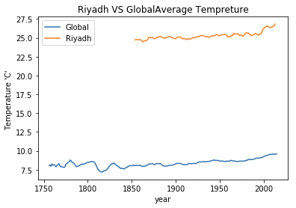

**Observation:**

* According to graph above table the difference between global average temperature and Riyadh average temperature is been consistent over time
* Riyadh temperature is quickly changing over time comparing to Global temperature. As you can see the in chart above, in 2000 the temperature increased 2 C.
* The following is the componence between Riyadh Temperature and Global temperature

|  |  |  |  |
| --- | --- | --- | --- |
| Year | Changing in global average temperature | Changing in Riyadh average temperature | Increasing/Decreasing over time |
| 1850-1900 | 7.6-7.8 | 25.0-25.6 | increasing |
| 1900-1950 | 7.8 – 8.5 | 25.6 – 25.8 | Increasing |
| 1950 - 2000 | 8.5-9 | 25.9 - 27 | increasing |

* Using Excel to create chart line, I calculate the moving avg by function in Excel call Moving Average in Data Analysis tools. In the chart below is different from the chart above the one I used in python, and that because the moving average in python cart is every 7 years. In Excel sheet the moving average is every 7 years