1. Create a PROJECT to do the following ONCE upon activation of the project:  
   - Open a dialog with the user to accept a STRING value, prompting the user to enter their**name and the current date**  
   - write this dialogue result to the **Output** panel in the tool   
   - open a NEW Notepad file  
   - write the same text in the Notepad file and save it titled : **<*Last Name - First Name*> - RPA_12.txt**(substitute your last name and first name value)**[5 points]**

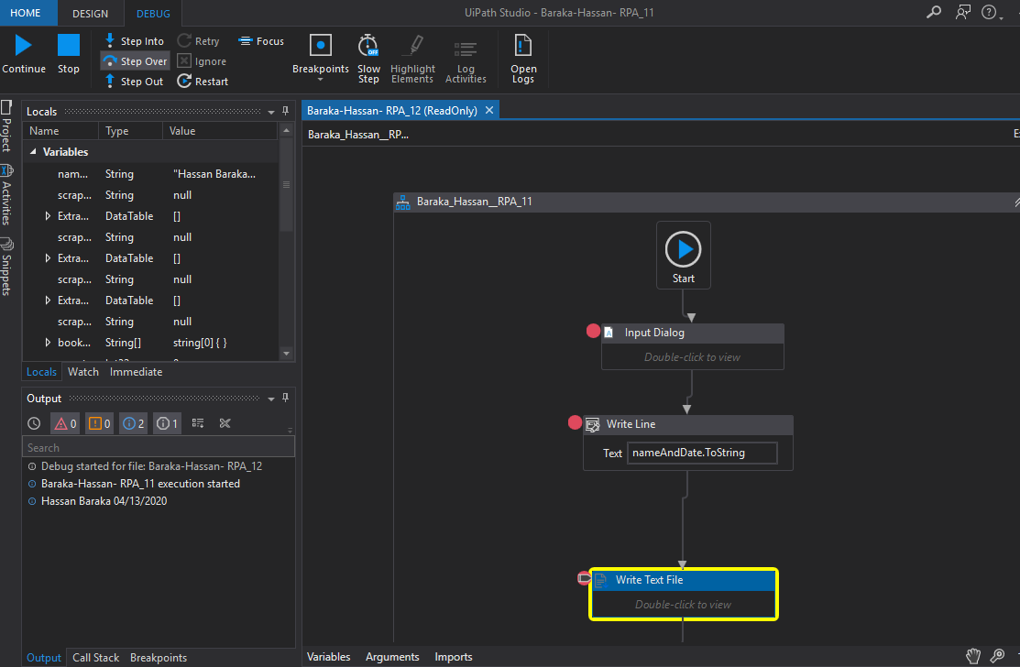

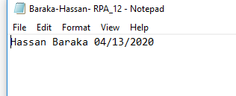

- set up a **HOTKEY** Trigger of **CNTL+ALT+M**  to execute the following steps when the user activates the Assistant Bot

1. ATTACH a new BROWSER instance to the Project  
   - Navigate to [Amazon.com](https://www.amazon.com/s?k=rpa+books&ref=nb_sb_noss_1)  
   - FOR**EACH OF THE FOLLOWING iterations (remember, the content defined above in point 1 is performed ONCE, not each time through the Assistant Bot trigger) - Assistant Bot must repeat for FOUR iterations**:  
   --> Enter the Search Term   
   --> ACTIVATE THE ASSISTANT BOT a total of FOUR TIMES  
   --> write the current date/time and Search term to the Notepad file **[5 points]**

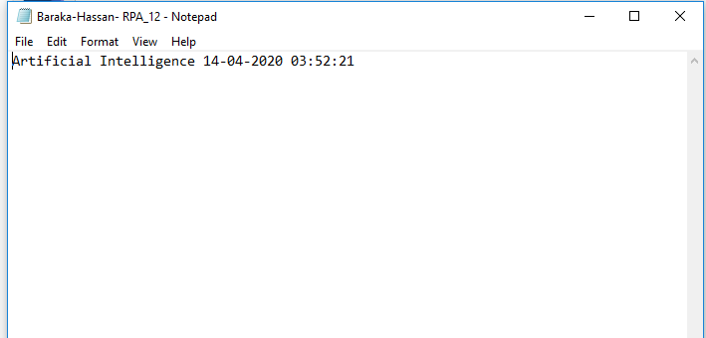

--> Complete a LOG MESSAGE activity containing the Search Term **[5 points]**

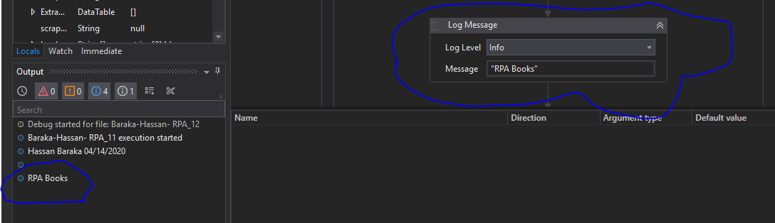

FOR EACH ACTIVATION, capture the content of the **Properties** between the Data Capture from the Amazon Web Page and the next activity step and write it to a SEPARATE DOCUMENT File titled: ***<LastName - FirstName> - DEBUG RPA 12.docx***. This includes embedded pictures showing the Property group, Property title, and Property Contents. **[10 points]***Search Terms*:  
RPA Book  
Artificial Intelligence  
Process Automation  
Natural Language Processing  
  
*IN OTHER WORDS: As the User*  
*1) Enter the first search term in the Amazon Search Bar  
2) activate the bot to perform the step(s) below  
3) when the bot completes the iteration, enter the second search term in the Amazon Search Bar  
4) activate the bot  
5) enter the third search term  
6) activate the bot  
7) enter the fourth search term  
8) activate the bot  
9) the bot should finish all activities in the project*

1. The Assistant Bot   
   - Extract ALL Book Titles and the related FORMAT (e.g. Paperback, Kindle, etc.) (on all PAGES for this search) to a MAXIMUM of 9 (nine) matching entries  
   - Write message to the Notepad file  for each book TITLE which contains the term "**Process**" containing the Title and Format

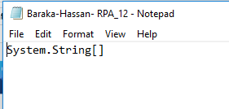

- Output the Search Term and the COUNT of the titles containing "**Process**" to the Output panel

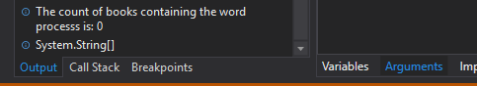

1. DEBUGGING messages  
   - Display the message "Search is concluded" and the current date/time

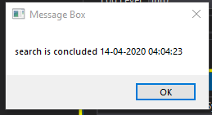

- At the conclusion of the Assistant Bot Automation - Display a message to the User **"Debugged and Done  " + current date/time** and write this same message to the Output panel**[5 points]**

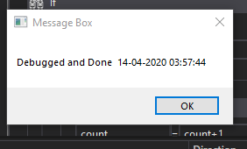

1. LOG Files  
   - Submit the three LOG files generated by the UiPath Studio for the submitted execution [5 points]
2. Submit the project XAML file**[5 points]**  
   Use the following naming convention**<*Last Name - First Name*> - RPA_12.xaml**  
   [NOTE: if you are NOT using UiPath, submit the equivalent project file]
3. Submit a DOCUMENT containing screen captures of the Studio showing your BREAKPOINT  within the multiple FLOWCHART Activities)**[5 points]**
4. Run the project  
   SUBMIT the Notepad document result [see above]  
   SUBMIT a screen capture of the Studio Output panel showing the results and your

debugging comments [see above]

73f45750-a06e-47d7-9667-8bcfeb507933

Keyboard Shortcutsclose