全国2012年10月自学考试英语写作试题和答案

课程代码：00603
请考生按规定用笔将所有试题的答案写在答题纸上。
注意事项：
1. 答题前，考生务必将自己的考试课程名称、姓名、准考证号用黑色字迹的签字笔或钢笔填写在答题纸规定的位置上。
2. 用黑色字迹的签字笔或钢笔将答案写在答题纸上，不能答在试题卷上。
Ⅰ. Supply the missing paragraph. (20 points)
The following passage is incomplete with one body paragraph missing. Study the passage carefully and write the missing paragraph in about 100 words. Make sure that your tone and diction are in unity with the passage provided.
The Magic of Music
Music is one of the most common forms of entertainment. I can hardly think of anyone who doesn’t like music. It appears that wherever you go, music is playing or someone is listening to his or her MP3 or CD player. From middle school students to business executives, almost everyone seems to be a keen music lover. Why do people enjoy music so much? I believe music works like magic: it pleases our senses, lightens our moods, and helps to develop friendship.
To begin with, music appeals to us greatly because heating is one of our most receptive and pleasure-feeling senses. Our ears are capable of heating and interpreting an extremely broad range of pitch and tones. Yet, other than music, the day-to-day sounds we usually hear are a scattered and unrelated series of overlapping middle tones, for example, voices and construction noise. The lack of harmony and variation in these sound waves can cause a headache. Conversely, music is the only kind of sound that is comprised of a harmonized and logical sequence of high and low tones. It is simply and naturally pleasing to our senses.
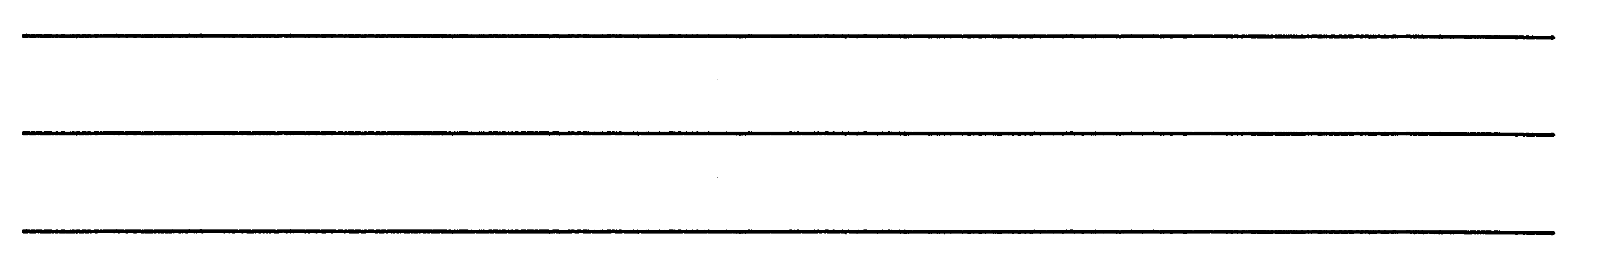
Finally, music is of great value because it is a means of establishing a common interest among both friends and strangers. Friends frequently take pleasure in sharing new music. The quality of a particular piece of music is something that even strangers can agree on without much debate. Strangers from different countries can easily become friends through the simple process of singing or dancing together to music. Music, the only universal language, binds people together.
Therefore, music has magic power which stimulates our senses and enhances our moods and emotions. It also serves as a means for establishing closer ties between friends and strangers alike. Indeed, a life without music would be boring and difficult.
Ⅱ. Write an outline. (20 points)
Read the following passage carefully and compose a “topic outline” for it.
Leonardo da Vinci
Leonardo da Vinci’s works of art made him world-famous. But there was far more to this great man of ideas than just the Mona Lisa’s pretty face. Leonardo is often thought of primarily as an artist, and with masterpieces such as The Last Supper and the Mona Lisa to his credit, his place in art history is assumed. Yet his notebooks show that his main interests lay elsewhere—in engineering and technology. The notebooks are full of drawings and designs for all kinds of inventions—from calculating machines to tanks, from parachutes to helicopters. If his pioneering work on anatomy is also taken into consideration, we can easily see why Leonardo is considered one of the greatest geniuses of all time. He is not only an outstanding artist, but also a great scientist.
Born in 1452, Leonardo was given only a rudimentary education in his early age. After ten years in the workshop of the artist Verrocchio, he set up as a freelance artist. Some of his works have survived, and reveal a stunning combination of technical skills with very careful observation. His works also reveal an emerging fascination with technology, with technical drawings of equipment of all kinds.
Leonardo was particularly fascinated by the technology of warfare. At this time, Florence was at war with the Pope, and Leonardo realized that this was an opportunity to make use of his new inventions for better guns and other military equipment. However, the war ended before anything could come of his plan and he returned to his painting.
At the age of thirty, he left his home town and eventually moved to Milan, where he spent seventeen years under the patronage of Ludovico Sforza, the Duke of Milan. Here he continued to combine his scientific and technological work with his painting, which was of perspective and proportion. During this period, he painted The Last Supper and developed his ideas for chemical weapons and flame-throwers.
When Sforza was driven from power by the French, Leonardo returned to Florence and spent four years working for Cesare Borgia as an engineer and military architect. He now became fascinated with flight. He studied birds for clues about how to fly and drew sketches of machines resembling helicopters.
In 1506, he returned to Milan and became increasingly focused on science. He began to study human anatomy and the circulation of blood. He also drew up a comprehensive guide to the working of living creatures.
He died at Amboise in France, where he was welcomed by King Francois I. He continued to do the occasional sketch, a few designs and plans for buildings, but most of his time was devoted to sorting out his scientific papers.
Only twenty-one of his dozens of notebooks survive. Just seventeen paintings have been ascribed to him with certainty, and some of those are tunfinished. Leonardo may not have achieved the perfection that he aspired to but he came closer to it in more fields than anyone before or since.
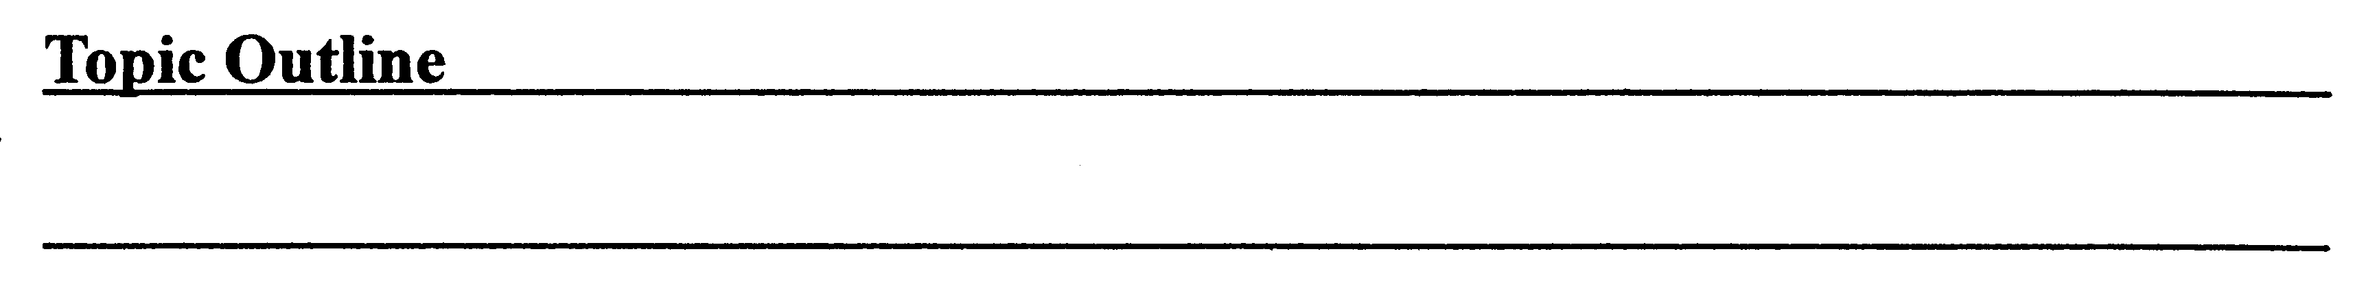
Ⅲ. Compose an essay. (60 points)
Many young people choose to overwork in order to make more money; however, persistent overwork will affect their health in the long,run. What is your opinion on this? Write a 300-word expository essay explaining your views.

2012年10月全国自考英语写作试卷参考答案
