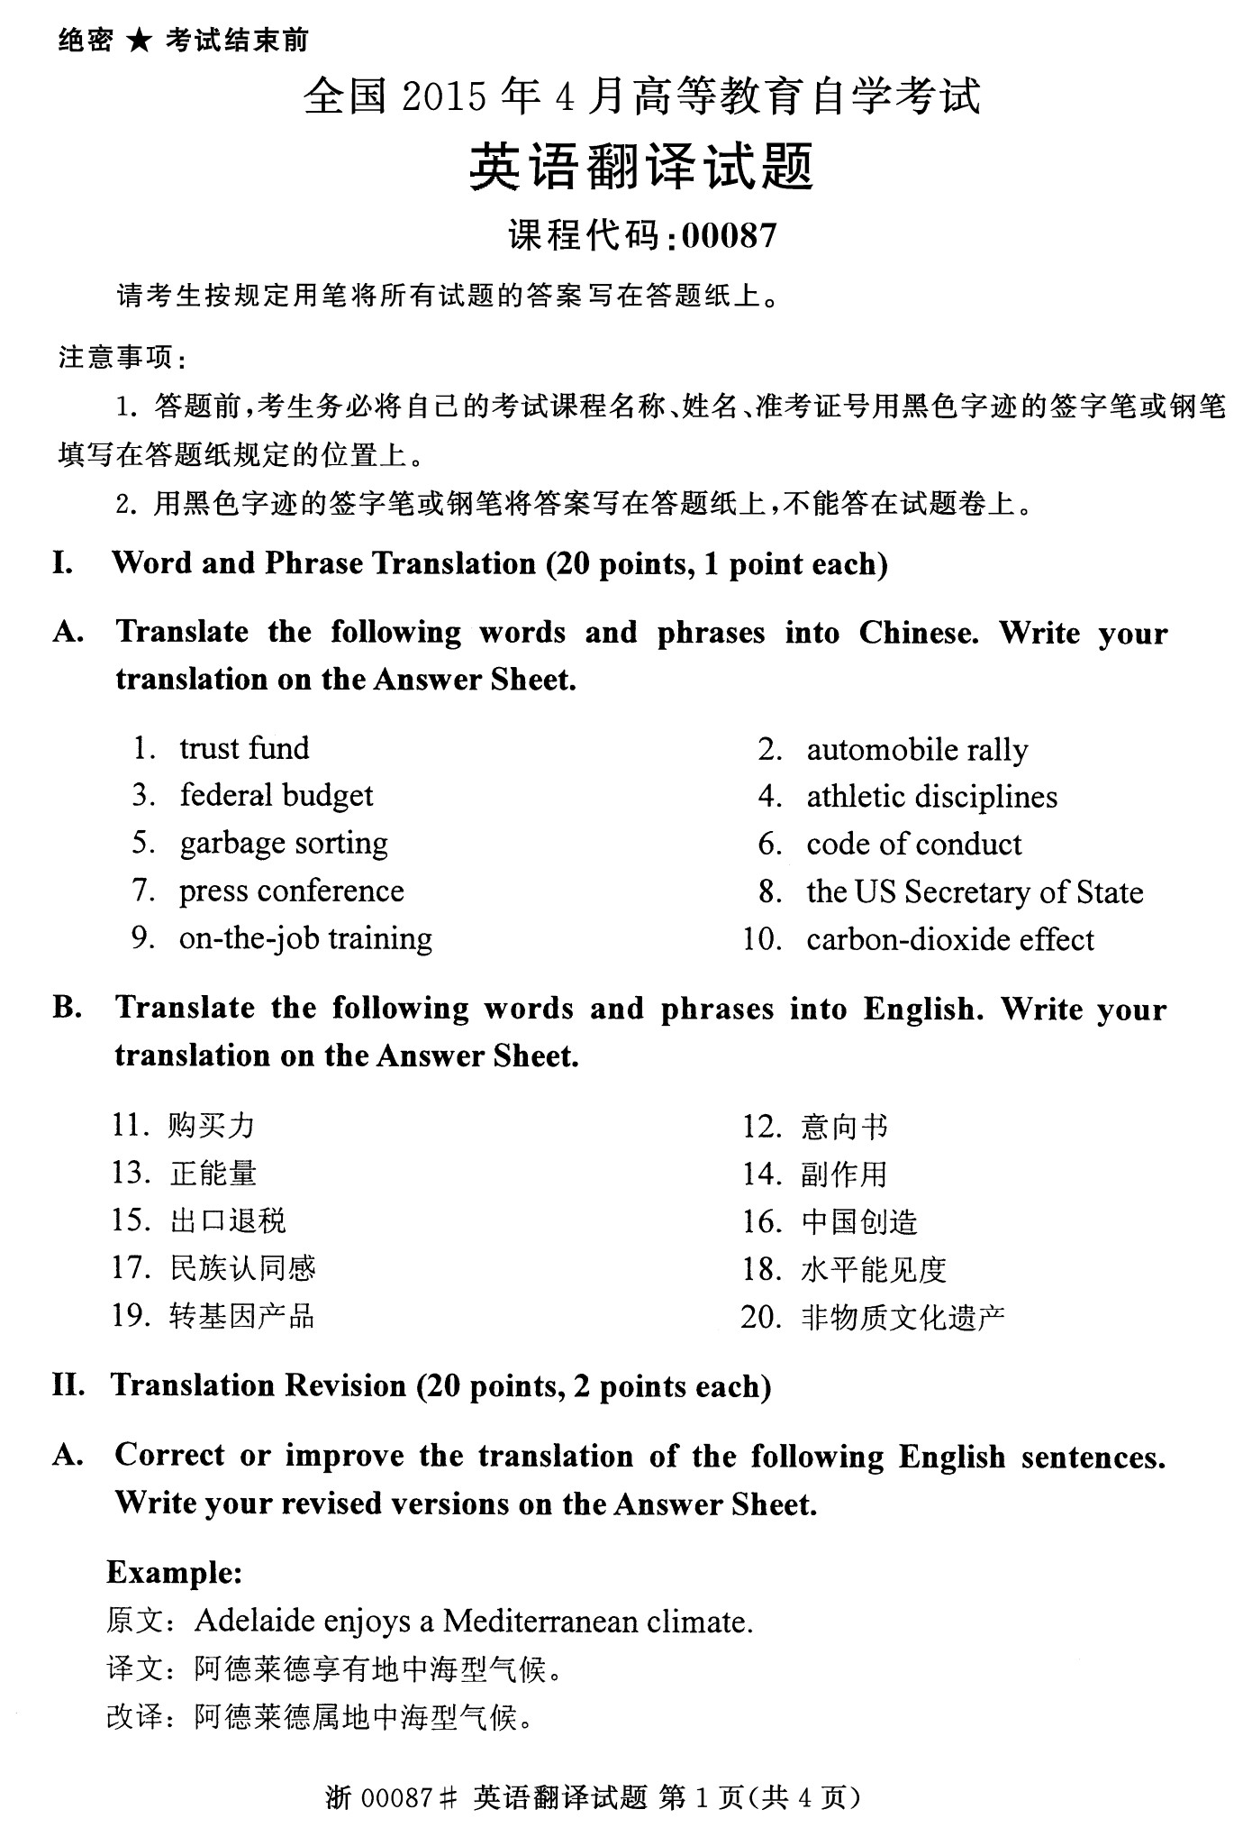
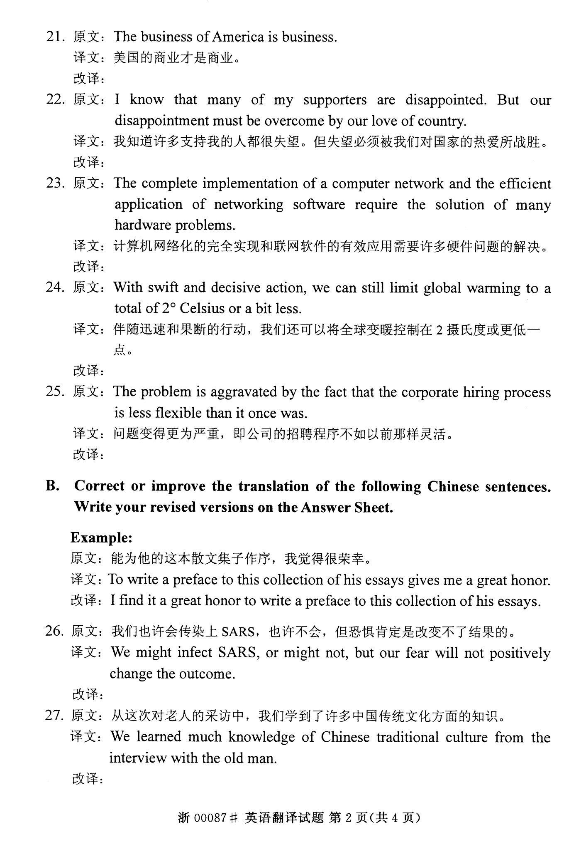
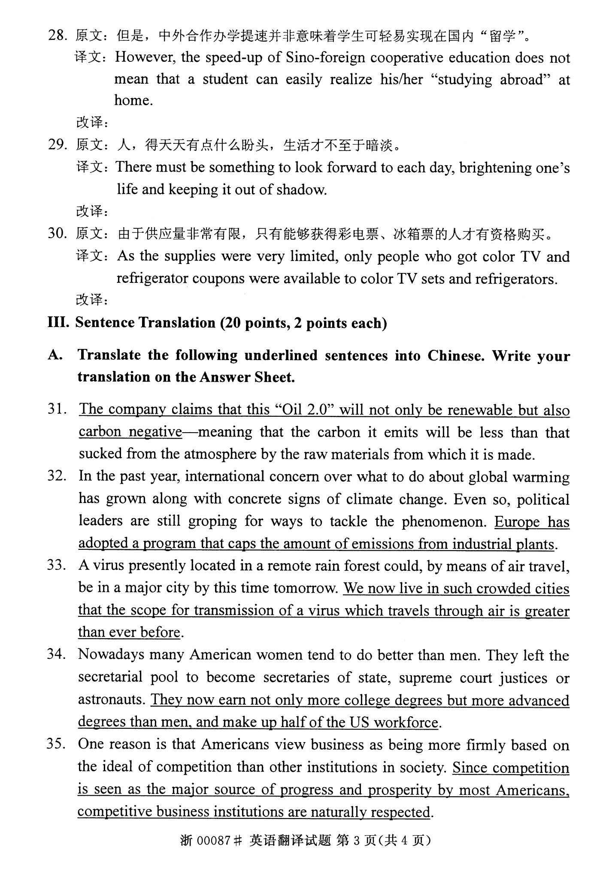
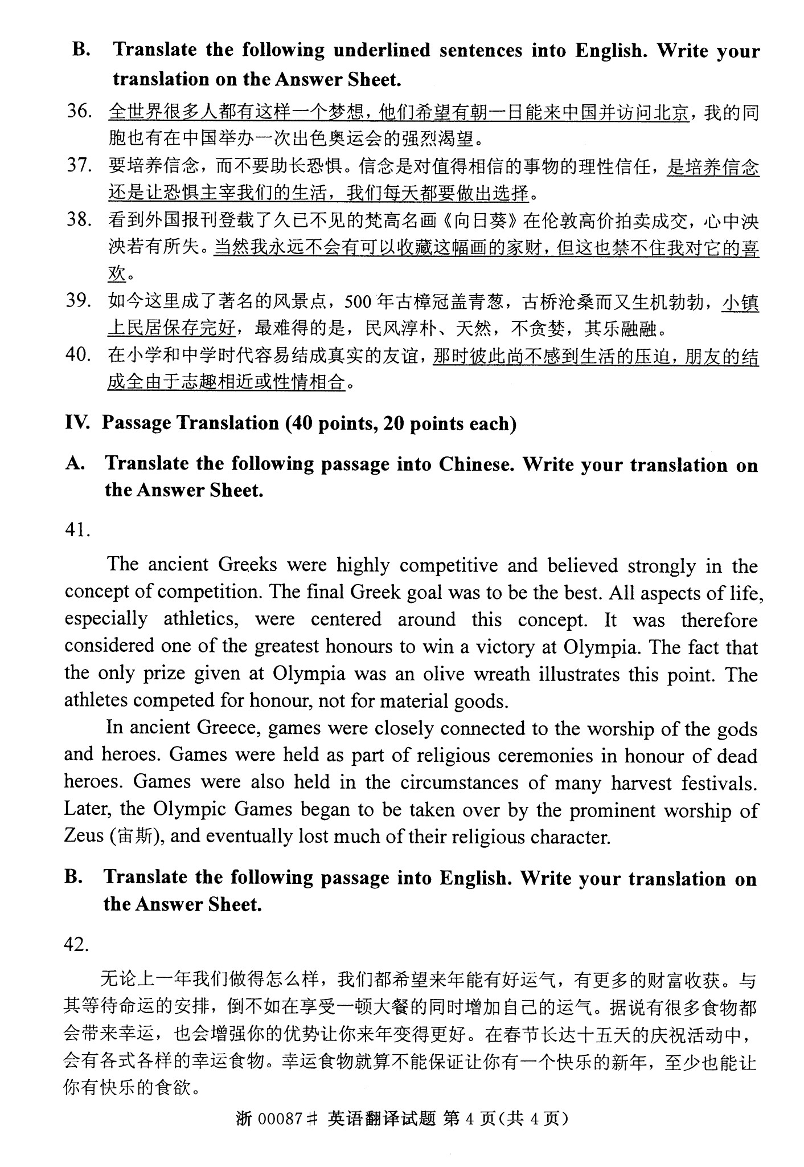

答案
1.信托基金.
2.汽车拉力赛
3.联邦预算
4.体育学科
5.垃圾分类
6.行为守则
7.记者会现场
8.美国国务卿
9.在职培训
10.二氧化碳的影响
11.Purchasing power
12.The letter of intent
13.The positive energy
14.Side effects
15.The export tax rebate
16.creation in China
17.A sense of national identity
18.Horizontal visibility
19.Transgenic products
20.Non material cultural heritage
28.However, Chinese foreign cooperation in running speed does not mean that students can easily achieve in the“domestic study”
29.Something to be look forward to each day ,it will be brightening one’s life and keeping it out of shadow
30.Because the supply is very limited, only can get the colorTV refrigerator tickets,tickets are eligible to purchase
31.该公司声称，“2.0号油”不仅是可再生能源而且不会产生二氧化碳。
32.欧洲通过了一个程序，帽子的产量遵从于工厂的流程
33.我们现在生活在如此拥挤的城市，病毒通过空气传播的途径比以前更为便利了
34.她们不仅获得更多的学士学位，而且技术程度比男人更为先进，在美国撑起了半边天
35.既然竞争白大多数美国人看成是社会进步和繁荣的主要源泉，商业机构间的相互竞争也自然应受到尊重
36.Many people in the world have a dream, that one day they could come to China and visit Beijing.
37.We have a choice each day to exercise faith or to allow fear to rule our lives.
38.Of course I will never have enough money to keep this painting, but I can not help loving it.
39.the houses in this town are well preserved
40.People make friends simply out o similar hobbies or compatible disposition.
41.古希腊人是高度竞争的，他们强烈地相信竞争这一概念。希腊人的最终目标是成就最好的自己。生活的各个方面，特别是竞技这一方面，集中贯穿于这一概念。因此，能在奥林匹克运动会上获得胜利被认为是无上的荣耀。事实上，在奥林匹亚上被授予的唯一的奖品橄榄花环说明了这一点。运动员为荣誉而竞争，而非物质。
在古希腊，游戏与人们对上帝或英雄的崇拜紧密相连。游戏是作为宗教仪式的一部分来纪念那些死去的英雄。游戏也会作为许多丰收的庆典。而后，奥林匹克运动会开始被宙斯的敬拜者接手，最终丢失了许多他们的宗教特征

