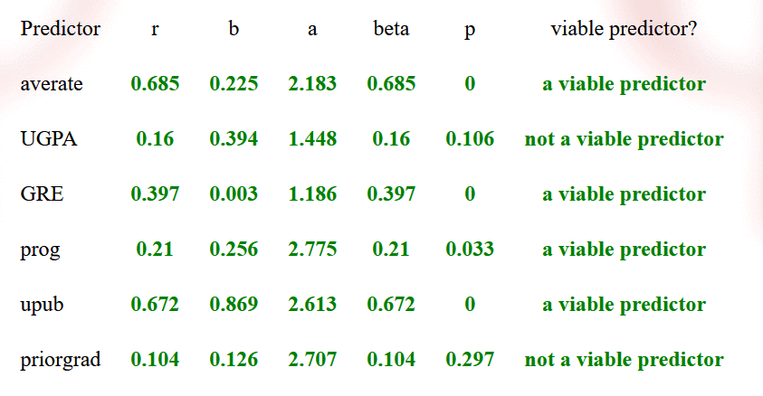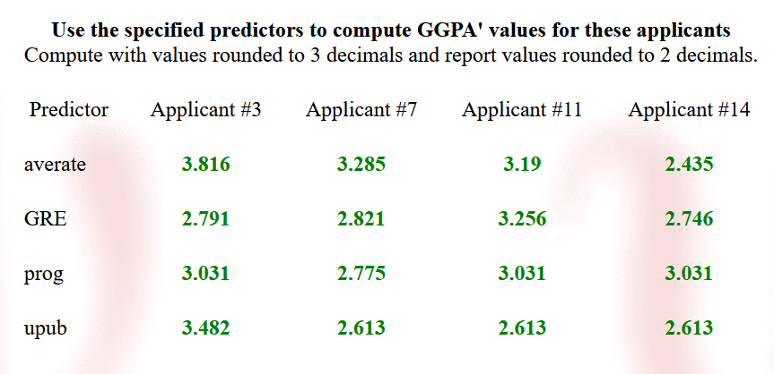

**942 Q1 Hw#2 data 🡪 942_q1h2_212_mod.sav & 942_q1h2_212b_app.sav**

1. Use 942_q2h2_142_mod.sav with the criterion GGPA and get the following values from a separate regression for each predictor (do not use exponential notation – convert any exponential notation to “regular decimal format”).

|  |  |  |  |  |  |  |
| --- | --- | --- | --- | --- | --- | --- |
| Predictor | r | b | a | β | p | Viable predictor ? |
| averate | 0.6848889 | 0.22524 | 2.18266 | 0.6848889 | 1.49e-15 | Y |
| UGPA | 0.1600173 | 0.3942 | 1.4479 | 0.1600173 | 0.106 | N |
| GRE | 0.3973196 | 0.0029616 | 1.1862761 | 0.3973196 | 3.25e-05 | Y |
| prog | 0.2104697 | 0.25613 | 2.77538 | 0.2104697 | 0.0328 | Y |
| upub | 0.6715917 | 0.86862 | 2.61298 | 0.6715917 | 8.2e-15 | Y |
| priorgrad | 0.1036959 | 0.1263 | 2.7072 | 0.1036959 | 0.297 | N |

1. Interpret the r, b & a values from above.

There’s a lot to remember when interpreting these values – the idea is use all the information available in the values, and express that information in terms of the behaviors and groups they represent.

* Significant or not, each b, β or, a is our best estimate of the population parameter – if nonsignificant, you can interpret it if you want, but be sure to mention if it is not significantly different from 0
* For this exercise, don’t classify the size of the linear relationship (small, medium, etc). Though this is a good idea when presenting your results, different research areas use different “standards”.
* When interpreting correlations involving quantitative predictors: Don’t tell me what that the correlation is “positive” or “negative”. Rather, use a description like, “More practice is associated with higher performance scores” or “Those who attended more therapy sessions tended to have lower anxiety scores”
* When interpreting correlations involving binary predictors: Don’t tell me that the correlation is “positive” or “negative”. Rather, use a description like, “Those in the treatment condition tended to have higher average success ratings than those in the control condition” or “The married participants had a higher average satisfaction than did the single participants.”
* When interpreting b-weights involving quantitative predictors: Tell me whether criterion scores are expected to increase or decrease, and by how much, for each 1-unit change in the predictor.
* When interpreting a-values involving quantitative predictors: Tell me what is the expected criterion score for those who have a predictor score of zero.
* When interpreting b-weights involving binary predictors: Tell me the difference (direction and amount) is the mean criterion score of the group coded 1 (be sure name that group) from the group coded 0 (be sure to name that group too).
* When interpreting a-values involving binary predictors: Tell me the mean criterion score of the group coded 0 (be sure to name that group).

|  |  |  |
| --- | --- | --- |
| predictor | term | Interpretation |
| averate | r | Greater first year graduate GPA is associated with greater recommendation letter ratings |
| b | For each one unit increase in recommendation letter ratings, first year graduate GPA is expected to increase by 0.225 points |
| a | Those with recommendation letter ratings of 0, first year graduate GPA is expected to be 2.183 |
| UGPA | r | First year graduate GPA is not correlated with undergraduate GPA |
| b | For each one unit increase in undergraduate GPA, first year graduate GPA is expected to increase by 0.394 but this difference is not statistically greater than 0 |
| a | Those with undergraduate GPA of 0 are expected to have first year graduate GPA of 1.448, but this is not statistically greater than 0 |
| GRE | r | Greater first year graduate GPA is associated with greater GRE scores |
| b | For each one unit increase in GRE, first year graduate GPA is expected to increase by 0.003 points |
| a | Those with GRE score of 0 are expected to have first year graduate GPA of 1.186 |
| prog | r | Being in the experimental program is associated with greater first year graduate GPA |
| b | Being in the experimental program is associated with a greater first year graduate GPA of 0.256 compared to being in the clinical program |
| a | Those in the clinical program are expected to have first year graduate GPA of 2.775 |
| upub | r | Having one or more undergraduate publications is associated with greater first year GPA |
| b | Having one or more undergraduate publications is associated with greater first year graduate GPA by 0.869 points |
| a | Students with no undergraduate publications are expected to have a first year graduate GPA of 2.613 |
| priorgrad | r | Whether a student has previously attended grad school has no relationship with first year graduate GPA |
| b | Students that have previously attended grad school are expected to have greater first year graduate GPA of 0.126 points, but this difference is not statistically greater than 0 |
| a | Not directly interpretable  Students that have not attended graduate school are expected to have a first year graduate GPA of 2.833, but this is not significantly different from those that have previously attended graduate school |

3. Use **942_q1h2_212b_app.sav** to obtain the following predicted GGPA values (using only viable predictors).

|  |  |  |  |  |
| --- | --- | --- | --- | --- |
| Predictor | Applicant #3 | Applicant #7 | Applicant #11 | Applicant #14 |
| averate | 3.815964 | 3.284929 | 3.189687 | 2.434518 |
| GRE | 2.791 | 2.821 | 3.256 | 2.746 |
| prog | 3.031 | 2.775 | 3.031 | 3.031 |
| upub | 3.482 | 2.613 | 2.613 | 2.613 |