# 6) Effector Blender

Model: ‘eb_12B.mdl’

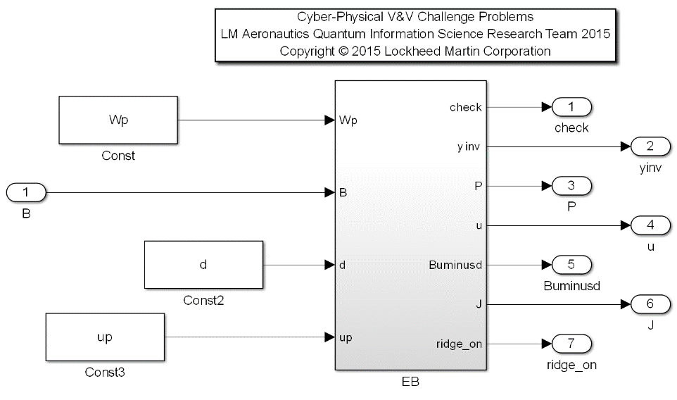Description: This example provides a subset of an algorithm commonly referred to as the control allocation method, which enables the calculation of the optimal effector (surface) configuration for a vehicle, given a problem type (typically desired acceleration error, or desired control minimization effort, or a combination of both). In this specific case, the problem type is control minimization of the form:

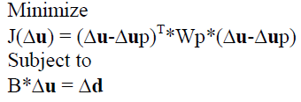

where J represents the cost of the control effort, u is the control solution, up is the preferred control solution, Wp is a Weighting matrix, B is the linearized control effectivity matrix, and d is the desired acceleration error [1]. In this specific case for the over-determined solution, when there are more surface effectors than commanded axes (n<m) where n is the length of the d vector, and m is the length of the u vector, an analytic solution exists [1].



where



[1] Bordignon, Ken, and John Bessolo. "Control Allocation for the X-35B." *2002 Biennial International Powered Lift Conference and Exhibit*. 2002.

|  |  |  |  |  |
| --- | --- | --- | --- | --- |
| Input Scope | Name | Subsystem Input # | Type | Description |
| Global (Specified) | Wp | 1 | Double | The control weighting preference matrix of size 5x5 |
| Global | B | 2 | Double | The control effectiveness matrix of size 3x5 |
| Global (Specified) | d | 3 | Double | The desired acceleration error 3x1 |
| Global (Specified) | up | 4 | Double | The preferred control solution 5x1 |

|  |  |  |  |  |
| --- | --- | --- | --- | --- |
| **Output Scope** | **Name** | **#** | **Type** | **Description** |
| Global | check | 1 | Double | Inversion Check Matrix of size 3x3 |
| Global | yinv | 2 | Double | Inverse of (B(inv(Wp’)B’ of size 3x3 |
| Global | P | 3 | Double | Transformation Gain Matrix Solution of size 5x3 |
| Global | u | 4 | Double | The control effector solution vector of size 5x1 |
| Global | Buminusd | 5 | Double | Error vector of constraint of size 3x1 |
| Global | J | 6 | Double | Total Cost of solution of size 1x1 |
| Global | ridge_on | 7 | Boolean | Ridge Regression Diagonalization Term Active |

Requirements:

1. When the determinant of B(inv(Wp’)B’ is <= 1e-12 as indicated by ridge_on set to True, the inversion of the B(inv(Wp’)B’ matrix should be accurate to 6 digits precision in that each element in the check output matrix is within a 1e-6 tolerance with respect to the elements of a 3x3 identity matrix.
2. When the determinant of B(inv(Wp’)B’ is > 1e-12 as indicated by ridge_on set to False, the inversion of the B(inv(Wp’)B’ matrix should be accurate to 12 digits precision in that each element in the check output matrix is within a 1e-12 tolerance with respect to the elements of a 3x3 identity matrix.
3. The output u vector should be a 5x1 vector.
4. The 2-norm of the output Buminusd should be less than 0.01.
5. The output cost J shall be the minimum possible value given the set of input conditions.