# 8) SWIM Airspeed

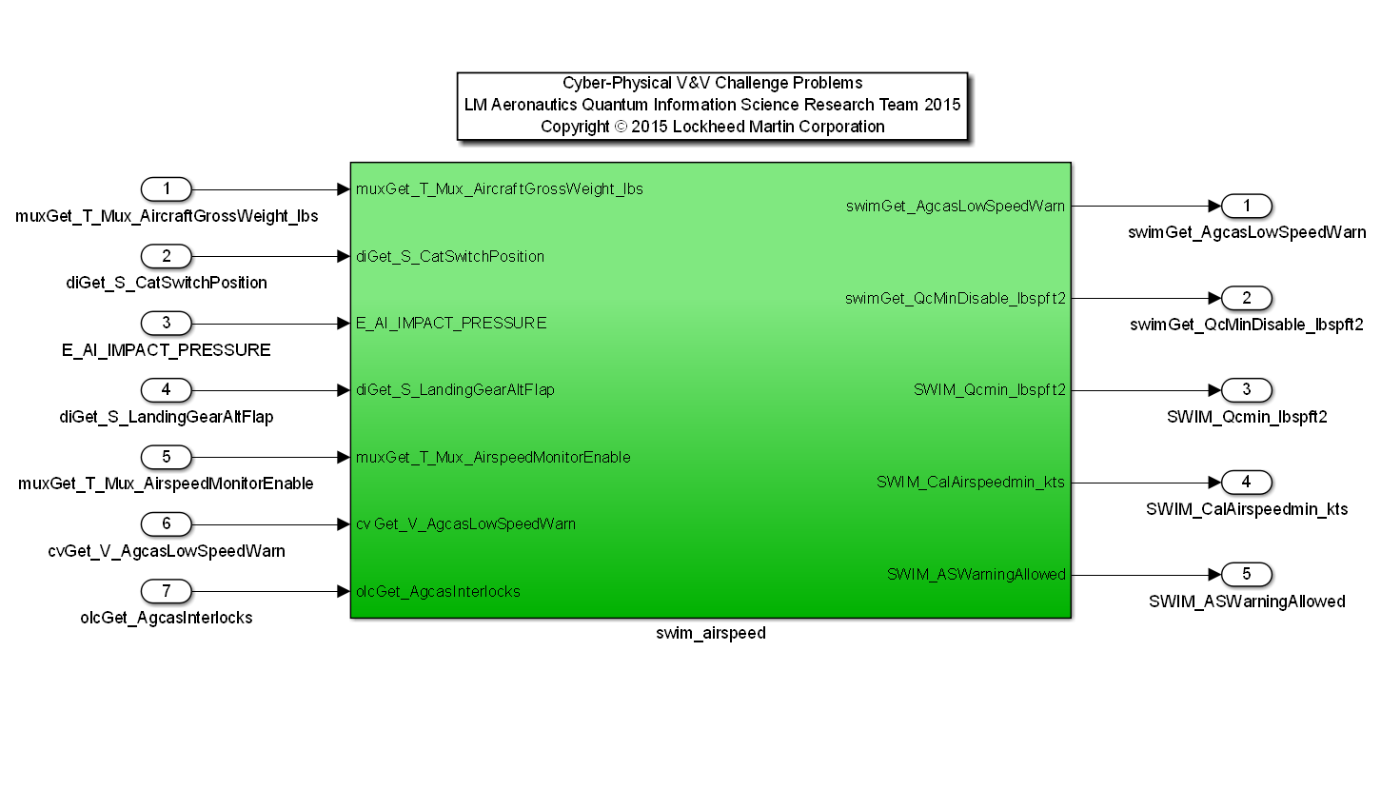 Model: ‘swim_12B.mdl’

Description: This example provides a safety algorithm for monitoring airspeed in the SWIM (System Wide Integrity Monitor) suite in order to provide warning to an operator when the vehicle speed is approaching a boundary where an evasive flyup maneuver cannot be achieved.

|  |  |  |  |  |
| --- | --- | --- | --- | --- |
| **Input Scope** | **Name** | **Subsystem Input #** | **Type** | **Description** |
| Global | muxGet_T_Mux_AircraftGrossWeight_lbs | 1 | Double | Aircraft gross weight |
| Global | diGet_S_CatSwitchPosition | 2 | Integer | Store Category of vehicle (I or III) |
| Global | E_AI_IMPACT_PRESSURE | 3 | Double | Air Data Impact Pressure |
| Global | diGet_S_LandingGearAltFlap | 4 | Boolean | Powered Approach Discrete |
| Global | muxGet_T_Mux_AirspeedMonitorEnable | 5 | Boolean | Indicates the aircraft is at an altitude when the airspeed monitor can be enabled |
| Global | cvGet_V_AgcasLowSpeedWarn | 6 | Boolean | Low speed warning indication from the automated ground collision avoidance system |
| Global | olcGet_AgcasInterlocks | 7 | Boolean | Indicates state of automated ground collision avoidance system (Notfailed or Failed) |

|  |  |  |  |  |
| --- | --- | --- | --- | --- |
| **Output Scope** | **Name** | **#** | **Type** | **Description** |
| Global | swimGet_AgcasLowSpeedWarn | 1 | Boolean | Low speed warning detection |
| Global | swimGet_QcMinDisable_lbspft2 | 2 | Double | Impact pressure value corresponding to 20 knots slower than warning airspeed threshold in order to disable ongoing warnings. |
| Global | SWIM_Qcmin_lbspft2 | 3 | Double | Warning trigger of minimum impact pressure in which a safe AGCAS evasive maneuver can be accomplished |
| Global | SWIM_CalAirspeedmin_kts | 4 | Double | Warning trigger corresponding minimum airspeed in which a safe AGCAS evasive maneuver can be accomplished |
| Global | SWIM_ASWarningAllowed | 5 | Boolean | Low speed warning allowed |

Requirements:

1. The SWIM Airspeed algorithm shall output the minimum AGCAS airspeed required to perform a 2g flyup as follows:

Auto GCAS Minimum Vcas (knots) =

SQRT{[2*Load Factor*Gross Weight]/[Air Density at sea level *

Coefficient of Lift Max*Wing Area]} / 1.6891 (ft/s/knots)

where

Load Factor = 2 gs

Gross weight of the aircraft

Air Density at sea level = 0.0023769 slugs/ft^3

Coefficient of Lift Max = 1.24 (CAT I) and 1.10 (CAT III)

Wing Area of the F-16 = 300 ft^2

Thus,

IF CAT I, Auto GCAS Minimum Vcas (knots) = 1.25921 * SQRT(Gross Weight) + 10.0

IF CAT III, Auto GCAS Minimum Vcas (knots) = 1.33694 * SQRT(Gross Weight) + 10.0

1. When a low speed warning is allowed, as computed by the SWIM Airspeed algorithm, a low speed warning shall be true when the vehicle air data impact pressure is less than the warning trigger for minimum impact pressure in which a safe AGCAS evasive maneuver can be accomplished where:

The warning trigger for minimum impact pressure in which a safe AGCAS evasive maneuver can be accomplished is computed as

SWIM_Qcmin_lbspft2 = [(-2.0906 + 0.020306*Auto GCAS Minimum Vcas) + 0.1] * (70.7184 (lbspft2/in Hg))