# 5) Neural Network

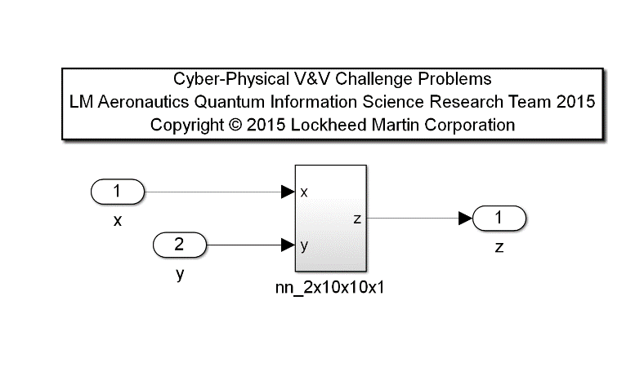Model: ‘nn_12B.mdl’

Description: This example is a two-input single-output two hidden layer feed forward nonlinear 2x10x10x1 neural network. Neural networks of this form are common utilities in modeling and simulation for capturing complex numerical dependencies. In this example, a single dependent variable, z, is computed based on two independent parameters, x and y.

|  |  |  |  |  |
| --- | --- | --- | --- | --- |
| **Input Scope** | **Name** | **#** | **Type** | **Description** |
| Global | x | 1 | Double | First Input Signal |
| Global | y | 2 | Double | Second Input Signal |

|  |  |  |  |  |
| --- | --- | --- | --- | --- |
| **Output Scope** | **Name** | **#** | **Type** | **Description** |
| Global | z | 1 | Double | Dependent Variable Output Signal |

The truth data for this example is included in the matlab file, nn_12B_data.mat, in the matrix original_data ϵ ℝ200x3 . xt is the 1st column, yt is the 2nd column, and zt is the 3rd column of data for 200 indices.

Requirements:

1. The maximum value of the NN output, z, shall always be less than or equal to 1.1, regardless of the input values.
2. The minimum value of the NN output, z, shall always be greater than or equal to -0.2, regardless of the input values.
3. Using a first order finite backward difference equation, the spatial derivatives of Δz/ Δxt = (z(n,1)-z(n-1))/(xt(n,1)-xt(n-1,1) and Δz/ Δyt = (z(n,1)-z(n-1))/(yt(n,1)-yt(n-1,1) shall never exceed a top bound of +10 or bottom bound of -35 (e.g. -35 <= Δz/ Δ(xt,yt) <= 10), where n denotes an index to the current values and n-1 denotes the prior values in the included truth data for xt and yt.
4. The absolute error between the zt truth data and the output z shall never exceed a tolerance of 0.01, for the equivalent input of (xt, yt).