# 2) Tustin Integrator

Model: ‘integrator_12B.mdl’

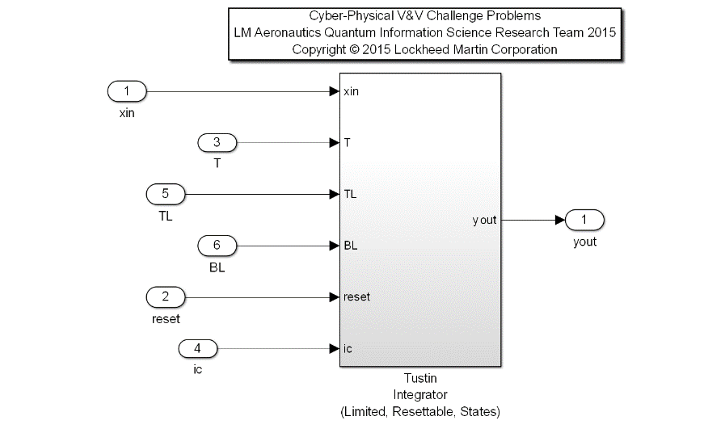Description: A common flight control utility for computing the Tustin Integration of a signal yout = T/2*(xin + xinpv)+ ypv. The algorithm bounds the allowable integration range with a position limiter, with TL as the Top Limit, and BL as the Bottom Limit. Other inputs are the signal to be integrated (xin), the time step (dt), a Boolean reset flag (reset), and the initial condition upon a reset condition (ic). A provision has been implemented for the limiter functionality in the algorithm. If the user plumbs a TL value that is less than BL, the algorithm will swap these numerical values to correctly bound the signal.

|  |  |  |  |  |
| --- | --- | --- | --- | --- |
| **Input Scope** | **Name** | **#** | **Type** | **Description** |
| Global | xin | 1 | Double | Input Signal to be integrated with the Tustin method |
| Global | T | 2 | Double | Time step quantified by rate of execution |
| Global | TL | 3 | Double | Top Limit bounding the output, yout. |
| Global | BL | 4 | Double | Bottom Limit bounding the output, yout. |
| Global | reset | 5 | Boolean | Reset control, initializes output to ic value. |
| Global | ic | 6 | Double | Initial Condition for yout when in reset mode. |

|  |  |  |  |  |
| --- | --- | --- | --- | --- |
| **Output Scope** | **Name** | **#** | **Type** | **Description** |
| Global | yout | 1 | Double | Output Signal result of Tustin integration method on xin |

Definitions:

* Normal operation: the integrator is not in reset mode, and the output is within the specified limits (TL and BL).
* ypv: prior yout value
* xinpv: prior xin input value
* SP: Saturation Point

Requirements:

1. When Reset is True and the Initial Condition (ic) is bounded by the provided Top and Bottom Limits (BL <= ic <= TL), the Output (yout) shall equal the Initial Condition (ic).
2. The Output (yout) shall be bounded by the provided Top and Bottom limits (TL and BL)
3. When in normal operation, the output shall be the result of the equation, yout = T/2*(xin + xinpv)+ ypv
4. The Output of this function shall approximate the integration of the value of the input signal over time within a specified tolerance, defined in subtests below:
   1. After 10 seconds of Computation at an execution frequency of 10 hz, the Output should equal 10 within a +/- 0.1 tolerance, for a Constant Input (xin = 1.0), and the sample delta time T = 0.1 seconds when in normal mode of operation.

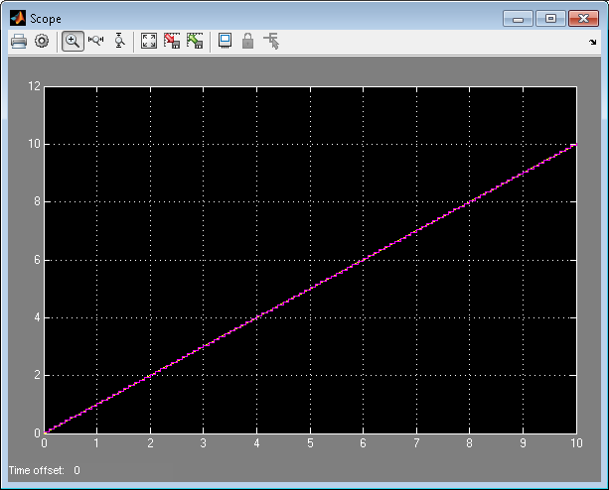 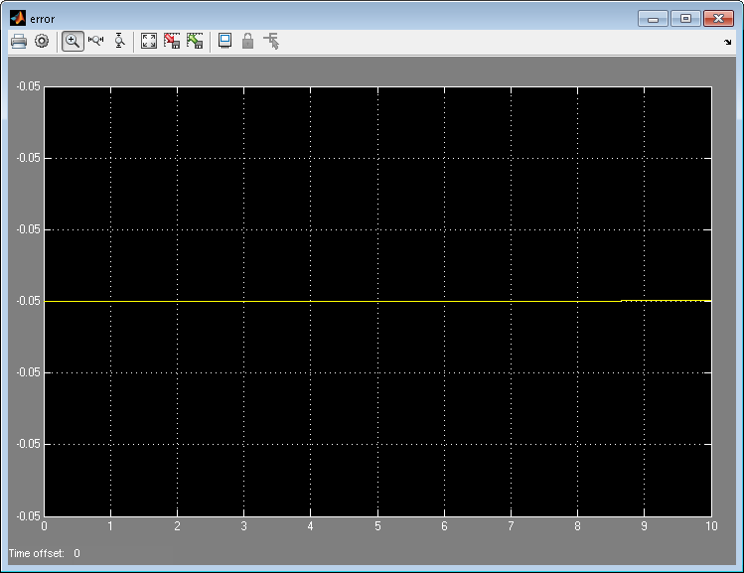

*Left Depiction: Magenta Line is Output of Function, Yellow Line is Perfect Integration*

*Right Depiction: Yellow Line is Error of Perfect Integration minus Output of Function*

1. Over a 10 second computational duration at an execution frequency of 10 hz, the Output should equal the sine of time t, sin(t), where time is defined as a vector from 0 to 10 by increments of 0.1 seconds within a +/- 0.1 tolerance for an input equal to the cosine of time t, cos(t), with the sample delta time T = 0.1 seconds when in normal mode of operation.

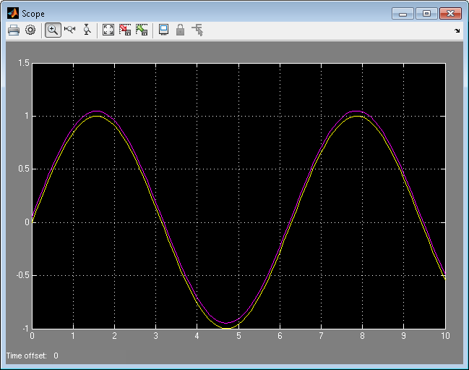 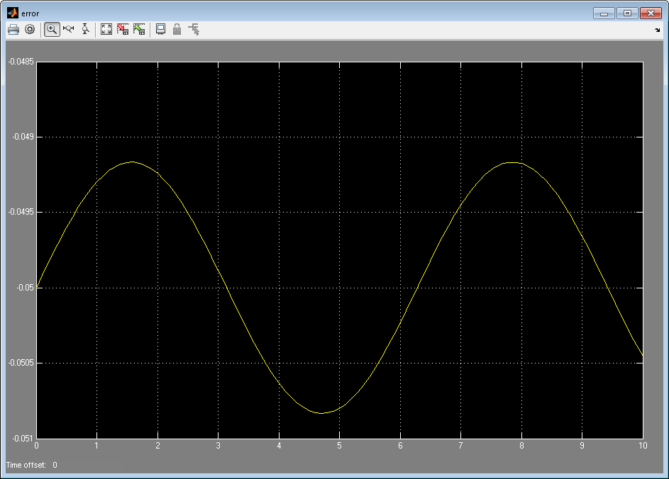

*Left Depiction: Magenta Line is Output of Function, Yellow Line is Perfect Integration*

*Right Depiction: Yellow Line is Error of Perfect Integration minus Output of Function*

Detailed Formal Property Derivation:

# 1. When Reset is True and the Initial Condition (ic) is

# bounded by the provided Top and Bottom Limits (BL<=ic<=TL),

# the Output (yout) shall equal the Initial Condition (ic).

# If the Initial Condition is not bound by the Limits

# during a Reset, the Output shall equal the saturation

# point (nominally with TL>=BL, ic>=TL impl SP==TL and ic<=BL impl SP==BL.

# Off-nominally with TL<BL, ic, ic>=BL impl SP==BL and ic<=TL impl SP==TL.

((reset and ic<=TL and ic>=BL) impl yout == ic); #1a

((reset and ic>=TL and ic>=BL and TL>=BL) impl yout == TL); #1b

((reset and ic<=BL and ic>=BL and TL>=BL) impl yout == BL); #1c

((reset and ic>=BL and ic<=TL and TL<BL) impl yout == BL); #1d

((reset and ic<=TL and ic>=BL and TL<BL) impl yout == TL); #1e

# 2. The Output (yout) shall be bounded by the provided Top

# and Bottom Limits (TL and BL).

(TL>=BL) impl (BL<=yout and yout<=TL); #2a

(TL<BL) impl (TL<=yout and yout<=BL); #2b

# 3. When in normal operation (as defined in reqs document), the Output

# (yout) shall be the result of the equation, yout = T/2*(xin + xinpv)+ypv.

#(not reset and ((TL{all}==10 and BL{all}==-10) and yout{all} <= 1*TL and yout{all} >= 1*BL) and abs(xin{all})<10.0 and T{all}==0.1 and ic{all}==0.0) impl (yout==0.5*T*(xin{t}+xin{t-1})+yout{t-1});

(not reset and (TL>=BL) and (0.5*T*(xin{t}+xin{t-1})+yout{t-1}>=BL) and (0.5*T*(xin{t}+xin{t-1})+yout{t-1}<=TL)) impl (yout==0.5*T*(xin{t}+xin{t-1})+yout{t-1});

#?(not reset and (TL>=BL) and (yout>=BL) and (yout<=TL)) impl (yout==0.5*T*(xin{t}+xin{t-1})+yout{t-1});

# 4. The Output (yout) of this function shall approximate the Tustin

# integration of the value of the input signal (xin) over time within

# a specified tolerance, defined in the following subtests:

# a) After 10 seconds of normal operation, the function computation

# at an execution frequency of 10 hz, yout should equal 10.0 within

# a +/- 0.1 tolerance, for a constant xin equal to 1.0, and sample

# delta time T equal to 0.1 seconds.

(xin{all}==1.0 and T{all}==0.1 and reset{never} and (TL{all}>=BL{all}) and (yout{all}>BL{all}) and (yout{all}<TL{all})) impl (abs(yout{0}-0*T)<=0.1 and abs(yout{1}-1*T)<=0.1 and abs(yout{2}-2*T)<=0.1 and abs(yout{3}-3*T)<=0.1 and abs(yout{4}-4*T)<=0.1 and abs(yout{5}-5*T)<=0.1 and abs(yout{6}-6*T)<=0.1 and abs(yout{7}-7*T)<=0.1 and abs(yout{8}-8*T)<=0.1 and abs(yout{9}-9*T)<=0.1 and abs(yout{10}-10*T)<=0.1 and abs(yout{11}-11*T)<=0.1 and abs(yout{12}-12*T)<=0.1 and abs(yout{13}-13*T)<=0.1 and abs(yout{14}-14*T)<=0.1 and abs(yout{15}-15*T)<=0.1 and abs(yout{16}-16*T)<=0.1 and abs(yout{17}-17*T)<=0.1 and abs(yout{18}-18*T)<=0.1 and abs(yout{19}-19*T)<=0.1 and abs(yout{20}-20*T)<=0.1 and abs(yout{21}-21*T)<=0.1 and abs(yout{22}-22*T)<=0.1 and abs(yout{23}-23*T)<=0.1 and abs(yout{24}-24*T)<=0.1 and abs(yout{25}-25*T)<=0.1 and abs(yout{26}-26*T)<=0.1 and abs(yout{27}-27*T)<=0.1 and abs(yout{28}-28*T)<=0.1 and abs(yout{29}-29*T)<=0.1 and abs(yout{30}-30*T)<=0.1 and abs(yout{31}-31*T)<=0.1 and abs(yout{32}-32*T)<=0.1 and abs(yout{33}-33*T)<=0.1 and abs(yout{34}-34*T)<=0.1 and abs(yout{35}-35*T)<=0.1 and abs(yout{36}-36*T)<=0.1 and abs(yout{37}-37*T)<=0.1 and abs(yout{38}-38*T)<=0.1 and abs(yout{39}-39*T)<=0.1 and abs(yout{40}-40*T)<=0.1 and abs(yout{41}-41*T)<=0.1 and abs(yout{42}-42*T)<=0.1 and abs(yout{43}-43*T)<=0.1 and abs(yout{44}-44*T)<=0.1 and abs(yout{45}-45*T)<=0.1 and abs(yout{46}-46*T)<=0.1 and abs(yout{47}-47*T)<=0.1 and abs(yout{48}-48*T)<=0.1 and abs(yout{49}-49*T)<=0.1 and abs(yout{50}-50*T)<=0.1 and abs(yout{51}-51*T)<=0.1 and abs(yout{52}-52*T)<=0.1 and abs(yout{53}-53*T)<=0.1 and abs(yout{54}-54*T)<=0.1 and abs(yout{55}-55*T)<=0.1 and abs(yout{56}-56*T)<=0.1 and abs(yout{57}-57*T)<=0.1 and abs(yout{58}-58*T)<=0.1 and abs(yout{59}-59*T)<=0.1 and abs(yout{60}-60*T)<=0.1 and abs(yout{61}-61*T)<=0.1 and abs(yout{62}-62*T)<=0.1 and abs(yout{63}-63*T)<=0.1 and abs(yout{64}-64*T)<=0.1 and abs(yout{65}-65*T)<=0.1 and abs(yout{66}-66*T)<=0.1 and abs(yout{67}-67*T)<=0.1 and abs(yout{68}-68*T)<=0.1 and abs(yout{69}-69*T)<=0.1 and abs(yout{70}-70*T)<=0.1 and abs(yout{71}-71*T)<=0.1 and abs(yout{72}-72*T)<=0.1 and abs(yout{73}-73*T)<=0.1 and abs(yout{74}-74*T)<=0.1 and abs(yout{75}-75*T)<=0.1 and abs(yout{76}-76*T)<=0.1 and abs(yout{77}-77*T)<=0.1 and abs(yout{78}-78*T)<=0.1 and abs(yout{79}-79*T)<=0.1 and abs(yout{80}-80*T)<=0.1 and abs(yout{81}-81*T)<=0.1 and abs(yout{82}-82*T)<=0.1 and abs(yout{83}-83*T)<=0.1 and abs(yout{84}-84*T)<=0.1 and abs(yout{85}-85*T)<=0.1 and abs(yout{86}-86*T)<=0.1 and abs(yout{87}-87*T)<=0.1 and abs(yout{88}-88*T)<=0.1 and abs(yout{89}-89*T)<=0.1 and abs(yout{90}-90*T)<=0.1 and abs(yout{91}-91*T)<=0.1 and abs(yout{92}-92*T)<=0.1 and abs(yout{93}-93*T)<=0.1 and abs(yout{94}-94*T)<=0.1 and abs(yout{95}-95*T)<=0.1 and abs(yout{96}-96*T)<=0.1 and abs(yout{97}-97*T)<=0.1 and abs(yout{98}-98*T)<=0.1 and abs(yout{99}-99*T)<=0.1 and abs(yout{100}-100*T)<=0.1);

# b) After 10 seconds of normal operation, the function computation

# at an execution frequency of 10 hz, yout should equal the sine

# of time t, sin(t), within a +/- 0.1 tolerance, for an input xin

# equal to the cosine of time t, cos(t), and sample

# delta time T equal to 0.1 seconds.

(xin{0}==1 and xin{1}==0.995 and xin{2}==0.98007 and xin{3}==0.95534 and xin{4}==0.92106 and xin{5}==0.87758 and xin{6}==0.82534 and xin{7}==0.76484 and xin{8}==0.69671 and xin{9}==0.62161 and xin{10}==0.5403 and xin{11}==0.4536 and xin{12}==0.36236 and xin{13}==0.2675 and xin{14}==0.16997 and xin{15}==0.070737 and xin{16}==-0.0292 and xin{17}==-0.12884 and xin{18}==-0.2272 and xin{19}==-0.32329 and xin{20}==-0.41615 and xin{21}==-0.50485 and xin{22}==-0.5885 and xin{23}==-0.66628 and xin{24}==-0.73739 and xin{25}==-0.80114 and xin{26}==-0.85689 and xin{27}==-0.90407 and xin{28}==-0.94222 and xin{29}==-0.97096 and xin{30}==-0.98999 and xin{31}==-0.99914 and xin{32}==-0.99829 and xin{33}==-0.98748 and xin{34}==-0.9668 and xin{35}==-0.93646 and xin{36}==-0.89676 and xin{37}==-0.8481 and xin{38}==-0.79097 and xin{39}==-0.72593 and xin{40}==-0.65364 and xin{41}==-0.57482 and xin{42}==-0.49026 and xin{43}==-0.4008 and xin{44}==-0.30733 and xin{45}==-0.2108 and xin{46}==-0.11215 and xin{47}==-0.012389 and xin{48}==0.087499 and xin{49}==0.18651 and xin{50}==0.28366 and xin{51}==0.37798 and xin{52}==0.46852 and xin{53}==0.55437 and xin{54}==0.63469 and xin{55}==0.70867 and xin{56}==0.77557 and xin{57}==0.83471 and xin{58}==0.88552 and xin{59}==0.92748 and xin{60}==0.96017 and xin{61}==0.98327 and xin{62}==0.99654 and xin{63}==0.99986 and xin{64}==0.99318 and xin{65}==0.97659 and xin{66}==0.95023 and xin{67}==0.91438 and xin{68}==0.8694 and xin{69}==0.81573 and xin{70}==0.7539 and xin{71}==0.68455 and xin{72}==0.60835 and xin{73}==0.52608 and xin{74}==0.43855 and xin{75}==0.34664 and xin{76}==0.25126 and xin{77}==0.15337 and xin{78}==0.053955 and xin{79}==-0.046002 and xin{80}==-0.1455 and xin{81}==-0.24354 and xin{82}==-0.33915 and xin{83}==-0.43138 and xin{84}==-0.51929 and xin{85}==-0.60201 and xin{86}==-0.67872 and xin{87}==-0.74865 and xin{88}==-0.81109 and xin{89}==-0.86544 and xin{90}==-0.91113 and xin{91}==-0.94772 and xin{92}==-0.97484 and xin{93}==-0.99223 and xin{94}==-0.99969 and xin{95}==-0.99717 and xin{96}==-0.98469 and xin{97}==-0.96236 and xin{98}==-0.93043 and xin{99}==-0.88919 and xin{100}==-0.83907 and T{all}==0.1 and reset{never} and (TL{all}>=BL{all}) and (yout{all}>BL{all}) and (yout{all}<TL{all})) impl (abs(yout{0}-0)<=0.1 and abs(yout{1}-0.099833)<=0.1 and abs(yout{2}-0.19867)<=0.1 and abs(yout{3}-0.29552)<=0.1 and abs(yout{4}-0.38942)<=0.1 and abs(yout{5}-0.47943)<=0.1 and abs(yout{6}-0.56464)<=0.1 and abs(yout{7}-0.64422)<=0.1 and abs(yout{8}-0.71736)<=0.1 and abs(yout{9}-0.78333)<=0.1 and abs(yout{10}-0.84147)<=0.1 and abs(yout{11}-0.89121)<=0.1 and abs(yout{12}-0.93204)<=0.1 and abs(yout{13}-0.96356)<=0.1 and abs(yout{14}-0.98545)<=0.1 and abs(yout{15}-0.99749)<=0.1 and abs(yout{16}-0.99957)<=0.1 and abs(yout{17}-0.99166)<=0.1 and abs(yout{18}-0.97385)<=0.1 and abs(yout{19}-0.9463)<=0.1 and abs(yout{20}-0.9093)<=0.1 and abs(yout{21}-0.86321)<=0.1 and abs(yout{22}-0.8085)<=0.1 and abs(yout{23}-0.74571)<=0.1 and abs(yout{24}-0.67546)<=0.1 and abs(yout{25}-0.59847)<=0.1 and abs(yout{26}-0.5155)<=0.1 and abs(yout{27}-0.42738)<=0.1 and abs(yout{28}-0.33499)<=0.1 and abs(yout{29}-0.23925)<=0.1 and abs(yout{30}-0.14112)<=0.1 and abs(yout{31}-0.041581)<=0.1 and abs(yout{32}--0.058374)<=0.1 and abs(yout{33}--0.15775)<=0.1 and abs(yout{34}--0.25554)<=0.1 and abs(yout{35}--0.35078)<=0.1 and abs(yout{36}--0.44252)<=0.1 and abs(yout{37}--0.52984)<=0.1 and abs(yout{38}--0.61186)<=0.1 and abs(yout{39}--0.68777)<=0.1 and abs(yout{40}--0.7568)<=0.1 and abs(yout{41}--0.81828)<=0.1 and abs(yout{42}--0.87158)<=0.1 and abs(yout{43}--0.91617)<=0.1 and abs(yout{44}--0.9516)<=0.1 and abs(yout{45}--0.97753)<=0.1 and abs(yout{46}--0.99369)<=0.1 and abs(yout{47}--0.99992)<=0.1 and abs(yout{48}--0.99616)<=0.1 and abs(yout{49}--0.98245)<=0.1 and abs(yout{50}--0.95892)<=0.1 and abs(yout{51}--0.92581)<=0.1 and abs(yout{52}--0.88345)<=0.1 and abs(yout{53}--0.83227)<=0.1 and abs(yout{54}--0.77276)<=0.1 and abs(yout{55}--0.70554)<=0.1 and abs(yout{56}--0.63127)<=0.1 and abs(yout{57}--0.55069)<=0.1 and abs(yout{58}--0.4646)<=0.1 and abs(yout{59}--0.37388)<=0.1 and abs(yout{60}--0.27942)<=0.1 and abs(yout{61}--0.18216)<=0.1 and abs(yout{62}--0.083089)<=0.1 and abs(yout{63}-0.016814)<=0.1 and abs(yout{64}-0.11655)<=0.1 and abs(yout{65}-0.21512)<=0.1 and abs(yout{66}-0.31154)<=0.1 and abs(yout{67}-0.40485)<=0.1 and abs(yout{68}-0.49411)<=0.1 and abs(yout{69}-0.57844)<=0.1 and abs(yout{70}-0.65699)<=0.1 and abs(yout{71}-0.72897)<=0.1 and abs(yout{72}-0.79367)<=0.1 and abs(yout{73}-0.85044)<=0.1 and abs(yout{74}-0.89871)<=0.1 and abs(yout{75}-0.938)<=0.1 and abs(yout{76}-0.96792)<=0.1 and abs(yout{77}-0.98817)<=0.1 and abs(yout{78}-0.99854)<=0.1 and abs(yout{79}-0.99894)<=0.1 and abs(yout{80}-0.98936)<=0.1 and abs(yout{81}-0.96989)<=0.1 and abs(yout{82}-0.94073)<=0.1 and abs(yout{83}-0.90217)<=0.1 and abs(yout{84}-0.8546)<=0.1 and abs(yout{85}-0.79849)<=0.1 and abs(yout{86}-0.7344)<=0.1 and abs(yout{87}-0.66297)<=0.1 and abs(yout{88}-0.58492)<=0.1 and abs(yout{89}-0.50102)<=0.1 and abs(yout{90}-0.41212)<=0.1 and abs(yout{91}-0.3191)<=0.1 and abs(yout{92}-0.22289)<=0.1 and abs(yout{93}-0.12445)<=0.1 and abs(yout{94}-0.024775)<=0.1 and abs(yout{95}--0.075151)<=0.1 and abs(yout{96}--0.17433)<=0.1 and abs(yout{97}--0.27176)<=0.1 and abs(yout{98}--0.36648)<=0.1 and abs(yout{99}--0.45754)<=0.1 and abs(yout{100}--0.54402)<=0.1);