# 9) Euler 321 Inertial to Body Frame

Model: ‘euler321_I2B_12B.mdl’

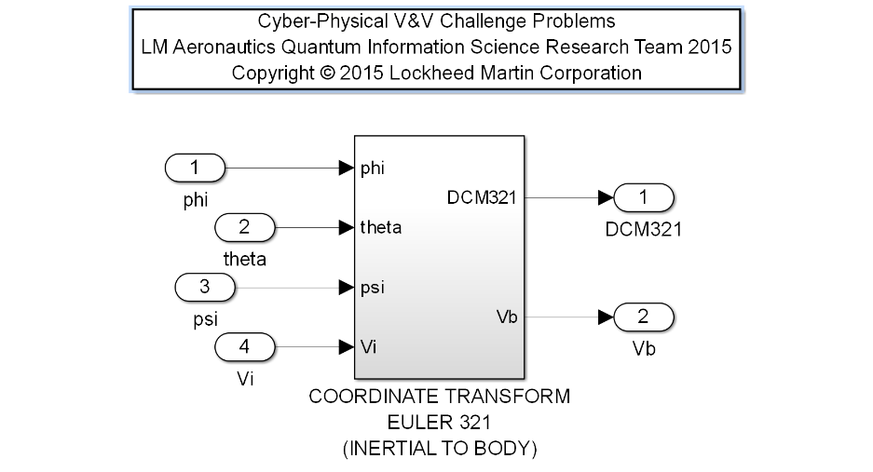Description: This component creates a Rotation Matrix describing a 321 rotation about the z-axis, y-axis, and finally x-axis of an Inertial frame in Euclidean space, and, given an Input Vector, outputs the representation of the Input Vector in the new rotated frame.

Note the y-axis and x-axis subsequent rotations are the second and third transform operations, identified in the 321 operation by the 2 and 3 label description, respectively. The latter two operations are rotations about the intermediate frames.

The computed Rotation Matrix Shall Equal a Special Orthogonal(3) 3x3 with the following properties: (i) the rows and columns of the Output Matrix shall be orthonormal; (ii) the Output Matrix multiplied with the Transpose of the Output Matrix shall be the Identity (3x3) Matrix; and (iii) the determinant of the Output Matrix shall be equal to 1.

|  |  |  |  |  |
| --- | --- | --- | --- | --- |
| **Input Scope** | **Name** | **#** | **Type** | **Description** |
| Global | phi | 1 | Double | Roll angle [rad] |
| Global | theta | 2 | Double | Pitch angle [rad] |
| Global | psi | 3 | Double | Yaw angle [rad] |
| Global | Vi | 4 | Double | 3x1 Inertial Vector |

|  |  |  |  |  |
| --- | --- | --- | --- | --- |
| **Output Scope** | **Name** | **#** | **Type** | **Description** |
| Global | DCM321 | 1 | Double | 3x3 Rotation Matrix |
| Global | Vb | 2 | Double | 3x1 Body Vector |

Definitions:

Euler3 Roll rotation: 

Euler2 Pitch rotation: 

Euler1 Heading Rotation: 

Requirements:

1. The Rotation Matrix Output, DCM321, of this Function Shall Equal a 3x3 Matrix Product of a 3x3 Euler 3 (Roll) Rotation Matrix times a 3x3 Euler 2 (Pitch) Rotation Matrix times a 3x3 Euler 1 (Heading) Rotation Matrix.
2. The Body Vector Output, Vb, of this Function Shall Equal a 3x1 Vector Product of the 3x3 Rotation Matrix Output, DCM321, times the Input Inertial Vector, Vi.
3. The magnitude of the Body Vector Output, Vb, shall equal the magnitude of the Input Inertial Vector, Vi.
4. The Rotation Matrix, DCM321, shall be invertible with the exception of the case where theta = +/- pi/2 radians.
5. The Rotation Matrix, DCM321, shall provide a distinct mapping from the input vector, Vi, to the output vector, Vb, for each pitch angle, theta. Note: the DCM321 is not distinct for all phi and psi inputs.
6. The rows and columns of the Rotation Matrix, DCM321, shall be orthonormal. For instance, denoting r1 as row 1 and r2 as row 2 of DCM321, <r1, r2> = r1 r2T = 0 and <r1, r1> = r1 r1T = 1. Likewise, with c1 as column 1 and c2 as column 2 of DCM321, <c1, c2> = c1 c2T = 0 and <c1, c1> = c1 c1T = 1.
7. The Rotation Matrix, DCM321, multiplied by the transpose of the Rotation Matrix, DCM321T shall be the Identity (3x3) Matrix.
8. The determinant of the Rotation Matrix, |DCM321|, shall be equal to 1.0.