Work progress

Week 1
Hamza BOURBOUH

Software installation
the following softwares are installed and tested :
CocoSim dependencies :
Matlab R2016a and R2015a,
Zustre,
Python2.7
Z3,
LustreC (2 versions https://github.com/coco-team/lustrec and https://cavale.enseeiht.fr/git/lustrec).

For testing objectives I installed the following Verimag tools :
Lustre-V4 Verimag release (lesar, luciole, lus2ec …)
Simulink2Lustre and Stateflow2Lustre (s2l, sf2lus, ss2lus).

Documentation about stateflow to Lustre
All documentation that I use are in “doc” folder in my github (https://github.com/hbourbou/stateflow2Lustre-automaton/tree/master/doc)
The most interesting documents among them are :
TR-2004-16 : Technical report of emsoft04 article : “Defining and translating a “safe” subset of Simulink/Stateflow into Lustre” N, Scaife, C. Sofronis, P, Caspi, S, Tripakis and Maraninchi 2004.
Other documents are used to understand some technical details in Lustre or Stateflow.
Please feel free to send me any documentation you think it will help.

Presentation Verimag Vs Automaton
I made a presentation (https://github.com/hbourbou/stateflow2Lustre-automaton/tree/master/reports/presentation_Verimag.pdf) that resume what is done by Verimag about translating Stateflow2Lustre and my version of translation. This presentation is not yet finished and it has the current plan :
1. Abstract
2. A safe subset of Stateflow
2.1 A short description of Stateflow
2.2 The interpretation algorithm
2.3 Semantic issues with Stateflow
3. Simple conditions identifying a “safe” subset of Stateflow
4. Lustre and automaton (pre, when and current operators, explanation of Until and Unless)
5. Translation into Lustre
5.1 Encoding of states Verimag version
5.2 Translation into Automaton : First Version.
It contains my first version of translating Stateflow to Automaton, this version is tested with 3 examples and compared with Verimag version using LustreC compiler. The objective is to translate as many examples as I can in order to find the general conception to all examples.
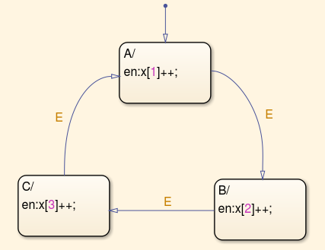
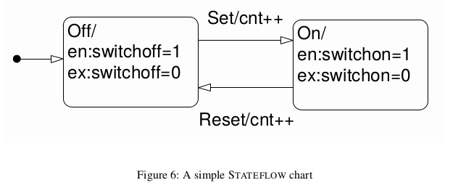
The Example tested and validated are :

The following example is not yet finished, I am working on it.
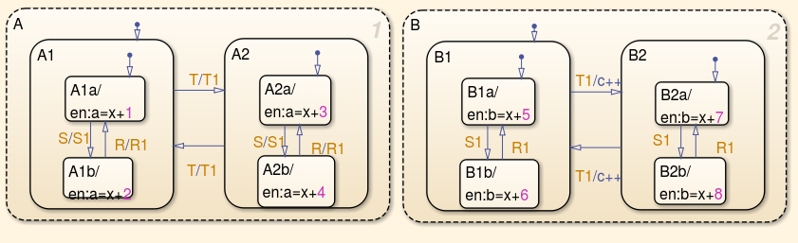

My first version of Translation is :
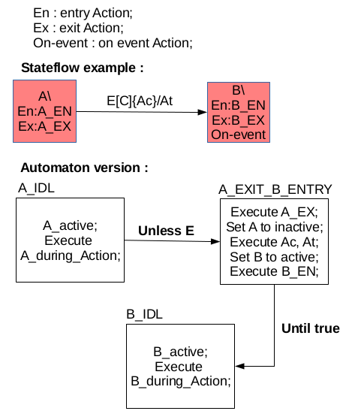

What to do for next week
I am planing to :
- Finish examples and their translation,
- Write the general Algorithm for all tested examples,
- Implementing the Algorithm in Matlab to generate automatically the Lustre code.

