**COMP7106 Big data management [Section 2B, 2022] Assignment 2**

**Student Name: HUANG BINQIAN**

**Student ID: 3036032724**

The code for the three questions is in one program. Use pycharm to open the program.

**Part 1: index development**

Run “main.py”, then input:

**data\coords.txt**

**data\offsets.txt**

The output is:

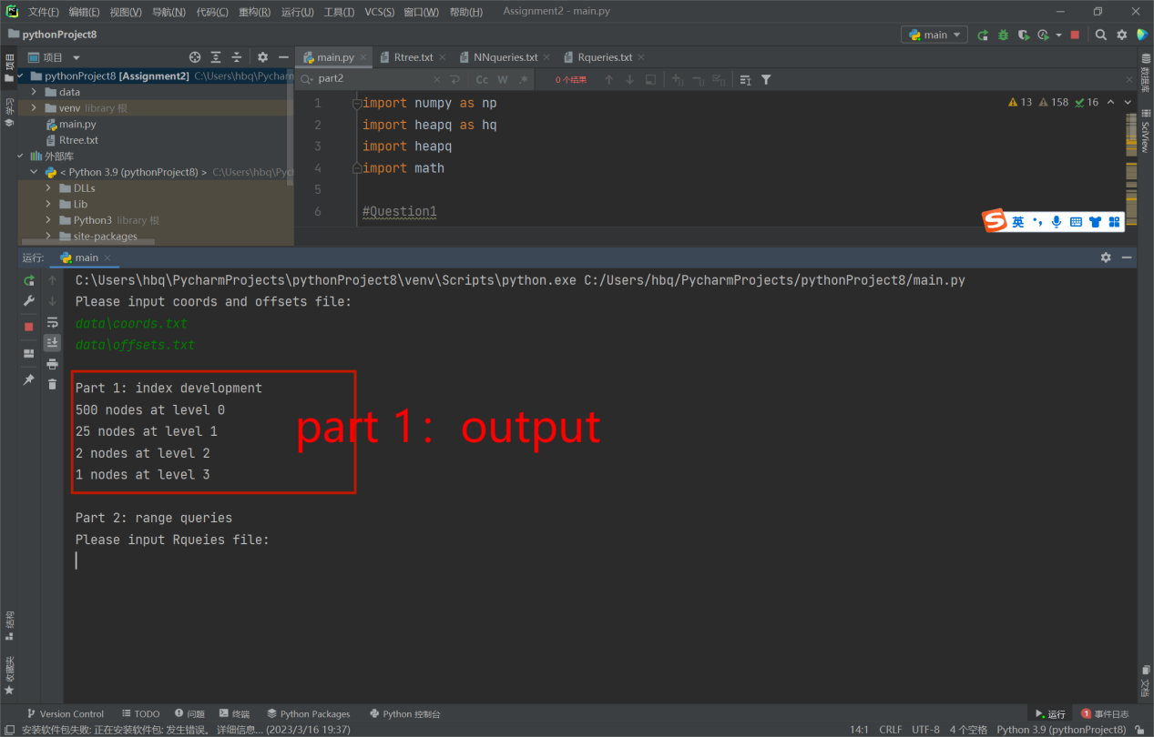

Besides, the program generates “Rtree.txt” file in venv.

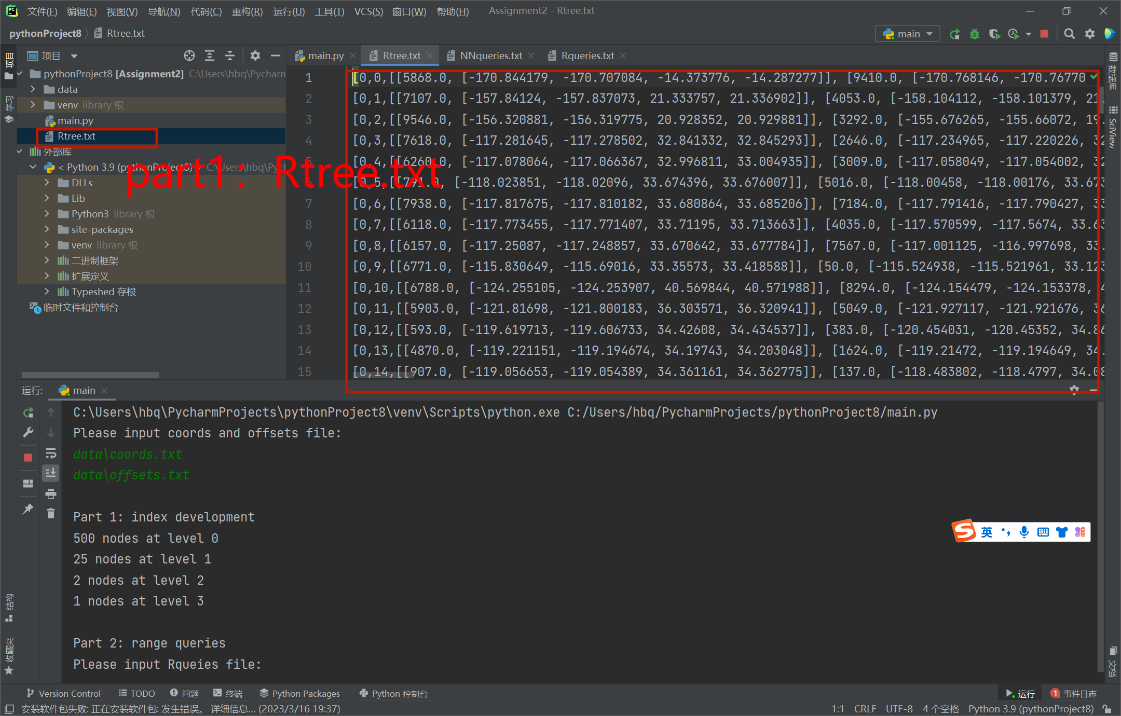

**Part 2: range queries**

Input:

**data\Rqueries.txt**

The output is:

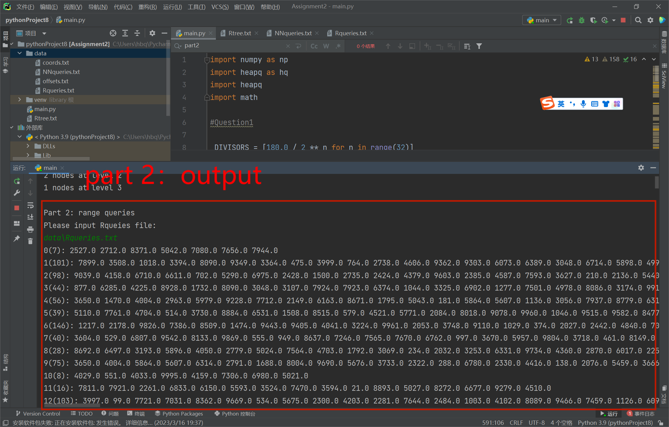

**Part 3: KNN queries**

Input:

**data\Rqueries.txt**

Then input the value of k, for example if k=10, input **10**.

The output is:

