**Your CS Account**

As a student in CS251, you should have already been assigned a user accounts for the CS department machines (e.g., the Linux machines in the CS lab and the UNIX servers such as bert.cs.uic.edu which you can connect to remotely).

This account is different from your university-wide NetID.

CS Majors are assigned an account which will continue to exist from semester to semester until you graduate. Your username is usually your first initial followed by your last name (and maybe a number). For example:

My NetID: lillis

My CS Account: jlillis

Non-majors are assigned "temp" accounts at the beginning of each semester (username temp123 for example). Temporary accounts expire at the end of each semester.

**Finding Your username**

There is a system to determine from your NetID your CS account (if you have one). Assuming you have access to a browser, go to this page:

<https://www.cs.uic.edu/bin/view/ComputerSupport/Accounts>

Follow the **"View your CS account information here"** link. You will then enter your NetID and login.

Once you know your CS username, you can login to a lab machine.

Your password is initially set to your UIN.

Try logging into a lab machine.

**Changing Your Password**

Your UIN is not a very good password. For example, I and the TAs have access to your UIN via blackboard.

So, let's change it! From your login session on a lab machine do the following:

* Under Applications, find the "Terminal" program and start it.
* You should see a window that looks something like this:

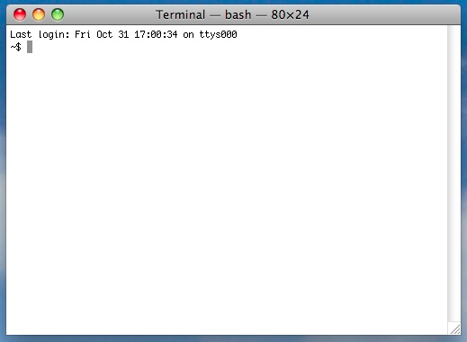

* You now have access to the "shell": a program in which you type commands.
* Type the command yppasswd into the terminal.
* You will be asked to enter your current password (your UIN) and then the new, more secure password you have chosen.

Once you have changed your password, log out of the machine and try to log back in.

**Remote Access to Your CS Account**

You can remotely access your CS account by logging into one of the department servers such as bert.cs.uic.edu and bertvm.cs.uic.edu.

This is done using a "secure shell" client program on your personal machine.

**Windows**:

A program called PuTTY is a popular secure shell client for Windows.

You can download it for free from [www.putty.org](http://www.putty.org)

Usage is pretty straightforward (and there are many online resources).

Once you connect from your local machine to one of the CS servers, you will have a shell running on the server. Poke around. You will find exactly the same files that you see from the machines in the lab!

**Mac**:

If you have a Mac, find and run the terminal program. You will get a shell running locally on your machine (fun fact: MacOS is built on top of a variant of UNIX!).

From the shell you can run the ssh program to start a remote shell running on bert as follows:

% ssh <cs-username>@bert.cs.uic.edu

For example, I would do the following:

% ssh jlillis@bert.cs.uic.edu

**Copying Files To and From Your CS Account**

Sometimes you will want to copy files from your local machine to your CS account and vice-versa.

**Windows and Mac:** For this you want an "sftp" client program. **Filezilla** is a popular choice for both Windows and Mac:

<https://filezilla-project.org/>

**Mac:** Alternatively, Mac users already have an sftp client which you can run from the shell/terminal like you run the ssh client. For example:

% sftp [jlillis@bert.cs.uic.edu](mailto:jlillis@bert.cs.uic.edu)

Once connected you enter sftp commands by typing them. There are many tutorials available online. But here is a list of some useful commands:

help pwd cd get put mget mput pwd