* Final X,Y,theta = 6.35cm, 101.6cm, -10deg
* Camera pitch = 15 deg
* Camera Matrix:
  + 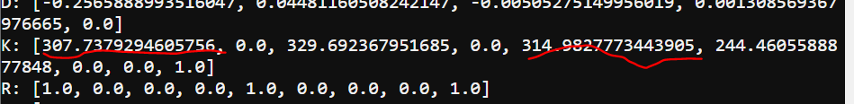
* Height of camera lens = 9.6 cm