实验4 嵌套查询和数据更新

班级:计科二班 学号:20171205079 姓名:李振浩

实验目的：

1．熟练掌握SQL Server查询分析器的使用方法，加深对标准SQL查询语句的理解。

2．熟练掌握简单表的数据嵌套查询和数据更新的操作方法。

实验内容：

创建教学管理数据库“JXGL”，在“JXGL”数据库中创建3-2中的三张表并添加数据，实现数据的单表查询操作。

实验步骤：

在教学管理“JXGL”数据库中写出下列操作的SQL语句

1. 查询其它系中比计算机系所有同学年龄都小的学生的学号、姓名和所在系；

SELECT Sno,Sname,Sdept FROM Student

1. WHERE Sdept != 'CS' AND Sage <ALL(SELECT Sage FROM Student WHERE Sdept = 'CS')

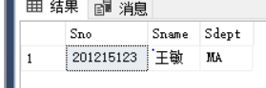

1. 查询1号课的选课成绩高于1号课平均成绩的同学的学号和成绩；

SELECT Sno,Grade FROM Sc

1. WHERE Cno = '1' and Grade > (SELECT AVG(Grade) FROM Sc WHERE Cno = '1')

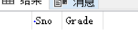

1. 查询年龄大于所在系平均年龄的同学的学号、姓名和所在系；

SELECT Sno,Sname,Sdept FROM Student y

WHERE Sage > (

SELECT AVG(Sage) FROM Student x

WHERE y.Sdept = x.Sdept

1. Group By Sdept)

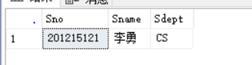

1. 查询选修了全部课程的学生的学号和姓名；

SELECT Sno,Sname FROM Student

WHERE NOT EXISTS

(SELECT * FROM Course

WHERE NOT EXISTS

1. (SELECT * FROM SC WHERE Sno = Student.Sno AND Cno = Course.Cno))

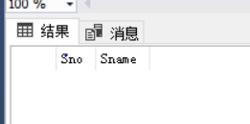

1. 查询选修了201215122选修的全部课程的学生的学号；

SELECT DISTINCT Sno FROM Sc SCX

WHERE NOT EXISTS

(SELECT * FROM Sc SCY

WHERE SCY.Sno='201215122' AND

NOT EXISTS (SELECT * FROM SC SCZ

WHERE SCZ.Sno = SCX.Sno AND SCZ.Cno = SCY.Cno))

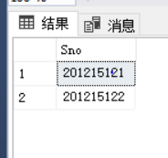

1. 验证union、intersect、except；

select * from student

where sdept = 'cs'

union

select * from student

where sdept = 'ma'

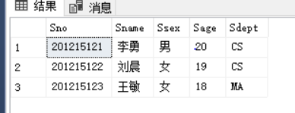

select * from student

where sdept = 'cs'

intersect

select * from student

where sage = '20'

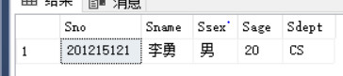

select * from student

where sdept = 'cs'

except

select * from student

where sage = '20'

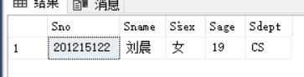

1. 新建表sno_avg，表中包含学号和平均成绩两列；把有选课记录的同学的学号和所选课程的平均成绩插入到sno_avg表中；

create table sno_avg(

sno char(9) primary key,

avg double precision

)

insert into sno_avg

select sno,avg(grade) from sc group by sno

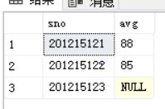

1. 把所有“数据库”课程的选课成绩置空；

update sc

set grade = NULL

WHERE Cno =

select cno from course where cname = '数据库')

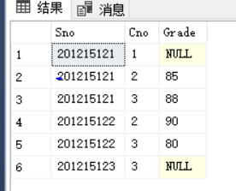

1. 删除“数据库”课程的选课记录；

delete

from sc

where exists

(select * from course where course.cno = sc.cno and course.cname = '数据库')

1. 验证违反约束的更新操作;
2. insert 语句违反约束；
3. insert into sc values(NULL,'1',90)

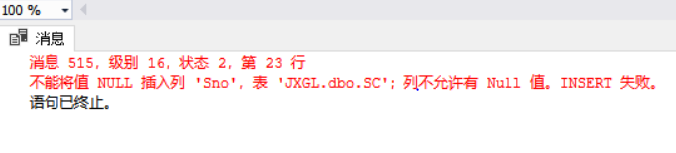

1. Update 语句违反约束；

update sc

set sno = NULL

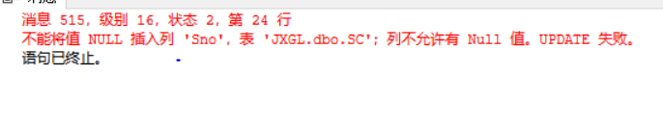

1. Delete 语句违反约束；
2. delete from course where cno = '1'

