3：

1. select * from S where A = ‘10’
2. Select A,B from S
3. Select * from S,T
4. Select * from S,T where S.c = T.c
5. Select * from S,T where S.A < T.C
6. Select C,D from S union select * from T

4:创建表

create table S(

sno char(9) primary key,

sname char(30),

status smallint,

city char(30)

)

create table P(

pno char(9) primary key,

pname char(30),

color char(5),

weight smallint

)

create table J(

jno char(9) primary key,

jname char(30),

city char(30)

)

create table SPJ(

sno char(9),

pno char(9),

jno char(9),

qty int,

foreign key (pno) references P(pno),

foreign key (jno) references J(jno),

foreign key (sno) references S(sno),

)

插入记录

insert into S values('S1','精益',20,'天津')

insert into S values('S2','盛锡',10,'北京')

insert into S values('S3','东方红',30,'北京')

insert into S values('S4','丰泰盛',20,'天津')

insert into S values('S5','为民',30,'上海')

insert into P values('P1','螺母','红',12)

insert into P values('P2','螺栓','绿',17)

insert into P values('P3','螺丝刀','蓝',14)

insert into P values('P4','螺丝刀','红',14)

insert into P values('P5','凸轮','蓝',40)

insert into P values('P6','齿轮','红',30)

insert into J values('J1','三建','北京')

insert into J values('J2','一汽','长春')

insert into J values('J3','弹簧厂','天津')

insert into J values('J4','造船厂','天津')

insert into J values('J5','机车厂','唐山')

insert into J values('J6','无线电厂','常州')

insert into J values('J7','半导体厂','南京')

insert into SPJ values('S1','P1','J1',200)

insert into SPJ values('S1','P1','J3',100)

insert into SPJ values('S1','P1','J4',700)

insert into SPJ values('S1','P2','J2',100)

insert into SPJ values('S2','P3','J1',400)

insert into SPJ values('S2','P3','J2',200)

insert into SPJ values('S2','P3','J4',500)

insert into SPJ values('S2','P3','J5',400)

insert into SPJ values('S2','P5','J1',400)

insert into SPJ values('S2','P5','J2',100)

insert into SPJ values('S3','P5','J1',200)

insert into SPJ values('S3','P1','J1',200)

insert into SPJ values('S4','P5','J1',100)

insert into SPJ values('S4','P6','J3',300)

insert into SPJ values('S4','P6','J4',200)

insert into SPJ values('S5','P2','J4',100)

insert into SPJ values('S5','P3','J1',200)

insert into SPJ values('S5','P6','J2',200)

insert into SPJ values('S5','P6','J4',500)

1)

select sno from spj where jno = 'j1'

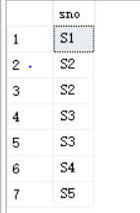

2)

select sno from spj where pno = 'p1'

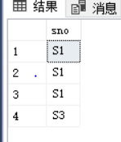

3)

select sno from spj

where jno = 'j1' and exists

(select * from p where color = '红' and spj.pno = p.pno)

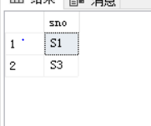

4)

select jno from spj

where not exists

(select * from s where s.sno = spj.sno and city = '天津') and exists

(select * from p where p.pno = spj.pno and color = '红')

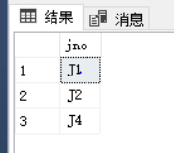

1. :

select distinct jno from spj x

where not exists

(select pno from spj y

where y.sno = 'S1' and

not exists

(select * from spj z

where z.jno = x.jno and z.pno = y.pno))

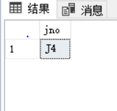

5:

1)

select sname,city from s

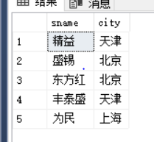

2)

select pname,color,weight from p

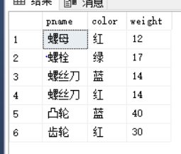

3)

select jno from spj where sno = 'S1'

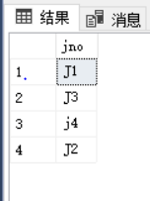

4)

select pname,count(*) from p,spj

where p.pno = spj.pno and jno = 'j2'

group by pname

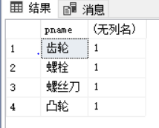

5)

select pno from s,spj

where s.sno = spj.sno and city = '上海'

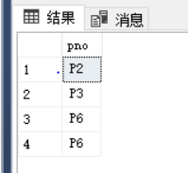

6)

select jname from s,spj,j

where s.sno = spj.sno and j.jno = spj.jno and s.city = '上海'

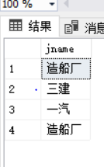

7)

where not exists(

select * from s

where s.city = '天津' and

exists(select * from spj z where z.sno = s.sno and z.jno = x.jno)

)

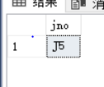

8)

update p

set color = '蓝'

where p.color = '红'

9)

update spj

set sno = 'S3'

where sno = 'S5' and pno = 'P6' and jno = 'j4' and QTY = 500



10)

alter table spj add

constraint fk_sno

foreign key (sno) references S(sno) on delete cascade

delete from s

where sno = 'S2'

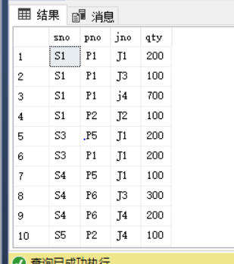

11)

insert into spj values('S2','J6','P4',200)

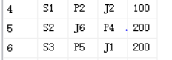

9:

create view lzh(sno,pno,qty)

as

select sno,pno,qty from spj

1:

select pno,count(*) from lzh

group by pno

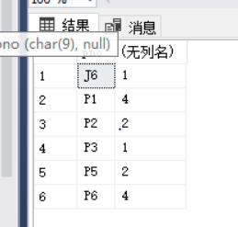

2:

select * from lzh where sno = 's1'

