The TP53 gene produces the p53 protein, nicknamed the "Guardian of the Genome." Its main job is to monitor cellular stress and DNA damage, acting as a master brake on abnormal cell division.

When p53 is altered or destroyed, the primary defense system against cancer fails, allowing mutated cells to replicate unchecked.

How p53 Works Normally
Under healthy conditions, p53 levels are kept low by an inhibitor protein called MDM2. When a cell experiences stress (UV light, radiation, chemical mutagens, or metabolic stress), p53 is activated and triggers one of two pathways:
- Cell Cycle Arrest (Repair): p53 activates p21 (CDKN1A), halting the cell cycle at the $G_1/S$ phase checkpoint. This gives the cell time to repair damaged DNA before copying it.
- Apoptosis (Self-Destruction): If the DNA damage is beyond repair, p53 activates pro-apoptotic proteins like BAX and PUMA to safely destroy the damaged cell before it can turn malignant.

How TP53 Gets Affected (Inactivation)
The TP53 pathway is disrupted in over 50% of all human cancers. This usually occurs through three main mechanisms:
- Missense Point Mutations: Single-letter DNA mutations alter p53's DNA-binding domain (DBD). The mutated p53 protein loses its ability to bind target genes like p21 or BAX.
- MDM2 Overexpression: Certain cancers overproduce MDM2, causing healthy p53 proteins to be tagged for destruction before they can respond to DNA damage.
- Viral Oncoproteins: High-risk viruses (such as HPV) produce proteins (like HPV E6) that directly target host p53 for rapid degradation.

How a Cancer Cell Emerges (The Cascade)
When p53 functionality is lost, a normal cell undergoes a multi-step transformation into a malignant cancer cell:
- Normal Cell + DNA Damage
- p53 is Mutated / Inactive
- No Cell Cycle Arrest (Damaged DNA is replicated during S-phase)
- Mutations Accumulate (Additional oncogenes turn ON (e.g., KRAS, MYC), Tumor suppressors turn OFF (e.g., RB1, BRCA1))
- Uncontrolled Mitosis (Cell ignores death signals & evades apoptosis)
- Cancer Cell Formation (Forms a tumor, triggers angiogenesis, & metastasizes)
Without p53 to enforce DNA repair or trigger cell death, mutated cells gain survival advantages, multiply rapidly, and continuously collect secondary genetic mutations →giving rise to a fully malignant cancer.

The p53 Network from StringDB
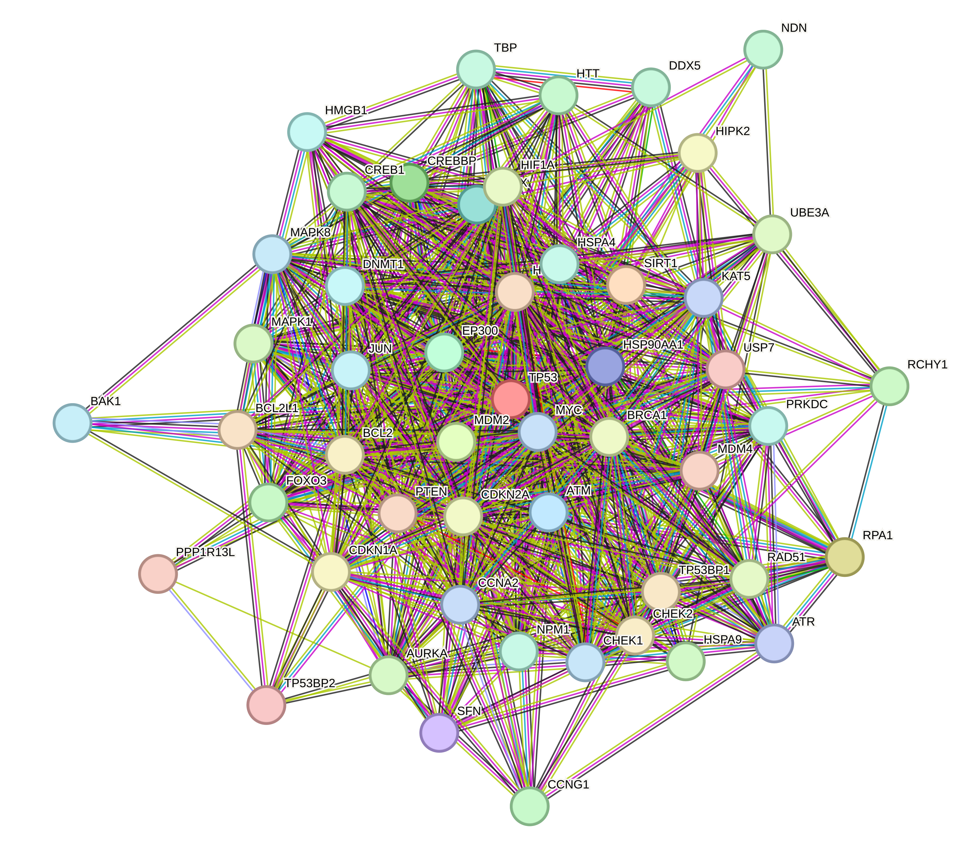
Targeting both MDM2 and ep300 to restore and modulate p53 function represents a highly worthwhile therapeutic strategy for advancing precision oncology and developing more effective cancer treatments.

Bioinformatics Pipeline

1. Exploration using Open Target & Uniprot
A database search to validate P53 as a key protein in cancer.

2. PPI Mapping using STRING Database
Construct Protein-Protein Interaction (PPI) based on empirical data and literature.

3. Topological Analysis using Cytoscape & CytoHubba
Centrality computation (Degree, Closeness, and Betweenness) to find main “hub”.

4. 3D Identification using PDB and PyMOL
Structural mapping of binding sites and active motifs in selected targets.

Topological Analysis: Identifying Critical Hub (CytoHubba)
Rank | node_name | Degree | Closeness | Betweenness
1 | MDM2 | 43 | 46.5 | 77.8467
2 | EP300 | 41 | 45.5 | 77.224
3 | MYC | 41 | 45.5 | 49.87226

MDM2 dominates the Betweenness, Closeness, and Degree among other proteins. This makes it the most crucial hub in the network.

