**School Data Script**

**Overview of School Data:**

The purpose of this analysis was to provide a statistical and graphical summary of schools based on a variety of factors. Some of the factors include student population and the number of students passing key subjects like math and reading. The usage of panda allows for the large dataframe to be navigated and augmented easily to compare the schools in factors like passing percentages, school type, or size. The purpose of this activity was to remove a specific subset of students and compare the differences in district summary that this omission creates.

**School Data Results:**

* By removing the ninth graders from Thomas High School:
  + **Reading:**
  + 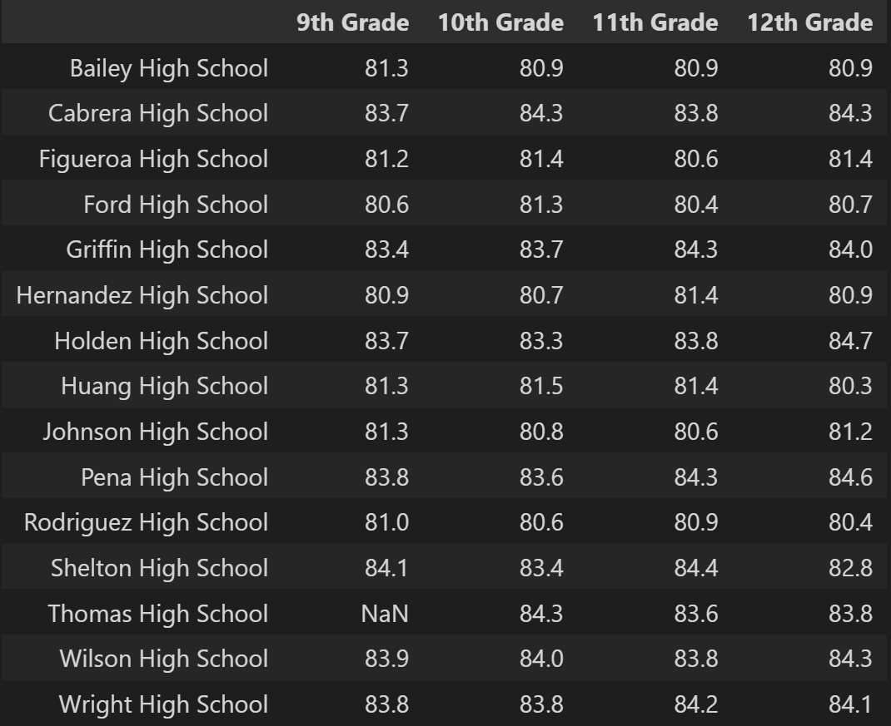
  + **Math:**
  + 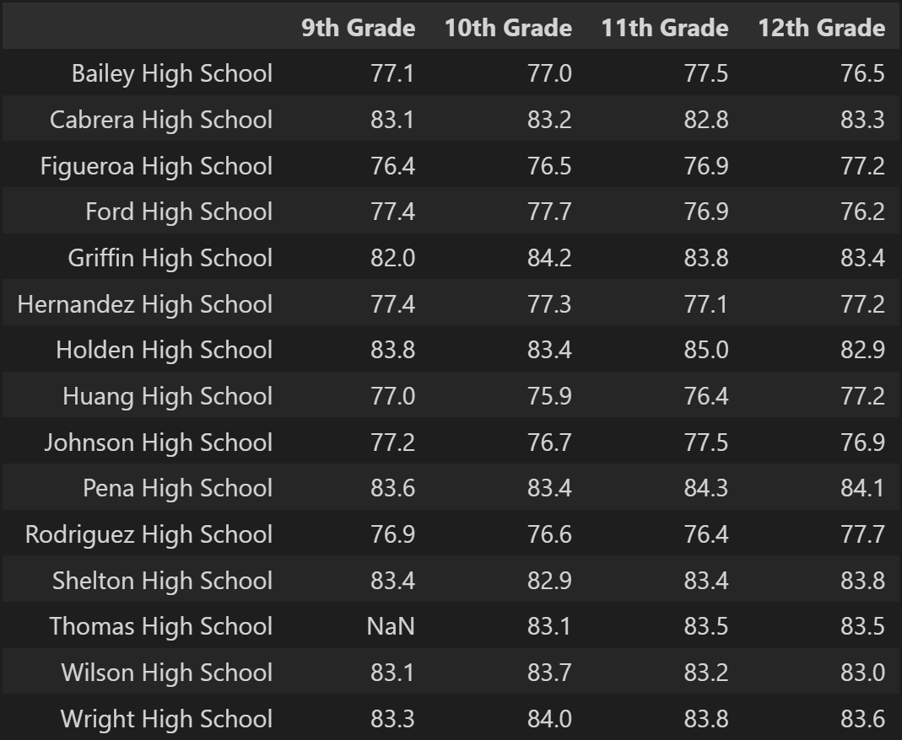
* **Thomas High School Summary:**
  + Math passing % dropped from 93% to 67%
  + Readings passing % dropped from 97% to 70%
  + Overall passing % dropped from 91% to 65%
  + Thomas dropped out of being a top five scoring school

**School Data Summary:**

Percentages ($600-651 per student budget) for math reading and overall fell to (respectively)

* 76%
* 86%
* 66.7%

Percentages for Medium (1000-2500) for math reading and overall (respectively)

* 93%
* 96%
* 89%

Charters school for math reading and overall (respectively)

* 93%
* 96%
* 90%