FMSD_RH_201401_OLAP_53rdWeek
FUNCTIONAL QUALITY ASSURANCE PLAN

Edition | 1.0

Reference: 1.0 | Editor : FuturMaster | Revision: 02/06/2012

DOCUMENT VALIDATION

 | Name | Function | Date | Signature
Author | Philippe Marquois | Developper | 10/13/2014
Controller
Approving

RECIPIENTS LIST

Recipients list
Name | Organization | Action | information

LAST MODIFICATIONS
Last modifications list
Reference | Date | Modifications | Modified paragraph | Author
V1 | 07/25/2014 | First version |  | Philippe Marquois
V2 | 10/27/2014 | Second version : add extra test on analyzer line (without multichronology)
V3 | 10/28/2014 |  | 2.2.4.3
V4 | 11/24/2014 | Add the test point |  | Kun WANG
V5 | 12/11/2014 |  | 2.1 , 2.2.1 | Philippe Marquois
V6 | 03/20/2015 | Add comment for DDA date display | 2.2.3.1 | Philippe Marquois
V7 | 04/13/2015 | Add remark about launch/promo based on dates | 2.1 | Philippe Marquois

TABLE OF CONTENTS
1. Général DESCRIPTION 5
1.1 Wish Document 5
2. FEATURE DESCRIPTION 6
2.1 general Description 6
2.2 MANAGEMENT RULE FOR CONFIGURATION 12
2.2.1 NO VALUE MUST BE INPUT IN A FALSE 53rd WEEK 13
2.2.1.1 Description 13
2.2.2 HIDE FALSE 53rd WEEK IN TEMPLATE WITH SIMILAR +/-P +/-Y 14
2.2.2.1 Description 14
2.2.2.2 Current Behavior Line Analyzer (with multi-Chronology) 14
2.2.2.3 Expected Behavior 15
2.2.2.4 Current Behavior Line Analyzer (without multi-Chronology) 16
2.2.2.5 Expected Behavior 16
2.2.2.6 Current Behavior Line Analyzer (without multi-Chronology) 18
2.2.2.7 Expected Behavior 18
2.2.2.8 Current Behavior DDA 19
2.2.2.9 Expected Behavior 19
2.2.3 SHOW FALSE 53rd WEEK IN TEMPLATE WITH VARIOUS +/-P +/-Y 21
2.2.3.1 Description 21
2.2.3.2 Current Behavior DDA 21
2.2.3.3 Expected Behavior 21
2.2.3.4 Current Behavior Line Analyzer (without multi-Chronology) 22
2.2.3.5 Expected Behavior 22
2.2.3.6 Current Behavior Line Analyzer (without multi-Chronology) 22
2.2.3.7 Expected Behavior 23
2.2.4 TIME SERIES SHIFTING OFFSET 24
2.2.4.1 Description 24
2.2.4.2 Current Behavior DDA 24
2.2.4.3 Expected Behavior 25
2.2.5 +/- Y +/- P values must not include false 53rd weeks 26
2.2.5.1 Description 26
2.2.5.2 Current Behavior DDA 26
2.2.5.3 Expected Behavior 27
2.2.5.4 Current Behavior DDA 27
2.2.5.5 Expected Behavior 28
2.3 Relative Functions 29
2.4 Message Translation 29
2.5 Buny 29
2.6 Database 30
2.7 Difference Between FMWin and Buny 30
2.7.1 FMWeb 30
2.7.2 FMExcel 30
3. Planning AND Development 31
3.1 development plan 31
4. test plan 32
4.1 Feature test outline 32
4.1.1 Functional test design 32
4.1.1.1 FMwin 32
4.1.1.2 Pimport and Pexport, Revise 34
4.1.1.3 FMweb 34
4.1.1.4 FMExcel 35
4.1.2 Localization test desgin 35
4.1.3 Compatibility 35
4.1.3.1 Windows Client (Fmwin) 35
4.1.3.2 FMweb 35
4.1.3.3 FMExcel 35
4.2 Acceptance test outline 35
4.2.1 FM powered by raima 35
4.2.2 FM powered by Oracle 36

Général DESCRIPTION

Wish Document
FMWish_RH_201401_OLAP_53rdLineAnalyzer

FEATURE DESCRIPTION

general Description
The 53rd week management is not handled homogeneously in all OLAP templates.

When the 53rd week management is enabled,then, in FM, each daily/weekly times series stores 53 weeks/year of data. When the 53rd week is not a real calendar week, it is named as a false 53rd week.

- Requirement N°1
When a false 53rd week period is displayed in a grid, there must be no value displayed in this period, and no value must be enable to be input.

- Requirement N°2
If template uses daily/weekly times series with similar offsets (+/- P, +/- Y) then only the real 53rd week must be displayed and false 53rd weeks will be hidden. (naturally if a 53rd period is included template displayed horizon.)

- Requirement N°3
a) If template uses daily/weekly times series with various offsets (+/- P, +/- Y) then a 53rd period must be displayed systematically for series including a 53rd period in their displayed horizon.

b) If template uses daily/weekly times series with various offsets (+/- P, +/- Y) then a 53rd period must be displayed systematically in dates header if a 53rd period is included template displayed horizon. (template dates header is based on the first serie of the template definition).

- Requirement N°4
Time series shifting offsets (based on DRP Lead times) must handle 53rd week management. There must be no shifted values on a false 53rd week.

- Requirement N°5
Start/End dates calculation of serie using an +/- P offset value and Horizon value must not take into account “false 53rd weeks”. The values set for +/- P offsets or Horizon must count only real calendar periods (1 unit set in +/-P or in Horizon corresponds to a calendar period).

Remark: Template based on Promo/Launch based on dates (First Day of each promotion, First Shipping Day of each promotion, Last Day of each promotion, Last Shipping Day of each promotion, 1st Week in store per promo, 1st Week shipping per promo, First Shipping Month of each Promotion, Last Shipping Month of each Promotion, First Month of each Promotion, Last Month of each Promotion, Start date of each launch, Start date of each replenishment, Start date of each F.O.C, Last date of each launch, Last date of each replenishment, Last date of each F.O.C, Availability date, First month of each launch, First month of each replenishment, First month of each F.O.C, Last month of each launch, Last month of each replenishment, Last month of each F.O.C, Availability date month of each launch) will keep previous behaviors (requirements above will not be applied).

- For example: a template is based on financial year date based on on 01/2015 and we need to display the whole previous year (-P : -52)
- The current result will be that the starting date will be set on 02/2014 (the false 53rd week 2014 is recorded as an existing period).
- When requirement n°5 will be fullfilled then the starting date will be set on 01/2015 => the whole previous year can be displayed.

- The problem still remains, the following year in 01/2016. 2015 has a real 53rd week, so the starting date will be set on 02/2015…
Since years can have 53 weeks then we need to be able to set offset +/- P with +/-53.
In that case we must set an offset P:-53 to get the the starting date at 01/2015

- Anyway the problem still remains, the following year in 01/2017. 2016 has only 52 weeks, so the starting date will be set on 53/2015 if we use an offset of P:-53. => the template will display more than the whole previous year.

- To avoid this cyclic issue, the offset +/-P : +/- 53 must not be considered as a weekly offsets but as a year offset.
So that way, back to our example A.: a template is based on financial year date based on on 01/2015 and we need to display the whole previous year (-P : -53).

- The current result will be that the starting date will be set on 01/2014 (01/2015 -1 year = 01/2014).

- the following year 01/2016. the starting date will be set on 01/2015 (01/2016 -1 year = 01/2015).

- In all situation, the whole previous year can be displayed without changing manually and cyclicly +/- P offset.

- In weekly time bucket template, the value +/-P : +/- 53 (*N) will be a year offset:
+/- P: 52 => offset of 52 weeks.
+/- P: 53 => offset of one year. (same calculation as +/- Y:1)
+/- P: 105 => offset of one year and 52 weeks. (same calculation as +/- Y:1 and +/-P: 52)
+/- P: 106 => offset of two years (same calculation as +/- Y:2)

- In daily time bucket template, the value +/-Y : +/- 53 (*N) and +/-P : +/- 371 (*N) will be a year offset:
+/- Y: 52 => offset of 52 weeks.
+/- Y: 53 => offset of 1 year.
+/- P: 105 => offset of 1 year and 52 weeks.
+/- Y: 106 => offset of 2 years
+/- P: 371 => offset of 1 year. (in that case a week is 7 days)
+/- P: 372 => offset of 1 year and 1 day. (in that case a week is 7 days)
+/- P: 742 => offset of 2 years. (in that case a week is 7 days)
+/-P:7 +/-Y:52 => offset of 1 year. (in that case a week is 7 days)

More generally, if total offset (+/-Y plus +/-P) is equal to 53(*N) weeks then offset is equal to 1(*N) year.

- For example: a template is based on financial year date based on on 01/2015 and we need to display the whole previous year (-P : -53) and Horizon is 52

- The result will be that the starting date will be set on 01/2014 and the ending displayed date will be set on 52/2014.
=> the whole previous year is displayed!

- The following year 01/2016. 2015 has a real 53rd week, so the starting date will be set on 01/2015 (-53 weeks is -1 Year !) but ending date is 52/2015. The real 53rd week of 2015 is missing.

Since years can have 53 weeks then we must set an horizon of 53 to diplay a whole year.

- The problem still remains, the following year 01/2017. The starting date will be set on 01/2016. If we use an horizon of 53 then ending date will be set to 01/2017
=> the template display more than the whole previous year.(ending date should be 52/2016)

- To avoid this cyclic issue, the horizon : +/- 53 must not be considered as a weekly leadtime time but as a leadtime in year. Calculation will be done as +/- 1 year minus +/- 1 week.

So that way, back to our example B.: a template is based on financial year date based on on 01/2015 and we need to display the whole previous year (-P : -53) and Horizon is 53.

- The result will be that the starting date will be set on 01/2014 and the ending displayed date will be set on 52/2014.(01/2014 plus one year => 01/2015 minus 1 week => 52/2014)
=> the whole previous year can be displayed!

- The following year 01/2016. 2015 has a real 53rd week, so the starting date will be set on 01/2015 (-53 is -1 Year !) and ending date is 53/2015. (01/2015 plus one year => 01/2016 minus 1 week => 53/2015)

- In all situation, the whole previous year can be displayed without changing manually the horizon value.

- In weekly time bucket template, the Horizon value H : 53 (*N) will be a year (*N) horizon:
H: 52 => horizon of 52 weeks.
H: 53 => horizon of one year.
H: 105 => horizon of one year and 52 weeks.
H: 106 => horizon of two years

- In daily time bucket template, the Horizon value +/-H : +/- 371 (*N) will be a year (*N) horizon:
H: 371 => horizon of 1 year. (in that case a week is 7 days)
H: 372 => horizon of 1 year and 1 day. (in that case a week is 7 days)
H: 742 => horizon of 2 years. (in that case a week is 7 days)

H: 318 => horizon of 1 year. (in that case a week is 6 days)
H: 319 => horizon of 1 year and 1 day. (in that case a week is 6 days)
H: 636 => horizon of 2 years. (in that case a week is 6 days)

- For example: a template is based on financial year date based on on 01/2015 and we need to display the 2 last weeks of 3 previous years (4 last weeks of 2014,2013 and 2012)
Horizon is 2 and the serie offset is +/- P: -2
+/- P: -2 +/- Y: -1
+/- P: -2 +/- Y: -2

- Without the requirement n°5, the template would display
w50/2014 w51/2014 w52/2014 Ø
w50/2013 w51/2013 w52/2013 Ø
w50/2012 w51/2012 w52/2012 Ø

the last periods are empty.

- With the requirement n°5 implemented, the template would display
w49/2014 w50/2014 w51/2014 w52/2014
w49/2013 w50/2013 w51/2013 w52/2013
w49/2012 w50/2012 w51/2012 w52/2012

the 4 last weeks of 3 previous years are displayed !

- The next year 01/2016, without the requirement n°5 implemented: the template would display

w50/2015 w51/2015 w52/2015 w53/2015
w50/2014 w51/2014 w52/2014 Ø
w50/2013 w51/2013 w52/2013 Ø

- Weeks 53 of year 2014 and 2013 are empty. In the display one week is missing for those 2 lines (2014 and 2013)

- The next year 01/2016, with the requirement n°5 implemented: the template would display

w50/2015 w51/2015 w52/2015 w53/2015
w49/2014 w50/2014 w51/2014 w52/2014
w49/2013 w50/2013 w51/2013 w52/2013

A problem still remains , the real 53rd week of year 2015 introduced an offset.

- To avoid this cyclic issue,starting dates must be readjusted.To do so, the number of false 53rd weeks are numbered during starting date calculation of each template line; this gives an offset introduced by false 53rd week for each line.Then, starting dates are shifted in order to each line get the same offset.

So that way, back to our example C.: a template is based on financial year date based on on 01/2016 and we need to display the 4 last weeks of 3 previous years (4 last weeks of 2015,2014 and 2013).

w50/2015 w51/2015 w52/2015 w53/2015 0 false 53rd week offset L1
w49/2014 w50/2014 w51/2014 w52/2014 1 false 53rd week offset L2
w49/2013 w50/2013 w51/2013 w52/2013 1 false 53rd week offset L3

L1 starting date is shifted of 1 period ( L2 and L3, no shifting)

That way we can display:

w49/2015 w50/2015 w51/2015 w52/2015 w53/2015
w49/2014 w50/2014 w51/2014 w52/2014 Ø
w49/2013 w50/2013 w51/2013 w52/2013 Ø

- Weeks 53 of year 2014 and 2013 are empty. In the display no week is missing!

- Requirement N°6

False 53rd week must not be recorded as a real calendar period when template is configured as Data By >1.

This requirement will be partially fulfilled in this feature. Only the case where Data By value is equal to the number of days in the week (daily chronology template) is treated.
The other use cases must be treated in a specific dedicated wish.

Those requirements allow a new management of display in Line OLAP. To revert quickly to the previous way of display, a new RDM.ini variable has been created OLAP_ADVANCED_53WEEK_DISPLAY=0).
By default, this variable value is set to 1.

MANAGEMENT RULE FOR CONFIGURATION

Terminology:
When the 53rd week option is activated in FM, daily/weekly series contain 53 weekly periods.

In the rest of the document, if the 53rd period does not refer to a calendar week, it will be named as a “false 53rd week”.

In the rest of the document, if the 53rd period refers to a calendar week, it will be named as a “real 53rd week”.

NO VALUE MUST BE INPUT IN A FALSE 53rd WEEK

Description
If a grid (DDA Spread or Analyzer, Edit Time series) displays a false 53rd weeks then cells for those periods must be locked.

A new option “Lock False 53rd week “ is created. By default the option is activated.
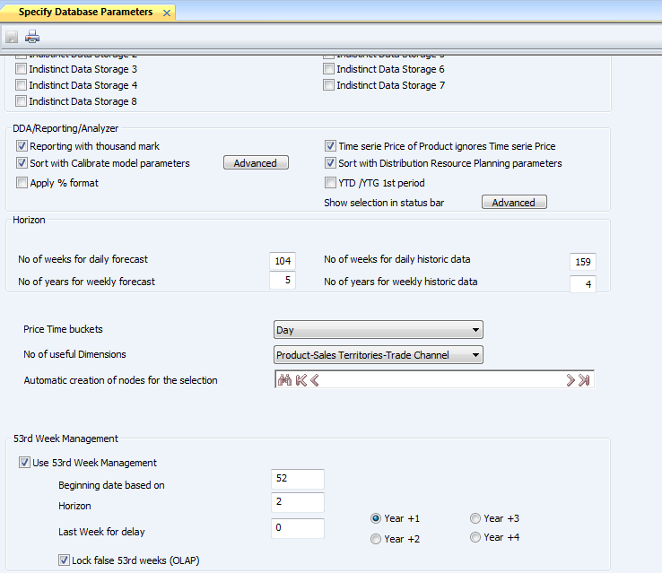

HIDE FALSE 53rd WEEK IN TEMPLATE WITH SIMILAR +/-P +/-Y

Description
If template uses daily/weekly times series with similar offsets (+/- P, +/- Y) then only the real 53rd week must be displayed and false 53rd weeks will be hidden:

In Line Analyzer there is no (+/- P, +/- Y) offsets so only real 53rd week must be displayed, as well.

Current Behavior Line Analyzer (with multi-Chronology)

Template definition:
Using a daily time serie with value 1 on each period (7 days/ week), using multichronology
Week starts on Sunday in this example!

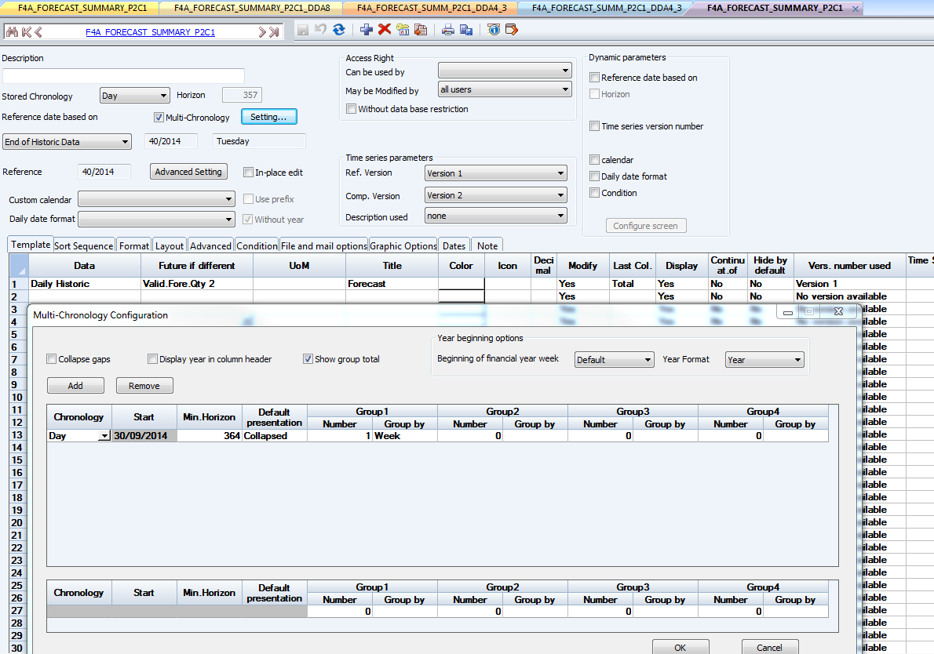
Result:

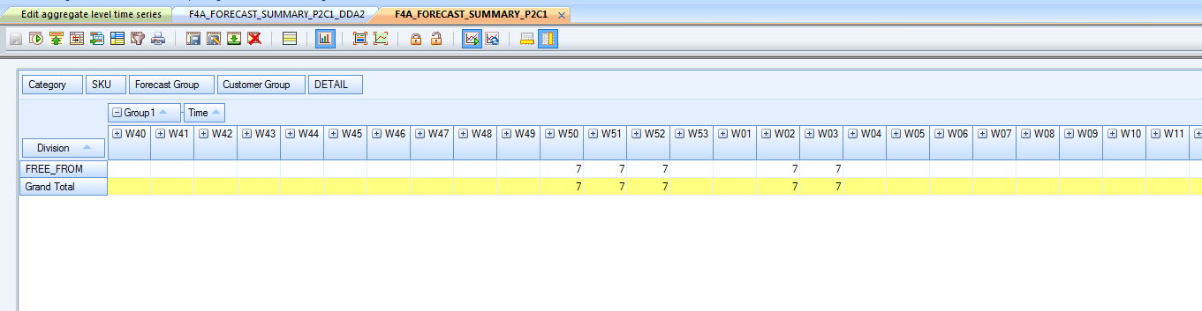
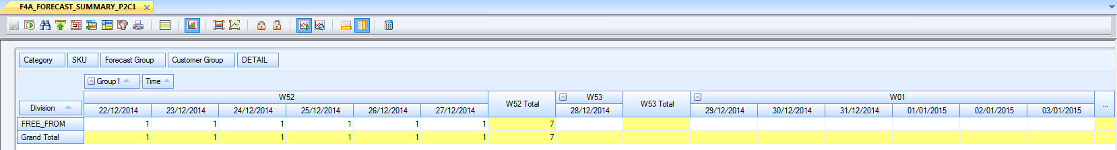

Expected Behavior
Template definition:
(Same as 2.2.1.2)

Result:
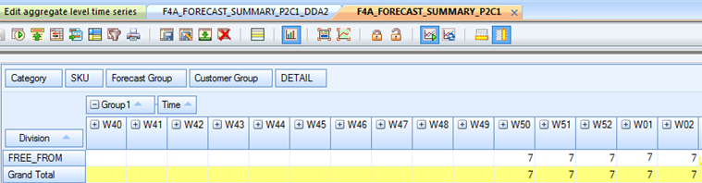

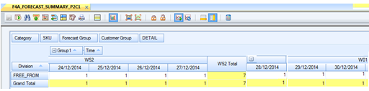

Current Behavior Line Analyzer (without multi-Chronology)

Template definition:
Week starts on Sunday in this example!

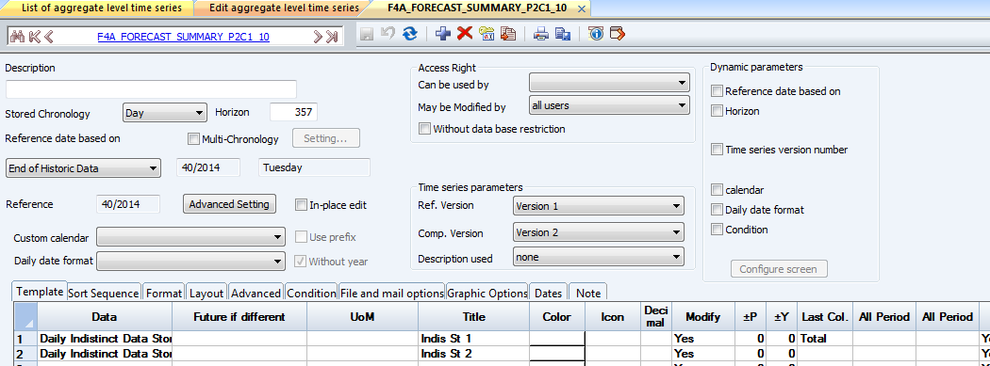

Result:
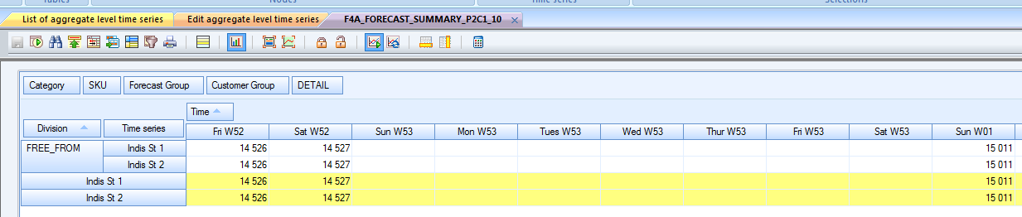

Expected Behavior
Template definition:
(Same as 2.2.1.2)

Result:
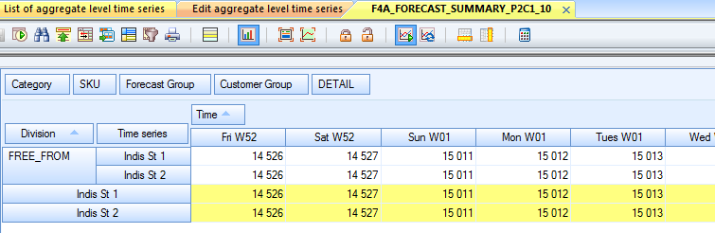

Current Behavior Line Analyzer (without multi-Chronology)

Template definition:
Week starts on Sunday in this example!

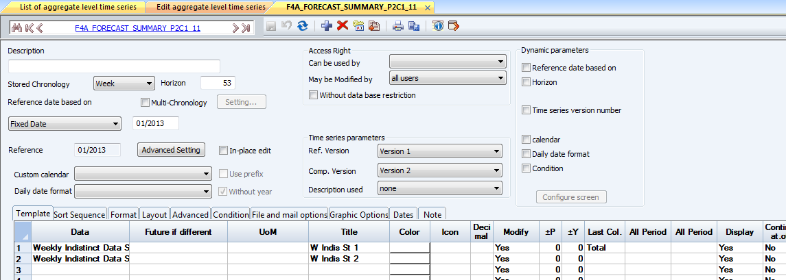

Result:
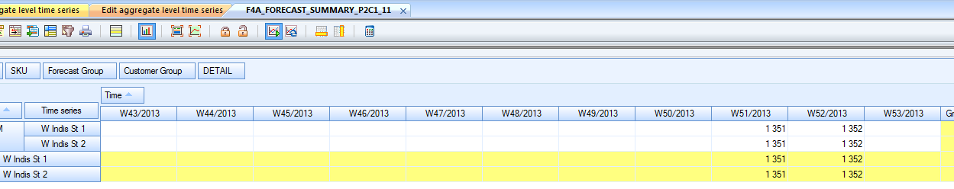

Expected Behavior
Template definition:
(Same as 2.2.1.2)

Result:
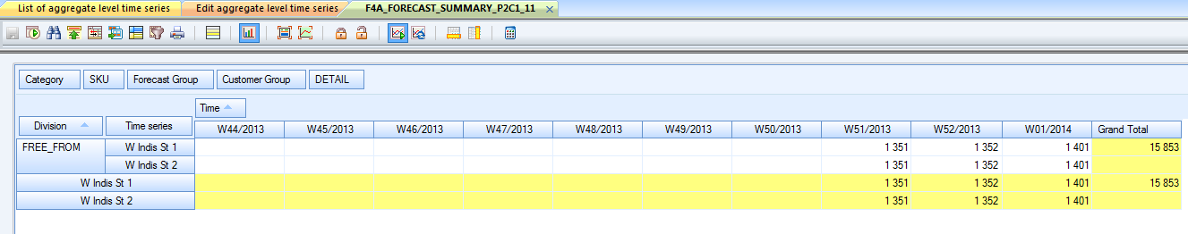

Current Behavior DDA

Template definition:
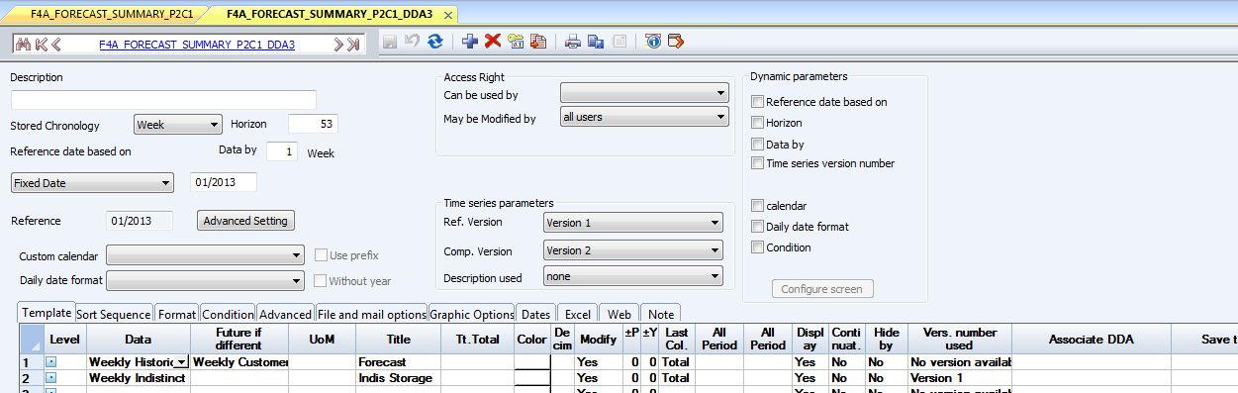

Result:
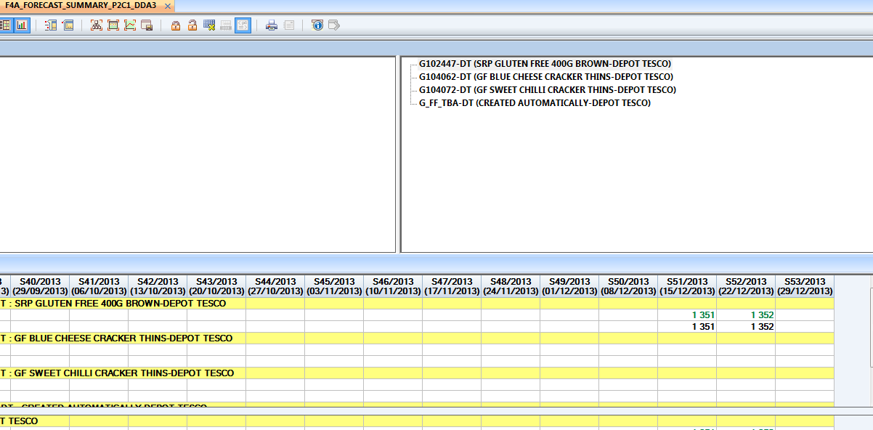

Expected Behavior
Template definition:
(Same as 2.2.2.2)

Result:
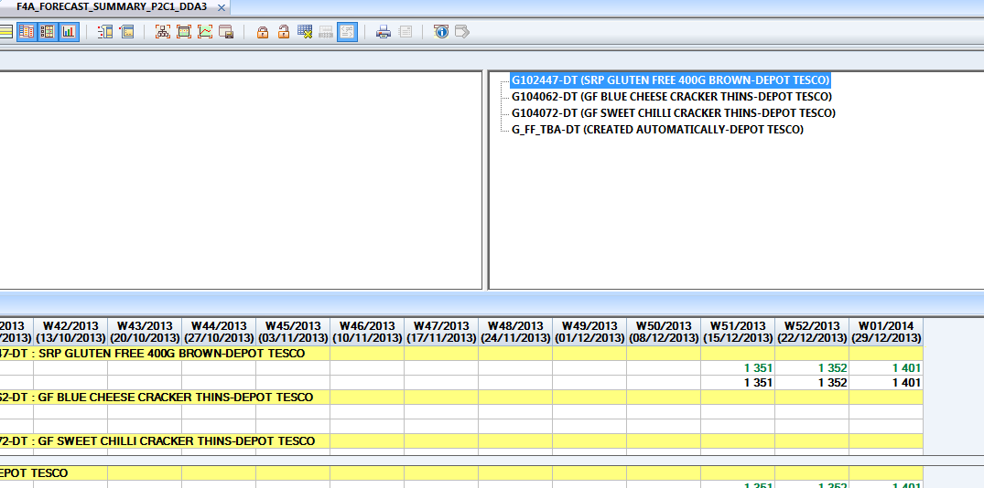

SHOW FALSE 53rd WEEK IN TEMPLATE WITH VARIOUS +/-P +/-Y

Description
If template uses daily/weekly times series with various offsets (+/- P, +/- Y) then a 53rd period must be displayed systematically for series including a 53rd period in their displayed horizon.

Date tooltips displayed at the screen bottom for false 53rd periods will be the same as period 1 of following year.

Current Behavior DDA
Template definition:
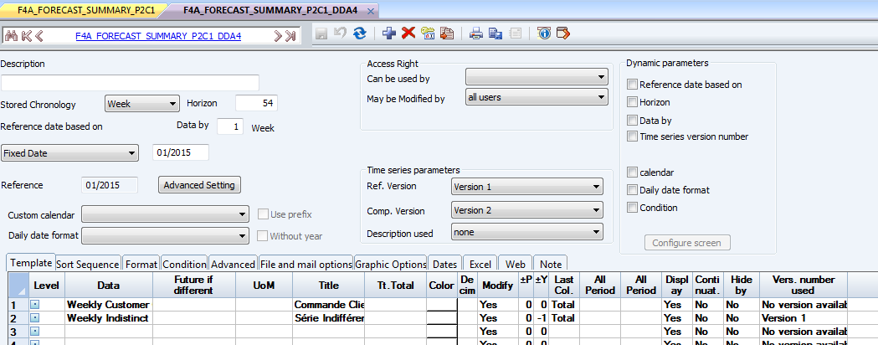

Result:
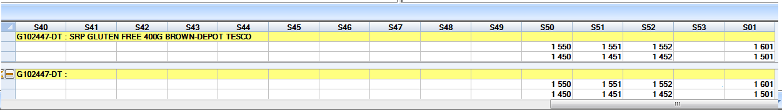

Expected Behavior
Template definition:
(Same as 2.2.3.1)

Result:
(Same as 2.2.3.2)

No Change on the current behavior.

Current Behavior Line Analyzer (without multi-Chronology)
Template definition:
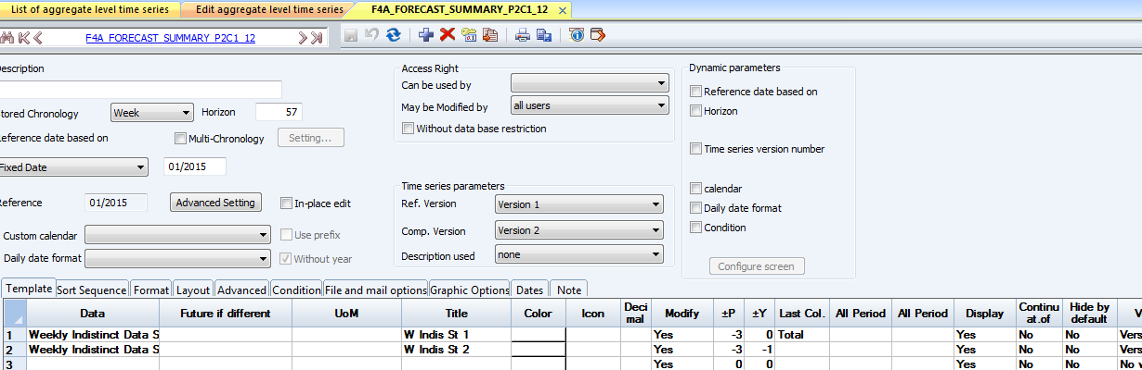

Result:
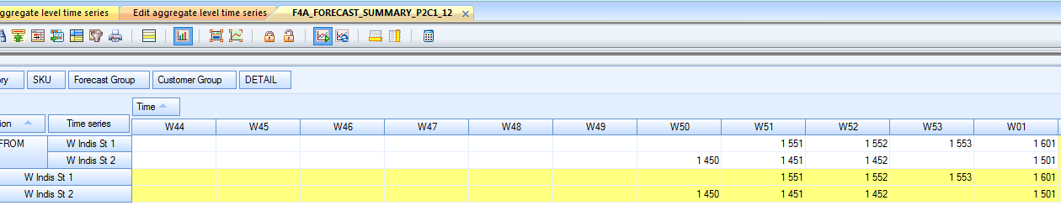

Expected Behavior
Template definition:
(Same as 2.2.3.1)

Result:
(Same as 2.2.3.2)
No Change on the current behavior.

Current Behavior Line Analyzer (without multi-Chronology)
Template definition:
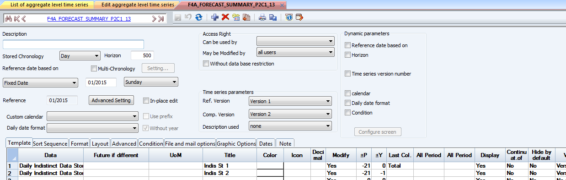

Result:
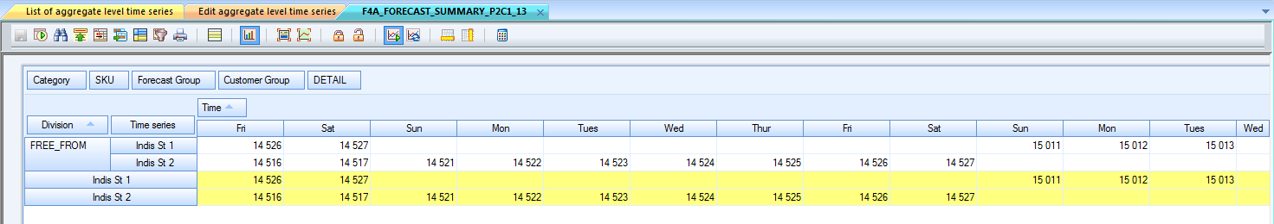
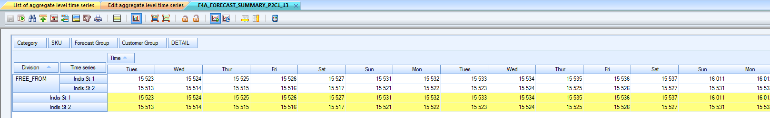

Expected Behavior
Template definition:
(Same as 2.2.3.1)

Result:
(Same as 2.2.3.2)
No Change on the current behavior.

TIME SERIES SHIFTING OFFSET

Description
Time series shifting offsets (based on DRP Lead times) must handle 53rd week management. There must be no shifted values on a false 53rd week.

Current Behavior DDA
Template definition:
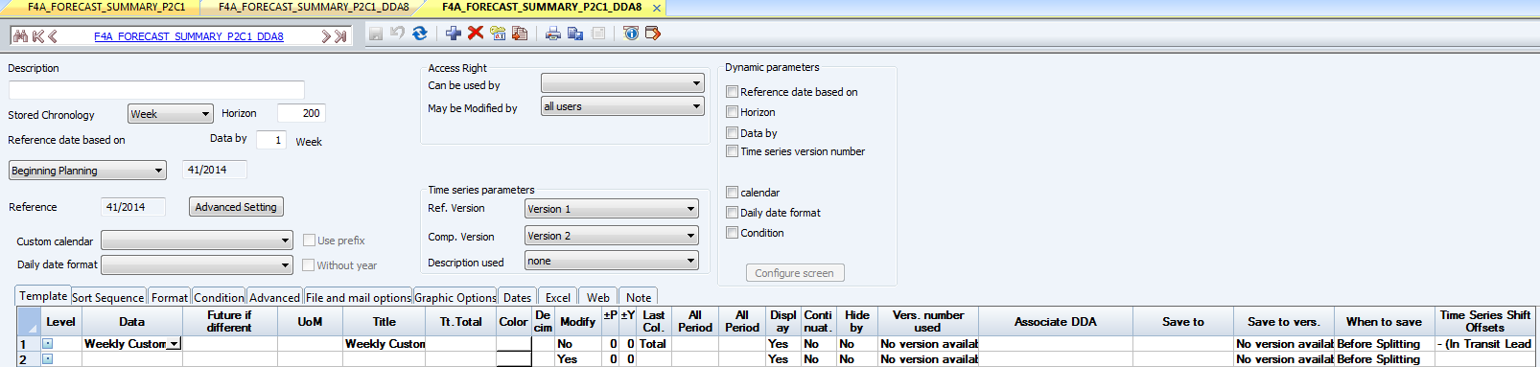

Result:

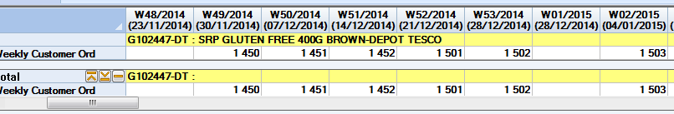
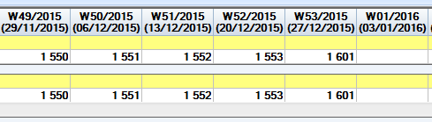

Expected Behavior
Template definition:
(Same as 2.2.4.1)

Result:
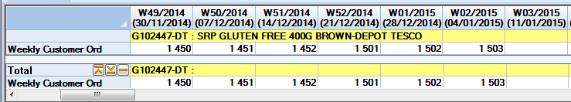

+/- Y +/- P values must not include false 53rd weeks

Description
Start/End dates calculation of serie using an +/- P offset value must not take into account “false 53rd weeks”. The values set for +/- P offsets must count only calendar periods.

Current Behavior DDA
Template definition:
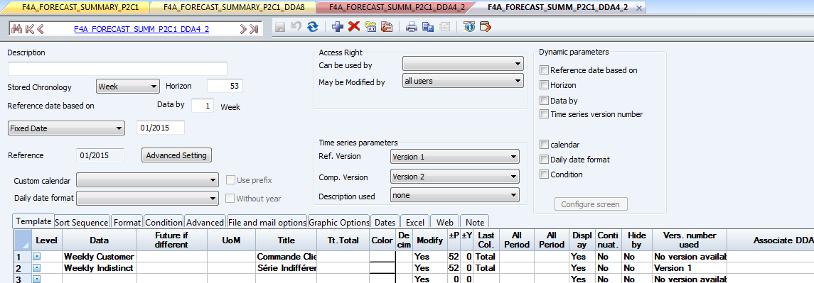

Result:
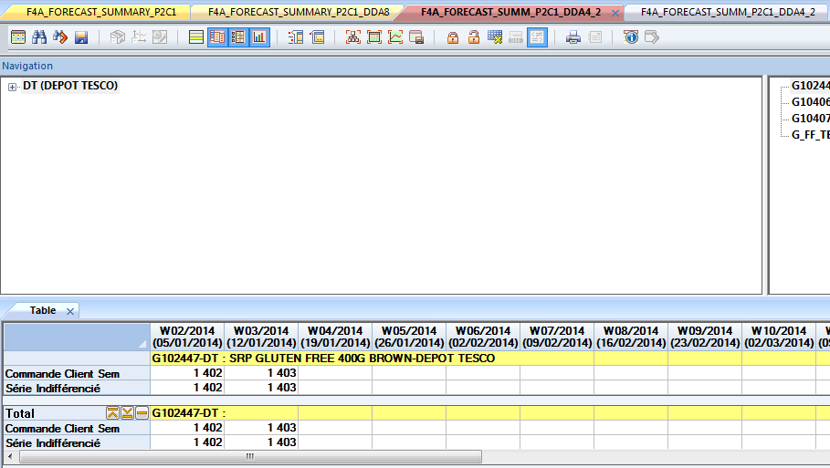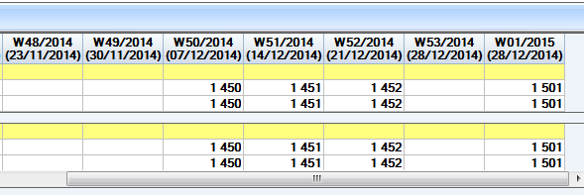

Reference Based on is w01/2015,and +/- offset is -52, so the start date of diplay should be w01/2014. Currently false 53rd week are recorded as a calendar period, this is why start date is set as w02/2014.

Expected Behavior
Template definition:
(Same as 2.2.5.1)

Result:
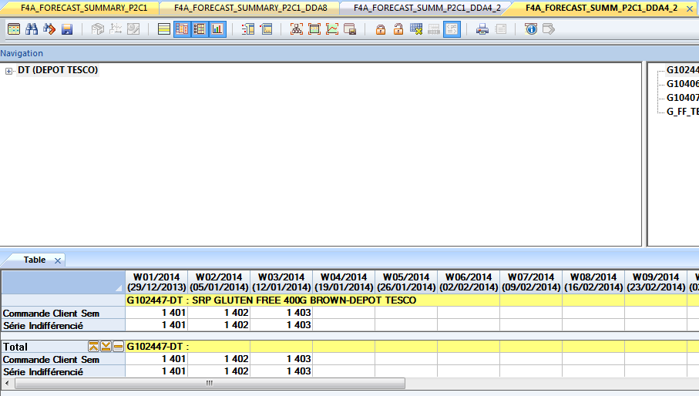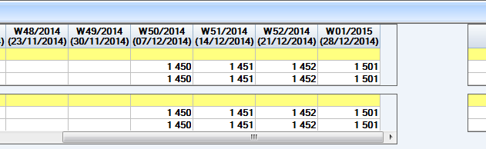

Current Behavior DDA
Template definition:
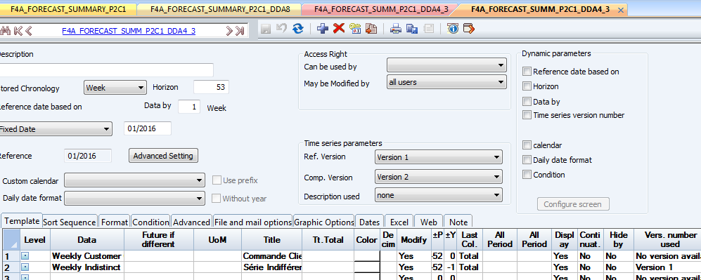

Result:
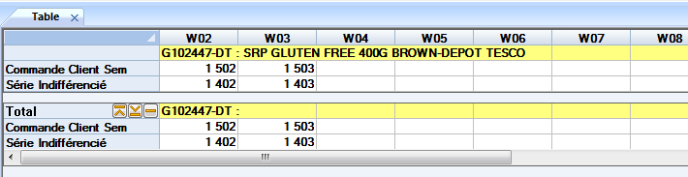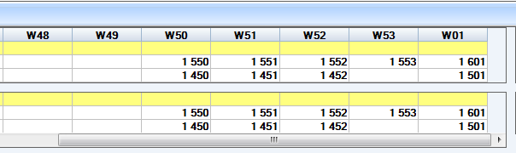

Expected Behavior
Template definition:
(Same as 2.2.5.1)

Result:
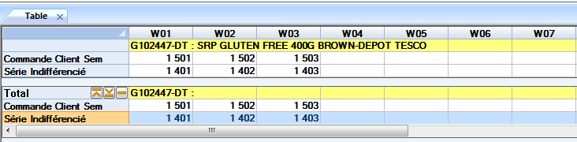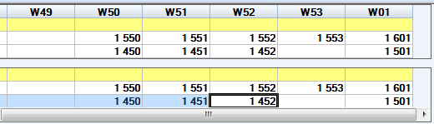

Relative Functions
[Check whether the feature effect the following relative functions. Do development and unit test of it if it’s supported. You can add some development notes to memo column if necessary. ]
Relative Function | Support (Yes/No) | Memo
PImport |  | [Add the command line and options if it’s supported. ]
PExport |  | [Add the command line and options if it’s supported. ]
Revise |  | [Add the command line and options if it’s supported. ]
Save Layout
Favorite
Shortcut
Workspace

Message Translation
[Collect all of the messages for translation.Deveoper will send the FQAP to Tech Writer after releasing test build so that he can review and correct the messages and translation. ]
Message ID | English | French | Chinese

Buny
[Think about whether this feature will be developed in Buny. If yes, which fucntion should be implemented in FMEngine.]
Support in Buny(Yes/No) | Function in FMEngine

Database
[Think about whether this feature will add or change some new data in database. And think about whether support open the new database in old version. If yes we need have a document to describe the design of these data. ]
Change database(Yes/No) | Document of database design and influence by wish
 | [Add the hyperlink of database design document and describe the data structure in the document. Describe what will be happen when open old database in FMWin new version and what will be happen when open new database in FMWin old version.]

Difference Between FMWin and Buny
[If Buny and FMWin implement the same feature, normally we want them to implement the feature all the same. But if one of application can’t implement some of the subfeature or implements in a different way, please describe all the differences here.]

FMWeb
[If the implementation is different between FMWeb & FMExcel, please describe the difference of FMWeb here.]

FMExcel
[If the implementation is different between FMWeb & FMExcel, please describe the difference of FMExcel here.]

Planning AND Development

development plan
[In the case of a long development, we will describe here the development steps to plan.]
[Plan Sample.]
Task | Days | Stat Date | End Date | Owner | Decription

test plan
Version: 7.4 Monthly, Daily/Weekly

Feature test outline
[List all test points here including functional test, performance test and localization test ]

Functional test design

FMwin

Module : OLAP
NO | TESTPOINT DESCRIPTION
001 | - UI  - N/A
002 | - Function  - 53rd week disabled:  - Result is the same as before.  - 53rd week enabled:  - Check the 53rd week displayed for series:  - Weekly time series  - Daily time series  - Scenarios when about false 53rd week display:  - All series in a template use similar offsets (+/- P, +/- Y):  - Real 53rd weeks are displayed.  - False 53rd weeks are hidden.  - For time series in a template use various offsets (+/- P, +/- Y):  - 53rd period is displayed for series including a 53rd period in their displayed horizon.  - Real 53rd weeks can be edited, and false can’t.  - For Line analyzer multi-chronology calculation:  - Real 53rd weeks are displayed.  - False 53rd weeks are hidden.  - Group total result should not include false 53rd week.  - False 53rd weeks will be skipped when use time series shift offset.  - Total column result include YTF/YTD should not include false 53rd week when use continuous time series:  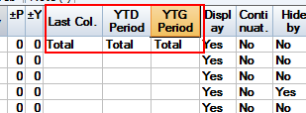  - False 53rd weeks won’t be displayed on graph horizontal axis.  - False 53rd weeks should be included when count the horizons:  - Template displayed horizon  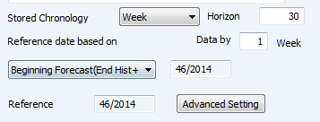  - Line analyzer multi-chronology horizon count:  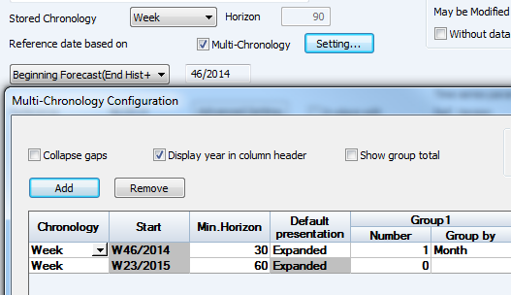  - Horizon count when use ±P offset value:  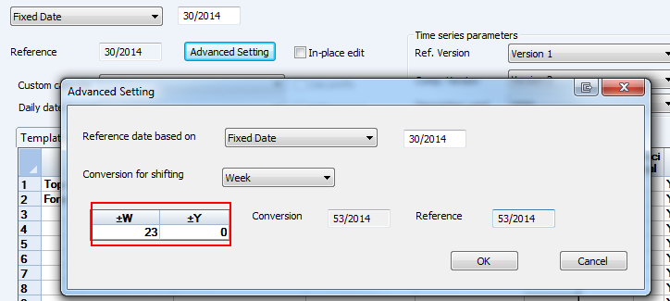  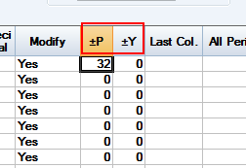  - For daily time series:  - In line analyzer, for daily time series, false 53rd week should not be displayed when we choose header related to week.  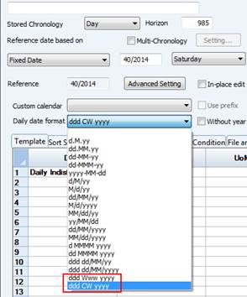  - False 53rd week should not be shown when change the ‘Number of Days by Week’ or ‘First day of the week’:  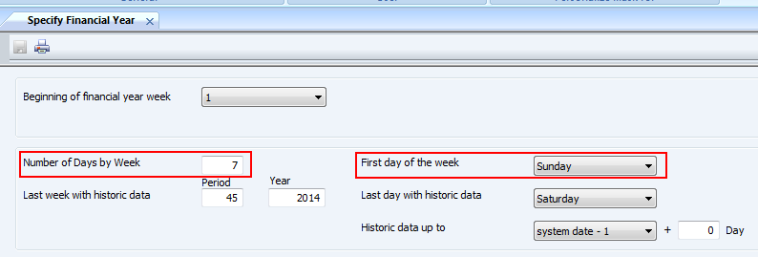  - Client calendar:  - False 53rd week should be lock  - When applied to the OLAP template, header content should be correct

Pimport and Pexport, Revise
NO | TESTPOINT DESCRIPTION
001 | N/A

FMweb
NO | TESTPOINT DESCRIPTION
001 | Same as fmwin for DDA and line report module

FMExcel
NO | TESTPOINT DESCRIPTION
001 | Same as fmwin for DDA and line report module

Localization test desgin
NO | TESTPOINT DESCRIPTION
001 | - String  - N/A

Compatibility

Windows Client (Fmwin)
NO | TESTPOINT DESCRIPTION
001 | - Fmwin  - OLAP:  - Old DB disabled with 53rd week  - Old DB enabled with 53rd week
- Fmbatch
- N/A

FMweb
NO | TESTPOINT DESCRIPTION
001 | - DDA, Line report:  - Old DB disabled with 53rd week  - Old DB enabled with 53rd week

FMExcel
NO | TESTPOINT DESCRIPTION
001 | - DDA, Line report:  - Old DB disabled with 53rd week  - Old DB enabled with 53rd week

Acceptance test outline
[According to the previous user stories, this section contains all things to test on a large scale, on specific data or specific customer databases. ]

FM powered by raima
NO | TESTPOINT DESCRIPTION
001 | Step:  - Go to Config ->Specify Database parameters, enable the 53rd week management.  - Create a DDA template with weekly time series:  - Set the horizon cover a least one year  - Add some time series, set the offset with the same horizon  - Run to the result  Expect result:  - Real 53rd week should be displayed, and false one should be hidden
002 | Step:  - Go to Config ->Specify Database parameters, enable the 53rd week management.  - Create a DDA template with daily time series:  - Set the horizon cover a least one year  - Add some time series, set the offset with the different horizon  - Run to the result  Expect result:  - 53rd period is displayed for series including a 53rd period in their displayed horizon.  - Real 53rd weeks can be edited, and false can’t.

FM powered by Oracle
NO | TESTPOINT DESCRIPTION
001 | Step:  - Go to Config ->Specify Database parameters, enable the 53rd week management.  - Create a DDA template with weekly time series:  - Set the horizon cover a least one year  - Add some time series, set the offset with the same horizon  - Run to the result  Expect result:  - Real 53rd week should be displayed, and false one should be hidden
002 | Step:  - Go to Config ->Specify Database parameters, enable the 53rd week management.  - Create a DDA template with daily time series:  - Set the horizon cover a least one year  - Add some time series, set the offset with the different horizon  - Run to the result  Expect result:  - 53rd period is displayed for series including a 53rd period in their displayed horizon.  - Real 53rd weeks can be edited, and false can’t.

