FMWish_RH_201401_OLAP_53rdLineAnalyzer

wishes

Edition | 1.0

Reference: 1.0 | Editor : FuturMaster | Revision: 2014.01.21

DOCUMENT VALIDATION

 | Name | Function | Date | Signature
Author | Marquois Philippe | Development | 2014-09-02 | PM
Controller
Approving | House Richard | Manager Consultant

RECIPIENTS LIST

Recipients list
Name | Organization | Action | information

LAST MODIFICATIONS
Last modifications list
Reference | Date | Modifications | Modified paragraph | Author
V1 | 2014-09-02 | First version | Initial document | PM

TABLE OF CONTENTS
1. Général DESCRIPTION 4
1.1 goal 4
1.2 Introduction 4
1.3 Expect delivery date 4
1.4 TerminologY 4
2. application senarios and FEATURE DESCRIPTION 5
2.1 Senario 1 for rule 1 : Time Series Values are shifted to The Wrong Period : 9
2.2 Senario 2 for rule 3 : Template Configuration Including Time Series with Similar +/- P offsets 11
2.3 Senario 3 for rule 4 : Template Configuration Including Time Series with Different +/- P offsets : 12
2.4 Senario 4 for Rule 5 : Template Configuration Including Time Series with Similar +/- P offsets 13
2.5 Senario 5 for Rule 6 : Time Series shifting must Not Shift to A False 53rd Week 14
2.6 Senario 6 for Rule 6 : Template Configuration Including Time Series with Similar +/- P offsets 14
3. Development recommendation 15
3.1 SPECIAL CASE 15

Général DESCRIPTION

goal
to standardize the 53rd week management in OLAP.

Introduction
When Database option “53rd week management” is activated, then OLAP templates have various behaviors concerning the display of the 53rd week.
The purpose of the feature will be to correct unexpected and uncorrect current behaviors and then standardize 53rd management behavior for all OLAP templates.

Expect delivery date
02/2015 FM main Version 7, Release Candidate 7.3

TerminologY

When the 53rd week option is activated in FM, daily/weekly series contains 361(7 days)/53 periods.

In the rest of the document, if the 53rd period does not refer to a calendar week, it will be named as a “false 53rd week”.
In the rest of the document, if the 53rd period refers to a calendar week, it will be named as a “real 53rd week”.

application senarios and FEATURE DESCRIPTION

Feature Description:

Handle the calendar period of the 53rd week in a Template means:

Rule 1:
- When “53rd week management” option is activated then times series quantitites must be displayed in their correct corresponding period, including the real 53rd week.

Rule 2:
- No quantity must be display and input in a false 53rd week.

Rule 3:
- If template uses daily/weekly times series with similar offsets (+/- P, +/- Y) then only the real 53rd week must be displayed (false 53rd weeks will be hidden).

Rule 4:
- i) If template uses daily/weekly times series with various offsets (+/- P, +/- Y) then a 53rd period must be displayed systematically for series including a 53rd period in their displayed horizon.

ii) If template uses daily/weekly times series with various offsets (+/- P, +/- Y) then a 53rd period must be displayed systematically in dates header if a 53rd period is included template displayed horizon. (template displayed horizon is based on the first serie of the template).

Remark:
We need to display a false53rd week in such case:
Ex: display 53 weeks of a serie in years Y and Y+1 (Y = 2014)
Year 2015 01 02 03 04 …...53 01
Year 2014 01 02 03 04 …...01 02

The real 53rd week of 2015 introduces an offset of display, that’s why we have to display a false 53rd week in 2014.
- Year 2015 01 02 03 04 …...53 01
- Year 2014 01 02 03 04 …...53 01

Rule 5:
- Start/End dates calculation of serie using an +/- P offset value must not include “false 53rd weeks” in its value. +/- P offset value must refer only to a number of calendar periods.

- If template uses daily/weekly times series with similar offsets (+/- P, +/- Y)

Ex: display 53 weeks of 2 series in year Y-1 (Y = 2015) using based on date 01/2015 and P:-52
Currently, false 53rd week introduces an offset, since it is counted as a normal calendar week in offsets (+/- P, +/- Y) value.
- Year 2014 02 03 04 …...53 01
- Year 2014 02 03 04 …...53 01

We need to display:
- Year 2014 01 02 03 04 …...52 01
- Year 2014 01 02 03 04 …...52 01

- If template uses daily/weekly times series with various offsets (+/- P, +/- Y) then we have to shift start/end displayed dates of series in order not to count false 53rd week as calendar period.

Ex: display 53 weeks of a serie in years Y-2 and Y-1 (Y = 2016) using based on date 01/2016 and P:-52 and P:-52 & Y:-1
Currently, the false 53rd week introduce in offset, since it is counted as a normal calendar week in offsets (+/- P, +/- Y) value.
- Year 2015 02 03 04 …...53 01
- Year 2014 02 03 04 …...53 01

We need to display:
- Year 2015 01 02 03 04 …...52 53 01
- Year 2014 01 02 03 04 …...52 53 01

Rule 6: Time series shifting offsets (based on DRP Lead times) must not shift values on a false 53rd week.

Rule 7: if rules 1->6 are fulfilled, then the option 53rd week management must be enabled by default.

Synthetic overview of handling 53rd week in OLAP templates:

 | Analyzer Line | DDA | Line Report | Column Analyzer | Column Report
Rule 1 | ☑  (multichronology)  ☑ | ☑ | ☑ | ☑ | ☑
Rule 2 | ☑ | ☑ | ☑ | ☑ | ☑
Rule 3 | ☑ | ☑ | ☑ | ☑ | ☑
Rule 4 | N/A  (no +/-P +/-Y in multichronology)  ☑ | ☑ | ☑ | ☑ | ☑
Rule 5 | ☑ | ☑ | ☑ | ☑ | ☑
Rule 6 | ☑ | ☑ | ☑ | ☑ | ☑
Rule 7 | ☑ | ☑ | ☑ | ☑ | ☑

☑: correctly managed.
☑: not correctly managed.

2.1 Senario 1 for rule 1 : Time Series Values are shifted to The Wrong Period :

In Line Analyzer (Time series are displayed in Line, a wrong offset appear using multichronology daily/weekly): ☑
Using a daily time serie with value 1 on each period (7 days/ week)
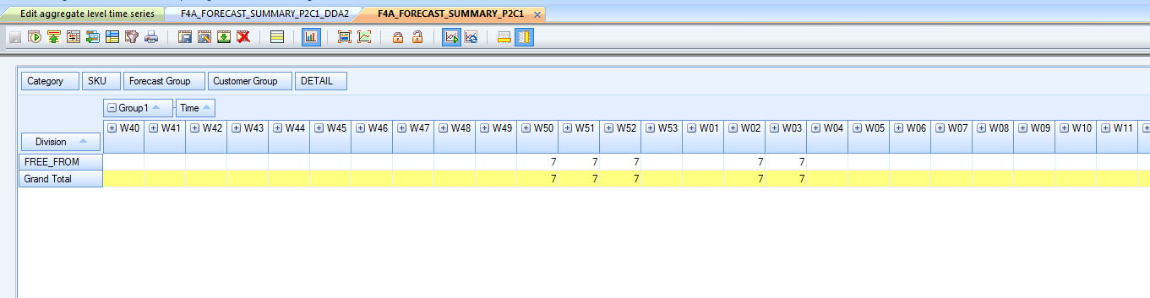

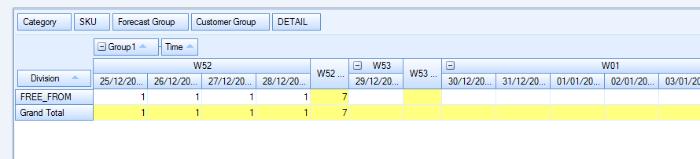

In a DDA (Time series are displayed in Line): ☑
Using a daily time serie with value 1 on each period, data by =7 (7 days/ week)

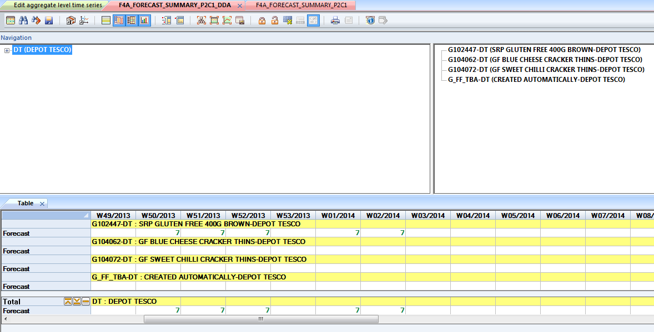

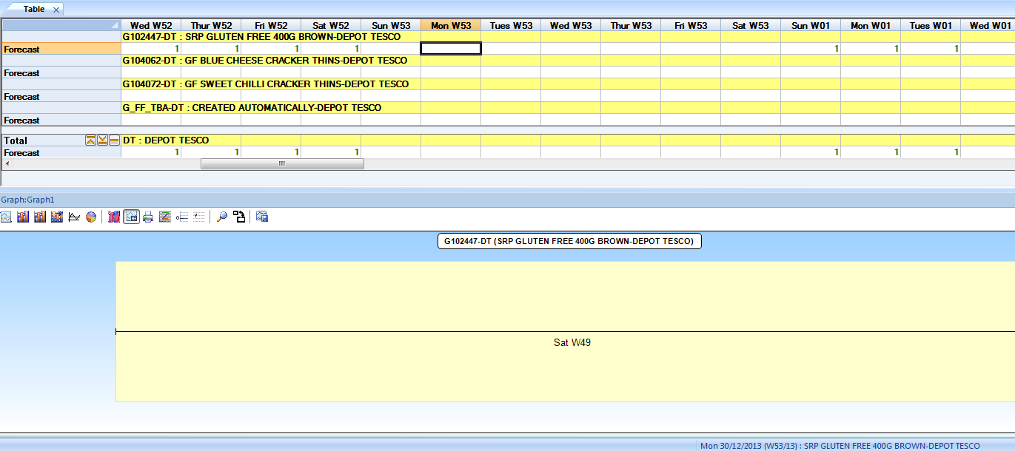

Senario 2 for rule 3 : Template Configuration Including Time Series with Similar +/- P offsets
Analyzer line: Both series have the same offset, the false 53rd week should not be displayed. ☑
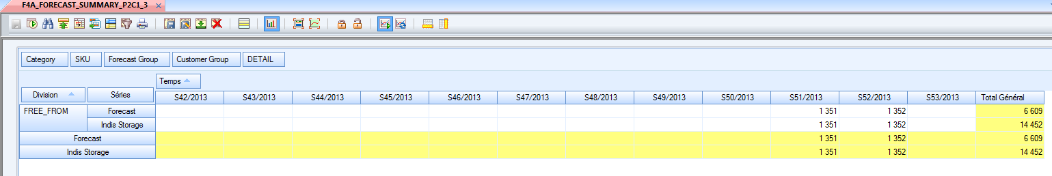

Line Report: Both series have the same offset, the false 53rd week is not displayed ☑
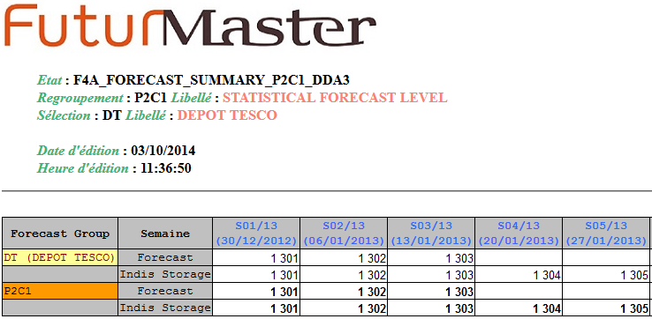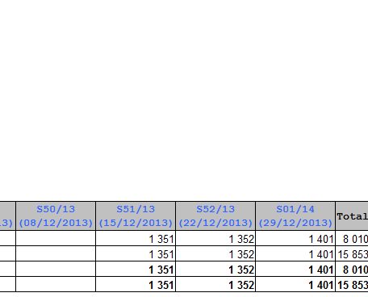

DDA: Both series have the same offset, the false 53rd week should not be displayed.: ☑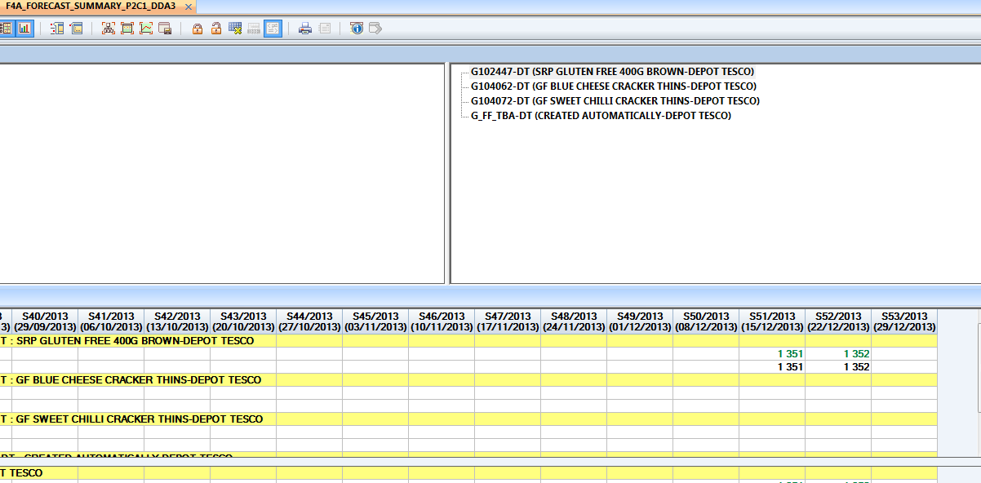

Senario 3 for rule 4 : Template Configuration Including Time Series with Different +/- P offsets :

DDA: Both series have various offset, the false 53rd week should be displayed.: ☑

Using 2weekly time series displayed in year 2015 and 2014 , a false 53rd week is displayed in 2014.
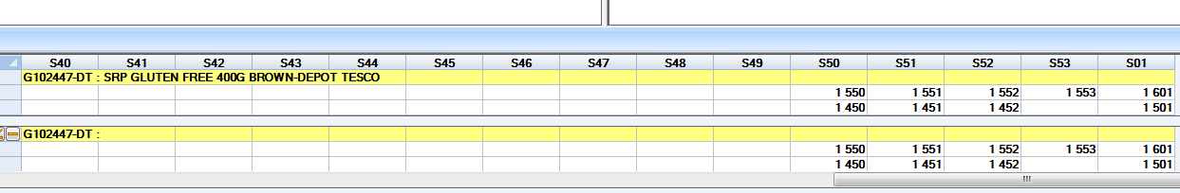

Senario 4 for Rule 5 : Template Configuration Including Time Series with Similar +/- P offsets
a) ☑
With a based on date set at 01/2014 and an offset of +/- P equal to -52, the time serie should be display from 01/2013.
Since the False 53rd week of year 2013 is considered as a calendar week then display start from 02/2013
- Wrong!
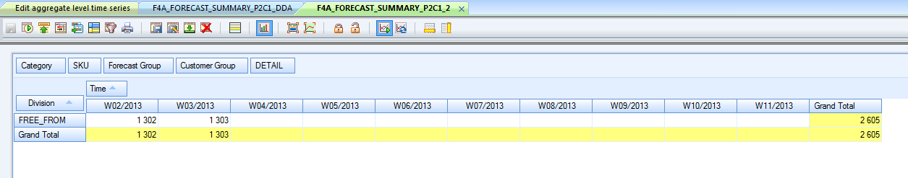

b) ☑
With a based on date set at 01/2013 and an offset of +/- P equal to +52, the time serie should be display from 01/2014.
Since the False 53rd week of year 2013 is considered as a calendar then display start from 53/2013
- Wrong!

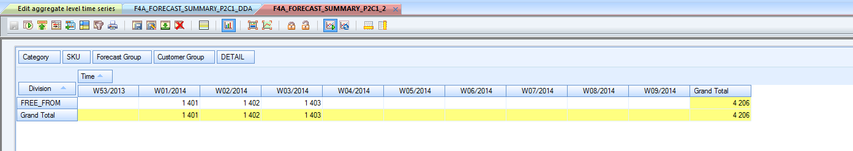

Senario 5 for Rule 6 : Time Series shifting must Not Shift to A False 53rd Week
Using a positiv shifting (positive transit lead time: +1): ☑
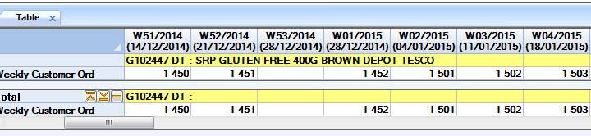
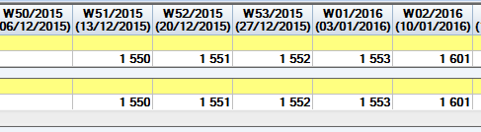

Senario 6 for Rule 6 : Time Series shifting must Not Shift to A False 53rd Week
Using a negativ shifting (negativ transit lead time: -1): ☑

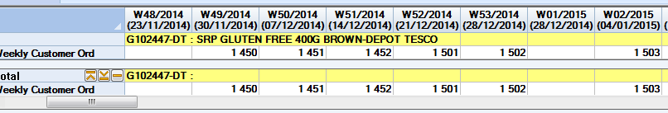
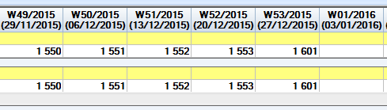

Development recommendation

SPECIAL CASE
The multichronoly in Line Analyzer.

