Data Visualization in R
Participant Guide
Last Updated: May 2023
Contents
Course Overview 4
Description 4
Pre-Requisites 4
Course Goal 4
Learning Objectives 4
Acknowledgements 4
How This Document Works 4
How the Course Works 5
How the Virtual Classroom Works 5
How the PHAC R Users Slack Workspace Works 5
How Support Outside of the Virtual Classroom Works 6
Course Materials 6
Day 1 7
Schedule 7
Energizer: Silly Hats and Glittery Pants 8
Demo 11
After Class: Independent Activity 1 12
Part 1: Data Wrangling 14
Part 2: Data Exploration 19
Part 3: Pan-Canadian COVID-19 Wastewater Testing Visualization 32
Day 2 33
Schedule 33
Activity: “Worst” Practices in Data Visualization (Part 1) 34
Activity: Rules to ‘Viz’ By 35
Activity: “Worst” Practices in Data Visualization (Part 2) 36
After Class: Independent Activity Day 2 37
Part 1 37
Part 2 44
Day 3 48
Schedule 48
Review Activity: Pie-Chart of Fortune! 49
Activity: Practice Time! 49
Appendix 1: Independent Activity Day1 Answer Key 50
Appendix 2: Independent Activity Day2 Answer Key 53
Part 1 53
Part 2 61

Course Overview

Description
This course is designed to introduce participants to common packages and best-practices for programming compelling data visualizations in R. The course will be delivered as a series of two half-day virtual classroom sessions, with a third day to provide opportunities for summary, synthesis, and peer-supported practice. Please note that this course is currently in development and is subject to change.

Pre-Requisites
Participants should have a background in epidemiology and have previously completed CFEP scientific communications training in data visualisation (or equivalent). Participants are also expected to have completed prior learning (e.g., Introduction to R for Public Health Investigations) or have experience with R.

Course Goal
Participants will improve knowledge and confidence in applying R to create attractive visuals useful for summarizing public health data.

Learning Objectives
By the end of this course, participants will be able to:
- Apply knowledge of R-coding to automate common graphics used in public health.
- Connect elements of effective graphic design to R coding practices in data visualization.
- Discuss considerations for data visualisation to avoid potential harms to small or vulnerable communities.
- Discuss differences between base R and the grammar of graphics (ggplot) coding styles for data visualization.

Acknowledgements
This course wouldn’t be possible without the support of our subject matter experts, who volunteer their time and great expertise. A special thanks to Naj Saqib (PHAC), Chris Mill (BCCDC), and Shirley Chen (PHAC).

How This Document Works
This document is intended to compile all the information and materials you will need for energizers, small group activities, and independent exercises throughout the course.
Unless otherwise specified, all course materials are located here: GitHub - hc-sc/tdu-datavizr
Please follow the instructions on the GitHub page to download the course materials.

How the Course Works
This course utilises self-study activities. Practical exercises used in this course are designed to give participants an opportunity to apply concepts learned in the virtual classroom and further develop their R programming skills. Support is available to learners outside the virtual classroom via the #slack channel to ask questions or discuss the materials in more detail.
How do I know if I should make use of support outside the virtual classroom?

Though this component is not mandatory, the Training and Development Unit R courses are highly participatory and rely on self-study to further skill development. Do not hesitate to reach out to your course facilitators on #slack when:

- You have lingering or new questions regarding the material covered in videos or the virtual classroom; and/or
- You are struggling with the practical exercises or are unclear as to what you are supposed to do.

How the Virtual Classroom Works
Virtual classroom time takes place from 1 pm ET 3-4 hours each day. The classroom will open at 12:30pm ET and close at 4:30pm ET. Please join 15 minutes prior to the start of the virtual class. Details to join the virtual classroom can be found in the calendar invitation sent to you by the Training and Development Unit.

How the PHAC R Users Slack Workspace Works
In addition to the virtual classroom, learners are invited to join the Slack workspace used for this training (including facilitators, subject matter experts, and participants from other R training). Within this workspace is a private channel for the course – here participants will post responses to discussion questions, or have additional opportunity to engage with facilitators, subject matter experts, and peers. This private channel and its contents are visible only to facilitators, your peers in the course, and subject matter experts invited to participate in the session.
Note: If you are not able to access the TDU R #slack workspace and/or are not able to see the private channel associated with your training (denoted by a lock symbol and date: e.g., ) by end of day on the day prior to the first day of the course, please email ceprtraining-formationcmiu@phac-aspc.gc.ca

How Support Outside of the Virtual Classroom Works
This is optional. Reach out to your course facilitators and subject matter experts by posting your question to the #slack channel associated with this training event and someone will respond to your question as soon as possible. If more intensive or one-on-one support is needed, please directly reach out to your course facilitators on #slack. Note, on day 3 of the course there will be a block of time set aside for practice and troubleshooting the practical exercises associated with days 1-2 of the course.

Course Materials
Where a weblink is not provided in this document, all course materials and resources are located in GitHub. All materials for required self-learning will be posted one week prior to the start of course. Please email ceptraining-formationcmu@phac-aspc.gc.ca at your earliest convenience should you have any troubles accessing the course materials via the link below.
TDU GitHub repository: GitHub - hc-sc/tdu-datavizr
Instructions to download materials from GitHub: https://github.com/hc-sc/tdu-intror/blob/main/Instructions_Download_Course_Materials.pdf

Day 1

Schedule
Session | Activity | Description
Virtual Classroom | Welcome and Introductions | Presentation
Virtual Classroom | Base R graphical system | Lecture
Virtual Classroom | Data formatting | Lecture
Virtual Classroom | Break
Virtual Classroom | Energizer: Silly hats and glittery pants | Activity
Virtual Classroom | Grammar of graphics and ggplot | Lecture
Virtual Classroom | Demo | Demonstration on data visualization in R
Virtual Classroom | Debrief | Review and questions
Virtual Classroom | Wrap-Up | Presentation and Q&A
Application | Independent Activity | Independent study

Energizer: Silly Hats and Glittery Pants
Description: To be completed during the virtual classroom session. One of the most important skills that an avid data visualizer needs to develop is the ability to interpret and explain the relationship occurring in their data visualization!
We have provided several simple charts that depict a fictitious relationship between some uncommonly analyzed variables. With your small group, brainstorm your best description of what’s going on in your data visualization, and select one person from your group to present the story to the large group debrief. You will only have five minutes to think up your story – so work quickly!
Your story should include the following three elements:
  - The hypothesis, or research question that was investigated;
  - What relationship was found; and
  - What are the hypothesized causal drivers of the observed relationship
Instructions:
- Participants will be split into small groups. Please take note of your group number, and navigate to the corresponding Jamboard in the table below.
- Each group will receive a silly figure displaying a totally nonsensical relationship on a pre-populated jamboard.
- Each group will have 5 minutes to develop their story behind the relationship displayed on the figure.
- After 5 minutes, participants will reconvene in the large group
- A volunteer from each group will have 1-2 minutes to explain the story behind the figure that their breakout group came up with.

Group | Silly Figure / Relationship | Jamboard link
1 | age and likelihood of being covered in glitter | https://jamboard.google.com/d/1FP6eQw72FH2ISnYAXace4eQq6r6rYoFMkWqLAFL9qAM/edit?usp=share_link
2 | year and popularity of fancy hats (sales volume) | https://jamboard.google.com/d/1qhShgq4cS0oYRXKD3mu49g7veXsBW31RIqjFgpCVZpE/edit?usp=share_link
3 | anxiety and likelihood of enthusiastically joining a conga line | https://jamboard.google.com/d/1KzZ2cnqgMrm5al1Qzcd-5H8QQDiOwTWuTJuuuXMNtpI/edit?usp=share_link
4 | hours of sleep and fanciness of pants (on a scale of old jogging pants to sequined mermaid tail) | https://jamboard.google.com/d/1MiOx2NlMeOHtyWdtwMG1BTeqUMt4Czso0bjHt178Ff8/edit?usp=share_link
5 | time of day and level of enthusiasm about receiving a handwritten invitation to a fancy-dress party | https://jamboard.google.com/d/1Jqw6El6LeL7-AZlfbGMhY09K3fDY1ANDV_AM1MvwKuM/edit?usp=share_link

Example:
I am the sole proprietor of a very successful local bookshop. I have broken down sales volume of various book themes to better understand what sorts of books I should carry throughout the year. I notice something interesting about sales volume of ghost stories.

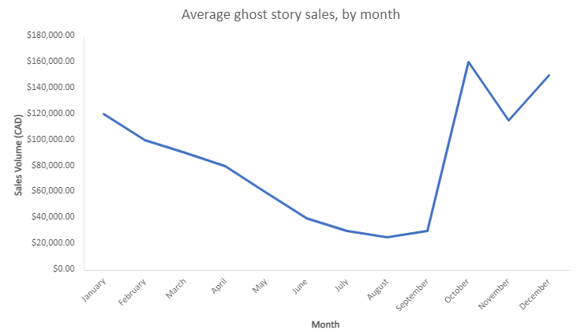
This is what I think is going on, given my understanding of my industry and consumer base:
- Sales spike in the fall because people are getting excited for Halloween and are most interested in scary ghost stories.
- Sales drop off in November after Halloween.
- Sales spike again in December because there is significant interest in ghost stories over the holidays (e.g., A Christmas Carol) and during the darkest time of the year.
- Sales drop off consistently through the remainder of the winter, spring, and summer as the days get longer and when people are less likely to choose ghost stories for entertainment.

In-class Demo
During this session we will provide a demo. Please follow instructions in the virtual classroom for accessing materials, as applicable.

After Class: Independent Activity 1
To be completed following the virtual classroom session.
Duration: 90 minutes. (Reminder that there is an in-class practice session scheduled for Day 3 of the course).

Materials:

data/
daily viral load/
viral_load csv (11 files)
demographics/
pruid.csv
region.pop.csv
weekly_mavg/
7Day Avg.csv (11 files)
covid_ww.csv (if you skip part 1, use this file)

scripts/
01_data_wrangling.R
02_data_exploration.R
03_data_visualization.R

output/
(this is where your output files go)

Instructions

This is designed as an independent coding activity in R, but feel free to work with a friend, and always remember that our course #slack community is there to help if you get stuck or are confused by any of the instructions.

There are three parts to this independent exercise:
- Part 1: Data Wrangling
- Part 2: Data Exploration
- Part 3: Data Visualization

We want these exercises to work best for how you learn and for what you would like to focus on. Therefore, if you want the full experience of working through data, thinking about how to combine data and manipulate it to achieve a format conducive to plotting; we suggest that you start with Part 1 and work through data wrangling before moving on to parts 2 and 3. In the real world, you will never be in a situation where you won’t have to consider what data you have and what shape they are in, so this is good practice.
If, however, you code a little slower, and want to make sure you maximize your time working strictly on the visuals – feel free to jump straight into Part 2: Data Exploration, where you’ll work through different examples of data visualizations for exploring your dataset using both baseR and ggPlot coding conventions.

When you’re comfortable with the basics of coding different types of charts for data visualization in R, proceed on to Part 3: Data Visualization. We have provided a basic set of instructions to orient you in constructing the final visualization, but Part 3 is really meant to be open-ended. You get to decide how best to present these data and tell a story using all the data visualization tools at your disposal!

Introduction

You are a federal epidemiologist working with the Canadian COVID-19 Wastewater consortium. Your supervisor has asked you to coordinate with the partner provinces and territories to produce a comparison of COVID-19 viral load signals from wastewater testing sites across Canada.

You have reached out to the 11 different provinces and territories involved in testing wastewater, and they have each sent you a data export of the viral load signals for each day of testing at each of the jurisdictions sample sites. They have also sent you the calculated 7-day moving average values for these sites as well.

One of the areas of interest that your supervisor has tasked you with exploring, is whether sites servicing high population areas have shown different patterns in their wastewater data compared to lower population areas. You have therefore compiled data on the population size of each province, as well as the regional/municipality population size surrounding each of the wastewater testing sites.

Setting up your workspace

Download the project folders from the course Github site: https://github.com/hc-sc/tdu-datavizr.

The project folders for Day 1 should be under Exercises/Day1/covidww. This directory should contain three folders: (1) data; (2) scripts; (3) output. Refer to the Materials section above for the organization of files within these folders. Once you have confirmed that your project folders are set up locally, you can get started on working on your data visualization project!

Part 1: Data Wrangling

You’ll need to compile the data from daily and weekly measurements into a cohesive dataset. In order to do this – you’ll need to import and explore the structure of data to figure out what is necessary to combine things.

Note: there are 11(!) different provinces and territories’ worth of data, so we would suggest starting with a smaller subset of the data first to familiarize yourself. For the pre-written examples, we’ll start by using only the MB and QC datasets – but choosing any of the different provinces and territory to walk through the code with will work.

Task | Example Code
Prepare a clean workspace. (Note it’s best to click the little broom icon above the environment pane, but this code example will work too).
Load required packages: here(); tidyverse(); rio() | 
Import an example of daily data using two provinces as examples. | 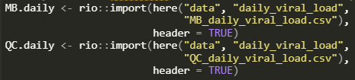
Explore the structure of these datasets | 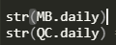

Q1) What do you notice about the format of the daily_viral_load datasets? How are the data organized? Are they all the same? Do they all contain the same variables?

Let’s have a look at the weekly (*_7DayAvg.csv) datasets next using the same approach.

Import and review the structure of the weekly datasets. | 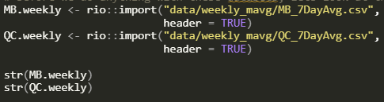

Q2. What do you notice about the weekly datasets? Are they in the same format as the daily ones? What’s different about these ones? Based on what we talked about in the lecture portion of Day 1, which data format seems better suited to generating plots in R.

We are going to want to combine datasets together (e.g., combining daily datasets together, then combining weekly datasets together, then combining these two larger datasets) – but first we need to make sure they’re all in a consistent format. It seems like the best way to do this is to make the daily_viral_load datasets match the format of the weekly 7DayAvg.csv data.

Q3. What function(s) will you use to convert the daily datasets into a format consistent with the weekly ones?

Still sticking with our simplified example of using only a subset of our total datasets, (e.g., MB and QC data only) proceed with creating a version of the daily datasets that match the format used in the weekly datasets.

Task | Example Code
Change the daily datasets from wide format to long format in order to match the formatting of data in the weekly datasets. | 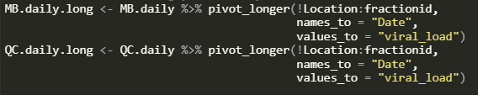
Combine the daily datasets into a single data frame
Combine the weekly datasets into a single data frame
Combine the aggregated daily and weekly data sets into a single data frame

Note that, depending on how you imported your data in the beginning, you may need to go back and reformat your Date variable to join these datasets together properly.

Task | Example Code
Fix the Date variable format and join the datasets together successfully! | 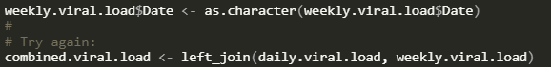

PAUSE here for a second to capture the steps you’ve now completed.

- You’ve assessed the data you have available to you.
- You’ve reformatted data from wide to long-format to facilitate plotting.
- You’ve aggregated datasets by using bind_rows
- You’ve fixed the format of Date data to allow for joining datasets
- You’ve performed a table join using left_join

Amazing work! Give yourself a pat on the back! Now to think about what else we need to do to get our data in shape for creating some data visualizations.

- We’ve only been working with a subset of our total, national dataset so far – so we’ll need to figure out how to include the rest of the provinces and territories into the same dataset.
- You’ll notice there’s a folder containing demographics data – we’ll want to explore these datasets and include them into our master dataset eventually.

Task | Example Code
Import and reformat all of the daily_viral_load csv files into long format. Combine all daily datasets into a single data frame. Combine all weekly datasets into a single data frame. Join these two data frames together into a single, long-format data frame. | There are two strategies for doing all these steps.  - Simple, but lots of code. Re-use the code from above to import and manipulate the data from all 11 provincial/territorial datasets.  - Less simple, but also less code-heavy. Challenge: use the automation features in R to import all the datasets at once, convert them to long format, combine, and join them all into a single data frame. An example of how to do this is available in the provided script 01_data_wrangling.R (hint, try looking up the list.files() function in base R, and the map() function from tidyverse.)

Now that we’ve got all of our COVID-19 wastewater data (daily, weekly measurements) loaded into a single, consistently formatted data frame, it’s time to add our demographic data to the mix.

Task | Example Code
Import and review the structure of the pruid.csv dataset. | 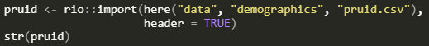
Import and review the structure of the region.pop.2021.csv dataset. | 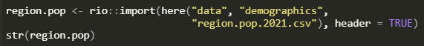

Based on the output from str() it looks like we can join the region.pop dataframe easily with our large covid.ww dataset from before. Let’s go ahead and do that, joining on the consistent identifiers between the two datasets.

Task | Example Code
Join region.pop with covid.ww data frames.

Next step is to combine this with our final dataset: the pruid.csv data. PRUID is the provincial unique identifier assigned to each province and territory in Canada, and the dataset contains provincial population estimates for each. This may help you later when comparing wastewater sites if you’re interested in measurements from large vs small population provinces. You’ll notice, however, that the pruid.csv doesn’t share a unique identifier with either of our previous datasets. You will then, have to create one in order to join these together.

Add a variable to the pruid data frame to allow you to join using key-value pairs. Hint: keep it as simple as possible.
Join this modified pruid data frame with your covid.ww data frame created earlier.

And just like that, you have your final dataset ready to go! Take a minute to review the variables in the dataset, and rename things to achieve consistency and make it easier to understand what the variables represent.

Task | Example Code
Rename variables in your final dataset to achieve a consistent format. | 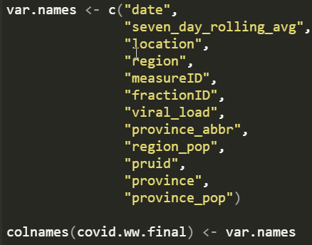
Write your final dataset to disk.

Part 2: Data Exploration
One of the most effective uses of data visualization is to explore and better understand the data in your dataset. In this next section, we’ll see how we can do this using both base R graphics, and ggplot style coding.

Task | Example Code
Clear your workspace, then load required packages | 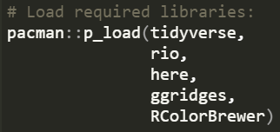
Import your dataset from part 1. | 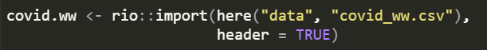

Note: the rio() package is super useful and makes it easy to import a wide range of file formats. One thing it tends to do, however, is automatically format dates as ‘integer-dates’ which can give us a headache later on. Let’s go ahead and fix this now.

Task | Example Code
Reformat the date variable. | 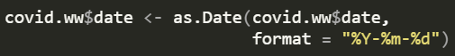

For this part of the exercise, we’re going to explore four different areas of the dataset using data visualizations:
- How many observations we have over the range of dates available in the data
- Data by location
- Range of measurements of COVID-19 viral_load
- Regional and provincial/territorial population sizes

Please note that if you’d rather explore the data in another way – please do so! These are just suggestions to allow you to practice creating visualizations and get comfortable with the tools available to you in R.

(1) Date ranges and (2) Location data
Let's see how many observations we have over the range of dates present in the dataset. We can quickly do this using the hist() function (histogram) in base R.
Task | Example Code
Create a histogram in R to assess the range of dates and how many observations are available across the date range. | 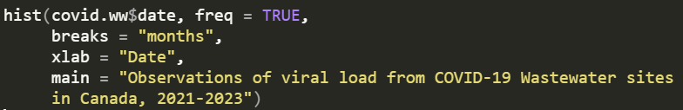
Q4. What does the freq=TRUE argument do in the hist() function? What happens if you set this to FALSE?
Sticking with base R graphics, let’s explore some of the individual sites for comparison. Choose 3 locations of covid wastewater sites and plot the number of observations over time for each site. Plot them all on the same chart by changing your plot parameters (e.g., par() function).
This may be the first time you’ve used the par() function. It controls the plotting space for R graphics and is very powerful (and at times very frustrating). The main things that we’ll use it for are setting the number of panels for multi-panel plots; e.g., par(mfrow = c(3, 1)) tells R that we want to change the plotting parameters to create a plotting space with 3 rows and 1 column. This results in three plots positioned next to one another vertically.
Task | Example Code
Set up your plot parameters to allow for plotting multiple plots on the same page.
Plot the observations over time for three separate COVID-19 wastewater sites. | 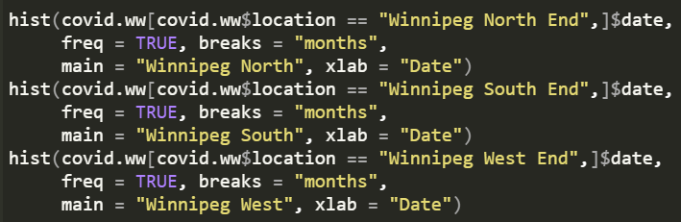
You can imagine it would take a lot of code to do this for every single site. Let’s switch to using ggplot() to see how we can look at all of the various sites in a single graphic more easily.
Q5: What argument(s) in ggplot() will we use to make a multi-panel plot?
Let’s go ahead and make a multi-panel plot showing the observations over time from our dataset, with each panel of the plot dedicated to only one location site.
Task | Example Code
Use ggplot to start a plot using the covid.ww data frame, and assigning ‘date’ as the x-variable
Add a histogram layer to the plot, and set the number of bins to 20.
Apply a faceting function to split the plot into multiple panels by location and province
Apply a simple theme to the plot
Note: for best results, view the resulting plot in a larger window using the Zoom command above your plot-pane.
Q6: When you look at the results of your plots, what are some of your key takeaways?

(3) Viral load ranges
Ok! We’ve spent some time with histograms looking at the range of observation frequency over time, let’s shift gears now and have a look at our primary outcome variable: viral_load. The simplest way to analyse these data are starting with scatter plots. Let’s pick one location and see if we can use a scatter plot to assess the magnitude of viral_load over time. For this example, we’ll use “Saskatoon, SK” as our location, but feel free to choose from any in the dataset.
Task | Example Code
Clear the graphics device, resetting the par() changes that you made earlier | 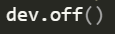
Create a scatter plot of viral_load over time for one location using base R graphics. | 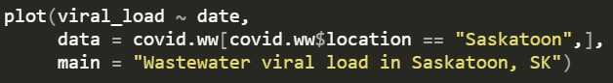
Since this is a time-series plot, connect the points by adding a line-series on top of the scatter plot. Change the line type to ‘dotted’ | 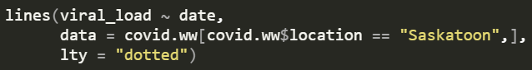
From the chart output, we can see that the viral load ranges for Saskatoon range from 0 to approximately 250 particles / sample volume. This is good to know, but doesn’t give us a lot of information on the median distribution of these data. For this, we’ll want to add a box-and-whisker plot to the visualization. For more information on these, read up on the help file by typing “?boxplot()” in your R console.
Task | Example Code
Create a simple boxplot of the viral_load data from your previous example of a single covid wastewater sampling site.
Great! You’ve created a simple, but effective box-and-whisker plot of the data. You’ll notice that there is a box with a thick dark line in the middle, with ‘whiskers’ extending from the top and bottom, and, depending on the site you’ve selected, there may be some observations plotted as points either above or below the whiskers.
Q7: What does each component of the box-plot represent (e.g., the top and bottom lines of the box, the line in the middle of the box, the extent of the top and bottom whiskers, and any points that lie outside of the whiskers)? Use the function manuals in R by typing ?boxplot() and ?geom_boxplot() into the R console to help you. Note: there may be slight differences in the calculations used between base R and ggplot(), but just focus on the general idea when answering.

Now that you’ve got a solid understanding of box-and-whisker plots, let’s incorporate both the scatter plot and the box-plot into the same multi-panel chart side-by-side using base R graphics! (Yes, you can do this without using ggplot!) Since boxplots don’t require a lot of real-estate on the x-axis, let’s devote approximately 75% of the x-axis to the scatter plot, and 25% to the boxplot by using the layout() function for base R graphics.
Note: layout() in this example takes the place of our earlier example, where we used par(mfrow = c(1, 3)). You can think of these functions doing similar things, in that they are changing the parameters of the plotting space, however, layout() gives you some additional options not available in par(mfrow()).

Task | Example Code
Set up a multi-panel plot area using the layout() function, and specifying a matrix of one row with two columns. (e.g., two plots side-by-side), with the first column having a width of 3, and the second column a width of 1. | 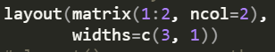
Next, we’ll revisit our friend, the par() command, and change the margins surrounding our plotting panes. There are two margins we’re interested in here: inner margins and outer margins. Inner margins control the space within a plot pane, and outer margins control the spaces surround the plot pane. We specify the unit spaces that we want around the plot panels by specifying the space on the “bottom”, “left”, “top”, “right” in this order.
So, when you see par(mar = c(5, 4, 3, 0) – this means that we want our inner plot panel margins to have 5 units of space on the bottom, 4 units on the left, 3 on the top, and 0 on the right. We can do similarly for outer margins: oma = c(0, 0, 3, 0). Here, we’re changing the top outer margin to have 3 units of space, so that we can later fit a title above both of the plots in our multi-paneled plot.
Using par(mar(), oma()) Adjust your margins to have 5 units of space on the bottom, 4 on the left, 3 on top, and zero on the right. Adjust your outer margins to allow for an additional 3 units of space on the top.

Create a scatter plot with viral_load on the y-axis, date along the x-axis, and add a second plot layer to add dotted lines to the visualization. | 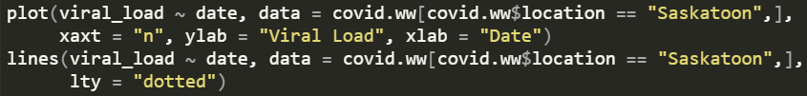
Add the second plot (boxplot) to the visualization. Note that the margins from the above command will be retained, so we’ll want to first change the left margin back to 0. Set axes = FALSE so you don’t duplicate them on the chart.
We’ll add a title to the plot using the mtext() function so that we can print it in an outer margin. This way, it’s spaced nicely above both of the plot panels.
So we managed to create a multi-paneled figure showing a scatter plot, with an additional line layer, and a boxplot, all on the same graph, using base R graphics! Achievement unlocked!
You can imagine doing this for every wastewater site location becoming very tedious. So for fun (and to retain our sanity), let’s explore another type of chart available to us in ggplot: the Ridgeline plot. Ridgeline plots let you compare the distribution of data across a number of discrete variables. They are visually attractive, however, can hide some parts of your data, so beware using them. Since we’re exploring our dataset, and not producing any final figures for presentation – these are a fine option to use. Ridgeline plots are available as part of the ggridges package, so if you haven’t already, make sure to load that library before proceeding.
For the following plot – we’ll apply the geom_density_ridges() geometric layer. This will produce density plots similar to a histogram, but a little more visually attractive, and in a more efficient way of looking at the distribution of viral load from our COVID19 wastewater site data all at once.
Task | Example Code
Start a ggplot using covid.ww as your data, and map viral_load to the x-axis, and province_abbr to the fill mapping.
Note: we’ll reorder province_abbr by using fct_reorder, and sort them using the pruid variable.

Add the geometric layer: geom_density_ridges and map the y-axis to location, using the same reordering trick we used above. (Note we have to reverse the order to have the legend present in the same order as the data).
Adjust the x-axis scale to remove outlier data. They aren’t useful in this graphic. Then set a minimal theme. | 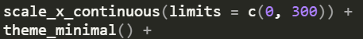
Add a title, legend labels, and axis labels. | 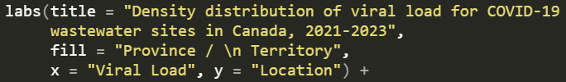
Note: you’ll need to adjust the justification for long plot titles to have it fit better on the chart.

(4) Regional and Provincial Population data
Obviously, the provinces and territories represented in our dataset have varying population sizes – and the same likely goes for the regions or municipalities that each wastewater sampling location are from. Let’s take a few minutes to compare the population sizes of the regions surrounding the COVID-19 wastewater testing facilities.
Note: population data is taken from census measurements, not from any sort of water service-area. Therefore, any conclusions we can make about population size and COVID-19 viral loads will not be considered highly accurate, but may uncover some trends in the data nonetheless.
Starting with base R: let's create a simple grouped bar plot to compare sizes of the provincial populations for each site. For base R plotting, we'll want to subset the data first so we don't have repeat observations in our dataset.
Task | Example Code
Create a subset of your covid.ww dataset that contains unique observations of province_abbr, location, region_pop, and province_pop
Since we’ll be comparing data across multiple provinces, we may want to assign a color to be used for each province ahead of time so that we can specify this when we create our plot. Create a new table containing a column for province_abbr and a second column containing a color to be used when displaying that province. Join this with the pop.table you just created. | 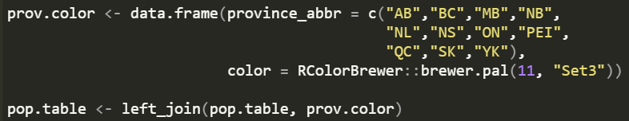
Now that you’ve created a subset dataframe, let’s create some visuals with it using base R.
Task | Example Code
Set the margins around your plot space to be 5 on the bottom, 10 on the left, 3 on the top, and 4 on the right. | 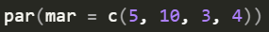
Create a barplot using region_pop as the height of the bars, and set the names to be the location of wastewater sites. | 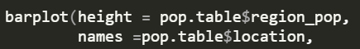
Continue adjusting the plot, using the following adjustments:  Character expansion of the names = 0.75  Color = the color variable in your pop.table data frame  Set a label for your x-axis  Set your barplot to horizontal orientation  Set axes = TRUE  Rotate the orientation of your labels using las = 1  Create a title for your plot | 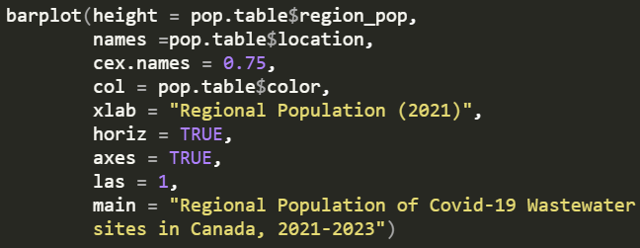
Add a legend to your plot, using the unique (non-redundant) vectors from your province_abbr and color variables in the pop.table dataset.  Position the legend so that it doesn’t interfere with your data series.  Change the character expansion (cex) to 60% of it’s regular size. | 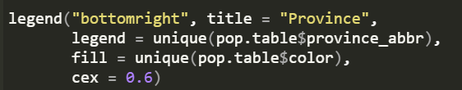
Note: in the 02_data_exploration.R script, there are a few more exercises on bar charts in base R and ggplot that walk through how to create grouped bar charts to better visualize hierarchy of province and location. We won’t include them in this tutorial, but feel free to review the code if you’d like to see how to group your data within a bar chart.
Let’s move on to an example that’s a little bit different, but still let’s us compare group sizes in an attractive visual way: bubbleplots! A bubbleplot is a special case of a scatterplot – in a bubbleplot, the size of the points is mapped directly to a variable in your data. While comparing circle sizes isn’t something the human eye is great at doing – bubbleplots are still an attractive visual that helps to tell your data-story in certain circumstances.
Let’s practice by comparing the population size of covid wastewater sites to inform the size of points in a bubbleplot, while we organize our data by province using different colors.

Task | Example Code
Initialize a ggplot object using the pop.table data, and assign the following mapping aesthetics: your x-axis and color fill should be the province, y-axis should be the regional population size. | 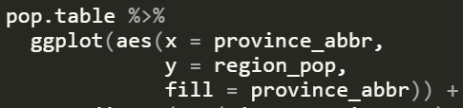
Set a geometric layer for creating the points on the chart. Since we have multiple points in the same range for several of the provinces, rather than geom_point(); we’ll use geom_jitter() instead. Use the aesthetics function to map the regional population to the size argument of aes(); and set the alpha to a value of 0.6 for 60% transparency. Use shape 21 (e.g., filled circle with an opaque outline); and set the color of the outline to ‘black.’
Next, set the minimum and maximum relative scale size for the plot points (i.e., bubbles) so that they don’t become too small/large to be visible.
Provide a color palette for the chart. Note that there are 11 provinces/territories included in the dataset, so you’ll need a palette with 11 colors. Here, we’ve used the “Spectral” palette from the RColorBrewer package. Apply a minimal theme. | 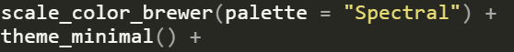
Create some reasonable titles and labels for your new bubble plot! | 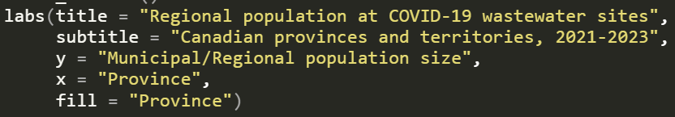
Relish in your new bubbleplot! Hurrah!
Q8) So far, you’ve practiced several different ways of creating plots using base R graphics, and ggplot() packages. Which method do you prefer? Do you see any advantages of one over another? What scenarios would you be more inclined to you base R graphics, or ggplot graphics?

Part 3: Pan-Canadian COVID-19 Wastewater Testing Visualization
After all that data exploration, you should be an absolute expert with the COVID-19 wastewater data. Your final task is to create an attractive visualization using the data provided in this exercise. Feel free to choose either ggplot or base R graphics systems to create a single data visualization that includes the following elements:
- The daily viral load as a data series over time.
- The 7-day moving average as a data series over time.
- Multiple plot panes.
- Data comparison from multiple sites and provinces.
Use examples from the code in part 2 to help guide your visualization. Feel free to use geometric layers that weren’t covered in the examples, if you’re comfortable doing so. If you get stuck and need help – remember you can always reach out on #slack, and we’ll have dedicated practice time available with help from facilitators and subject-matter experts on Day 3 of the course.
Happy plotting!

Day 2

Schedule
Session | Activity | Description
Virtual Classroom | Welcome | Presentation and debrief for Day 1 content
Virtual Classroom | Applying best practices in data visualization | Lecture
Virtual Classroom | “Worst” practices in data vis part 1 | Small group activity
Virtual Classroom | Rules to ‘viz’ by | Small group activity
Virtual Classroom | Break
Virtual Classroom | “Worst” practices in data vis part 2 | Large group discussion, lecture and small group activity
Virtual Classroom | Wrap-Up | Presentation, incl. check-in
Application | Independent Activity | Independent study
Support on Slack | Optional | For learners to engage more deeply with materials or ask questions relating to the self-study exercise (optional)

Activity: “Worst” Practices in Data Visualization (Part 1)
To be completed during the virtual classroom session.
Description: It’s a race to the bottom! Using your advanced knowledge of graphic design best-practices, we’re challenging you to work as a group to come up with the most heinous, retina-shattering visual theme that you can muster.
Work with your group to create a custom theme function that breaks as many of the rules that we’ve talked about in the classroom as possible.
Choose one person from the group to share their screen and adjust the R code provided, creating a theme() function that renders the viewer speechless with the atrocities that it commits against reasonable graphic-design best practices. Choose a second member of the group to present the function and describe how it violates considerations for graphic-design and accessibility back in the large group setting.
Bonus! One of our facilitators has challenged you to create an even worse data visualization than what they were able to come up with. See the code in the file ugly-viz.R for inspiration!
Materials:
- ugly-viz.R
- bchips_dataset_2022.csv
Instructions:
- Each small group will apply theming elements to a data visualization to make a figure that breaks all the rules for best practices when it comes to data visualization.
- Each group will be provided with a dataset and a code script.
- Small groups will have 20 minutes to edit the code and alter the figure and compete with their colleagues to create a figure that is worse than the example provided.
- Small group facilitators are available to troubleshoot during the activity.
- Return to large group to debrief on the monstrous graphics created by each small group, explicitly stating which best practice or rule you decided to violate (10 minutes)

Activity: Rules to ‘Viz’ By
To be completed during the virtual classroom session.
Instructions:
- Based on the lecture on data visualization best practices and the horrors witnessed in the worst practices in data visualization activity, participants will develop a list of rules to viz by for data visualization and its applications in R
- In small groups, participants will:
  - Add as many rules as they can think of to the jamboard in 5 minutes.
  - Using dots or icons in jamboard, collectively vote on which three rules to put forward as rules to viz by for data visualization.
Group | Jamboard link
1 | https://jamboard.google.com/d/19XFQ6sYC8tsViwyj4VyixX4PSBUQ_ACqZPD2UVJ8KAI/edit?usp=share_link
2 | https://jamboard.google.com/d/1_3N1N9Edh9Egsf6gbEr5NySRcoo_OXAoy5_SZFTtzDE/edit?usp=share_link
3 | https://jamboard.google.com/d/1V7Bpcq56qZP4PvLBXrwgwfsKvLbT3r2xEq2fKVlLuDo/edit?usp=share_link
4 | https://jamboard.google.com/d/1A3LN4FAEWeTtRhBfBHojXSeg-1NSES0HmoKKtKds3kY/edit?usp=share_link
5 | https://jamboard.google.com/d/13NSoPl9StTBPtjqqf4QuZpmxZiCzYO6VaODrWw4CchU/edit?usp=share_link

Activity: “Worst” Practices in Data Visualization (Part 2)
To be completed during the virtual classroom session.
Duration: 15 minutes
Instructions:
- Based on the lecture on data visualization best practices on equity, diversity, and inclusiveness (EDI), participants will connect practices in data visualization to potential harms to small or vulnerable communities in the context of applied public health practice.
- In the large-group format, participants will be asked to brainstorm ways that proper EDI considerations may be violated in data visualizations based on the three following topic areas:
  - Person: For example, inclusion/exclusions in the data, choices related to colour palette.
  - Place: For example, small denominators / areas, display by address on a map vs. three-digit postal code.
  - Time: For example, time series data and application of cultural context (e.g., outbreaks and holidays or events with significant travel).

- A link to Jamboard will be shared where participants can post their ideas for each topic area. We will have approximately 5 minutes per topic for brainstorming and discussion.
  - Link: https://jamboard.google.com/d/11YgONYItdlo6QVb1GGBB5X6ap1l0Xr4-R2DA3sY3Fsg/edit?usp=share_link
- Participants can review their Do No Harm checklist while discussing topic area.

After Class: Independent Activity Day 2

Part 1
To be completed following the virtual classroom session.
Materials:
- bchips_dataset_2022.csv
- bchips_data_documentation.html
- ugly_viz.R

Duration
45 minutes

Introduction

In the virtual classroom, you were introduced to a data visualization that was horrendous. Worse yet, you conspired with your colleagues to make an even worse visualization. Once your retinas have recovered, you realized that you can’t relax until this terrible data visualization is off your conscience. You feel compelled to make the world a better place by applying data visualization best practices to fix the data visualization.
Review the code that was used to create the non-accessible figure and answer the questions below. Then, once you’ve identified solutions to making a visualization that complies with graphic-design best practices discussed in class, modify the provided code to make an improved visualization we can all be proud of!
Review the code provided and the figure it creates.

Task | Code
Open the script ugly_viz.R located in the scripts folder
Load the required packages | 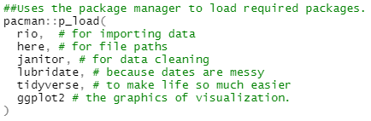
Import fonts from windows | 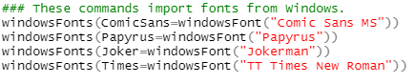
Import data
Create a custom theme to apply to the visualization. | 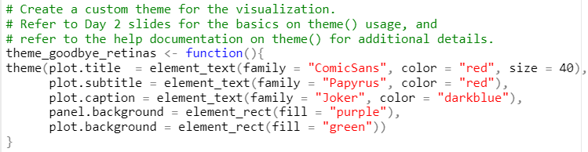
Create the data visualization and apply the customized theme to the plot. | 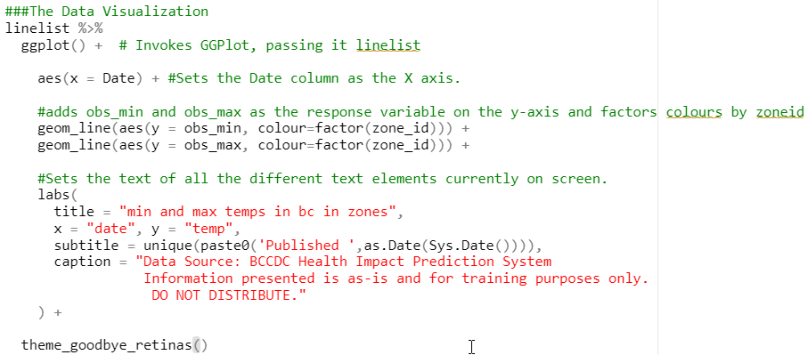

You’ve created a visualization of a year’s worth of daily temperature data for each British Columbia Heat Impacts Prediction System (BCHIPS) zones.

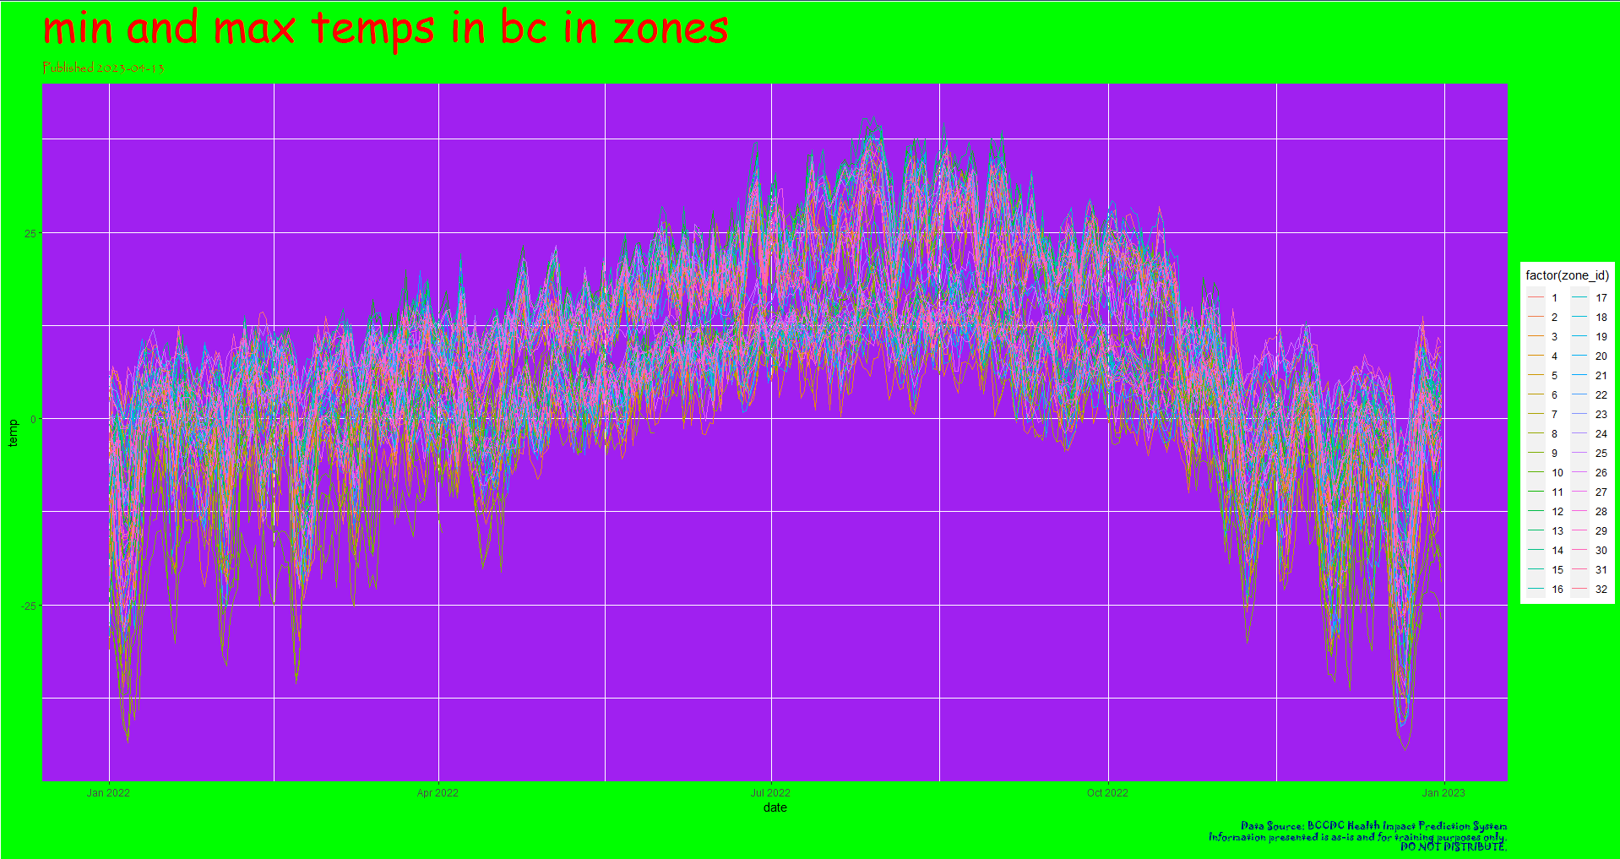
What information do you think the original author of this figure trying to show by displaying the data like this?
In words (i.e., without using coding examples), explain how you can manipulate the data and the visualization to only show what is necessary?

List changes you will need to make to this figure to bring it back in line with data visualization best practices.

Clean the dataset to remove any unnecessary variables. A data dictionary is included in your data folder. If you want to integrate additional data, by all means! Be creative, but don't overdo it. List any ideas you have here:

Create a new data visualization that incorporates data visualization best practices.
Advanced and intermediate R users: Create your own ggplot statement to generate a new figure(s)
Beginner R users: If the coding is too challenging for the time provided, please feel free to prioritize your understanding of the ggplot statement provided to create the data visualization above and write your own “pseudocode” to outline what your process will be.
Note: An R code script providing a solution is available in your course materials should you need a reference as you write your own code and/or process.

Part 2
To be completed independently following the virtual classroom session.
Duration: 60 minutes

Materials:
- chlamydia_infographic.pptx
- chlamydia_linelist.csv
- chlamydia_infographic.R

Introduction
Scenario: you’ve been mobilized into a public health unit that publishes regular data visualization in an infographic on case rates throughout the jurisdiction. Recently, there has been an increase in the rates of chlamydia cases throughout the jurisdiction. A junior analyst has prepared an infographic based on their data analysis, outlining their recommendations to senior management. Having recently taken the TDU’s RDataViz course, you’ve been asked to give things a second look, and confirm whether you agree with the analyst’s assessment of the situation. You have been provided with the data and code used for making the visual product.
This jurisdiction has limited resources and capacity for risk communications, so it is important that you identify and target the most appropriate group(s) to help increase awareness about the issue. This infographic may also help the program area to make possible changes to program delivery. As the senior epidemiologist on the file, it is up to you to make sure that the messaging being used to make recommendations is accurate.
Instructions
Complete the questions below after reviewing the infographic provided. The questions will help to guide you through the information to consider when assessing the junior analyst’s infographic.

(Optional: Alter the R code provided to recreate the data visualizations using the data from chlamydia_linelist.csv. You can alter the current code or create new graphics using code from previous activities in the course. As always – feel free to try something new as well)

Bonus!: Recreate the infographic in the pptx. file including any updated recommendations.

Note: See the table below for a data dictionary of variables included in the dataset

Variable name | Description
id | Identification number of the case
disease | Type of infection of the case
sex | Sex of the case  Options:  - F = Females  - M = Males
age | Age of the case (years)
ethnicity | Ethnicity of the case  Options:  - Black  - East Asian  - Indigenous  - Latin American  - Middle Eastern  - South Asian  - Southeast Asian  - White  - Unknown
partners_coded | Number of partners reported by the case
region | Region that the case resides  Options:  - A  - B  - C
reporteddate_new | Date of reported case (mm/dd/yyyy)

- In your own words, describe the evidence provided by the data visualizations in the infographic that contribute to the final recommendations made by the junior analyst? (I.e., why would the junior analyst have come to these conclusions?) Do you agree with their interpretation of the situation?

- The analyst has interpreted from the epidemic curve that cases are young (e.g., 18-34) and are peaking around late September, which coincides with exposure during “Frosh week” / back to school. Do you agree with this assessment?

- From the information presented in the pie charts, do you agree male cases should be prioritized for risk communications? What other information would you like to know?

- Open the dataset chlamydia_linelist.csv. Do you notice any variables with incomplete data? Without doing any analysis, can you think of any limitations that might arise due to the data completeness? How might this affect the data visualizations in the infographic?

- Open the R script for this activity: chlamydia_infographic.R. What do you notice about the first steps taken for creating the pie charts? Do you have any recommendations for changes to the way the pie charts are constructed? Do you have any recommendations for changes to the way the epidemic curve is constructed?

- Briefly summarise what the change(s) to the evidence communicated by the figure/infographic would be after you apply your list of changes from the previous step. How do your recommendations differ from those told by the junior analyst? Why is this important?

- Although this infographic is meant for internal reporting, what harm can be done by misrepresenting the data?

Step 2 (Optional) - Alter the R code to recreate the data visualizations using the data already provided. You can alter the current code or create new graphics using code from previous activities. Review the file chlamydia_infographic_answer_key.R if you want to see an example of R code to help improve the data visualizations in the infographic. Steps for altering the code are included in the answer key in Appendix 2.

Day 3

Schedule
Session | Activity | Description
Virtual Classroom | Welcome | Presentation
Virtual Classroom | Review Activity | Large group activity
Virtual Classroom | Practice Time! | Virtual office hours
Virtual Classroom | Course Wrap-Up | Presentation, incl. evaluation

Review Activity: Pie-Chart of Fortune!
Instructions: Refer to the activity instructions provided in the virtual classroom.

Activity: Practice Time!
To be completed during the virtual classroom session.
Instructions:
Participants will have some time to work on independent activities associated with days 1 and 2 of the course. Facilitators will hold virtual office hours during this time. Participants can drop-into the Zoom session with their questions or for help with troubleshooting the activities as they practice their R skills!
Note: Participants are expected to rejoin the virtual classroom once this activity has concluded. A time to rejoin the virtual classroom will be provided to participants prior to opening the practice time session.

Appendix 1: Independent Activity Day1 Answer Key
Q1) What do you notice about the format of the daily_viral_load datasets? How are the data organized? Are they all the same? Do they all contain the same variables?
Daily vial load datasets appear to be in wide-format, with dates as columns. The two provincial datasets assessed in the example appear to be formatted the same, and a quick look through the remainder daily viral load csv’s all seem to be in a similar format and contain the same variables. Likely there was some issue in exporting these data sets.

Q2. What do you notice about the weekly datasets? Are they in the same format as the daily ones? What’s different about these ones? Based on what we talked about in the lecture portion of Day 1, which data format seems better suited to generating plots in R.
Weekly datasets are in long-format, with a date column that contains row entries for each date a measurement was taken. These are in long-format compared to the wide-format used for daily viral load readings. The long-format used for the weekly readouts will be easier to generate visualizations from.

Q3. What function(s) will you use to convert the daily datasets into a format consistent with the weekly ones?
The best and likely easiest is to use pivot_longer() as part of the tidyverse package. There may be various responses for this, however, given that there are multiple ways of achieving the same goal in R.

Q4. What does the freq=TRUE argument do in the hist() function? What happens if you set this to FALSE?
When set to TRUE – the bars on the histogram represent the frequency of observations in the dataset. If this is set to FALSE, then the bars indicate the density distribution of the total data instead.

Q5: What argument(s) in ggplot() will we use to make a multi-panel plot?
There are two functions within ggplot that make it easy to create multi panel figures. The first one is facet_wrap() which automatically positions the panels so they fit into the figure. The second, facet_grid() requires the user to specify how the panels are configured.

Q6: When you look at the results of your plots, what are some of your key takeaways?
Not all sites started collecting data at the same time, so if we choose to compare multiple sites, we’ll want to make sure that we’re comparing the sites that have data collected in the same time frame. It looks like NS, NB, PEI and YK all began wastewater sampling later in 2022, whereas BC, MB, ON, QC and SK generally started earlier. Some provinces with multiple sites had locations where sampling started earlier, and additional sites were added later (e.g., MB, NS). It appears that locations where sampling started earlier were often more highly populated regions.

Q7: What does each component of the box-plot represent (e.g., the top and bottom lines of the box, the line in the middle of the box, the extent of the top and bottom whiskers, and any points that lie outside of the whiskers)? Use the function manuals in R by typing ?boxplot() and ?geom_boxplot() into the R console to help you. Note: there may be slight differences in the calculations used between base R and ggplot(), but just focus on the general idea when answering.
Bottom of box = 1st quartile, middle = median, top = 3rd quartile. Whiskers extend out +/- approximately 1.5 times the inter-quartile range (e.g., the difference between quartiles 1 and 3). Points that lay outside of the whiskers correspond to outliers.
Q8) So far, you’ve practiced several different ways of creating plots using base R graphics, and ggplot() packages. Which method do you prefer? Do you see any advantages of one over another? What scenarios would you be more inclined to you base R graphics, or ggplot graphics?
Note: answers may vary.
Some situations that may call for base R graphics could include when you’re exploring data very quickly. Charts that you’re not planning on saving or publishing. When you’re adding to a report that already includes base R graphics to preserve look and feel. When you’re using packages that output visualizations using base R graphics only.
Ggplot graphics take slightly longer to set for more simple graphics, but generally are more easily customizeable. Ggplot is a great system to use to set up template code that you can re-run in your script with different data if you’re going to re-use the same data visualizations over and over again.

Appendix 2: Independent Activity Day2 Answer Key

Part 1
Additional materials:
- ugly_viz_answer_key.R

What information do you think the original author of this figure trying to show by displaying the data like this?
[Answers may vary]. The author may be trying to display the temperature variations from January 2022 to January 2023 across all 32 zones of British Columbia mapped out by the BC Heat Impacts Prediction System interactive online mapping system.

In words (i.e., without using coding examples), explain how you can manipulate the data and the visualization to only show what is necessary?
You will need to manipulate the visualization depending on the message you are trying to convey. For example, the author has added all 32 zones in one visualization: this makes it difficult to identify the key message.
If you are trying to stay as close to the original message as possible, you will want to illustrate the temperature variations across the zones. However, you might want to group some zones together and create several visualizations illustrating the temperature variations across the grouped zones. You might also decide to create 32 different data visualizations that would each contain the temperature variations of one zone at a time.
Additionally, we might have completely missed the point the original author was trying to make. It is possible that the original author was trying to compare a specific zone or multiple specific zones to others. In that case, we would manipulate the visualization to highlight the zone(s) of interest. This can be done by manipulating the color, the contrast, and the opacity of the zone(s) of interest so that the zone(s) can stand out. For accessibility considerations, make sure you do not rely on color only to convey meaning.
Finally, depending on our desired analysis of the data, we might decide that we are only interested in a few specific zones. We could manipulate the data to filter out all the other zones in order to focus on the zones of interest only. We could then manipulate the visualization to plot the temperature variations of each of those zones individually or together.

List changes you will need to make to this figure to bring it back in line with data visualization best practices.
- Simplify the visualization so the message is clear and easy to understand.
  - Avoid including too much information in a single visualization as it may blur the message.
  - Decide on the specific question you want to investigate and use that to hone in on a simpler data visualization.
- Include accessibility principles in the visual consistency and layout of the visualization.
  - Ensure the colors and their contrast fit accessibility standards. This means that you will need to switch your color palette to be inclusive to people with low vision. Do not rely on color only to share a message – your message should still be conveyed if the visualization is printed in black and white.
  - Reconsider the location of your titles for a more balanced visualization.
  - Reconsider the sizes of the different titles to create some hierarchy.
- Ensure the text is readable and accessible.
  - Use typefaces that have clear and recognizable characters like sans serif fonts such as Arial, Calibri, Tahoma, Verdana, Helvetica, or Lucida Grande.
  - Ensure the color of the font is readable against the background color and that the contrast is high enough to fit accessibility standards.

Create a new data visualization that incorporates data visualization best practices.
Advanced and intermediate R users: Create your own ggplot statement to generate a new figure(s)
Beginner R users: If the coding is too challenging for the time provided, please feel free to prioritize your understanding of the ggplot statement provided to create the data visualization above and write your own “pseudocode” to outline what your process will be.
Note: A R code script providing a solution is available in your course materials should you need a reference as you write your own code and/or process.
Example code:
Task | Code
Load the required packages | 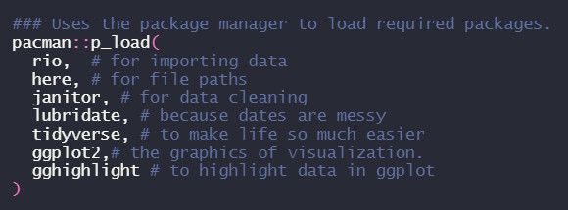
Import data
Remove unnecessary variables | 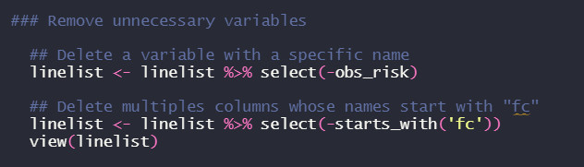
Create the first example of a beautified data visualization (an individual visualization per specific zone) | 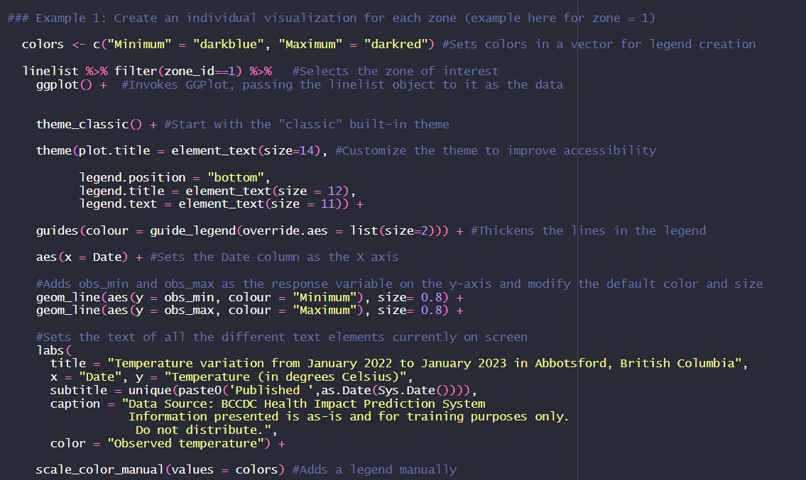
Create the second example of a beautified data visualization (a multi-panel visualization for selected zones) | 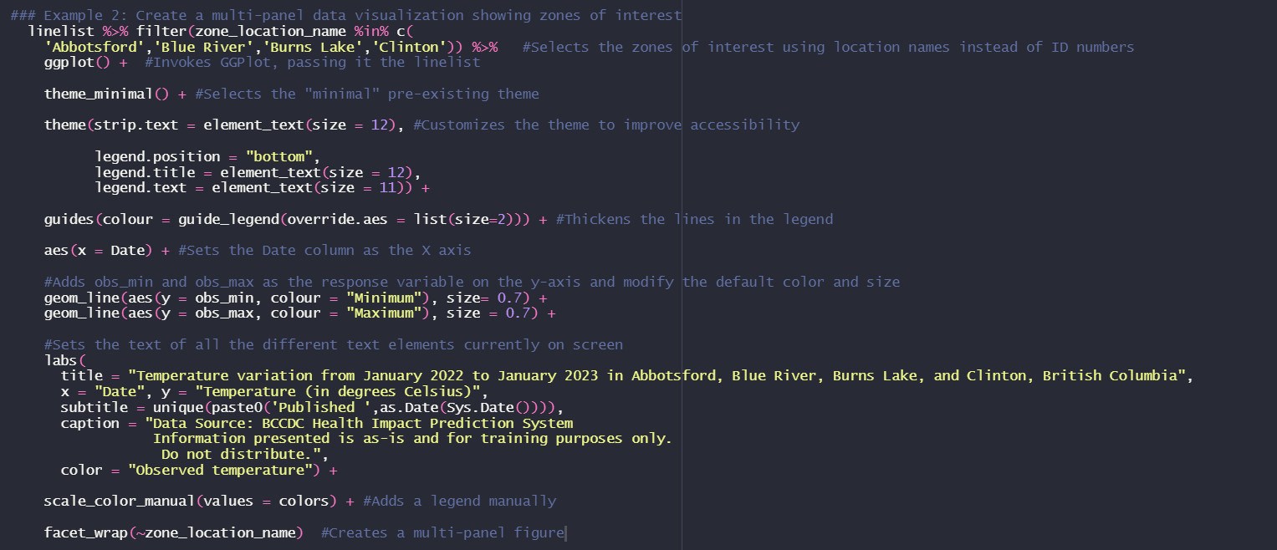
Create the third example of a beautified data visualization (a single zone is highlighted against the rest) | 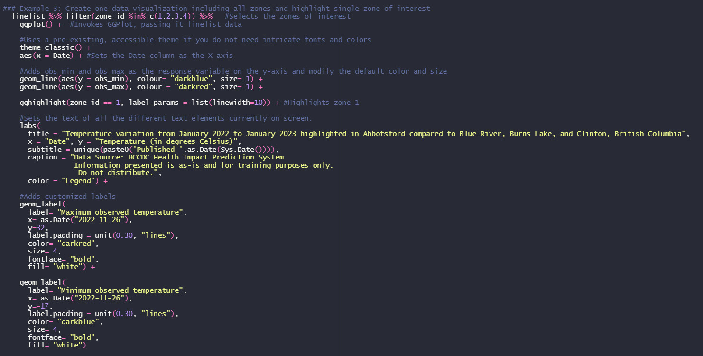

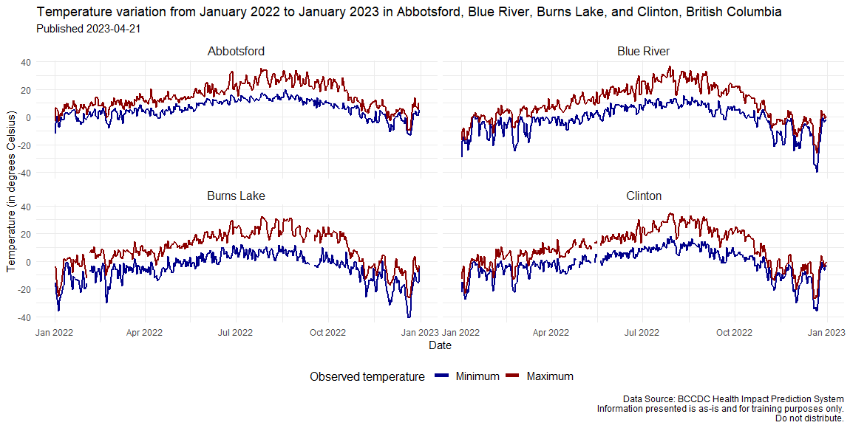

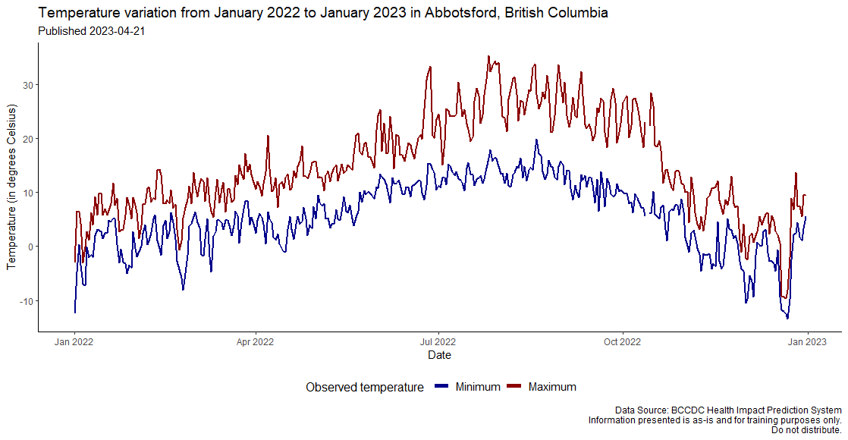

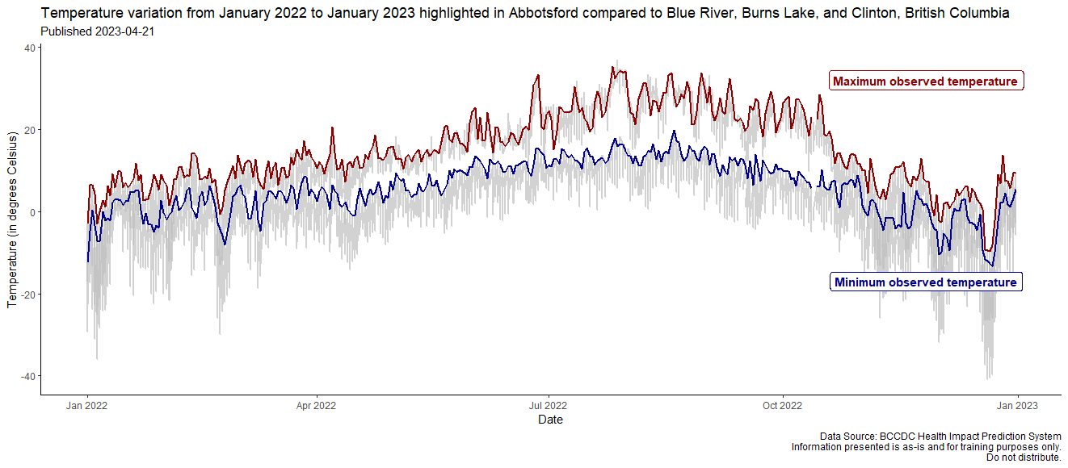

Part 2
Materials:
- chlamydia_infographic.pptx
- chlamydia_linelist.csv
- chlamydia_infographic.R

- In your own words, describe the evidence provided by the data visualizations in the infographic that contribute to the final recommendations made by the junior analyst? (I.e., why would the junior analyst have come to these conclusions?) Do you agree with their interpretation of the situation?
The junior analyst has concluded that it is young males that are perpetuating the chlamydia outbreak among the student population in Region C. The epi curve supports this conclusion that the outbreak happened in September/October among young people which could coincide with Frosh week/back to school. The pie charts also show that ~75% of males have more than 1 partner whereas only 25% of women have more than 1 partner.

- The analyst has interpreted from the epidemic curve that cases are young (e.g., 18-34) and are peaking around late September, which coincides with exposure during “Frosh week” / back to school. Do you agree with this assessment?
It does appear that cases peaked around the end of September which could coincide with Frosh week/back to school as most of the cases were in the 15-24 year category. It could be helpful to see if the peak was seen in each region or if there is one region in particular (where the school could be located?) that the outbreak is occurring in.

- From the information presented in the pie charts, do you agree male cases should be prioritized for risk communications? What other information would you like to know?
The way the pie charts are currently presented on the infographic does allow the reader to jump to the conclusion that males have a higher number of partners and therefore should be targeted for intervention. However, there is still a lot of information missing and a more thorough analysis is needed before jumping to that conclusion. To start, the number of cases per category should be added (n=) or at the very least, the total number of cases per figure (N=).

- Open the dataset chlamydia_linelist.csv. Do you notice any variables with incomplete data? Without doing any analysis, can you think of any limitations that might arise due to the data completeness? How might this affect the data visualizations in the infographic?
When looking at the dataset, the ‘partners_coded’ variable is very incomplete, especially among females. As this was one of two indicators used for the infographic, the data visualization could be misleading especially since there was no mention of this limitation (misclassification bias). If the total sample size for this indicator had been written on the infographic, or if it included the number of missing cases, we would have been able to see immediately that the total number of men who reported the number of partners (n=14) differed from the total number of women who reported the number of partners (n=26). By just glancing at the data, we can also see that the handful of men who have multiple partners are mostly older.

- Open the R script for this activity: chlamydia_infographic.R. What do you notice about the first steps taken for creating the pie charts? Do you have any recommendations for changes to the way the pie charts are constructed? Do you have any recommendations for changes to the way the epidemic curve is constructed?
Note: Answers may vary.
The first operation in the code is to drop any missing values, making the resulting pie charts look as though they are based on a complete dataset, when in fact, there are many observations missing from the data.
Possible visuals that could be helpful:
- Split the epi-curve into female cases by age, and male cases by age
- Add labels to the pie charts, indicating the numbers of cases with missing data
- Add age categories to the pie charts; or
- Split the pie charts into multiple categories that show age of cases

- Briefly summarise what the change(s) to the evidence communicated by the figure/infographic would be after you apply your list of changes from the previous step. How do your recommendations differ from those told by the junior analyst? Why is this important?
Note: Answers may vary
In the original assessment, it looked as though the priority group for risk communications should be those between 18-34, and particularly males, who were seen to have much higher numbers of sexual partners.
However, upon reassessment, it appears that while the number of cases is still greater in the 15-24 age category, this is primarily attributed to female cases.
Information regarding numbers of sexual partners appears to be quite limited in the dataset, especially among the 15-24 age category that is identified in the epidemic curve, and the age category of the majority of cases does not align well with the age category of cases with high numbers of sexual partners (i.e., older male cases).
In this scenario:
- It may not be the most effective strategy to highlight young males for risk communications, as the majority of cases are young females.
- Ensuring that messaging will reach males with multiple sexual partners (aged 35-44) should also be considered.

- Although this infographic is meant for internal reporting, what harm can be done by misrepresenting the data?
Note: Answers may vary

- Targeting the wrong group of the population for risk communications could result in a lack of communications to the groups that need the messaging most.
- Focusing the outbreak resources and messaging towards those in the 15-24 age category (e.g., University students) only may stigmatize youth in the area
- Chlamydia infections can be asymptomatic, so ignoring groups of the population who have potential for spreading the illness to many partners may prevent the outbreak from being resolved in a timely fashion.

Optional
Create new data visualizations to investigate relationships and conclusions from the chlamydia outbreak infographic
Advanced and intermediate R users: Create your own ggplot statement to generate a new figure(s)
Beginner R users: If the coding is too challenging for the time provided, please feel free to prioritize your understanding of the ggplot statements provided to create the data visualizations included in the infographic and write your own “pseudocode” to outline what your process will be.
Note: An R script providing a solution is available in your course materials should you need a reference as you write your own code and/or process.
Example code:
Task | Code
Load the required packages | 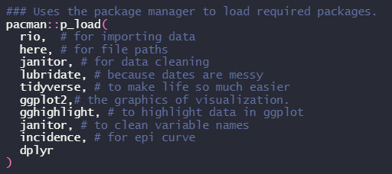
Import data | 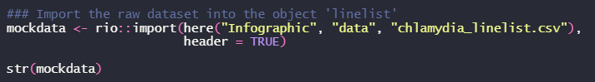
Clean the data as necessary
Create new variable based on age categories | 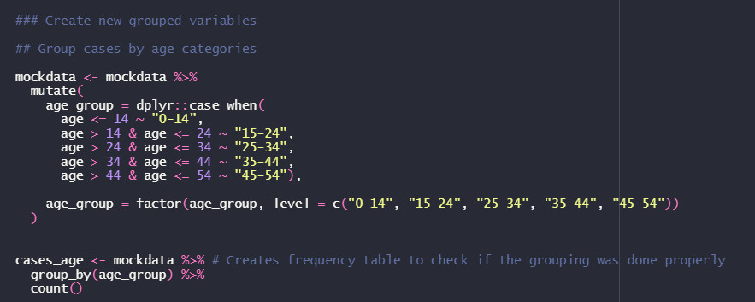
Create new variable based on number of sexual partners | 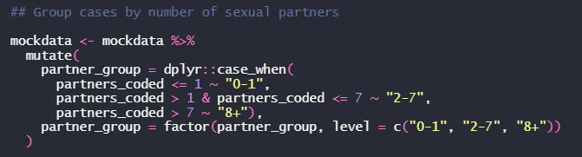
Create two different epi curves based on the variable sex.  Start by filtering out male cases for the epi curve with female cases only. Create incidence object based on case report date per 7-day interval, grouped by age categories. Plot the incidence object to create an epi curve.  Save the epi curve in the output folder. | 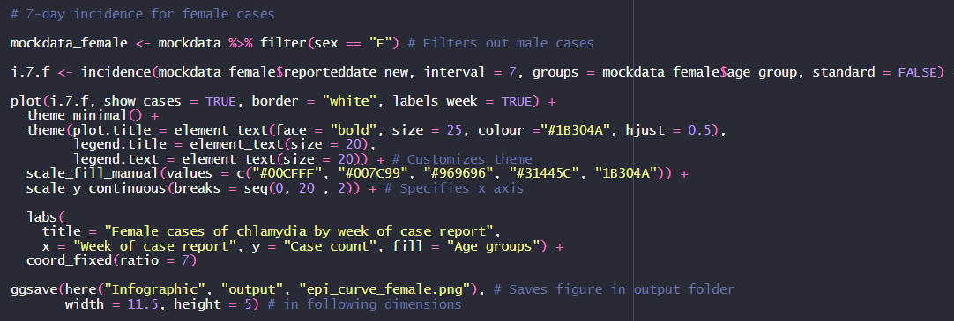
Next, filter out female cases for the epi curve with male cases only. Create incidence object based on case report date per 7-day interval, grouped by age categories. Plot the incidence object to create an epi curve.  Save the epi curve in the output folder. | 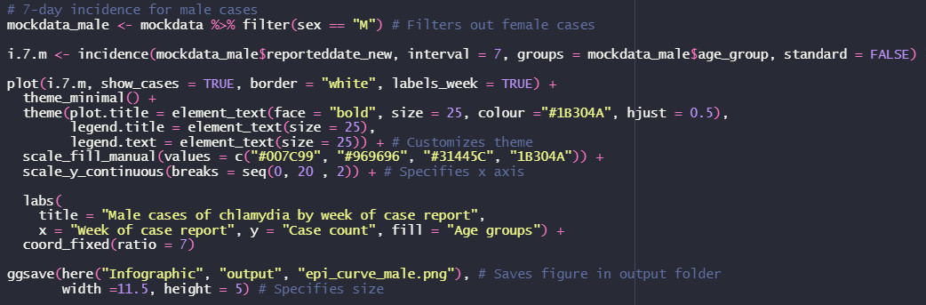
Create the same pie charts, but include missing values.
You’re going to need to recode the number of sexual partners group variable (partner_group) as a character in order to assign a value, in this case “Missing”, to the NAs. This modification will provide more options when it comes to customizing the plot. Namely, it allows us to select the color of the NAs in the graph.
Create a subset of data for female cases grouped by how many sexual partners they’ve reported having.  In this improved visualization, we are adding labels to the chart. We are also adding missing values, which puts into perspective the proportions previously reported in the infographic.  Plot this subset of data into a pie chart and save it to the output folder. | 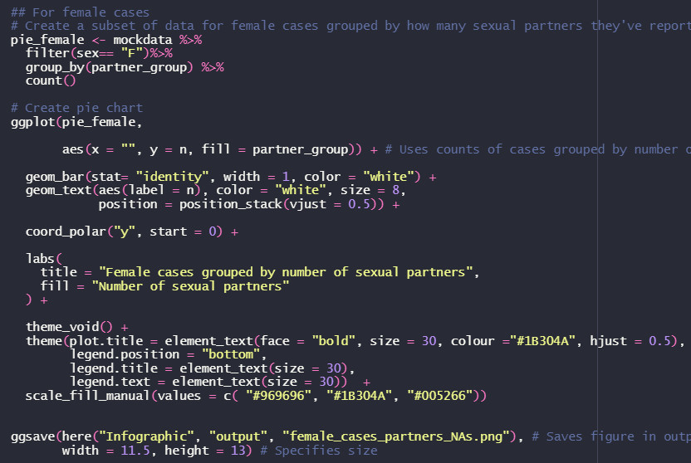
Create a subset of data for male cases grouped by how many sexual partners they’ve reported having.  Plot this subset of data into a pie chart and save it to the output folder. | 