Module 3
Welcome back!
So far in the course, we’ve gotten used to navigating our datasets using Tidyverse functions.
In this module, we’ll be practicing another critical skill: working with multiple datasets!

Scenario update
Blarney! It’s a good thing that D.N.P. cruise-lines thought to hire an epidemiologist for their voyage! Passengers with symptoms of abdominal pain or worse have been reporting to the ship’s infirmary like crabs to catfood! Something isn’t sitting well on this boat, and you’ve got a sneaky suspicion that you might be facing an on-board outbreak.
You can’t make bricks without clay, however, and we cannot make conclusions without evidence. We’ll need to do some basic epidemiology to assess if there are any commonalities between the sick passengers before we can report our recommendations to the captain.
Thankfully, the ship’s nurse has been quite co-operative and provided you with the records of individuals that have reported to the infirmary over the last few days. Upon opening the email and giving it a quick scan, however, you realize that none of the demographic information (e.g., age, sex) has been included in the data. In fact, it turns out that the nurse aboard the S.S. Rainbow Cake takes personal data confidentiality VERY SERIOUSLY, and passenger names aren’t even included!
Instead of names, passenger health data have been coded to use a personal identification number (PIN). Lucky for us, the nurse keeps a copy of the ship’s manifest, and recorded a PIN for each passenger, but these datasets are separate, and you’ll need to find a way to combine in order to figure out who’s who! Good thing you’ve been practicing data appends and joins!

Learning Objectives
By the end of Module 3, you will be able to
- Describe your plan for combining multiple datasets together.
- Combine multiple datasets using Tidyverse syntax.
- Explain use-cases for several different types of data-join operations.

Part A: Exploring datasets and mapping out a data collation plan
In this module, you’ve been given several datasets that you’ll want to combine in order to calculate some summaries.
First, however, you’ll need to review what data you’ve been provided with, and formulate a strategy for combining datasets in a way that makes most sense for the types of analyses you’ll want to do.

Abdo datasets
In your Module3 datsets folder you should see the following files, that correspond to data extracts related to passengers with abdominal pain complaints:
abdo_Feb10.csv
abdo_Feb11.csv
abdo_Feb12.csv
abdo_Feb13.csv
abdo_Feb14.csv
Each of the abdo_ files are formatted the same way and contain data collected on a single date. These files were extracted from the infirmary’s database, and contain several rows of metadata at the top of the file that you’ll want to filter out. They also all contain the following variables:
Data dictionary for data extracts from the ship infirmary
Variable | Definition
Pass_ID | Unique identifier given to ship passengers
Recorded temperature | Oral temperature taken during medical visit (degrees celsius)
Recorded height | Passenger height measurements taken during medical visit (cm)
Recorded weight | Passenger weight measurement taken during medical visit (kg)
CEDIS | CEDIS Chief complaint code, input by nurse at check-in (see additional handout)

Passenger manifest
The ship’s nurse has also provided you with a copy of their passenger manifest - which thankfully has the Pass_ID included, as well as the demographic information you’ll need to summarize the epidemiology of passengers experiencing symptoms of illness.
Also - lucky us, it seems as though the ship’s infirmary does a much better job of maintaining the passenger manifest as well! So we shouldn’t have to worry about cleaning it a second time. There are, however, more variables than we really need for answering our questions about who is getting sick - so we’ll want to focus just on the variables pertinent to our analysis. Lets focus on keeping the following:
Variables to keep from the passenger manifest
Variable | Definition
Pass_ID | The unique identifier given to each passenger by the crew of the S. S. Rainbow Cake.
Age | Age of the passenger at the time of the cruise departure.
Gender | Reported gender of the passenger.
Member status | Which tier of rewards member. May determine access to different amenities or food items.
Boarding date | What date the passenger boarded the cruise ship.

Data collation plan
Now that we have an idea about what our datasets will look like, we should sketch out a strategy for how our data sets can be joined together. Starting with our abdo datasets: these are all in the same format, but separated out for each day. We’ll want to append these datasets together, and create a new variable to indicate what the date was that the symptoms were reported.
For our append operation, we’ll be using the following function:
bind_rows(dataset1, dataset2, etc..., .id = "id")
Simply, bind_rows will combine our data by stacking the rows on top of each other. Its important to ensure that all the column names are consistent, otherwise we’ll get a messy bunch of rows with mostly NA’s in them.
The argument .id=“id” will produce a new column that contains a character string of the filename. This will then let us identify which observations were recorded on each day, and we can then mutate() a new column based on this to represent the onset date.
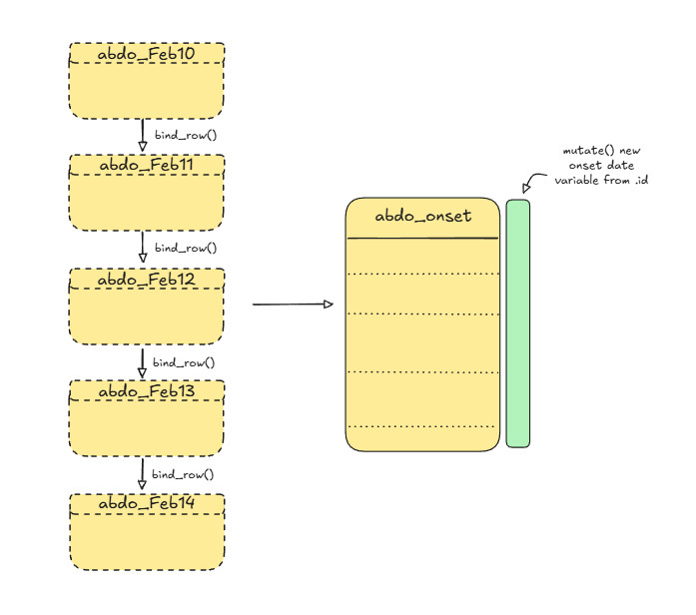
Using bind_row() to append the abdo datasets into one.
Once we have a working abdo dataset in place, we can turn our attention to the passenger manifest file. This manifest has already been cleaned by the ship’s staff, and contains the unique passenger ID variable that we can use as a key variable. The dataset is, however, still saved as an Excel workbook, and contains the messy header and extraneous variables - so you’ll need to revisit how we imported this properly in Module 1 if you’ve forgotten, and then select the variables to keep from the table above. When that’s done, we’ll join the two tables together with the key variable.
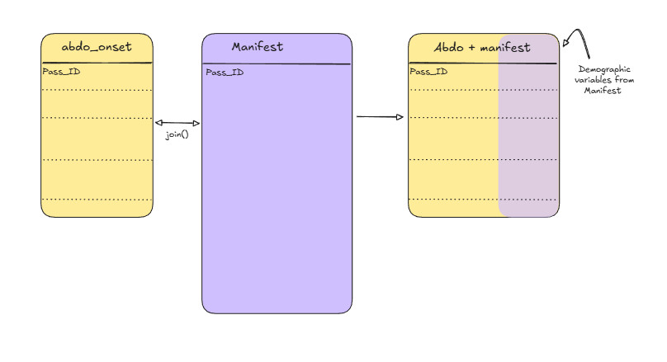
Collating abdo and manifest datasets using table join
 Important
Make sure that you think about what table join is the most appropriate for the end result you’re hoping to achieve! Also, the order that you specify the tables matters with some table joins! If you need help remembering how each of the different join types work, refer to the references on mutating joins and filtering joins!

Code-along for Part A
If you’re feeling confident, then we encourage you to try establishing the code yourself for this exercise. However, we’ve provided the code that we used below. Remember, there’s always multiple ways to accomplish the same thing, so don’t worry if your code doesn’t always match what we’ve done!

Importing and appending the Abdo datasets
# Load required libraries
# library(pacman)
# p_load(tidyverse)
# create a vector to store consistent and simple variable names for abdo datasets
abdo_names <- c("pass.ID", "pass.temp", "pass.height", "pass.weight", "CEDIS")
# load abdo datasets using read_csv from the readr tidyverse package:
abdo_feb10 <- read_tsv("participant_data/module3/abdo_Feb10.txt", col_names = abdo_names, skip = 4)
abdo_feb11 <- read_tsv("participant_data/module3/abdo_Feb11.txt", col_names = abdo_names, skip = 4)
abdo_feb12 <- read_tsv("participant_data/module3/abdo_Feb12.txt", col_names = abdo_names, skip = 4)
abdo_feb13 <- read_tsv("participant_data/module3/abdo_Feb13.txt", col_names = abdo_names, skip = 4)
abdo_feb14 <- read_tsv("participant_data/module3/abdo_Feb14.txt", col_names = abdo_names, skip = 4)
Great! Notice that we used skip = 4 to remove the header row, since we’ve stipulated our own headers in the abdo_names vector.
Next, let’s append these datasets together using the bind_rows() function.
abdo_combined <- bind_rows(abdo_feb10,
abdo_feb11,
abdo_feb12,
abdo_feb13,
abdo_feb14,
.id = "id")
Now that we have our combined abdo dataset, we can go ahead and mutate a new column based off our ‘id’ variable that was created when we used bind_rows. For this, we’ll revisit the case_when and ymd functions as well from Module 1.
abdo_combined_onset <-
abdo_combined %>%
mutate(onset.date = case_when(
id == "1" ~ ymd('2025-02-10'),
id == "2" ~ ymd('2025-02-11'),
id == "3" ~ ymd('2025-02-12'),
id == "4" ~ ymd('2025-02-13'),
id == "5" ~ ymd('2025-02-14')
))
Now we can drop the “id” variable from our abdo_combined_onset dataset, and proceed to joining this dataset with our passenger manifest.
abdo_combined_onset <-
abdo_combined_onset %>% select(-id)
Before moving onto the passenger manifest, however, let’s clean up our workspace and remove the temporary objects that we created up till now.
rm(abdo_combined, abdo_feb10, abdo_feb11, abdo_feb12, abdo_feb13, abdo_feb14, abdo_names)
Great - we should be just left with the abdo_combined_onset object in your work session now.

Importing the passenger manifest
Now that we have our abdo dataset all ready to go, we can turn our attention to the updated passenger manifest file. In your Module 3 data folder, you should find the following file:
pass_manifest.xlsx
First, open this file in Excel and give it a look-through. It should look very familiar to the manifest that you worked on in Module 1, but the data cleaning issues identified in Module 1 have been cleaned up and the passenger ID variable has been added. Remember, you’ll still need to remove the header while importing this file!
# Import the dataset using readxl
# Note the readxl::read_excel allows for you to access functions from installed
# packages without loading the entire package.
pass_manifest <- readxl::read_excel("participant_data/module3/pass_manifest.xlsx",
skip = 10)
Now, recall earlier that we determined that we didn’t need to keep all of the data from the passenger manifest, so let’s use the select() function to choose only the variables that we want to keep.
pass_manifest_trunc <- #truncated, temporary object
pass_manifest %>%
# Note that we wrap variables with spaces in a back-tick
select(Pass_ID, Age, Gender, `Member Status`, `Boarding Date`)
We should have everything we need now to join these two datasets together!

Deciding on a join type to combine the two datasets
Now that we’re at the stage where we will actually join these datasets together, we need to carefully consider which join type we’ll want to use. Remember that there are both mutating joins - which change the data, but don’t drop observations, and filtering joins, which DO drop observations.
To help you decide which join you want - think through the following questions:
- What question are you ultimately trying to answer?
- Do you need all the data from both datasets?
- Which dataset contains the observations most important to you, and which dataset contains the supplementary information you’re trying to add?
Click to see our decision and reasoning
For this operation, we decided that a left_join would work best!
- A left join (left_join()) keeps all rows from the left (first) data frame, and adds matching columns from the right data frame based on the join key(s).
- If a row in the left data frame has no matching key in the right, the new columns are filled with NA.
- Rows in the right data frame that don’t match any left-side keys are dropped and do not appear in the result.
- Since we’re interested in the cases reporting abdominal symptoms primarily, and we’re looking to add supplementary demographic data, the left join makes the most sense, and keeps the results nice and tidy for us, without any extras.
 Warning
Don’t forget that the order of tables matters when invoking left_join().

Joining the final abdo and passenger manifest datasets
This is it! We’ve made it to the step where we finally get to join these datasets together into one, using the join type that we decided upon. Let’s take a quick look at the syntax for left_join().
left_join(x, y, by = ...)
- x is the table for which all the rows will be kept
- y is the table that you want to add data from
- by is an optional argument that specifies the key value to join the datasets on. Since we have “pass.ID” in the abdo dataset, and “Pass_ID” in the manifest, we have to let R know that these are common variables between the two tables.
# Time to join these datasets together!
abdo_manifest <- left_join(abdo_combined_onset, pass_manifest_trunc, by = c("pass.ID" = "Pass_ID"))

Part B: Separating, pivoting, and rejoining data
Let’s recap where we’re at so far:
- According to our abdo_manifest dataset, as of Feb 14th, we have 69 passengers aboard the S.S. Rainbow Cake who have fallen ill, reporting symptoms of abdominal pain or worse.
- We have established onset dates for each of the ill passengers by appending the individual abdo datasets together and establishing the date that they reported to the ship infirmary as a variable in our dataset.
- By joining the combined abdo dataset with a version of the passenger manifest that has a unique identifier assigned to each passenger, we were able to securely import demographic variables and attach them to the appropriate passengers.
Recall the reason that we completed these steps was so that we could produce some epidemiological summaries about the sick passengers, and establish whether or not there may be commonalities between symptoms and some characteristics about the individuals.
At present, we have our dataset of cases who reported at least abdominal pain, we’ve established their onsets from the reporting date, and we’ve joined our data with the demographic variables present from the passenger manifest!
Now it’s time that we address the manatee-in-the-room: the CEDIS variable! All of our symptom data are actually being stored in this one variable, coded using the Canadian Emergency Department Information Systems approach! Nurse Hookhand has once again shown her flair for data management!
 Did you know
The Canadian Emergency Department Information System (CEDIS) is a Canadian initiative to provide a systematic approach to data collection across hospital emergency departments nation-wide. The system was established through a collaborative, consensus based approach, and included input from hospital nurses, administrators, and researchers all across Canada. The goals of the approach were to create a system of systematically capturing and categorizing chief complaints in emergency departments and triage settings to facilitate clinical care, research and emergency department management with a specific, Canadian healthcare-system context.
Cool facts about CEDIS:
- CEDIS presenting complaint data are commonly used for syndromic surveillance systems (e.g., in Yukon, Yukon’s ED-SyS uses CEDIS codes from real-time ED data).
- Public health applications often rely on presenting complaints because they are completed promptly at triage, whereas discharge diagnosis codes may lag or be incomplete. Evidence from BC COVID-19 ED use analysis notes that CEDIS presenting complaints often have more complete coverage and are used for surveillance.
- CEDIS is integrated into NACRS for national reporting, enabling linking to other health administrative data.
References
Innes G, Murray M, Grafstein E. A consensus-based process to define standard national data elements for a canadian emergency department information system. Canadian Journal of Emergency Medicine. 2001;3(4):277-283. doi:10.1017/S1481803500005777
Bouchouar E, Hetman BM, Hanley B. Development and validation of an automated emergency department-based syndromic surveillance system to enhance public health surveillance in Yukon: a lower-resourced and remote setting. BMC Public Health. 2021 Jun 29;21(1):1247. doi: 10.1186/s12889-021-11132-w. PMID: 34187423; PMCID: PMC8240073.
Yao, J., Irvine, M. A., Klaver, B., Zandy, M., Dheri, A. K., Grafstein, E., & Smolina, K. (2023). Changes in emergency department use in British Columbia, Canada, during the first 3 years of the COVID-19 pandemic. CMAJ, 195(34), E1141–E1150. https://doi.org/10.1503/cmaj.221516
Canadian Institute for Health Information. (2025). National Ambulatory Care Reporting System (NACRS) metadata. https://www.cihi.ca/en/national-ambulatory-care-reporting-system-nacrs-metadata
Canadian Association of Emergency Physicians. (n.d.). Canadian Emergency Department Information System (CEDIS). https://caep.ca/resources/cedis/

Converting the CEDIS variable into useful symptom data
While there is undoubtedly rich information contained in the CEDIS variable, we’re going to have to think through what type of operations we’ll need to extract and use the information provided. Let’s list some considerations below.
- CEDIS codes are stored as 3-digit numbers. We have provided a PDF of the numeric translation in the folder for Module 3. You will need to translate the codes into the symptoms they represent in order to make sense of the data and summarize the reported symptoms.
- Codes are stored in a single variable, and multiple codes have been separated by a semi-colon. We’ll need to separate these out first into separate variables to facilitate using them in summaries.
- Not everyone reported the same number of symptoms, so whatever we do for the step above needs to ensure that the correct symptom code is reported to the correct variable, and only that variable.
We’ll start by tackling steps 2 and 3 first, then go back and figure out step 1.

Planning our approach
Tidyverse has some very useful functions that will enable us to separate out values from our CEDIS value and redistribute them into their own variables. We’ll walk through and explain some example code here - but as always, feel free to skip ahead and attempt to figure out the coding on your own if you feel comfortable doing so! There are more sophisticated and quicker ways to perform the operations than what we’ll show here, so if you have a better way to get the same results with the CEDIS data, please do so!!
Conceptually the approach that we’ll take will follow something like this:
- We’ll start by working with a simplified subset of our data that only includes the passenger ID (pass.ID) and the CEDIS variables.
- We’ll turn each pass.ID x CEDIS code into a separate row (i.e., multiple rows per individual, with only one CEDIS code present in the CEDIS variable) using the separate_rows() function.
- We’ll then use the pivot_wider() function to stretch the CEDIS data from long-format into wide-format.
- We’ll rename the variables based on the associated symptoms.
- Finally we’ll re-join these data back to our original table.
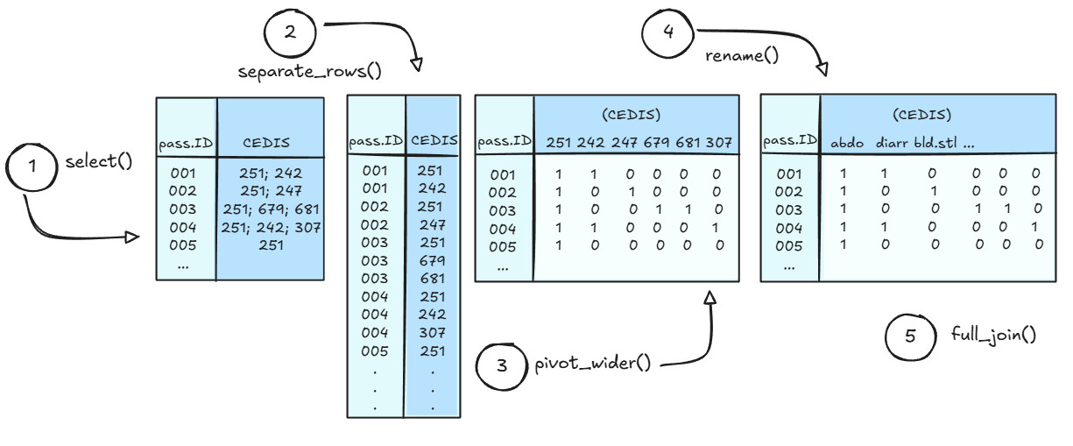
Data flow diagram for working with the CEDIS variable

Code-along for Part B
First, we’ll start by saving a temporary subset of our abdo-manifest object that contains only the pass.ID and CEDIS variables. This will help to ensure that we don’t mistakenly manipulate other variables in our dataset accidentally.
CEDIS_subset <- abdo_manifest %>%
select(pass.ID, CEDIS)

Apply separate_rows()
Easy enough, next, let’s check out the arguments we’ll need to specify in the separate_rows() function:
separate_rows(data, … , sep, convert)
- data = the data frame we want to modify (this is already handled with the %>% operator)
- … = tidy-select columns we want to target
- sep = the character used to separate the values we want to split up (e.g., “;”)
- convert = (T/F) this tells R whether or not we want to convert the resulting columns into whatever class the individual values are. For example, the CEDIS variable is presently stored as a character string because it mixes both numeric and character values. If we set convert = T, then the separated CEDIS codes will be treated as numeric, and if we set convert = F, then they’ll stay as characters.
 Warning
Note: the Tidyverse team has marked separate_rows() as end of lifecycle / deprecated. This doesn’t mean that the function won’t continue to work, but it does mean that the team will not continue to update it. The function that is intended to replace it is called separate_longer_delim(), however, it is still in experimental status, so we won’t official move to that one until a later time.

Let’s hit the CEDIS variable with our separate_rows() function and see what we get!
CEDIS_subset_long <-
CEDIS_subset %>%
separate_rows(CEDIS, sep = ';', convert = FALSE)
#view(CEDIS_subset_long)

Apply pivot_wider()
Now we can use the pivot_wider() function to create new variables based on the values present in the CEDIS variable.
pivot_wider(id_cols, names_from, values_from, values_fill)
- id_cols = the key or identity variable, in this case, pass.ID
- names_from = the variable containing the names that will be used for new variables
- values_from = the variable that contains the data you want to use to fill in under the new variable headings
- values_fill = a ‘fill’ value to be used to fill in the missing observations (e.g., 0, NA, etc.)
 Warning
Note: pivot_wider() assumes that each combination of the id_cols and names_from variables is unique. If duplicates exist in your dataset (e.g., two instances of pass.ID = 001 and CEDIS = 251), you must specify a function using values_fn() to define how those duplicate values should be handled (e.g., max for presence/absence, sum for counts).

CEDIS_subset_wide <-
CEDIS_subset_long %>%
mutate(value = 1) %>%
pivot_wider(id_cols = pass.ID,
names_from = CEDIS,
values_from = value,
values_fill = 0)

Rename() variables
On to the easy part! We now just have to rename the CEDIS codes into useful variable names!
Take a few minutes to review the CEDIS table that was provided in your participant folder and note down the symptoms that correspond with each of the codes.
Click to see the codes
Just kidding! You didn’t think we’d do all the work for you, did you?
Take a break from your RStudio console and give the PDF a quick read, you should be easily able to find the symptoms that correspond to the following CEDIS codes:
- 251
- 254
- 257
- 260
- 404
Need a short brain-break? Every thought about the differences between R and Python? Here’s a short video where Posit’s Chief Data Scientist, Dr. Hadley Wickham, talks about R versus Python.

R versus Python - more alike than different!
Ok - on to the coding step. If you still haven’t looked up the codes at this point - then follow along and see how we decided to rename the variables.
The rename() function allows you to specify exactly which variables you want to rename, and uses a “new.name” = “old.name” syntax. When you’re working with more complex datasets, or in the middle of a series of operations, its generally much safer to rename variables this way.
symptoms_table <-
CEDIS_subset_wide %>%
rename("abdo.pain" = "251",
"vomiting" = "257",
"diarrhea" = "254",
"bloody.stool" = "260",
"headache" = "404")

Join() with main dataset
Finally it’s time to join our symptoms data back with our main manifest!
Let’s go ahead and re-unite these data, using the pass.ID as the key variable! Note that this time, since the key variable is named the same in both datasets, we don’t actually need to specify the variable in our list of function arguments.
symptoms_manifest <- full_join(symptoms_table, abdo_manifest)
# Remove all but the specified objects from memory
#rm(rm(list = setdiff(ls(), c("symptoms_manifest"))))
Review your symptoms manifest object to ensure that everything looks in order. Once that’s finished, clean up your workspace, removing any of your temporary/intermediate data objects.

Part C: You’re an epidemiologist, remember?
Alright - up until now we’ve focused primarily on cleaning and manipulating data, which are essential skills for an epidemiologist to have. However, you were hired aboard the S. S. Rainbow Cake because you’re an epidemiologist and are trained to think about how data are used to solve public health issues, so let’s turn our focus now to exploring what are our data are telling us.
We need a tool to help turn our observations into meaningful summaries, and the summarize() family of functions will provide just that!
The summarize() function takes your specified data and summary functions (e.g., sum, mean, median, max, min, etc.) as input, and outputs a new data frame with the results stored as variables. The syntax should look fairly familiar at this point.
e.g.,
data %>% summarize(
summary_mean = mean(variable),
summary_median = median(variable),
summary_example3 = some.function(variable),
etc.
)
A very useful supplement to summarize() functions is the ability to group your data prior to the summaries being calculated. This allows you to create a summary of one variable for each level of another variable. E.g., calculating the median age for females and males separately.
You can group variables in one of two ways.
- Using the .by = argument inside the summarize() function. E.g., adding .by = Gender will split your data into groups of males and females only before carrying out the summary function indicated.
- Using group_by() before invoking summarize() in your tidyverse pipe operations. E.g.,
data %>%
group_by(grouping.variable) %>%
summarize(mean = mean(summary.variable),
median = median(summary.variable),
etc.)
Let’s list some summaries that we may be interested in, then work up an example using summarize().
Simple statistics to summarize:
- Mean, median and range of ages for all cases
- Numbers of total male and female cases
- Numbers of passengers with fever (e.g., > 38 degrees Celsius)
- Total numbers of cases reporting
  - Vomiting
  - Diarrhea
  - Headache
  - Bloody stool

Mean, median and range of ages
Let’s first look at a description of cases in the data:
symptoms_manifest %>%
summarize(.by = Gender,
mean_age = mean(Age, na.rm = TRUE),
median_age = median(Age, na.rm = TRUE),
max_age = min(Age, na.rm = TRUE),
min_age = max(Age, na.rm = TRUE)
)
## # A tibble: 2 × 5
## Gender mean_age median_age max_age min_age
## <chr> <dbl> <dbl> <dbl> <dbl>
## 1 Female 48.6 44.5 12 86
## 2 Male 53.3 50 15 85
It doesn’t appear that there are any differences in the age distribution of female and male cases based on what we see here.

Number and proportions of female vs. male cases
Next, let’s tally the total number of female and male cases, and calculate their proportions as well.
symptoms_manifest %>%
group_by(Gender) %>%
summarize(Total = n(),
Proportion = n()/sum(Total))
## # A tibble: 2 × 3
## Gender Total Proportion
## <chr> <int> <dbl>
## 1 Female 40 1
## 2 Male 29 1
Whoops! What do you notice above about our results? The proportion is returning the total number of female cases out of the total number of female cases, and vice-versa for males. This is because our .groups remain in effect in the summarize() function until we say otherwise. To get the correct proportions, we’ll need to adjust our code.
symptoms_manifest %>%
group_by(Gender) %>%
summarize(Total = n(), .groups = "drop") %>%
mutate(Proportion = Total / sum(Total))
## # A tibble: 2 × 3
## Gender Total Proportion
## <chr> <int> <dbl>
## 1 Female 40 0.580
## 2 Male 29 0.420
In the above summarize() call, we’ve told R that groups should be dropped in the result, and then used the Total variable to mutate a new variable that returns the proportion of the sum of the total for each female and male cases. This time, it works as expected.

Cases reporting with Fever
For this one, we’ll use mutate a new variable called “Fever” based on the temperature values, and then calculate the summaries based on that. Let’s go with anything over 38 degrees constituting a fever.
symptoms_manifest <-
symptoms_manifest %>%
mutate(Fever = case_when(
pass.temp > 38.0 ~ 1,
pass.temp <= 38.0 ~ 0,
TRUE ~ NA
))
symptoms_manifest %>%
count(Fever)
## # A tibble: 2 × 2
## Fever n
## <dbl> <int>
## 1 0 31
## 2 1 38
Hmm. Interesting - a little over half of our cases with abdominal pain were running a fever. Lets create some age groupings so that we can look a little more closely at age breakdowns.
symptoms_manifest <-
symptoms_manifest %>%
mutate(
age.group = case_when(
Age < 12 ~ "0–11",
Age < 18 ~ "12–17",
Age < 30 ~ "18–29",
Age < 50 ~ "30–49",
Age < 65 ~ "50–64",
Age >= 65 ~ "65+",
TRUE ~ NA
)
)
symptoms_manifest %>%
group_by(age.group) %>%
count(Fever)
## # A tibble: 8 × 3
## # Groups: age.group [5]
## age.group Fever n
## <chr> <dbl> <int>
## 1 12–17 0 2
## 2 18–29 1 4
## 3 30–49 0 12
## 4 30–49 1 18
## 5 50–64 0 9
## 6 50–64 1 7
## 7 65+ 0 8
## 8 65+ 1 9
 Note
It looks like ages 30-49 were experiencing fever most frequently. Does this give us any clues at this stage as to what we might be dealing with? Why or why not?

Now let’s look at our remaining symptoms by gender and by age group:
- Vomiting
- Diarrhea
- Headache
- Bloody Stool
symptoms_manifest %>%
group_by(Gender) %>%
summarize(
Vomit = sum(vomiting),
Diarrhea = sum(diarrhea),
Headache = sum(headache),
Bloody.Stool = sum(bloody.stool)
)
## # A tibble: 2 × 5
## Gender Vomit Diarrhea Headache Bloody.Stool
## <chr> <dbl> <dbl> <dbl> <dbl>
## 1 Female 32 39 31 19
## 2 Male 24 27 23 12
symptoms_manifest %>%
group_by(age.group) %>%
summarize(
Vomit = sum(vomiting),
Diarrhea = sum(diarrhea),
Headache = sum(headache),
Bloody.Stool = sum(bloody.stool)
)
## # A tibble: 5 × 5
## age.group Vomit Diarrhea Headache Bloody.Stool
## <chr> <dbl> <dbl> <dbl> <dbl>
## 1 12–17 2 2 2 0
## 2 18–29 3 4 3 4
## 3 30–49 24 29 23 13
## 4 50–64 15 14 12 5
## 5 65+ 12 17 14 9
Have a look at the results of the symptom breakdown by gender and age. Does anything stand out to you? Why or why not? What age ranges are the majority of your cases in? Is this any different than the general population on the ship?

Symptom onset dates
We’ll take a look next at symptom onset dates, and see if there’s any discernible pattern that we can identify from the summaries.
symptoms_manifest %>%
group_by(onset.date) %>%
count()
## # A tibble: 5 × 2
## # Groups: onset.date [5]
## onset.date n
## <date> <int>
## 1 2025-02-10 4
## 2 2025-02-11 22
## 3 2025-02-12 28
## 4 2025-02-13 13
## 5 2025-02-14 2
Are you starting to see a pattern here? These numbers appear to read very much like an outbreak curve typical of a point-source exposure.
Let’s plot these numbers using the ggplot() function so that we can have a quick visualization.
 Note
This course is not intended for training an in-depth focus on data visualizations, as that is the focus of another of TDU’s trainings: R for Data Visualization. In this module, we’ll introduce the very basics of summarizing data and generating a simple plot, but if you wish to read further, there are many resources available for you to learn on your own!
- R for Data Science (R4DS) - Visualize
- The grammar of graphics (ggplot2) reference page
If you’re ever looking for inspiration, here’s a link to a large collection of extensions for making ggplot2 even more powerful as a data visualization tool:
- Ggplot2 extensions gallery

To keep things simple for now, we’ll be using a very simple ggplot to look at the distribution of cases over time. We can easily incorporate this into our summary statement using the pipe operator %>%.
For this ggplot, you’ll need to specify the following arguments:
- aes() - the chart aesthetics (which variables should map to x and y on the chart?)
- geom_col() - the type of chart that we’d like to produce.
Since we’re already summarizing the data using our summarize() function, we’ll apply a geom_col() layer to visualize the summary as columns. If we were going to let ggplot do the summary for us, we could instead feed our raw data into the function, and use the geom_bar() argument.
Note that once ggplot has been called, additional layers to the chart must be chained using the + operator, not the %>% operator.
symptoms_manifest %>%
group_by(onset.date) %>%
count() %>%
ggplot(aes(x = onset.date, y = n)) +
geom_col()
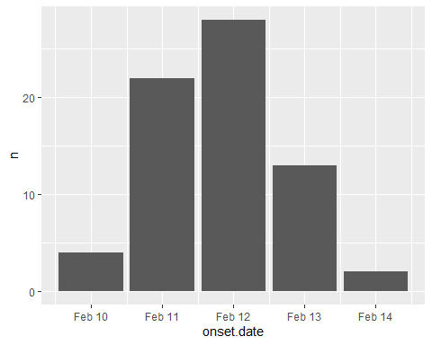
While there are many improvements that could be made to this chart, it does confirm our suspicions about the shape of the distribution of cases, this is definitely looking like the ship has experienced a point-source outbreak!

Further exploring the dataset
Luckily, at this stage, the outbreak appears to be in decline, and may even be over. However, as epidemiologists, we know that if we don’t identify the source of the illnesses, then they could occur again. Using our data-swashbuckling abilities - we have uncovered a number of very strong clues in this scenario so far.
Take a couple of minutes to summarize, from an epidemiological perspective, what you have learned about the cases and illnesses aboard the S. S. Rainbow Cake so far. This may help to hone your focus on where to investigate next!
Click to see the present clues in the investigation
Here’s some of the main considerations so far:
- There is a very strong point-source outbreak signal. We should be thinking about exposures that may have occurred at a single setting (e.g., meals, events).
- While all of our cases reported abdominal pain / discomfort, there are some that have reported much more serious symptoms. We may want to investigate these further.
- There does not appear to be any strong signals based on age and sex of cases.
- We are on a cruise ship and historically, gastrointestinal outbreaks cause by contaminated food are a common occurrence.

Differences in symptoms by onset date
Let’s go back to our symptoms and see if there are any differences in the symptoms by onset date. This time, we’ll summarize all of different symptoms by date using a clever little function called across().
The across() function works within either a mutate() or summarize() call, and allows you to repeat the same operation on a range of variables, rather than having to type them in over and over again. Here, we’ll use it to sum up the number of cases that reported each symptom for each each day in our dataset.
symptoms_manifest %>%
group_by(onset.date) %>%
summarize(
across(
c(vomiting, diarrhea, headache, bloody.stool, Fever),
~ sum(.x, na.rm = TRUE)
)
)
## # A tibble: 5 × 6
## onset.date vomiting diarrhea headache bloody.stool Fever
## <date> <dbl> <dbl> <dbl> <dbl> <dbl>
## 1 2025-02-10 3 4 3 1 1
## 2 2025-02-11 19 21 17 8 11
## 3 2025-02-12 22 27 24 17 20
## 4 2025-02-13 10 12 9 5 6
## 5 2025-02-14 2 2 1 0 0
 Note
Do you notice any differences between the numbers of passengers reporting symptoms? Why might vomiting, diarrhea, and headache be reported less often than the more severe symptoms of bloody stool and fever. What types of gastrointestinal diseases might cause bloody stool and fever?

Differences in symptoms by other variables
If you recall, there are still two variables in our dataset that we haven’t taken a look at yet:
- Member Status
- Boarding Date
Let’s leave no stones unturned, and see if we can identify any differences between the passenger’s symptoms and either their cruise-member-status or the day that they boarded the ship. Since bloody stool and fever are definitely the greater cause for concern, we’ll focus on those symptoms only.
symptoms_manifest %>%
group_by(`Member Status`) %>%
summarize(
across(
c(bloody.stool, Fever),
~ sum(.x, na.rm = TRUE)
)
)
## # A tibble: 3 × 3
## `Member Status` bloody.stool Fever
## <chr> <dbl> <dbl>
## 1 Gold 3 6
## 2 Platinum 3 4
## 3 Silver 25 28
symptoms_manifest %>%
group_by(`Boarding Date`) %>%
summarize(
across(
c(bloody.stool, Fever),
~ sum(.x, na.rm = TRUE)
)
)
## # A tibble: 2 × 3
## `Boarding Date` bloody.stool Fever
## <dttm> <dbl> <dbl>
## 1 2025-02-09 00:00:00 31 38
## 2 2025-02-10 00:00:00 0 0
 Note
Whoa! Did you just crack the outbreak code here!? There definitely looks to be something going on related to the date that passengers boarded the ship, as well as potentially their cruise-member-status.
Excellent epi-investigative skills!

Summary and quiz

Summary
Wow! You really covered a lot in this module - give yourself a well-earned pat on the back!
You managed to do all of the following, using only tidyverse functions:
- Joining multiple datasets using aggregation functions
- Joining multiple datasets using table-joins
- Manipulating the shapes of datasets using pivot functions
- Separating complex strings and creating new variables
- Summarizing data using summary()
- Creating a basic epidemiological curve
- Applying the across() function to summarize with multiple variables at once
That’s a lot! We even managed to sneak a small preview of regular expressions in there!

Quiz
Let’s do a quick review of the Tidyverse functions we used in this module:
1. You are given five daily abdo_ datasets with identical columns. Which function is most appropriate for combining them into a single dataset by stacking rows?
left_join(), because it preserves all rows bind_rows(), because the datasets have the same structure pivot_longer(), because it reshapes multiple datasets Submit
2. In bind_rows(…, .id = “id”), what does the .id argument capture?
A unique row number for each observation The source dataset each row came from The primary key used for later joins Submit
3. Why was skip = 4 used when importing the abdo datasets with read_tsv()?
To remove the first four rows containing metadata rather than data To skip missing values at the top of the file To improve import speed for large files Submit
4. Why was case_when() used instead of if_else() when creating new variables?
case_when() allows multiple conditional rules to be applied in order case_when() is faster for numeric variables if_else() cannot be used inside mutate() Submit
5. Why is it good practice to remove the temporary id variable before joining datasets?
It reduces file size and improves performance It prevents accidental use of the variable in joins or analyses Joins will fail if extra columns are present Submit
6. Why was left_join() used to join the abdo data to the passenger manifest?
To keep all passengers, even if no abdo record exists To keep only passengers with abdo symptoms Because left_join() automatically removes duplicates Submit
7. What problem does by = c(“pass.ID” = “Pass_ID”) solve in a join?
It converts character IDs to numeric It allows joining on variables with different names It ensures only unique IDs are matched Submit
8. What does separate_rows(CEDIS, sep = “;”) do?
Splits a single row into multiple rows based on CEDIS codes Creates new columns for each CEDIS code Removes duplicate CEDIS values Submit
9. Why is separate_rows() typically applied before pivot_wider() in this workflow?
To ensure one value per row before creating indicator columns To reduce the number of columns created To convert character variables into factors Submit
10. What assumption does pivot_wider() make about the data when creating new columns?
Each ID–value combination is unique All values are numeric There are no missing values Submit
11. If multiple rows exist for the same ID and symptom, which pivot_wider() argument can be used to resolve this?
values_fn names_sep id_expand Submit
12. What is the primary purpose of using values_fill in pivot_wider()?
To replace missing combinations with a default value To remove rows with missing data To convert logical values to numeric Submit
13. Why is it often useful to create symptom variables as 0/1 indicators?
They support straightforward summarization and modeling They reduce memory usage in all cases They prevent duplicate rows from occurring Submit
14. What advantage does using across() inside summarize() provide?
It allows the same summary operation to be applied to many variables at once It automatically reshapes the dataset It replaces the need for grouping variables Submit
15. Why is inspecting the data with functions like glimpse() important before and after joins?
To verify structure, variable types, and unexpected changes To permanently modify the dataset To optimize joins for performance Submit

