
MIDDLESEX UNIVERSITY
THE BURROUGHS, HENDON LONDON NW4 4BT

Title: Coursework 1 – Data Science Practices
Student Name/Surname: Haydn Campbell
Student ID: M01001693

Word Count: …

Contents
1. Understanding Of The Data 3
2. Data Preprocessing 5
3. Exploratory Data Analysis (EDA) 7
4. Model Development and Evaluation 9
5. References 9

Understanding Of the Data
For my coursework, I have chosen a flight dataset that represents airline member data. The dataset records detailed information about individual members’ flight activity and loyalty program engagement/assignment. Although the specific airline or business name is not mentioned, the dataset includes several key variables of flight member interactivity.

This dataset provides information for analysing member behaviour, travel frequency, and loyalty engagement patterns over time. It allows for exploration of customer segmentation, prediction of loyalty tiers, and identification of key factors influencing member retention and travel activity. The dataset was sourced from Kaggle, a public platform for open datasets, and is released under a CC0 Public Domain license, allowing free use and analysis for educational and research purposes.

My goal is to apply clustering and classification techniques to identify which features most influence the FFP_TIER (a preassigned flight membership tier based on activity and rewards), to improve or redesign the tier assignment system to more accurately reflect members’ flight behaviours and value.

I believe that the most influential columns following the establishment of my goals will be FLIGHT_COUNT/Scaled_Flight_Count (Total number of flights across the 2 years of dataset recording), BP_SUM (Total basic points – not including bonus points), SEG_KM_SUM (Total flight km across the 2 year viewing of the dataset), SUM_YR_2 (Total distance travelled in year 2) and SUM_YR_1 (Total distance travelled in year 1) as these variables can be considered derived variables, representing a logical stepwise or cumulative progression of flight data, unlike features such as MAX_INTERVAL (Maximum time interval between flights in observation window) or avg_discount (Average discount rate), which are isolated measures and have no direct determined correlation with any other columns in the dataset.

Next, I will be defining the dataset and its contents using the basic exploratory functions: data.head(), data.tail(), data.shape, and data.info(), used to understand dataset dimensions (62,988 rows × 23 columns), structure, and data types.”

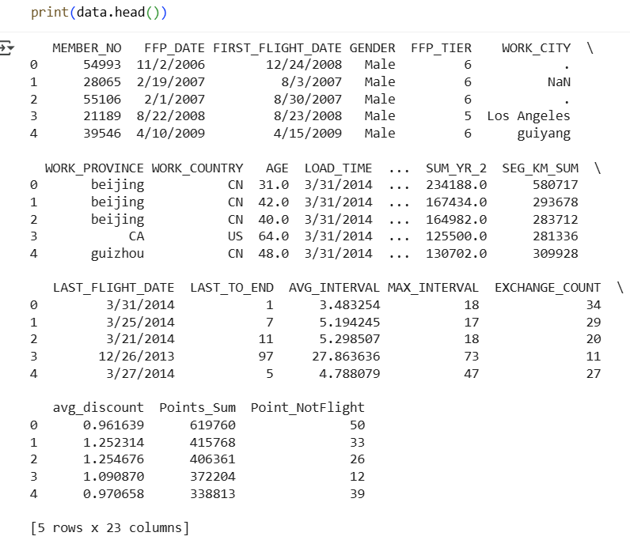

The image above displays the first five rows of all the columns of the flight dataset using the data.head() call.

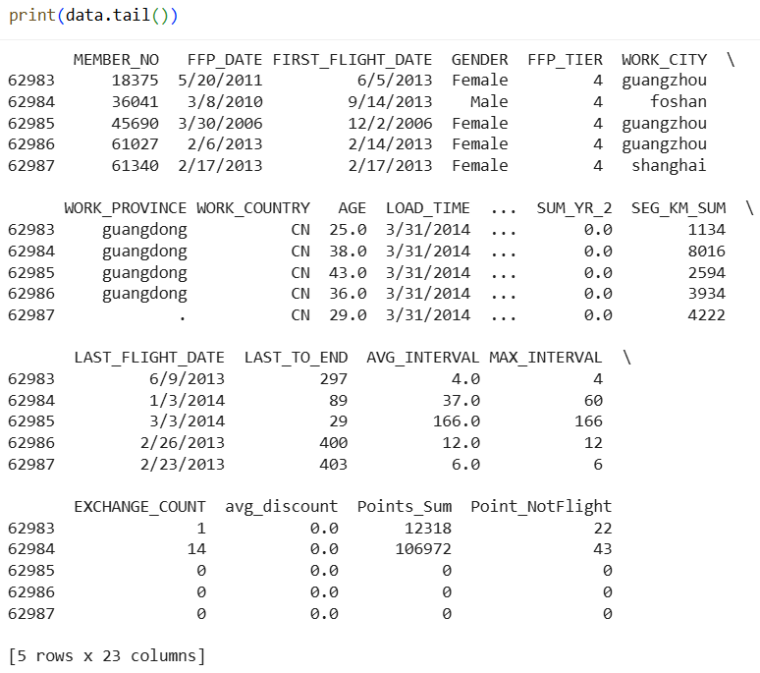

The image above displays the last five rows of all the columns of the flight dataset using the data.tail() call

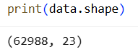

The image above shows the data.shape call which shows us (62988, 23) showcasing that there are 62988 separate pieces of data across 23 columns.

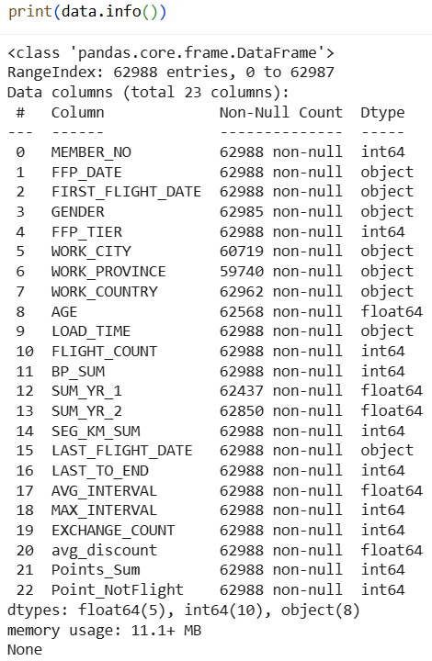

The image above shows the data.info() call returning a list of all the dataset’s column names and data types along with common data types; float64, int64 and object being used throughout the dataset.

Data Preprocessing
This section will go into the data preprocessing of the flight dataset, removing null values and replacing incorrect/unclean implementations. This will later allow us to replace Nan values with sophisticated values that fit a column or the dataset trend or minimise skew in later analysis.
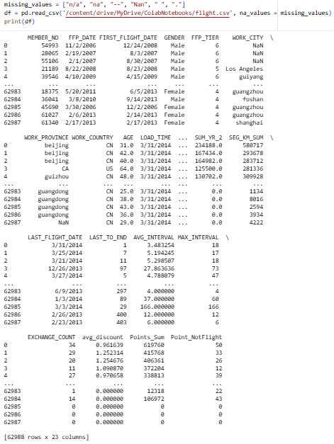

As shown in the image above the relevant column head and tail values have been replaced with ‘Nan’ from previously being empty row values ‘ ’ or hyphenated row values ‘—‘.


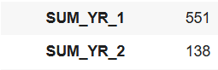
Secondly, I will use a simple imputer function to fill all numerical Nan values with its median replacement, as displayed in Figures 1 and 2:
Figure 1: Null values within SUM_YR_1 and 2 columns Figure 2: New values within SUM_YR_1 and 2 columns
As it is shown in Figure 1 (prior to the simple imputer function) and Figure 2 (following the use of the simple imputer function) the numerical Nan values are replaced with median powered values by selecting strategy=’median’ in the simple imputer of previous null values in all columns. This will allow me to later configure the silhouette clustering score and elbow method curve without having error messages returned. It also allows for the dataset to stay at a large size, not be deprecated/less useable due to frequent Nan values across multiple columns.
The same can be said for the image below which uses one-hot encoding for the transition of GENDER column to GENDER_male and GENDER_female.
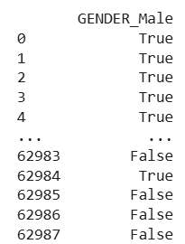
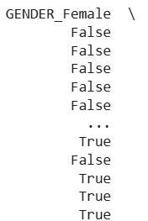

My last bit of normalisation was done to the FLIGHT_COUNT column reducing all integers in the column to be represented between 0 and 1 as shown below.
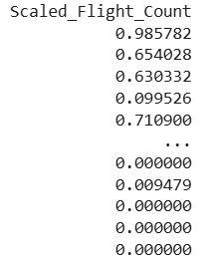

Exploratory Data Analysis (EDA)
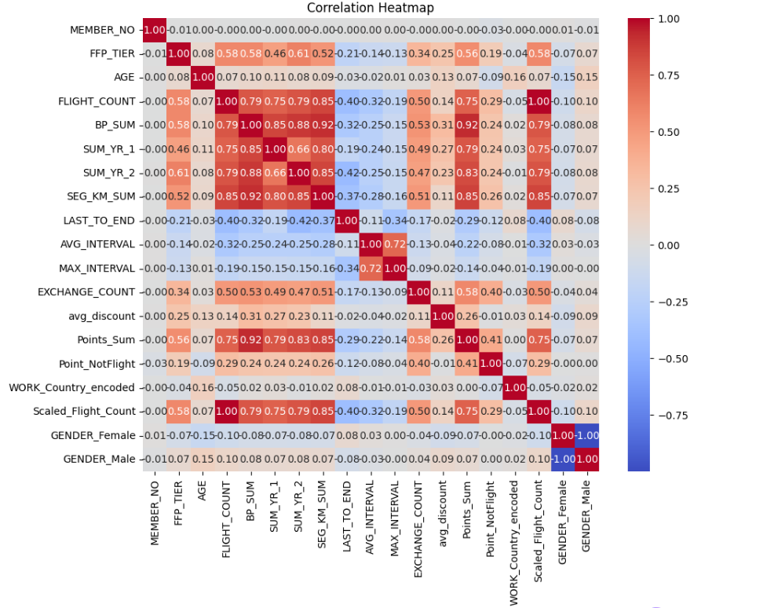
Moving onto EDA and my first bit of general visual correlation checking is done using a heatmap, I want to see the specific colourised correlations that each column of the dataset has on my target variable FFP_TIER. As it can be shown in Figure 3 (section within the black block).
Figure 3: Correlation Heatmap of all flight.csv columns

As seen in Figure 3, features such as FLIGHT_COUNT, SEG_KM_SUM, SUM_YR_1, BP_SUM and SUM_YR_2 show the strongest positive correlations with FFP_TIER, confirming their influence on tier assignment. These relationships reflect cumulative engagement, unlike independent measures such as avg_discount or MAX_INTERVAL. (Points_Sum is not being used in this investigation as the definition of the column on Kaggle in comparison to BP_SUM suggests that the assigned FFP_TIER provides bonus points for flight activity)
Next, I took the SUM_YR_1 and SUM_YR_2 column data and applied both to scatterplots with the FFP_TIER as the x axis determiner, which resulted in these two diagrams:
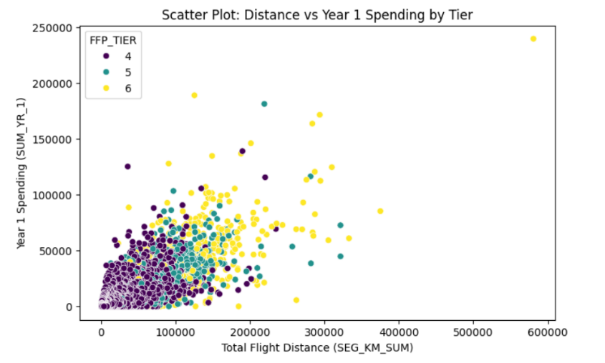

Figure 4: Scatterplot of SUM_YR_1 vs FFP_TIER

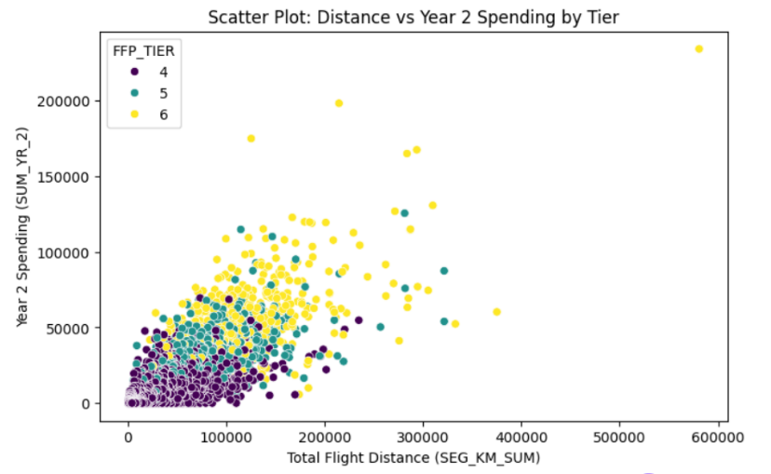
Figure 5: Scatterplot of SUM_YR_2 vs FFP_TIER
Figures 4 and 5 show a clear progressive relationship between flight distance (SUM_YR_1, SUM_YR_2) and FFP_TIER. While both years display similar trends, slightly stronger correlation in year two (0.61 vs 0.46) via the difference in gradient of the red trend line suggests increased engagement after tier establishment.

This suggests that Points_Sum is excluded from the analysis, as it includes bonus points awarded based on FFP_TIER, unlike BP_SUM. Using it could skew results by reflecting tier-based rewards rather than actual flight activity, leading to misrepresented tier assignments.

Lastly, I applied the Scaled_Flight_Count column data with the FFP_TIER separations to a scatterplot diagram, and these were the results:
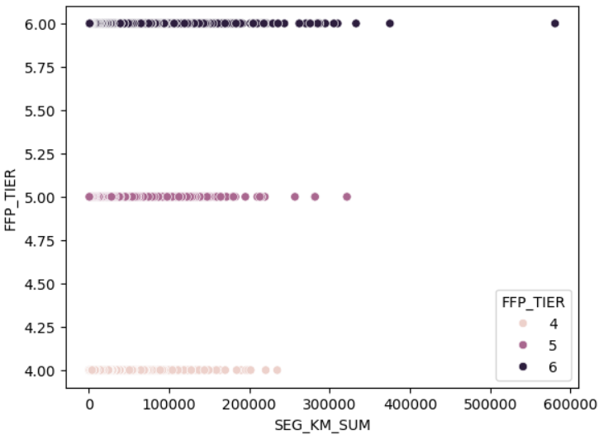

Figure 4: Scatterplot displaying FFP_TIER and SEG_KM_SUM

In Figure 4 we can see the slow but progressive rise in total flight km per flight member per FFP_TIER, I find these results interesting firstly because there are members of the 6th tier with total km flight distance for the 2-year data recording period the same as that of members in the 5th and 4th tiers. This is interesting because my initial assumption of tiers would have been structured arounds the bounds of total flight km, across the first two years of data recording along with the total sum of flight km. It’s also interesting to note that SEG_KM_SUM has a correlation value of 0.52 as of the correlation heatmap from Figure 1 suggesting that this visualization of data from the 2-year recording period of the dataset holds more significance than the SUM_YR_1 number of flights even though we could see each transition of FFP_TIER between each FFP_TIER.

Model Development and Evaluation
Since I am doing clustering analysis there is no ‘true’ FFP_TIER/target value instead model groups are based on similarity and require value reliance upon other values/columns. Therefore, as attached to the right, I have created the ‘cluster’ column which groups customers into natural segments based on flight distance (SEG_KM_SUM, SUM_YR_1, SUM_YR_2) and expenditure behaviour (Scaled_Flight_Count, Points_Sum) to see whether current FFP_TIER assignments align with these clusters. By using the K-Means to groups airline members with similar travel and spending patterns it allowed me to evaluate whether their assigned FFP_TIER aligns with their actual data behaviour.
Within my code I have also implemented a mapped alternative to the original ‘cluster’ column, as shown in Figure 7, for future correlations between FFP_TIER and the calculated ‘cluster_mapped’ (shown in Figure 8) columns this will make comparisons easier to spot visually when referencing the two in future.
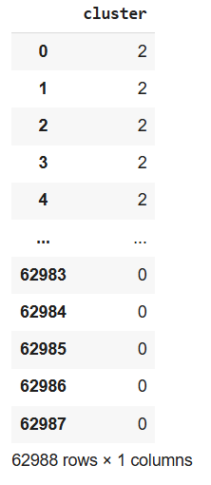

Figure 7: Simple imputer built ‘cluster’ column
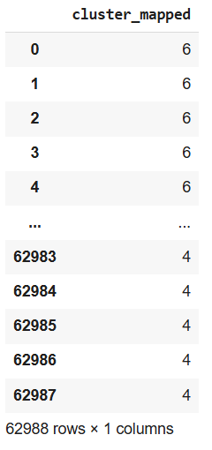

Figure 8: Re-mapped ‘cluster' aligning with FFP_TIER column
Figures 7 and 8 compare the original cluster assignments with the mapped cluster_mapped values aligned to FFP_TIER. This adjustment enables clearer correlation analysis and identification of inconsistencies in current tier assignment logic.
This mapping allows for clearer comparisons and correlations between the data-driven cluster assignments and the predefined membership tiers. By establishing this relationship, the cluster_mapped column can be used in future analysis to test the effectiveness of the current FFP_TIER system and identify potential misclassifications or opportunities for improved tier assignment.

Using the values created from the cluster column and the X_scaled value. I was able to compute the silhouette score as shown in figure 9:
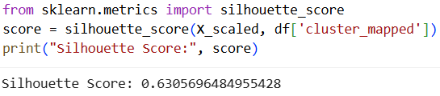

Figure 9: Silhouette score for FFP_TIER and correlated columns
From the calculated silhouette score of 0.63, in Figure 9, we can assume that the clustering captured columns (SEG_KM_SUM, SUM_YR_1, SUM_YR_2, Scaled_Flight_Count and BP_SUM) captured distinct group patterns, some overlap remains between member categories — potentially due to inconsistent tier definitions or overlapping behavioural thresholds.
Silhouette scores close to 1 implies strong separation between clusters (i.e., clear, distinct tiers). A score around 0.5–0.6 (as obtained here) reflects moderate cohesion — clusters are meaningful but not sharply divided. Scores below 0.3 typically indicate that the clustering structure does not represent natural groupings well. This score provides early evidence that while the dataset supports some natural segmentation, the existing FFP_TIER boundaries may not fully align with members’ true behavioural distribution and data found within the dataset.
Following this analysis of the silhouette score we can now move onto more specified causation of the value of 0.63 and why it’s not a value closer to 1. Using the ‘cluster_mapped’ column comparing it to the preassigned ‘FFP_TIER’s and display it in a new data frame mismatch_df. This will give us more specified targeting as to which rows are skewing the data and why.
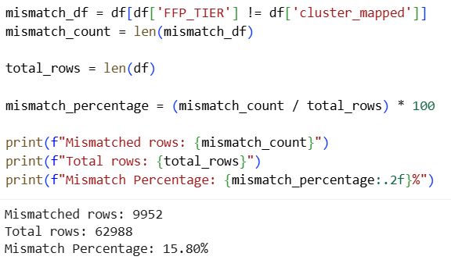

Figure 10: Mismatched rows and percentage of data frame mismatched
Figure 10 shows that 15.8% of members have mismatched FFP_TIER and ‘cluster_mapped’ classifications, suggesting potential inconsistencies in tier allocation that could affect reward fairness.
To evaluate the predictive validity of both the original and cluster-based tiering systems, Logistic Regression was implemented as a supervised classification model. The dataset was divided into 80% training and 20% testing subsets, allowing the model to learn the relationship between flight activity features — FLIGHT_COUNT, Points_Sum, SEG_KM_SUM, SUM_YR_1, and SUM_YR_2 — and the target variable. The model was first trained using the unclean dataset, where FFP_TIER served as the target, and then using the clean dataset, where the mismatched rows were removed, and cluster_mapped was used as the target.
Feature values were standardised using the StandardScaler method to ensure fair weighting across all numerical attributes. Performance was evaluated using metrics such as precision, recall, F1-score, and accuracy, supported visually through confusion matrix plots for both datasets.
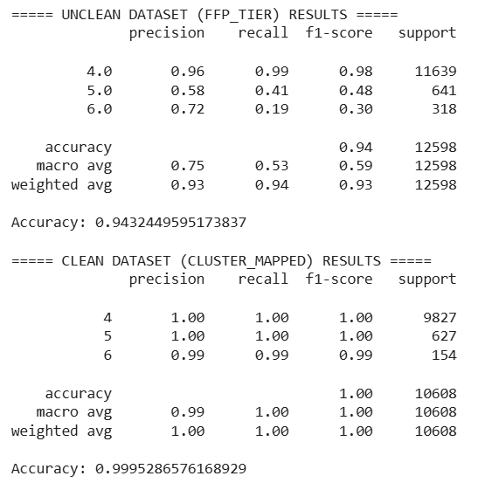

Figure 11: Clean(cluster_mapped) and unclean (FFP_TIER) dataset logistical regression results

The results shown in Figure 11, show a clear contrast between the two datasets. The unclean dataset achieved an accuracy of 0.94, with noticeable misclassifications in tiers 5 and 6, where recall values were as low as 0.19. This suggests that many tier assignments in the original dataset were inconsistent or based on less predictive features. Conversely, the clean cluster-mapped dataset achieved an almost perfect accuracy of 1.00, indicating strong internal consistency and alignment between member flight activity and assigned tiers.

These findings demonstrate that the cluster-mapped approach provides a more data-driven and reliable framework for future FFP_TIER assignment. By aligning membership tiers with measurable behavioural data rather than legacy assignments, the model can ensure a fairer and more accurate representation of customer flight engagement.

References
- Unclean Flight Members 2 Year Recorded Customer Dataset - https://www.kaggle.com/datasets/edisugiarto/unclean-airline-customer-dataset - Airline customer dataset for last 2 years activity
- Silhouette score explanation and clustering definition - What is Silhouette Score? - GeeksforGeeks

