The detector modelling module provides a comprehensive detector model, based on physical design parameters, giving the user accurate control over key model behaviour elements. IR detectors can be designed to be photodetectors or thermo-detectors. In this case, the work focuses on photovoltaic IR photodetectors, a commonly used detector type. This kind of detector is often called photodiode because it is a semiconductor diode (p-n junction) which is light sensitive. In this model, a single element infrared detector is simulated using classical parameters as inputs for the calculation, such as detector area, bandgap energy, doping, and detector temperature among others. In the source code, all the equations and resulting functions are described and referenced in order to allow the user to understand the procedure step by step. It is important to note that all the equations and parameters used are from classical models found in the literature, giving generality and reliability to the procedure. The disadvantage is, once classical parameters from the literature are used, the user must compare the obtained results with real measurements to estimate the error from the model. The model provides a spectral response, and several figures of merit, such as the detectivity and I×V characteristics. The Figure7 presents the detectivity and I×V characteristic calculated by the model for a Ge detector with the following parameters: detector area equals to 100x100 (µm2), detector temperature equals to 80 K, background temperature equals to 280 K (no source was used for the simulation, only the background radiation), and a positive doping of 1x1022 cm-3.

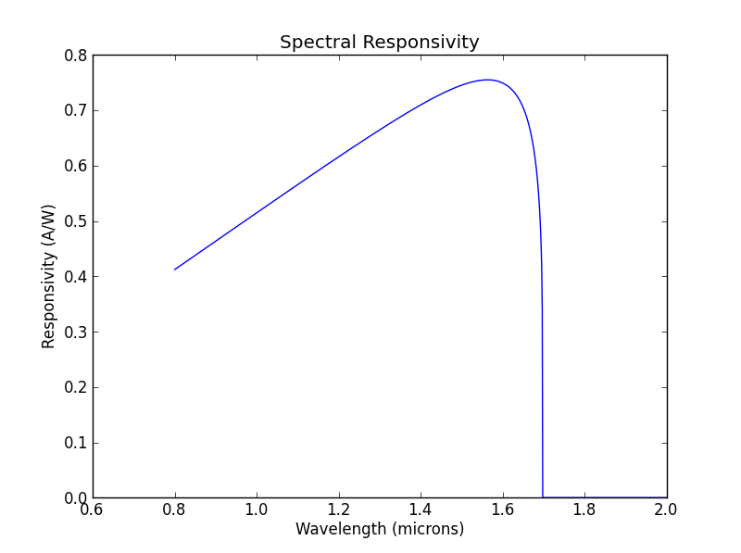 (a)

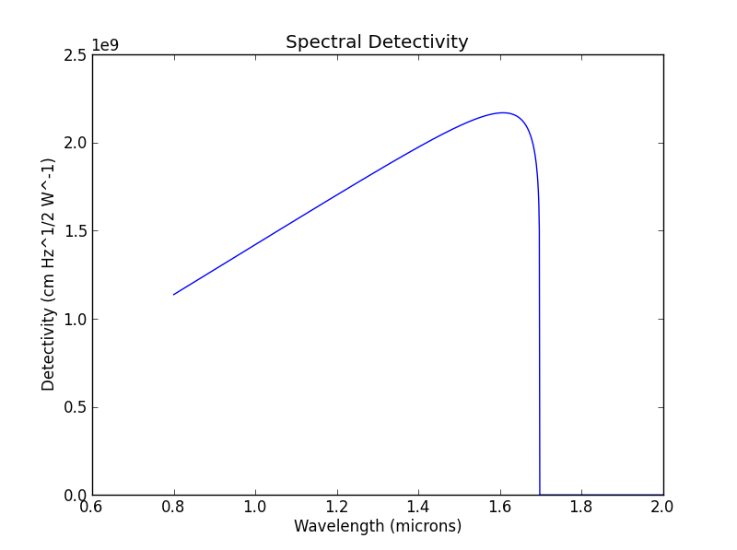(b)

Fig. x: results obtained using the toolkit detector simulation for a Germanium detector to predict its responsivity (a) and detectivity (b).

The figure x presents the responsivity in (a) and the detectivity in (b) calculated by the model. The model is in good agreement with measurements done at LabGE/ITA using InSb and Ge photodetectors. The estimated error is around 10% when compared with the peak values for responsivity and detectivity. These results from the work done at LabGE/ITA regarding these detectors will be published later.