Bubble Tube

A bubble tube is connected to an Arduino board with a wire wrapped around it for capacitive sensing. Underneath the bubble tube is a strip of tricolor LED. The color of the LED’s change. How the color changes, depends on the position of a switch. An air pump is also connected to the Arduino board through a SSR (Solid State Relay).

Directly above the tube is a webcam, connected to a computer. A .NET program is running on the computer, determining how close a person is to the bubble tube. The distance between a person and the bubble tube is send from the .NET program to the Arduino board.

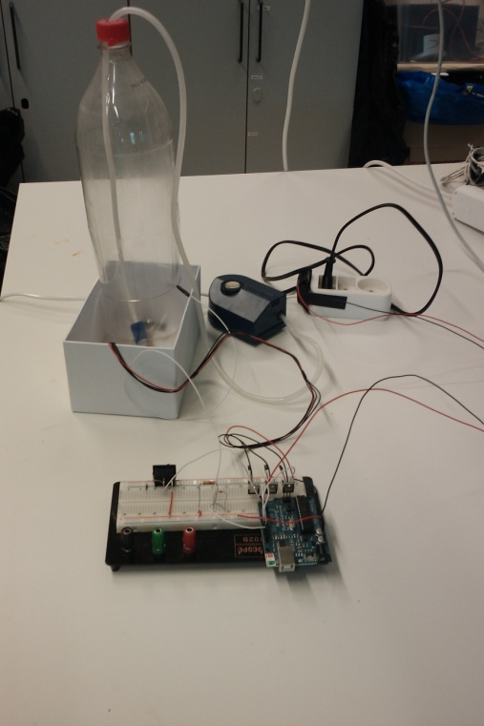

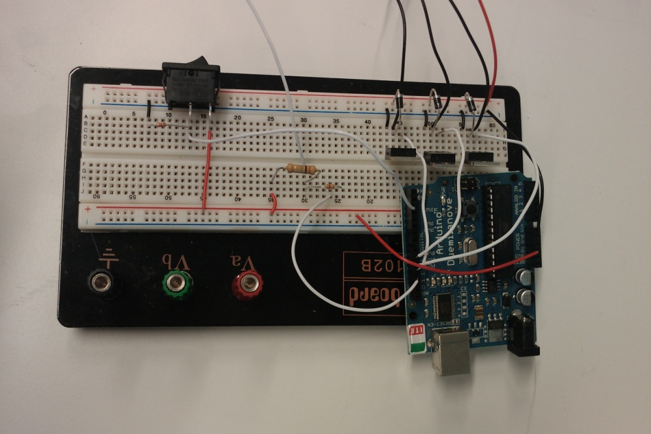

Overall setup.

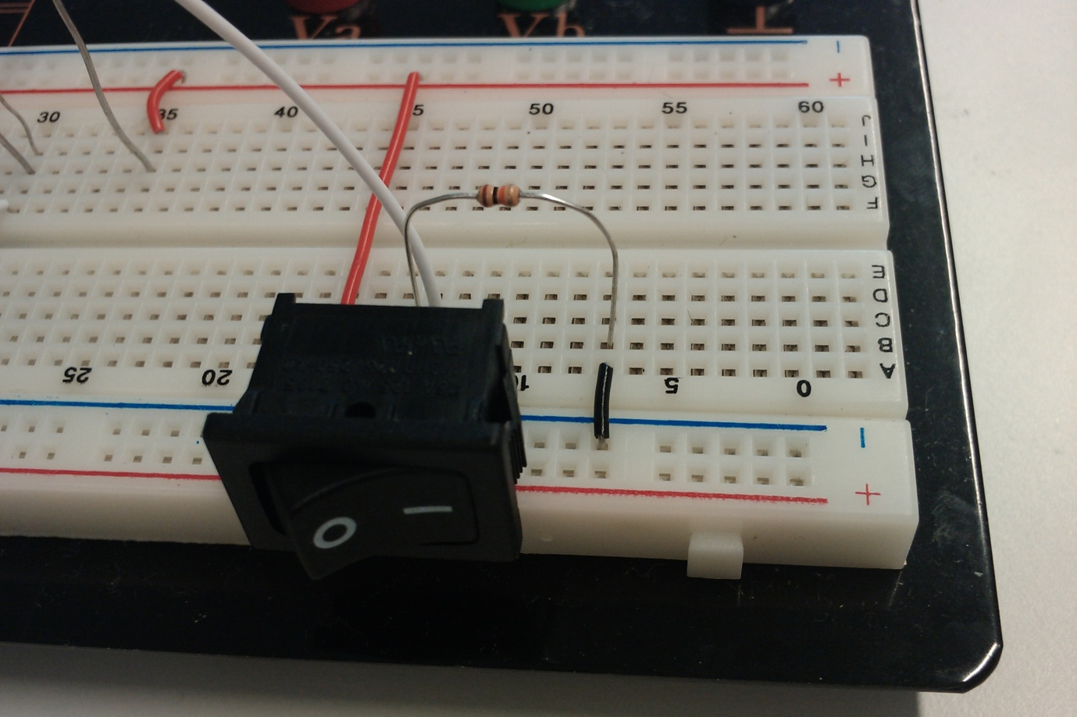

The switch controlling the two different behaviors.

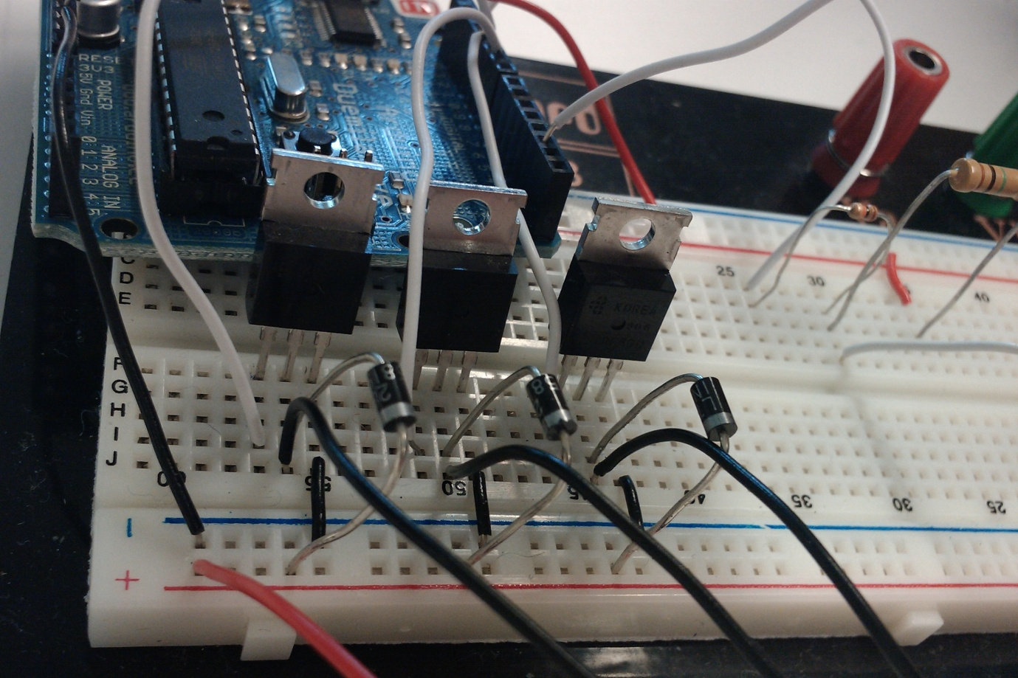

Setup of the three MOSFET transistors, controlling the color of the tricolor LED.

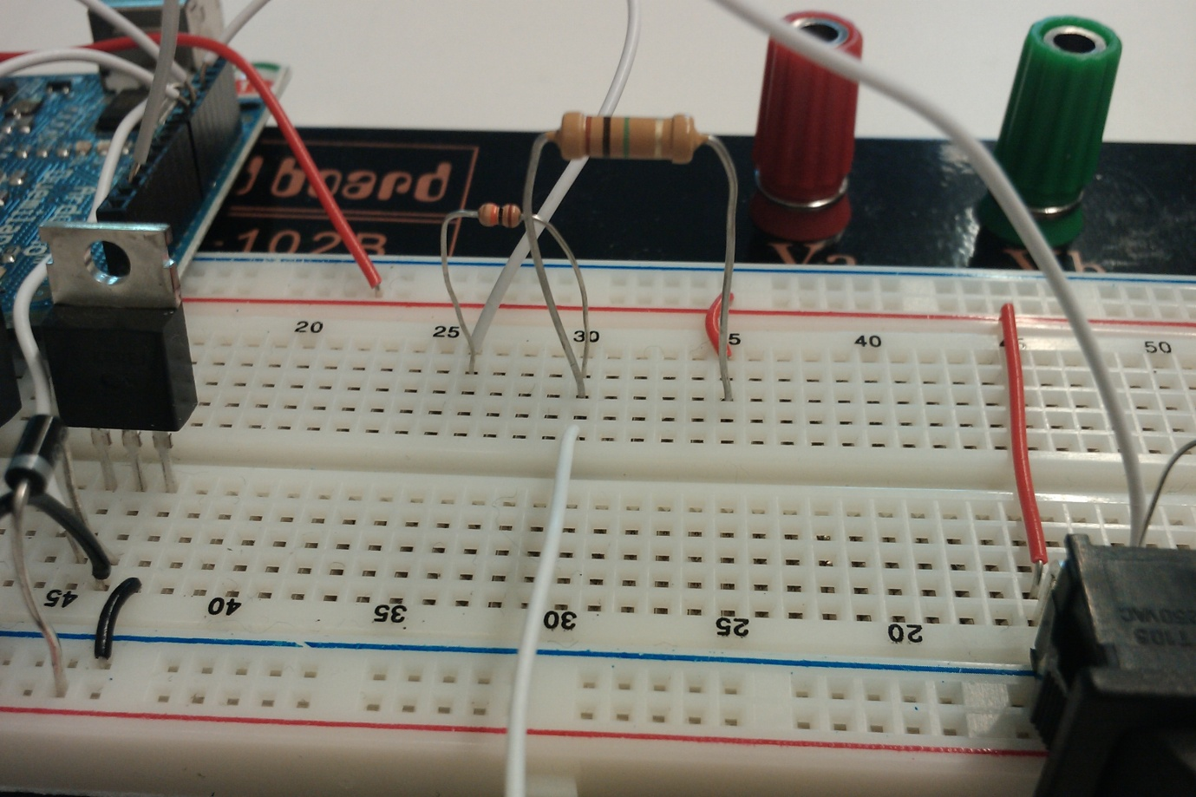

Setup of the capcitive sensor.

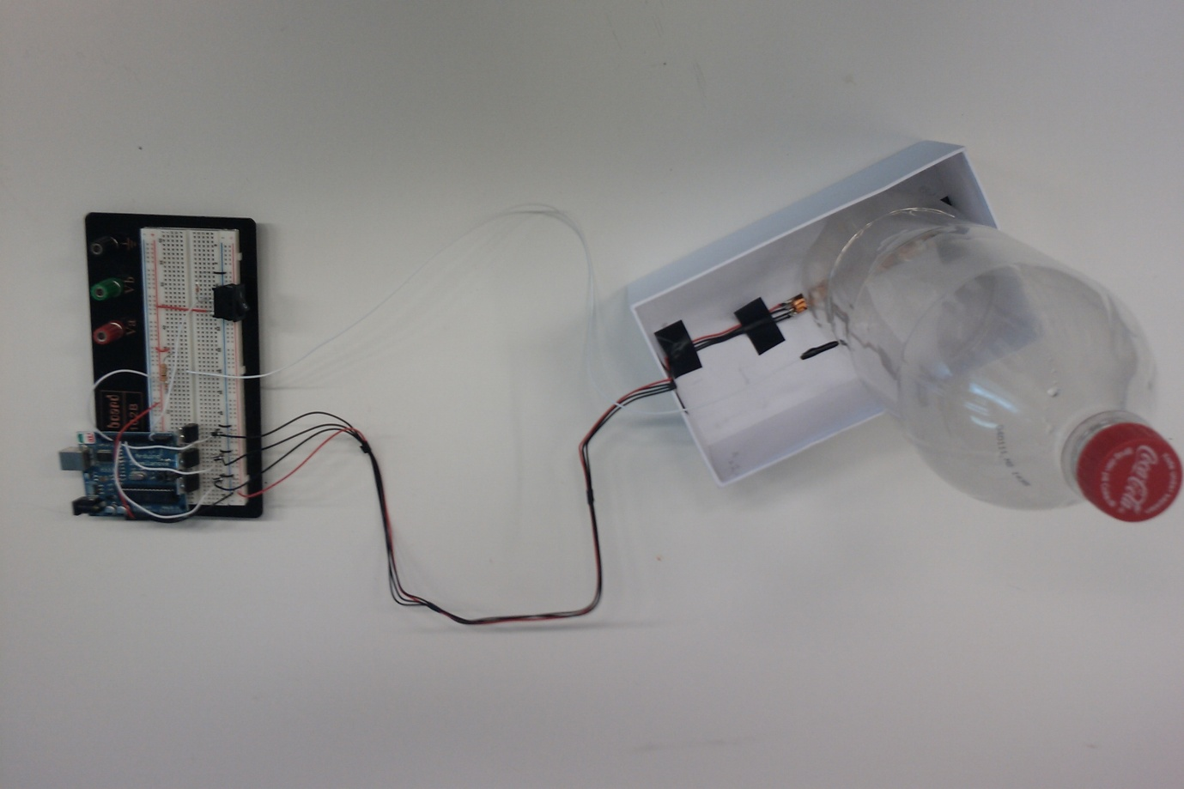

Top view

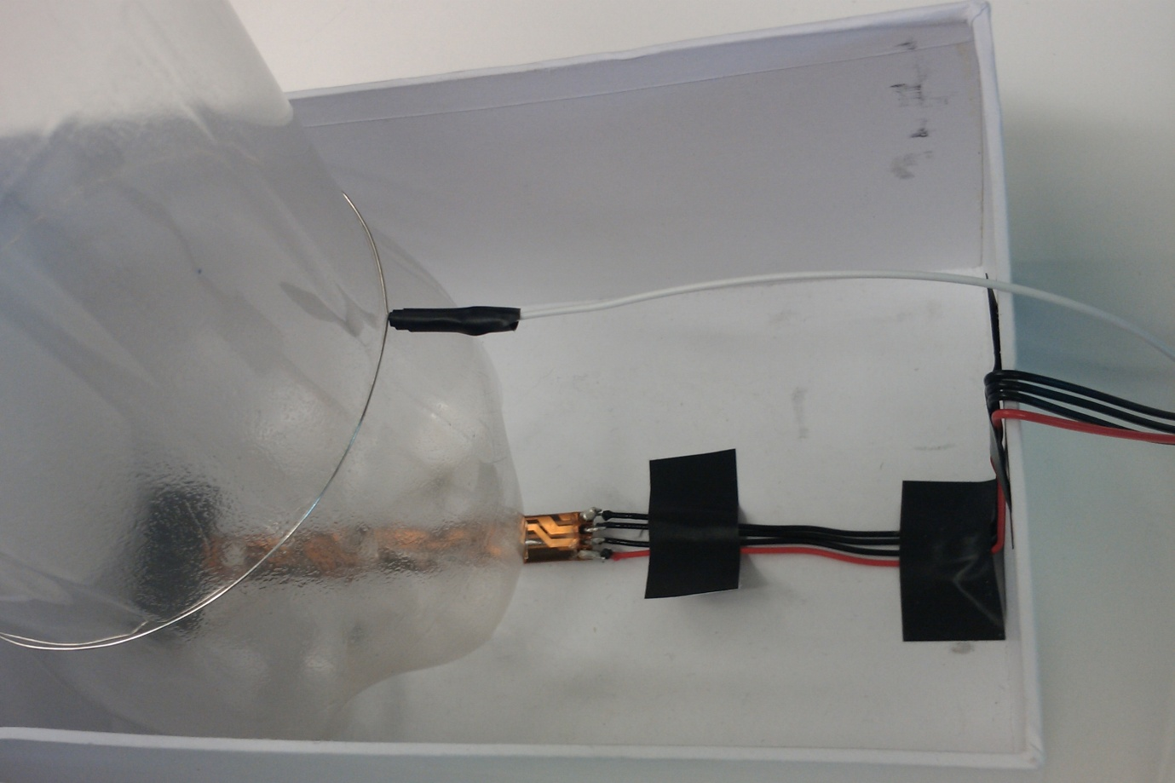

Connection of the wire for the capacitive sensor.

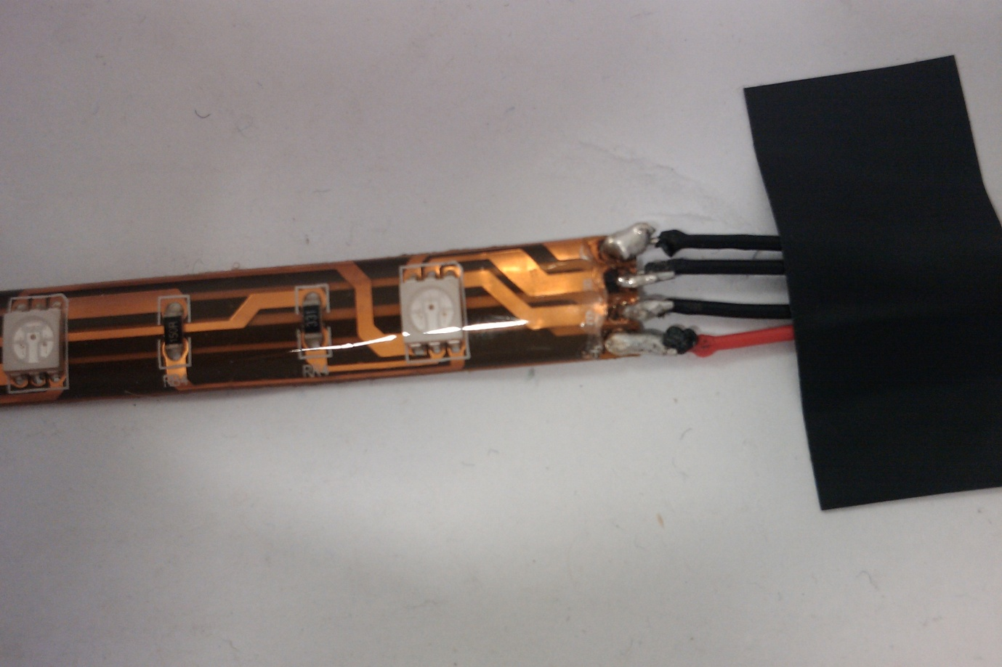

Connection of the wires to the tricolor LED strip.